Western States Air Quality Study (WSAQS)  Modeling Plan for Conducting Source Apportionment Modeling for the 2011 Modeling Year  Prepared by:  Z. Adelman  University of North Carolina  Institute for the Environment  Chapel Hill, NC 27599-6116  R. Morris  ENVIRON International Corporation  773 San Marin Drive, Suite 2115  Novato, California, 94945  April 27, 2015 | 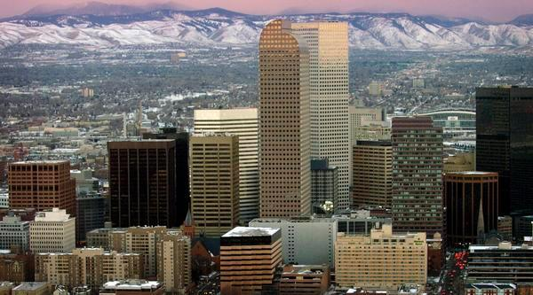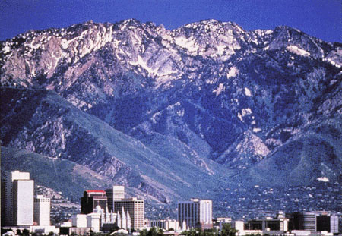  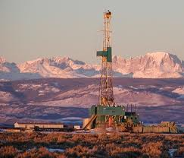

CONTENTS
TABLES ii
FIGURES iii
1 Executive Summary 1
2 Introduction 2
2.1 BACKGROUND 2
2.2 OVERVIEW OF 2011 BASE CASE MODELING 2
2.3 PURPOSE OF SOURCE APPORTIONMENT MODELING PLAN 6
2.4 OVERVIEW OF WSAQS SOURCE APPORTIONMENT MODELING APPROACH 6
3 GEOGRAPHIC SOURCE APPORTIONMENT 8
3.1 PURPOSE OF GEOGRAPHIC SOURCE APPORTIONMENT MODELING 8
3.2 CAMx GEOGRAPHIC SOURCE APPORTIONMENT MODELING PROCEDURES 8
3.2.1 Ozone State-Specific Source Apportionment Modeling 8
3.2.2 Particulate State-Specific Source Apportionment Modeling 10
3.3 POST-PROCESSING OF CAMx 2011 STATE-SPECIFIC SOURCE APPORTIONMENT MODELING RESULTS 11
3.3.1 CSAPR-Type Ozone and PM2.5 Analysis 11
3.3.2 Contributions to Ozone, PM_{2.5}, Visibility and Deposition at Monitoring Sites 12
3.3.3 Regional Haze Analysis 12
3.3.4 Spatial Maps of State Contributions 13
4 SOURCE SECTOR SOURCE APPORTIONMENT 14
4.1 Purpose of Source Sector Source Apportionment 14
4.2 CAMx SOURCE SECTOR SOURCE APPORTIONMENT MODELING PROCEDURES 14
4.3 POST-PROCESSING OF SOURCE-SECTOR SOURCE APPORTIONMENT MODELING 15
5 DETAILED SOURCE APPORTIONMENT MODELING 16
5.1 PURPOSE OF THE DETAILED SOURCE APPORTIONMENT MODELING 16
5.2 DETAILED SOURCE APPORTIONMENT MODELING PROCEDURES 16
5.2.1 Summer Ozone Source Apportionment Modeling 16
5.2.2 Winter Ozone Source Apportionment Modeling 18
5.2.3 Other Detailed Source Apportionment Modeling 18
5.2.4 Future-Year Source Apportionment Modeling 18
6 SOURCE APPORTIONMENT VISUALIZATION TOOL 19
6.1 PROTOTYPE OF THE SOURCE APPORTINMENT VISUALIZATION TOOL 19
6.2 NEXT STEPS IN DEVELOPING THE SOURCE APPORTIONMENT VISUALIZATION TOOL 22
7 REFERENCES 23
APPENDIX A: DESCRIPTION OF THE CAMX SOURCE APPORTIONMENT TOOLS A-1

TABLES
Table 2-1. Projection parameters for the WSAQS modeling domains. 3
Table 2-2. CAMx model configurations for WSAQS 2011a base case simulation 5

FIGURES
Figure 2-1. 36 km CONUS, 12 km WESTUS, and 4 km Three-State modeling domains used for developing PGM emission inputs. 3
Figure 3-1. Source Regions used in the WSAQS state-specific APCA ozone and PSAT particulate matter 2011 source apportionment modeling. 10
Figure 4-1. Five source regions used in the CAMx 36/12 km source-sector APCA ozone and PSAT particulate matter source apportionment simulation. 15
Figure 5-1. Three-State 4 km modeling domain to be used in the detailed source apportionment modeling. 17
Figure 6-1. Example screen shot from prototype web-based visualization tool after selecteing 3rd highest modeled DMA8 ozone day (July 9, 2008) at Rocky Flats monitoring site in Jefferson County, Colorado (08-059-0006). 20
Figure 6-2. Screen shot from prototype web-based visualization tool after selecting “expand all” from Figure 6-1. 21
Figure 6-3. Screen shot from prototype web-based visualization tool after clicking on the CO slice in top pie chart in Figure 6-1 so that bottom pie chart shows contributions of Colorado Source Categories. 22

Executive Summary
The Western States Air Quality Study (WSAQS) is performing photochemical grid modeling for the year 2011 using the Comprehensive Air Quality Model with Extensions (CAMx) version 6.10 and 6.20 and the Community Multiscale Air Quality (CMAQ) modeling system version 5.0.2. The WSAQS 2011 Modeling Protocol (UNC and ENVIRON, 2014a) details the CAMx and CMAQ configurations and justification for why they were chosen for the WSAQS. The development of a 2011 36/12/4 km modeling database and model performance evaluation of CAMx and CMAQ is presented in several reports (e.g., Adelman, Shanker, Yang and Morris, 2014) and products that are available on the Western Air Quality Data Warehouse (WAQDW). This document presents a Modeling Plan for conducting source apportionment modeling using the 2011 modeling database and the CAMx and CMAQ photochemical grid models (PGMs).
The WSAQS proposes to perform three types of ozone and particulate matter (PM) source apportionment simulations:
- Geographic source apportionment modeling to obtain the separate contribution of each western state’s anthropogenic emissions to ozone and PM concentrations, visibility impairment and sulfur and nitrogen deposition.
- Source-Sector source apportionment to obtain separate contribution of each major source category to ozone and PM concentrations, visibility impairment and sulfur and nitrogen deposition.
- Detailed source apportionment to obtain the contributions of subregions and subcategories of sources to ozone and PM concentrations, visibility impairment and sulfur and nitrogen deposition within the 4 km Three-State modeling domain.
The Geographic and Source-Sector source apportionment modeling will be performed using the CAMx model for the 2011 base case on the 36 km CONUS and 12 km WESTUS modeling domains using two-way grid nesting. For the Detailed source apportionment modeling we intend to use both CAMx and CMAQ models for the 4 km Three-State domain for portions of 2011 as resources are available. Results from the WSAQS source apportionment modeling will be implemented in a web-based source apportionment visualization tool that will be available on the WAQDW.

Introduction

BACKGROUND
The Western States Air Quality Study (WSAQS) includes cooperators from U.S. Environmental Protection Agency (EPA) Region 8, United States Forest Service (USFS), Bureau of Land Management (BLM), National Park Service (NPS) and state air quality management agencies (including Colorado, Utah, and Wyoming). The WSAQS is intended to facilitate air resource analyses for federal and state agencies in the intermountain western U.S. toward improved information for the public and stakeholders as a part of air quality planning including those undertaken under the National Environmental Policy Act (NEPA) as well as other studies. Funded by the EPA, BLM, and the USFS, and with in-kind support from the NPS and Colorado, Utah, and Wyoming state air agencies, by working closely with cooperators and overseeing the various agreements, the main focus of the study is on assessing the environmental impacts of sources related to oil and gas development and production. In particular, the cooperators will use photochemical grid models (PGMs) to quantify the impacts of proposed oil and gas development projects within the WSAQS region on current and future air quality, including ozone and visibility levels in National Parks and Wilderness Areas.
Air pollutant emissions data analysis and modeling expertise and skills are an integral need of the WSAQS participants to support routine application of PGMs during 2013 and 2014. The WSAQS cooperators have hired a modeling team that consists of the University of North Carolina (UNC) at Chapel Hill and ENVIRON International Corporation (ENVIRON) to assist in developing the technical data needed to perform the WSAQS as well as populate the Western Air Quality Data Warehouse (WAQDW). Under the technical direction of the Western Regional Air Partnership (WRAP), UNC/ENVIRON is working closely with the cooperating agencies to develop technical capacity and expertise.

OVERVIEW OF 2011 BASE CASE MODELING
The WSAQS developed 2011 annual CAMx modeling inputs for the 36 km continental U.S. (CONUS), 12 km western U.S. (WESTUS), and 4 km Three-State (CO-UT-WY) domains as shown in Figure 2-1 using Lambert Conformal Conic Projection (LCP) parameters defined in Table 2-1. The WSAQS performed 2011 annual CAMx simulations on all three grids using two-way grid nesting (Adelman, Shankar, Yang and Morris, 2014).

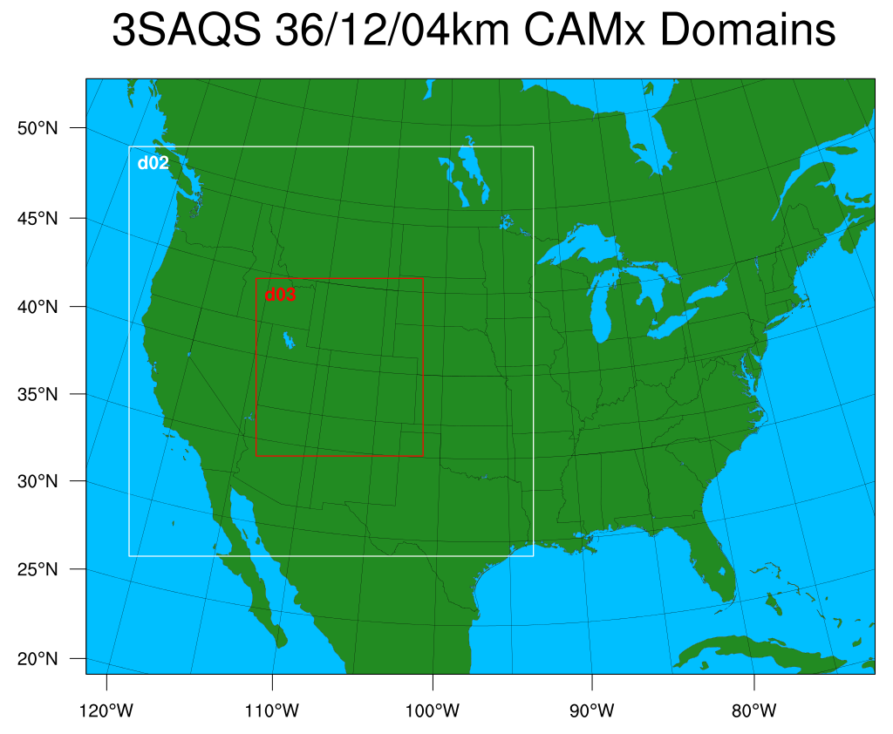
Figure 2-1. 36 km CONUS, 12 km WESTUS, and 4 km Three-State modeling domains used for developing PGM emission inputs.
Table 2-1. Projection parameters for the WSAQS modeling domains.
Parameter | Value
Projection | Lambert-Conformal
1st True Latitude | 33 degrees N
2nd True Latitude | 45 degrees N
Central Longitude | -97 degrees W
Central Latitude | 40 degrees N

Table 2-2 summarizes the CAMx version 6.1 (released April 2014) science configurations and options used for the WSAQS 2011a base case modeling. CAMx v6.1 included several updates that were used in the WSAQS, such as the CB6r2 chemical mechanism and the capability to simulate active methane emissions sources. CAMx was configured to predict ozone, PM species and wet/dry deposition.
We configured CAMx with the Piecewise Parabolic Method (PPM) advection solver for horizontal transport (Colella and Woodward, 1984) along with the spatially varying (Smagorinsky) horizontal diffusion approach. We also used K-theory for vertical diffusion using the CMAQ-like vertical diffusivities from WRFCAMx. The CB6r2 gas-phase chemical mechanism was selected for CAMx because it includes newer chemical kinetic rates, represents improvements over the other alternative CB05 and SAPRC99 chemical mechanisms, and includes an active methane emissions species. Details on the CAMx 2011a 36/12/4 km base case simulation are contained in the CAMx 2011 Modeling Protocol and preliminary Model Performance Evaluation reports (UNC and ENVIRON, 2014a; Adelman, Shanker, Yang and Morris, 2014) and are summarized as follows:
Meteorological Inputs: The WRF-derived meteorological fields were processed to generate CAMx meteorological inputs using the WRFCAMx processor. Details of the 3SAQS 2011 WRF meteorology data are available in UNC and ENVIRON (2014c)
Initial/Boundary Conditions: For the 2011a base case the boundary conditions (BCs) for the 36 km CONUS domain were based on the MOZART global chemistry model. Existing programs were used to interpolate from the MOZART horizontal and vertical coordinate system to the CAMx LCP coordinate system and vertical layer structure and to map the MOZART chemical species to the CB6r2 chemical mechanism being used by CAMx.
Photolysis Rates: Day-specific ozone column data were based on the Total Ozone Mapping Spectrometer (TOMS) data measured using the satellite-based Ozone Monitoring Instrument (OMI). Albedo was based on land use data. For CAMx there is an ancillary snow cover input that overrode the land use based albedo input. For CAMx, the TUV photolysis rate processor was used. CAMx was configured to use the in-line TUV to adjust for cloud cover and account for the effects aerosol loadings have on photolysis rates.
Landuse: To make optimal use of the Zhang dry deposition scheme, the fractional coverage of each land use category within each grid cell is needed.
Spin-Up Initialization: We used a 15-day spin-up period on the 36 km CONUS domain before adding the 12 and 4 km nested domains for the last two days of 2010 before the start of the 2011 calendar year (January 1, 2011).

Table 2-2. CAMx model configurations for WSAQS 2011a base case simulation.
Science Options | Configuration | Details/Comments
Model Codes | CAMx v6.1 – April 2014 Release | Version 6.11 posted December 2014 with minor bug fixes and Version 6.2 available in March 2015
Horizontal Grid Mesh | 36/12/4 km
36 km grid | 148 x 112 cells | 36 km CONUS domain
12 km grid | 239 x 206 cells | 12 km WESTUS domain
4 km grid | 281 x 299 cells | 4 km Three-State domain
Vertical Grid Mesh | 25 vertical layers, defined by WRF | Layer 1 thickness ~24- m. Model top at ~19-km above MSL
Grid Interaction | 36/12/4 km two-way nesting for CAMx
Initial Conditions | 15 day spin-up on 36 km grid | Clean initial conditions
Boundary Conditions | 36 km from global chemistry model | MOZART-GEOS5 data from NCAR used for 2011;  Sensitivity run will explore using GEOS-Chem BCs.
Emissions
Baseline Emissions Processing | SMOKE, MOVES2010b and MEGAN | MOVES2014 planned for 2011b base case
Sub-grid-scale Plumes | No plume-in-grid
Chemistry
Gas Phase Chemistry | CB6r2 in CAMx | Yarwood et al., 2010
Meteorological Processor | WRFCAMx | Compatible with CAMx V6.1
Horizontal Diffusion | Spatially varying | K-theory with Kh grid size dependence
Vertical Diffusion | CMAQ-like in WRFCAMx
Diffusivity Lower Limit | Kz_min = 0.1 to 1.0 m²/s or 2.0 m²/s | Applied land use dependent minimum Kz values using the CAMx utility program Kvpatch.
Deposition Schemes
Dry Deposition | Zhang dry deposition scheme (CAMx) | Zhang 2003
Wet Deposition | CAMx-specific formulation | rain/snow/graupel/virga
Numerics
Gas Phase Chemistry Solver | Euler Backward Iterative (EBI) -- Fast Solver
Vertical Advection Scheme | Implicit scheme w/ vertical velocity update (CAMx)
Horizontal Advection Scheme | Piecewise Parabolic Method (PPM) scheme
Integration Time Step | Wind speed dependent | ~0.1-1 min (4 km), 1-5 min (1 -km), 5-15 min (36 km)

A second version of the CAMx 2011a MPE report will be available in April 2015 that includes analyses of visibility, ammonia, ozone precursor, and dry deposition model performance. Additional ongoing work includes diagnostic sensitivity tests to examine the sensitivity of the CAMx model performance to key input assumptions. These diagnostic sensitivity tests include an examination of the CAMx model performance sensitivity to boundary condition (BC) inputs that are defined around the lateral boundaries of the 36 km CONUS domain. For the CAMx 2011a base case, the BCs were defined using 2011 output from the MOZART Global Chemistry Model (GCM) generated by the National Center for Atmospheric Research Atmospheric Chemistry Division. A 2011a2 sensitivity test examined the CAMx model sensitivity to BCs based on the GEOS-Chem GCM. Additional CAMx BC sensitivity tests are being performed using output from the AM3 GCM. Additional model sensitivity tests are being conducted for 2011 oil and gas emission updates as well as using the new MOVES2014 on-road mobile source emissions model. Ongoing work also includes a CMAQ 2011 4 km base case model simulation and model performance evaluation.

PURPOSE OF SOURCE APPORTIONMENT MODELING PLAN
The purpose of this source apportionment Modeling Plan is to describe the procedures and purposes of the WSAQS source apportionment modeling. This document describes the objectives, models, model configurations, source apportionment configuration and post-processing procedures for displaying the results.

OVERVIEW OF WSAQS SOURCE APPORTIONMENT MODELING APPROACH
The WSAQS is conducting source apportionment under Task 2 of Phase II of the 2015 WSAQS scope of work. The WSAQS Task 2 source apportionment modeling will primarily use the CAMx PGM and the Anthropogenic Precursor Culpability Assessment (APCA) ozone and Particulate Source Apportionment Technology (PSAT) source apportionment tools. However, the new CMAQ Integrated Source Apportionment Method (ISAM) may also be explored depending on project resources and an assessment of the reliability of the CMAQ ISAM source apportionment tool. The WSAQS source apportionment modeling will be conducted in six subtasks as follows:
- Subtask 2a – Modeling Plan: Development of a source apportionment design document (this report).
- Subtask 2b -- Geographic Source Apportionment: Contributions of western state’s anthropogenic emissions to downwind ozone and PM_{2.5} concentrations, visibility impairment and deposition.
- Subtask 2c – Emissions Sector Source Apportionment: Contributions of emission source categories to ozone and PM_{2.5} concentrations, visibility impairment and deposition.
- Subtask 2d – Detailed Source Apportionment: Source region and category source apportionment within the Three-State 4 km modeling domain.
- Subtask 2e – Detailed Source Apportionment using CMAQ: Perform the same 4 km detailed source apportionment as in Subtask 2d only using the CMAQ PGM.
- Subtask 2f – Source Apportionment Visualization Tool: Develop a web-based visualization tool populated with the WSAQS source apportionment modeling results that is hosted on the WAQDW.

GEOGRAPHIC SOURCE APPORTIONMENT

PURPOSE OF GEOGRAPHIC SOURCE APPORTIONMENT MODELING
The primary purpose of the geographic source apportionment modeling is to obtain the separate contribution of each western state’s anthropogenic emissions to ozone, PM_{2.5}, visibility and acid (nitrogen and sulfur) deposition. The source apportionment results will include contributions of each state’s anthropogenic emissions to downwind ozone and PM_{2.5} Design Values in a similar manner to EPA’s January 2015 transport analysis (EPA, 2015), only the WSAQS state-specific source apportionment will be for the 2011 base year compared to the 2018 future year used by EPA. The results will also be used to estimate the contributions of anthropogenic emissions to visibility impairment to help interpret when the most impaired days due to man-made emissions occur.

CAMx GEOGRAPHIC SOURCE APPORTIONMENT MODELING PROCEDURES
The WSAQS geographic source apportionment modeling will obtain state-specific contributions to downwind concentrations and deposition. Separate runs will be made to obtain ozone source apportionment and particulate, visibility and deposition source apportionment.

Ozone State-Specific Source Apportionment Modeling
The state-specific ozone source apportionment modeling will use the APCA ozone source apportionment tool and the 2011 36/12 km CAMx model configuration to estimate the contributions of each western state’s anthropogenic emissions to downwind ozone concentrations. We will use these results to estimate western U.S. ozone source-receptor relationships. Appendix A describes the CAMx source apportionment tools and how the APCA ozone method differs from OSAT. The attributes of the CAMx 36/12 km state-specific APCA ozone source apportionment modeling are as follows:
- CAMx Version 6.2.
  - CAMx v6.2 was released on March 23, 2015.
    - The CAMx 2011a base case used CMAQ v6.1 released in April 2014.
- 36 km CONUS and 12 km WESTUS domains using two-way grid nesting.
- APCA ozone source apportionment method.
- Source Regions (21):
  - Grid cell definitions of 17 individual western states, offshore shipping, Mexico, Canada and remainder eastern U.S. (21 Source Regions) as shown in Figure 3-1.
- Source Categories (5):
  - Natural emissions (biogenic, lightning, sea salt and WBD);
  - Three types of fires (wildfires, prescribed burns and agricultural burning); and
  - Remainder anthropogenic emissions.

- Source Groups (107):
  - The 21 Source Regions and 5 Source Categories results in 107 total Source Groups (=21 x 5 +2; 2 extra Source Groups for IC and BC) for which separate ozone contributions will be obtained.
  - Each APCA Source Group needs 4 reactive tracers to track ozone contributions. The 428 reactive tracers will run in parallel to the host model for the state-specific ozone source apportionment simulation.
- Modeling Period:
  - The CAMx state-specific ozone source apportionment modeling will be conducted for the entire 2011 calendar year with spin-up days.
- Emissions Scenario:
  - The 2011a base case emissions scenario will be used in the CAMx 2011 state-specific ozone source apportionment modeling. The 2011a base case is based on Version 1 of the 2011 National Emissions Inventory (NEI). WSAQS is currently working on a 2011b base case emissions inventory that will be based on NEI version 2 that will be available in the summer of 2015.
- Boundary Conditions:
  - Boundary Conditions (BCs) around the lateral boundaries of the 36 km CONUS domain will be based on the MOZART GCM with modified dust concentrations.
Boundary Condition Issues: The WSAQS has performed BC sensitivity tests that compared CAMx model performance using MOZART (MZ) and GEOS-Chem (GC) BCs for the 2011 calendar year. CAMx model performance using the MZBC greatly overstated the observed crustal (dust) PM concentrations. When BCs were based on the GC GCM the CAMx crustal estimates were much more reasonable but the inorganic particulate species and ozone model performance degraded relative to using the MZBC. WSAQS is currently conducting additional BC sensitivity tests including using the AM3 GCM. Note that dust BCs will have little effect on the CAMx ozone estimates (mainly through a reduction in sunlight and resultant photolysis rates). The CAMx 2011 state-specific ozone source apportionment simulation will use the most appropriate BCs at the time it is conducted.
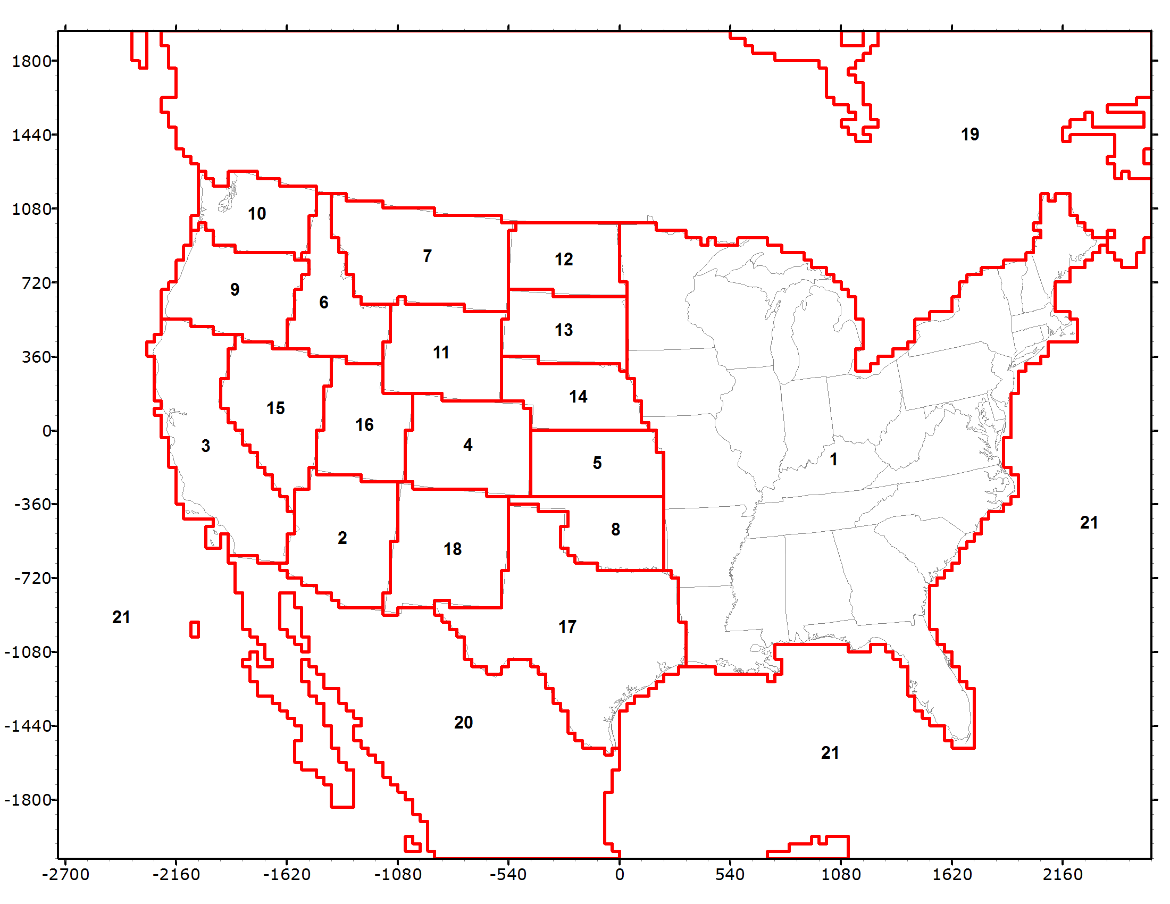
Figure 3-1. Source Regions used in the WSAQS state-specific APCA ozone and PSAT particulate matter 2011 source apportionment modeling.

Particulate State-Specific Source Apportionment Modeling
The CAMx state-specific PSAT PM source apportionment modeling will be conducted for 2011 using a similar approach as for the state-specific ozone analysis described above. The state-specific PM source apportionment will use the following PSAT families of reactive tracers (see Appendix A for details):
- Sulfate (SO4) [2 tracers]
- Nitrate (NO3) and Ammonium (NH4) [7 tracers]
- Primary PM (EC, OA, OPM2.5 and PMC) [6 tracers]
This configuration results in 15 reactive tracers to track PM contributions for each Source Group. The 107 Source Groups for the state-specific PM source apportionment run will use 1,605 reactive tracers, which is almost 4 times that needed for the state-specific ozone source apportionment run.
SOA Issues: Note that the state-specific PM source apportionment will not track the Secondary Organic Aerosol (SOA) component of PM using the PSAT source apportionment tool. To track SOA using PSAT requires 21 reactive tracers for each Source Group; including SOA would more than double the computational requirements of the PM source apportionment simulation. As the PM source apportionment simulation is estimated to take a month to complete, more than doubling the computational requirements would compromise the study.
The CAMx model does separate SOA into SOA that is primarily due to man-made (anthropogenic) sources (SOAA) versus SOA that is primarily due to natural (biogenic) sources (SOAB). This distinction is made based on the VOC precursor to the SOA; SOA due to aromatic VOC species are assigned to SOAA and SOA due to isoprene, terpenes and sesquiterpenes are assigned to SOAB. This is not an exact anthropogenic/biogenic SOA distinction as isoprene is emitted by both anthropogenic and biogenic sources, although biogenic isoprene emissions are typically much higher than anthropogenic isoprene emissions. More confounding the distinction of anthropogenic vs. biogenic SOA is fire emissions that emit both aromatic and isoprene/terpenes VOC species with some considered biogenic and others anthropogenic. Although the classification of fire emissions as being anthropogenic vs. natural has always been problematic. In the state-specific PM source apportionment post-processing, we will include SOAA and SOAB from the host model as their own “Source Groups” that will be added to the PSAT source groups in the post-processed files so that we account for all of the OA species and know the contributions of POA from the PSAT Source Groups as well as total SOAA and SOAB so we can distinguish between mainly anthropogenic vs. mainly biogenic SOA contributions.
CAMx 2011 Database: The WSAQS CAMx 2011 modeling databases currently include simulation 2011a (MZ BC) and 2011a2 (GC BC). Both simulations have PM issues related to the different BC assumptions; 2011a overstates dust, whereas 2011a2 has worse ozone and inorganic PM model performance. Given the importance of the BCs on western U.S. PM concentrations, WSAQS is in the process of performing additional targeted BC sensitivity tests to identify the optimal 2011 BC inputs. WSAQS is also in the process of developing a 2011b base case that will have numerous emission updates in addition to the BC updates (e.g., MOVES2014, updated 2011 oil and gas, used of version 2 of the NEI). The state-specific PM source apportionment modeling will use the most appropriate CAMx 2011 36/12 km modeling database at the time it is performed, which will likely be based on 2011a emissions and MOZART BCs with modified dust concentrations.

POST-PROCESSING OF CAMx 2011 STATE-SPECIFIC SOURCE APPORTIONMENT MODELING RESULTS
This section describes how we will post-process the CAMx 2011 36/12 km state-specific ozone and PM source apportionment modeling results.

CSAPR-Type Ozone and PM_{2.5} Analysis
The contributions of each upwind state’s anthropogenic emissions to ozone and PM_{2.5} Design Vales (DVs) will be processed in a similar manner as used in EPA’s Cross-State Air Pollution Rule (CSAPR; EPA, 2011) and January 2015 ozone transport analysis for the March 2008 ozone NAAQS (EPA, 2015). Observed average (AvgDV) and maximum (MaxDV) ozone and PM_{2.5} Design Values will be used for the 2009-2013 five year period at each U.S. monitoring site. We will use the Modeled Attainment Test Software (MATS) version 2.6.1 to estimate the contributions of each western state’s anthropogenic emissions to the observed AvgDV and MaxDV. Results will be reported in Excel spreadsheets that include the contributions of each state to downwind Design Values interpreted under the current NAAQS (e.g., 75 ppb for ozone) and potential new levels of NAAQS (65-70 ppb for ozone). The results will also be compared with state ozone and DV contributions from the WestJumpAQMS 2008 modeling results and EPA’s 2018 state DV contributions from EPA’s January 2015 transport analysis.

Contributions to Ozone, PM_{2.5}, Visibility and Deposition at Monitoring Sites
As was done in WestJumpAQMS, the WSAQS state-specific CAMx APCA ozone and particulate source apportionment contributions will be displayed at monitoring sites using pie charts. For each parameter (MDA8 ozone, 24-hour and annual PM_{2.5}, 24-hour visibility and sulfur and nitrogen deposition) these pie charts will included a comparison of the predicted and observed concentrations, the model bias (if available), the contribution due to BCs, and a pie chart of the source contributions for Source Groups within the 36 km CONUS modeling domain (Figure 3-1). However, unlike WestJumpAQMS that used interactive Excel spreadsheets to generate the pie charts, the WSAQS pie charts will be generated using a web-based interactive tool hosted on the WAQDW website. The WSAQS state-specific source apportionment contribution pie charts for DMA8 ozone and 24-hour PM2.5 will be similar to those generated by the interactive Excel spreadsheets found in the WestJumpAQMS final report Appendices with the following refinements:
- The pie charts will be generated using the web-based visualization tool on the WAQDW that is described in Chapter 6.
- The pie charts can be generated at monitoring sites for all days of the 2011 calendar year instead of just the top ten highest days displayed in West Jump AQMS.
- All pie charts will include a comparison of the predicted and observed concentrations for that day.
Pie charts of state contributions to ozone and PM_{2.5} Design Values would also be generated along with contributions to visibility and deposition.

Regional Haze Analysis
A special analysis will be conducted for visibility at IMPROVE monitoring sites using the state-specific PM source apportionment modeling results to compare modeled worst 20 percent (W20%) visibility days versus the 20 percent most impaired days due to anthropogenic emissions. For this analysis the user will be able to define what constitutes man-made emissions from a combination of anthropogenic U.S., anthropogenic offshore, anthropogenic Mexico, anthropogenic Canada, prescribed burns (Rx), agricultural burning (Ag) and Wildfire (WF) source categories.

Spatial Maps of State Contributions
Spatial maps of state contributions to the highest and regulatory relevant metric (e.g., 4th highest for DMA8 ozone and 98th percentile for 24-hour PM_{2.5}) concentrations will be generated using static plots, similar to Appendices C and G of the WestJumpAQMS final report. These state “footprint” spatial maps will be hosted on the WAQDW where they can be viewed using the WAQDW Image Browser. State contribution plots will be generated over all concentrations as well as maximum contributions to current NAAQS (e.g., 75 ppb for ozone) and potential future NAAQS (e.g., 65-70 ppb for ozone).

SOURCE-SECTOR SOURCE APPORTIONMENT

Purpose of Source Sector Source Apportionment
The source sector source apportionment will estimate the contributions of major source categories to ozone, PM, visibility and deposition for 2011 and the 2011 base case conditions. The 2011 source sector contributions will be compared to the 2008 WestJumpAQMS estimates.

CAMx SOURCE-SECTOR SOURCE APPORTIONMENT MODELING PROCEDURES
The CAMx APCA and PSAT source apportionment tools will be used to obtain concentration and deposition contributions of source sectors. CAMx will be run for the 2011 calendar year using the 36 km CONUS and 12 km WESTUS domains with two-way grid nesting. Separate source apportionment contributions will be obtained for the following major source categories:
- Natural Emissions (Biogenic, Lightning, Windblown Dust and Sea Salt);
- Wildfires (WF);
- Combined Prescribed Burns (Rx) and Agricultural Burning (Ag);
- Oil and Gas Sources (WRAP and NEI);
- EGU Point Sources;
- Remainder Point Sources;
- On-Road Mobile;
- Non-Road Mobile;
- Remainder Area (Non-Point) Sources.
The source-sector source apportionment modeling will be conducted using 5 source regions as shown in Figure 4-1 with the first four source regions corresponding to the states of Colorado, New Mexico, Utah and Wyoming and the fifth source region being the remainder of the 36 km CONUS domain. With 9 Source Categories and 5 Sources Regions, separate contributions will be obtained for 47 Source Groups (47 = 9 x 5 + 2). The APCA ozone and PSAT SO4, NO3/NH4 and Primary PM families of reactive tracers will be used in a single CAMx 2011 36/12 km source-sector source apportionment run resulting in 19 reactive tracers. This simulation will track source contributions from each Source Group, resulting in 894 total reactive tracers. The source-sector source apportionment modeling will not track SOA for the reasons given in Chapter 3.
The intent is to use the 2011b base case emissions scenario for the source-sector source apportionment modeling, or at least as many as the updates in the 2011b emissions scenario that are available. The 2011b updates over the 2011a base case include the following:
- Use of 2011 NEI versions 2 versus NEI version 1;
- Updated WRAP 2011 O&G emissions for Colorado, Utah and northern New Mexico that includes emissions from fracing engines and updated O&G emissions on tribal lands using the minor source new source review data.
- Updated 2011 fires (WF, Rx and Ag) emissions using more recent emission factors (EF).
The most appropriate BCs for the 36 km CONUS domain will also be used for the source-sector source apportionment modeling. The BCs around the lateral boundaries of the 36 km CONUS domain may be based on the MOZART GCM with modified dust concentrations or other alternative BC scenario (e.g., AM3) depending on results of the BC sensitivity modeling.
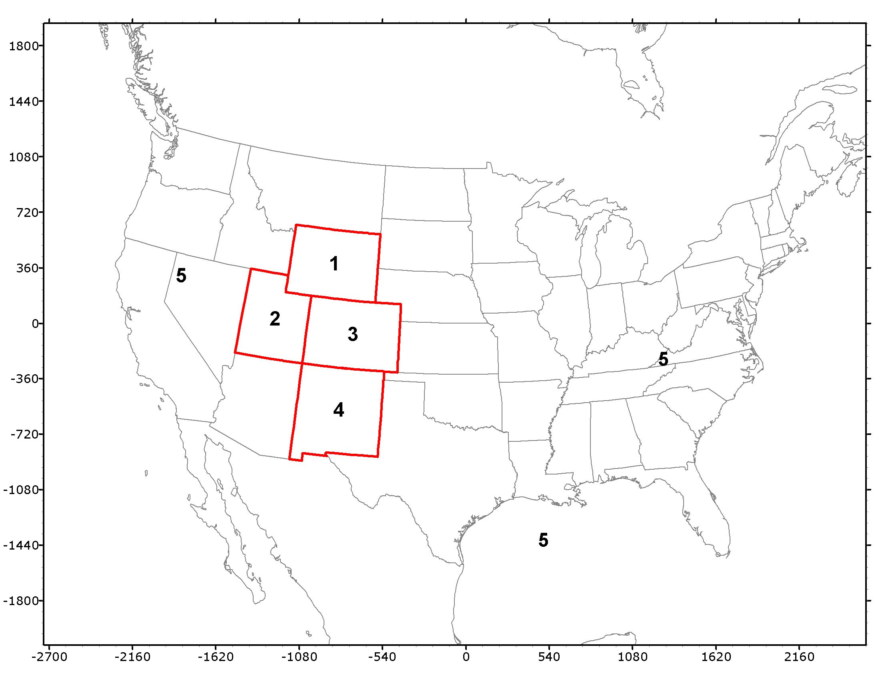
Figure 4-1. Five source regions used in the CAMx 36/12 km source-sector APCA ozone and PSAT particulate matter source apportionment simulation.

POST-PROCESSING OF SOURCE-SECTOR SOURCE APPORTIONMENT MODELING
The CAMx 2011b 36/12 km source-sector source apportionment modeling results will be post-processed to generate source-sector contributions to DMA8 ozone, 24-hour PM_{2.5} and 24-hour visibility at western U.S. monitoring sites for each day of 2011. Annual PM_{2.5} and sulfur and nitrogen deposition will also be obtained at Western U.S. monitoring sites. These results will be loaded into the web-based source apportionment visualization tool that will be available on the WAQDW web-site.
Static spatial maps of source sector contributions to ozone and PM_{2.5} concentrations and deposition will also be generated and made available for viewing on the WAQDW website.

DETAILED SOURCE APPORTIONMENT MODELING

PURPOSE OF THE DETAILED SOURCE APPORTIONMENT MODELING
The detailed source apportionment modeling will estimate source region and source category contributions at the sub-state level within the 4 km Three-State domain. The detailed 4 km source apportionment modeling will also be used to compare the CAMx and CMAQ source apportionment tools if resources are available.

DETAILED SOURCE APPORTIONMENT MODELING PROCEDURES
The detailed source apportionment modeling will divide the 4 km Three-State modeling domain into subregions and perform ozone and particulate source apportionment modeling to obtain subregional and sub-source category contributions. Figure 5-1 displays the 4 km Three-State domain that will be used in the detailed source apportionment modeling. The detailed source apportionment modeling will be limited to episodic modeling because the high-resolution 4 km modeling domain, multiple source regions, and multiple source categories will strain the available project resources. The detailed source apportionment modeling will be conducted late in Phase II of the WSAQS study when time and resources may be limited.

Summer Ozone Source Apportionment Modeling
The detailed summer ozone source apportionment modeling will be designed to investigate the contributions of oil and gas emissions to elevated summer ozone concentrations. We will first run the CAMx APCA source apportion tool for a summer month (e.g., July) or two (e.g., July and August). We will then set up and run the CMAQ ISAM ozone source apportionment for the same period or subset thereof if resources are available and the CMAQ ISAM source apportionment is believed to be a reliable tool.
The Three-State 4 km domain (Figure 5-1) will be divided up by O&G Basins as follows:
- Uinta Basin, UT;
- Paradox Basin (UT and CO) and remainder UT;
- Denver-Julesburg (D-J) Basin, CO;
- Piceance Basin CO;
- North San Juan Basin, CO;
- Raton Basin (CO only) and remainder of CO;
- New Mexico, including the South San Juan Basin and NM portion of Raton Basin;
- Southwest WY (including Jonah-Pinedale Anticline Development [JPAD] area and Upper Green River areas);
- Northeast Wyoming (Wind River, Big Horn and Powder River Basins); and
- Remainder of Three-State domain.

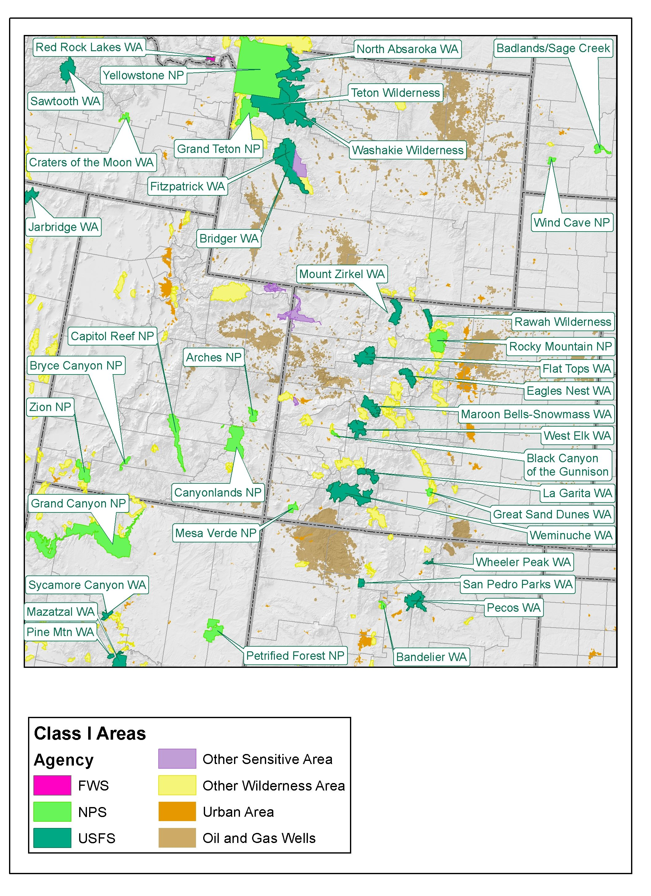
Figure 5-1. Three-State 4 km modeling domain to be used in the detailed source apportionment modeling.
The detailed summer ozone source apportionment modeling would examine contributions from several sources categories, including subcategories of O&G sources as follows:
- Natural (Biogenic, WBD, LNOx and SS);
- Drilling O&G;
- Well Production O&G;
- Mid-Stream (e.g., Compressors) O&G;
- On-Road Mobile;
- Non-Road Mobile;
- Point;
- Fires (WF, Rx and Ag); and
- Remainder Anthropogenic.
With 10 Source Regions and 9 Source Categories, 92 Source Groups and 368 total reactive tracers will be used for the detailed summer ozone source apportionment modeling.
Before setting up the CMAQ ISAM detailed summer ozone source apportionment modeling we will contact EPA to obtain their opinion of the reliability and readiness of the ISAM source apportionment tool. For the initial CMAQ ISAM ozone source apportionment runs we may want to collapse the Source Regions and Source Categories to smaller numbers to perform a test run to make sure it produces reasonable source apportionment results before committing to runs with larger computational requirements.
The detailed summer ozone source apportionment modeling results will be loaded into the web-based visualization tool hosted on the WAQDW website.

Winter Ozone Source Apportionment Modeling
WSAQS is in the process of developing PGM databases for the winter ozone events in 2011 and has prepared a winter WRF modeling plan (UNC and ENVIRON, 2014d). If the WSAQS winter ozone modeling is able to produce high ozone during the winter 2011 elevated ozone episodes in the Uinta Basin and JPAD area, winter ozone source apportionment modeling may be performed. These source apportionment runs would just be performed for the winter high ozone days with suitable amount of spin-up days. The local O&G emissions in the Uinta and/or JPAD areas would be divided into subcategories (like in the summer ozone modeling discussed above) with other source categories (e.g., point sources and on-road and non-road mobile sources) and regions also defined appropriately. We will report and analyze the winter ozone source apportionment in a manner similar to the approaches used for the summer ozone source apportionment modeling.

Other Detailed Source Apportionment Modeling
Based on the Geographic and Source-Sector source apportionment modeling using CAMx with a 36/12 km grid for 2011 annual period we may want to perform detailed 4 km source apportionment modeling for specific episodes using CAMx and/or CMAQ. For example, if the Source-Sector source apportionment modeling found high ozone concentrations with a large O&G contribution for a given period, detailed source apportionment modeling that divides the O&G source category into sub categories may be used to provide additional insight into specific emissions sources responsible for the high ozone concentrations.

Future-Year Source Apportionment Modeling
Some of the above detailed source apportionment modeling could be repeated using the 2020 future year emissions to determine how O&G and other source contributions are estimated to change over time.

SOURCE APPORTIONMENT VISUALIZATION TOOL
The WSAQS source apportionment results will be displayed using a web-based source apportionment visualization tool (Tool). The Tool will be hosted by the WAQDW being operated by Colorado State University (CSU). The functionality of the Tool will at first be similar to the interactive Excel spreadsheets that were provided as Appendices to the WestJumpAQMS final report. The Tool may be enhanced based on comments from users.

PROTOTYPE OF THE SOURCE APPORTINMENT VISUALIZATION TOOL
A prototype of the Tool was developed in 2014 and was populated and tested using source apportionment modeling data for the ten highest modeled DMA8 ozone days from the WestJumpAQMS. Ozone source apportionment results from WestJumpAQMS final report Appendix B state-specific and Appendix I source category-specific interactive Excel spreadsheets were used to populate the prototype Tool for testing. Figures 6-1 through 6-3 display example screen shots from the prototype Tool. The plots were based on the WestJumpAQMS Appendix I interactive spreadsheet data from the source category-specific source apportionment modeling. These data included separate ozone contributions from natural sources for the entire region (biogenic and fire sources) and anthropogenic ozone concentrations for fives source regions: CO, NM, UT, WY and Remainder of the 36 km CONUS domain.
Figure 6-1 shows a screen shot from the prototype Tool for the Rocky Flats monitoring site (CO Jefferson 0006) third highest modeled DMA8 ozone day (July 9, 2008). The green header area on the plot has two lines with the first line identifying the monitoring site selected and the second line including: (1) the day selected and its rank; (2) the predicted and observed DMA8 ozone on that day and the bias, in this case the predicted and observed DMA8 ozone are the same (75.6 ppb) resulting in 0.0% bias; and (3) the contributions from the Boundary Conditions (BCs) that are defined around the 36 km CONUS domain, which is 47.1 ppb (i.e., BCs contribute 62% of the ozone on this day). Two pie charts display the non-BC ozone contributions by source region (top) and source category (bottom) with the labels for the pie chart slices indicating the contribution to the total DMA8 ozone (with BCs). For example, the source region pie chart (top in Figure 6-1) indicates that approximately two-thirds of the non-BC contribution comes from Colorado; since the BCs contribute 62% of the ozone on this day, the Colorado total anthropogenic contribution is ~25%. The source category pie chart (bottom in Figure 6-1) indicates that the largest non-BC contributions to DMA8 ozone on this day were mobile sources (MOB; 24%), point sources (PTS; 6%), natural emissions (NAT; 4%), area sources (3%), oil and gas sources (ONG; 1%) and Mexico/Canada (N/A; 0%).
When clicking on the “expand all” tab on the left side of the Tool, the top pie chart expands from just showing Source Regions to showing Source Regions by Source Categories, as many of these slices are very small it is hard to read. An alternative way to look at Source Category contributions by Subregion is to click on the pie slice in the original top pie chart in Figure 6-1 and the bottom pie chart will then be the Source Category contributions for that subregion. For example, clicking on the Colorado pie slice gives Figure 6-3 in which the bottom Source Category pie chart is just for Colorado instead of all regions.

Figure 6-1. Example screen shot from prototype web-based visualization tool after selecting 3rd highest modeled DMA8 ozone day (July 9, 2008) at Rocky Flats monitoring site in Jefferson County, Colorado (08-059-0006).

Figure 6-2. Screen shot from prototype web-based visualization tool after selecting “expand all” from Figure 6-1.

Figure 6-3. Screen shot from prototype web-based visualization tool after clicking on the CO slice in top pie chart in Figure 6-1 so that bottom pie chart shows contributions of Colorado Source Categories.

NEXT STEPS IN DEVELOPING THE SOURCE APPORTIONMENT VISUALIZATION TOOL
The next step in the development of the Tool is the implementation of the prototype Tool within the WAQDW so that the Technical Committee can review and comment. When the first WSAQS source apportionment simulation is completed, the source apportionment modeling results will be post-processed and input into the Tool and made available to the WSAQS Technical Committee.

REFERENCES

Adelman, Z., U. Shankar, D. Yang and R. Morris. 2014. Three-State Air Quality Modeling Study CAMx Photochemical Grid Model Draft Model Performance Evaluation Simulation Year 2011. University of North Carolina at Chapel Hill and ENVIRON International Corporation. November 10, 2014. (http://views.cira.colostate.edu/tsdw/Forum/default.aspx?g=posts&t=5#post7).
Colella, P., and P.R. Woodward. 1984. The Piecewise Parabolic Method (PPM) for Gas­dynamical Simulations. J. Comp. Phys., 54, 174­201.
ENVIRON. 2014. User’s Guide – Comprehensive Air Quality Model with Extensions – Version 6.1. ENVIRON International Corporation, Novato, California http://www.camx.com. April 2014.
ENVIRON, Alpine, UNC. 2013. Western Regional Air Partnership (WRAP) West-wide Jump-start Air Quality Modeling Study (WestJumpAQMS) – Final Report. ENVIRON International Corporation, Novato, California. Alpine Geophysics, LLC. University of North Carolina. September 2013. (http://wrapair2.org/pdf/WestJumpAQMS_FinRpt_Finalv2.pdf).
EPA. 2011. Air Quality Modeling Final Rule Technical Support Document. U.S. Environmental Protection Agency, Office of Air Quality Planning and Standards, RTP, NC. June. (http://www.epa.gov/airtransport/CSAPR/pdfs/AQModeling.pdf).
EPA. 2015. Air Quality Technical Support Document for the 2008 Ozone NAAQS Transport Assessment. U.S. Environmental Protection Agency, Office of Air Quality Planning and Standards, RTP, NC. January. (http://www.epa.gov/airtransport/O3TransportAQModelingTSD.pdf).
UNC and ENVIRON. 2014a. 3SAQS Final Modeling Protocol – 2011 Emissions & Air Quality Modeling Platform. University of North Carolina, Chapel Hill, NC. ENVIRON International Corporation, Novato, CA. July. (http://vibe.cira.colostate.edu/wiki/Attachments/Modeling/3SAQS_2011_Modeling_Protocol_Finalv2.pdf).
UNC and ENVIRON. 2014b. 3SAQS CAMx Photochemical Grid Model Draft Model Performance Evaluation – Simulation Year 2008. University of North Carolina, Chapel Hill, NC. ENVIRON International Corporation, Novato, CA. September. (http://vibe.cira.colostate.edu/wiki/Attachments/Modeling/3SAQS_Base08b_MPE_Final_30Sep2014.pdf).
UNC and ENVIRON. 2014c. 3SAQS WRF 2011 Meteorological Model Application/Evaluation. University of North Carolina, Chapel Hill, NC. ENVIRON International Corporation, Novato, CA. July. (http://vibe.cira.colostate.edu/wiki/Attachments/Modeling/3SAQS_2011_WRF_MPE_v8_draft_Aug04_2014.pdf).
UNC and ENVIRON, 2014d. Western State Air Quality Modeling Study (WSAQS) Weather Research Forecast (WRF) Winter Modeling Workplan. University of North Carolina at Chapel Hill and ENVIRON International Corporation. December 2014. (http://vibe.cira.colostate.edu/wiki/Attachments/Work%20plans/WSAQS_WRF_Winter_Modeling_Final.pdf).
Yarwood. G., S. Rao, M. Yocke, and G.Z. Whitten. 2005. Updates to the Carbon Bond chemical mechanism: CB05. Final Report prepared for US EPA. Available at http://www.camx.com/publ/pdfs/CB05_Final_Report_120805.pdf.
Yarwood, G., J. Jung, G. Z. Whitten, G. Heo, J. Mellberg and E. Estes. 2010. “Updates to the Carbon Bond Mechanism for Version 6 (CB6).” Presented at the 9th Annual CMAS Conference, Chapel Hill, October.
Zhang, L., S. Gong, J. Padro, L. Barrie. 2001. A size-segregated particle dry deposition scheme for an atmospheric aerosol module. Atmos. Environ., 35, 549-560.
Zhang, L., J. R. Brook, and R. Vet. 2003. A revised parameterization for gaseous dry deposition in air-quality models. Atmos. Chem. Phys., 3, 2067–2082.

APPENDIX A: DESCRIPTION OF THE CAMX SOURCE APPORTIONMENT TOOLS

The CAMx/CMAQ photochemical grid models contain several different “Probing Tools” that can provide different kinds of information on the internal workings of the model, model sensitivity and source apportionment. Below we discuss these Probing Tools and in particular the CAMx reactive tracer Ozone Source Apportionment Technology (OSAT) and Particulate Source Apportionment Technology (PSAT) that are used to obtain ozone and PM_{2.5} source apportionment in this study.
Brute Force Sensitivity: Brute Force Sensitivity modeling can be performed using any photochemical model and involves the application of the model for a base case and then for a sensitivity simulation that has a perturbation in the model or model inputs. The difference in concentrations between the base case and sensitivity simulation is the sensitivity of the model to the selected perturbation. Although a brute force sensitivity simulation can be performed for any model attribute, it is most frequently applied to changes in emissions. For example, multiple brute force simulations of across-the-board VOC and NO_{X} emission reductions can be performed to develop an ozone isopleth (EKMA) diagram that can be used to help identify a VOC/NO_{X} emissions control path toward ozone attainment. Another example of Brute Force Sensitivity applications is the sequence of control measures that are used to ultimately demonstrate attainment of the ozone or PM_{2.5} standard as part of the development of a SIP control plan. Brute Force Sensitivity simulations have been used to completely eliminate (zero-out) emissions from a specific source region (e.g., state) or source sector (e.g., on-road mobile sources) and the differences in modeled concentrations between the base case and the specific source region/sector zero-out case has been interpreted as the contributions of that source sector. However, for reactive pollutants the zero-out approach is a sensitivity and not a source apportionment method. For example, the sum of the ozone contributions due to the zero-out modeling of all Source Groups does not add up to the base case ozone concentrations because the effect of altering the emissions in the zero-out runs changes the chemistry in the photochemical model simulation thereby altering the source-receptor relationships from those in the base case.
CAMx Ozone and PM Source Apportionment: CAMx contains two versions of an ozone source apportionment tool, the Ozone Source Apportionment Technology (OSAT) and the Anthropogenic Precursor Culpability Assessment (APCA). CAMx also contains the Particulate Source Apportionment Technology (PSAT) that estimates source apportionment for particulate matter (PM) species. All three source apportionment techniques use reactive tracers (also called tagged species) that run in parallel to the host model to determine the contributions of ozone and PM to user selected Source Groups. A Source Group is typically defined as the intersection between geographic Source Regions (e.g., grid cell definitions of states) and user selected Source Categories (e.g., point, on-road mobile, etc.). The intersection of the Source Regions and the Source Categories defines the Source Groups (e.g., on-road mobile sources from California) for which individual source apportionment contributions are obtained. Source apportionment provides contributions of emissions within each Source Group to concentrations under the current model simulation conditions, but does not necessarily estimate what would be the effect that controls on a given Source Group would have on the concentrations, which is a sensitivity question.
- CAMx Ozone Source Apportionment Technology (OSAT): The OSAT method follows VOC and NO_{X} emissions from each Source Group and when ozone is formed in the host PGM, OSAT estimates whether ozone formation was more VOC-limited or NO_{X}-limited and then allocates the ozone formed to Source Groups based on their relative contributions of the limiting precursor. The APCA ozone source apportionment technique differs from OSAT in that it recognizes that some emissions are not controllable (e.g., biogenic emissions) so focuses ozone source apportionment on controllable emissions. When ozone is formed due to the interaction of biogenic VOC and anthropogenic NO_{X} emissions under VOC-limited conditions, a case where OSAT would assign the ozone formed to the biogenic VOC emissions, APCA redirects the ozone formed to the controllable anthropogenic NO_{X} emissions. Thus, in APCA the only ozone attributable to biogenic emissions is when ozone is formed due to the interaction of biogenic VOC and biogenic NO_{X} emissions. or each Source Group, OSAT/APCA uses four reactive tracers to track its ozone contribution: the Source Group’s VOC and NO_{X} emissions and ozone attributed to the Source Group that is formed under VOC-limited or NO_{X}-limited conditions (O3V and O3N).
- CMAQ Integrated Source Apportionment Method (ISAM): The reactive tracer source apportionment technique for ozone and PM techniques have also been implemented in CMAQ (called the Integrated Source Apportionment Method or ISAM), but it has not been as widely used, tested and evaluated as the source apportionment tools in CAMx. The CMAQ ISAM source apportionment tool will be applied as part of the Detailed Source Apportionment and the results compared with CAMx source apportionment.
- CAMx Particulate Source Apportionment Technology (PSAT): The CAMx PSAT particulate source apportionment method has five different families of tracers that can be invoked separately or together (as well as with the OSAT/APCA ozone tracers) to track source apportionment of the following particulate species: Sulfur (SO₄), Nitrogen (NO₃/NH₄), Primary PM, Secondary Organic Aerosol (SOA) and Mercury (Hg). Because PSAT needs to track the PM source apportionment from the PM precursor emissions to the PM species, the number of tracers needed to track a Source Group’s source apportionment depends on the complexity of the chemistry and number of PM species involved. The Sulfur family requires only two reactive tracer species (SO₂ and SO₄) to track the formation of particulate sulfate from SO₂ emission source contributions for each Source Group. Whereas SOA family is the most expensive PSAT family with 18 reactive tracers needed for each Source Group in order to track the four VOC precursors (aromatics, isoprene, terpenes and sesquiterpenes) and the 7 condensable gas (CG) and SOA pairs. The five families of PSAT PM source apportionment tracers are provided below along with the definitions of the reactive tracers used in each family.
Sulfur (2 Tracers)
  - SO2_{i} Primary SO₂ emissions
  - PS4_{i} Particulate sulfate ion from primary emissions plus secondarily formed sulfate
Nitrogen (7 Tracers)
  - RGN_{i} Reactive gaseous nitrogen including primary NOx (NO + NO₂) emissions plus nitrate radical (NO₃), nitrous acid (HONO) and dinitrogen pentoxide (N₂O₅).
  - TPN_{i} Gaseous peroxyl acetyl nitrate (PAN) plus peroxy nitric acid (PNA)
  - NTR_{i} Organic nitrates (RNO₃)
  - HN3_{i} Gaseous nitric acid (HNO₃)
  - PN3_{i} Particulate nitrate ion from primary emissions plus secondarily formed nitrate
  - NH3_{i} Gaseous ammonia (NH₃)
  - PN4_{i} Particulate ammonium (NH₄)
Secondary Organic Aerosol (21 Tracers)
  - ARO_{i} Aromatic (toluene and xylene) secondary organic aerosol precursors
  - ISP_{i} Isoprene secondary organic aerosol precursors
  - TRP_{i} Terpene secondary organic aerosol precursors
  - SQT Sesquiterpene secondary organic aerosol precursors
  - CG1_{i} Condensable gases from aromatics (low volatility products)
  - CG2_{i} Condensable gases from aromatics (high volatility products)
  - CG3_{i} Condensable gases from isoprene (low volatility products)
  - CG4_{i} Condensable gases from isoprene (high volatility products)
  - CG5_{i} Condensable gases from terpenes (low volatility products)
  - CG6_{i} Condensable gases from terpenes (high volatility products)
  - CG7_{i} Condensable gases from sesquiterpenes
  - PO1_{i} Particulate organic aerosol associated with CG1
  - PO2_{i} Particulate organic aerosol associated with CG2
  - PO3_{i} Particulate organic aerosol associated with CG3
  - PO4_{i} Particulate organic aerosol associated with CG4
  - PO5_{i} Particulate organic aerosol associated with CG5
  - PO6_{i} Particulate organic aerosol associated with CG6
  - PO7_{i} Particulate organic aerosol associated with CG7
  - POH_{i} Particulate non-volatile organic aerosol from aromatic precursors
  - PPA_{i} Anthropogenic organic aerosol polymers (SOPA)
  - PPB_{i} Biogenic organic aerosol polymers (SOPB)
Mercury (3 Tracers)
  - HG0_{i} Elemental Mercury vapor
  - HG2_{i} Reactive gaseous Mercury vapor
  - PHG_{i} Particulate Mercury
Primary Particulate Matter (6 Tracers)
  - PEC_{i} Primary Elemental Carbon
  - POA_{i} Primary Organic Aerosol
  - PFC_{i} Fine Crustal PM
  - PFN_{i} Other Fine Particulate
  - PCC_{i} Coarse Crustal PM
  - PCS_{i} Other Coarse Particulate
DDM Sensitivity Modeling: Model sensitivity analysis can be performed using the Direct Decoupled Method (DDM) sensitivity analysis. DDM, and the related higher order DDM (HDDM), can produce a numerically intensive, direct sensitivity/uncertainty analysis. DDM can provide information on the sensitivity of ozone, PM or other concentrations to model inputs (e.g., IC, BC, and specific emissions). For example, it was used in the Houston area to identify where locations of potential highly reactive VOC (HRVOC) emissions would be that could explain the rapid rise in ozone at a particular time and location (i.e., assuming that VOC emissions are missing from the inventory, what emissions locations would best explain observed high ozone levels?). As a sensitivity method, DDM/HDDM can estimate the effects on the base case concentrations due to a change in emissions from a specific source group. In general, DDM is reasonably accurate to estimate the change in a reactive species concentration due to a change in emissions of up to ~20%, whereas HDDM can estimate the effects of larger amounts of emissions reductions on concentrations. Both CAMx and CMAQ contain versions of DDM/HDDM.
Process Analysis: Process Analysis is a tool in CAMx/CMAQ to extract additional information about the various physical and chemical processes in the model that produced the ozone and other concentrations. Information on VOC-limited versus NO_{X}-limited ozone formation, importance of local production versus entrainment of ozone aloft and identification of the contributions of individual VOC species to ozone formation are the types of information that can be obtained with Process Analysis. It can be a powerful tool for diagnosing the causes of poor model performance.

The WSAQS is also called the Three-State Air Quality Study (3SAQS) but has been expanded beyond the original three states of Colorado, Utah and Wyoming.
http://views.cira.colostate.edu/tsdw/
http://www.acd.ucar.edu/wrf-chem/mozart.shtml
http://ozoneaq.gsfc.nasa.gov/
http://cprm.acd.ucar.edu/Models/TUV/
http://www.acd.ucar.edu/wrf-chem/mozart.shtml
http://www.geos-chem.org/
http://www.gfdl.noaa.gov/am3-model
http://www.camx.com/files/camxusersguide_v6-20.pdf
http://www.airqualitymodeling.org/cmaqwiki/index.php?title=CMAQv5.0.2_Integrated_Source_Apportionment
http://www.epa.gov/airtransport/CSAPR/index.html
http://www.epa.gov/airtransport/ozonetransportNAAQS.html
http://www.epa.gov/scram001/modelingapps_mats.htm
http://www.wrapair2.org/WestJumpAQMS.aspx
http://www.wrapair2.org/WestJumpAQMS.aspx
http://www.airqualitymodeling.org/cmaqwiki/index.php?title=CMAQv5.0.2_Integrated_Source_Apportionment

