|  |  |
| --- | --- |
| **Three-State Air Quality Modeling Study**  **CAMx Photochemical Grid Model**  **Draft Model Performance Evaluation**  **Simulation Year 2011**  Prepared by:  **Z. Adelman, U. Shankar, D. Yang**  University of North Carolina  Institute for the Environment  Chapel Hill, NC 27599-6116  R. Morris  ENVIRON International Corporation  773 San Marin Drive, Suite 2115  Novato, California, 94945  November 10, 2014 | http://extras.mnginteractive.com/live/media/site36/2009/0129/20090129__DOWNTOWN_CM01~p1.jpgcolorado-flag.jpghttp://www.nahrepslc.org/Resources/Pictures/SaltLakeCity.jpgUtah Flag.GIF  http://t2.gstatic.com/images?q=tbn:ANd9GcTiWyKMQy1f6qdUtlC4h3RcXR894AGLyZEvnDYfBAlBfchPYY8anunst083.gif |

**Document Revisions**

|  |  |
| --- | --- |
| **Date** | **Description** |
| November 10, 2014 | Initial draft presented to the 3SAQS Technical Steering Committee on November 20, 2014; includes ozone, PM, and wet deposition performance evaluation |
|  |  |
|  |  |

CONTENTS

TABLES iii

FIGURES iv

ACRONYMS and ABBREVIATIONS ix

1 Executive Summary 1

2 Introduction 4

2.1 Background 4

2.2 Overview 4

3 Approach 6

3.1 CAMx Science and Input Data Configuration 6

3.2 Model Performance Evaluation Procedures 10

3.2.1 Overview of Model Performance Evaluation 10

3.2.2 Available Aerometric Data for the Model Evaluation 10

3.2.3 Atmospheric Model Evaluation Tool (AMET) 18

3.3 CAMx Post-processing and Model-Observations Pairing 18

3.4 Model Performance Statistics, Goals and Criteria 19

4 2011 Model Performance Evaluation 24

4.1 Ozone and Precursors Model Performance 24

4.1.1 3SAQS 12-km Domain Model Performance 24

4.1.2 3SAQS 4-km Domain Model Performance 29

4.1.3 Colorado Model Performance 34

4.1.4 Utah Model Performance 52

4.1.5 Wyoming Model Performance 70

4.2 Particulate Matter Model Performance 85

4.2.1 Correlations of Model Performance by Season 94

4.2.2 Performance Metrics of Monthly PM2.5 99

4.2.3 Monthly Average PM Performance Over the Domain 106

4.2.4 Comparisons of PM2.5 Composition in Urban and Rural Sites 115

4.3 Wet Deposition Model Performance 121

4.4 Vertical Ozone Model Performance 134

4.4.1 Boulder, Colorado 134

4.4.2 Trinidad Head, California 138

4.5 Comparisons to 3SAQS 2008 CAMx Performance 141

4.5.1 Ozone performance comparison 141

4.5.2 PM Performance Comparison 144

5 References 150

APPENDIX A A-1

A.1 CAMx Species Post-processing Expressions A-1

A.2 AMET Model to Observations Pairing Expressions A-3

# TABLES

Table 3‑1. Projection parameters for the 3SAQS modeling domains. 14

Table 3‑2. CAMx (Version 6.10) model configurations for 3SAQS 17

Table 3‑3. PM model performance goals and criteria. 28

Table 3‑4. Model performance evaluation statistical measures used to evaluate the CTMs. 31

Table 4‑1. 12-km domain ozone performance indicators 33

Table 4‑2. 4-km domain ozone performance indicators 38

Table 4‑3. Colorado ozone and gas-phase species performance indicators for 3SAQS 4-km CAMx Base 2011a simulation results 47

Table 4‑4. Utah ozone and gas-phase species performance indicators 64

Table 4‑5. Wyoming ozone and gas-phase species performance indicators 81

Table 4‑6. 12-km modeling domain particulate matter species performance indicators 92

Table 4‑7. 4-km modeling domain particulate matter species performance indicators 93

Table 4‑8. Accumulated annual wet deposition species performance indicators at all NADP sites in the 12-km modeling domain 131

Table 4‑9. Accumulated annual wet deposition species performance indicators at all CO NADP sites (12-km modeling) 131

Table 4‑10. Accumulated annual wet deposition species performance indicators at all UT NADP sites (12-km modeling) 131

Table 4‑11. Accumulated annual wet deposition species performance indicators at all WY NADP sites (12-km modeling) 131

Table 4‑12. 12-km CAMx modeling performance comparison of MDA8 at AQS sites between the 3SAQS Base08b and Base11a simulations 149

Table 4‑13. 12-km CAMx modeling performance comparison of MDA8 at CASTNet sites between the 3SAQS Base08b and Base11a simulations 149

Table 4‑14. 12-km CAMx modeling performance comparison of Total PM2.5 at IMPROVE sites between the 3SAQS Base08b and Base11a simulations 152

Table 4‑15. 12-km CAMx modeling performance comparison of Total PM2.5 at CSN sites between the 3SAQS Base08b and Base11a simulations 152

# FIGURES

Figure 3‑1. 36 km CONUS, 12 km WESTUS, and 4 km 3SAQS processing domain used for developing PGM emission inputs. 15

Figure 3‑2. Locations of AIRS O3 (pink) and FRM PM2.5 mass (yellow) monitoring sites in the three state region showing active and inactive (with black dot) sites (source: http://www.epa.gov/airquality/airdata/ad_maps.html). 20

Figure 3‑3. Locations of CSN speciated PM2.5 monitoring sites (source: http://www.epa.gov/ttn/amtic/speciepg.html). 21

Figure 3‑4. Locations of IMPROVE monitoring sites (source: http://vista.cira.colostate.edu/IMPROVE/) 22

Figure 3‑5. Locations of CASTNet monitoring sites (source: http://epa.gov/castnet/javaweb/index.html). 23

Figure 3‑6. Locations of NADP monitoring sites (source: http://nadp.sws.uiuc.edu/). 24

Figure 3‑7. Locations of UGRWOS monitoring sites (source: http://deq.state.wy.us/aqd/Upper%20Green%20Winter%20Ozone%20Study.asp) 26

Figure 3‑8. Locations of AMoN monitoring sites in the 3SAQS 4-km domain 27

Figure 4‑1. CAMx 3SAQS 2011 base case model performance for MDA1 (top) and MDA8 (bottom) O3 concentrations for all AQS (red) and CASTNet (blue) sites in the 12-km domain with (right) and without (left) using a 60 ppb observed ozone cut-off threshold. 35

Figure 4‑2.Q-Q plots of CAMx 3SAQS 2011 MDA8 for the 12-km modeling domain and the AQS (left) and CASTNet (right) monitoring networks 36

Figure 4‑3. CAMx mean monthly FB in MDA8 at all AQS (red) and CASTNet (blue) sites in the 12-km modeling domain 36

Figure 4‑4. CAMx 3SAQS 2011 base case monthly model performance for MDA1 (left) and MDA8 (right) O3 for all AQS (top) and CASTNet (bottom) sites in the 12-km domain. 37

Figure 4‑5. CAMx 3SAQS 2011 base case model performance for MDA1 (top) and MDA8 (bottom) O3 for all AQS (red) and CASTNet (blue) sites in the 4-km domain with (right) and without (left) using a 60 ppb observed ozone cut-off threshold. 40

Figure 4‑6.Q-Q plots of CAMx 3SAQS 2011 MDA8 for the 4-km modeling domain for the AQS (left) and CASTNet (right) monitoring networks 41

Figure 4‑7. CAMx mean monthly bias in MDA8 at all AQS (red) and CASTNet (blue) sites in the 4-km modeling domain 41

Figure 4‑8. CAMx 3SAQS 2011 base case monthly model performance for MDA1 (left) and MDA8 (right) O3 for all AQS (top) and CASTNet (bottom) sites in the 4-km domain. 42

Figure 4‑9. Q-Q plots of CAMx 3SAQS 2011 MDA8 for CO sites and the AQS (left) and CASTNet (right) monitoring networks 49

Figure 4‑10. CAMx 3SAQS 2011 base case model performance for MDA1 (top) and MDA8 (bottom) O3 for all AQS (red) and CASTNET (blue) sites in Colorado with (right) and without (left) using a 609 ppb observed ozone cut-off threshold. 50

Figure 4‑11. CAMx mean monthly bias in MDA8 at Colorado AQS (red) and CASTNet (blue) sites. 51

Figure 4‑12. Colorado AQS site-specific monthly MDA8 NMB performance. 52

Figure 4‑13. CO CASTNet site-specific monthly MDA8 NMB performance 53

Figure 4‑14. CAMx 3SAQS 2011 base case monthly model performance for MDA1 (left) and MDA8 (right) O3 for all AQS (top) and CASTNET (bottom) sites in Colorado. 54

Figure 4‑15. Annual 2011 MDA8 O3 time series at the AQS Ft. Collins, CO CSU (FTCO) monitor; 4-km (red) and 12-km (blue) CAMx results 55

Figure 4‑16. Annual 2011 MDA8 O3 time series at the AQS Ft. Collins, CO West (FTCW) monitor; 4-km (red) and 12-km (blue) CAMx results 55

Figure 4‑17. January 2011 hourly O3 (top) and NO2 (middle) at the Welby, CO AQS monitor (shown in the bottom Google Earth imagery). 56

Figure 4‑18. Annual 2011 MDA8 O3 time series at the CASTNet Gothic, CO monitor 57

Figure 4‑19. CAMx 3SAQS 2008 base case monthly model performance for hourly O3 (UL), NO2 (UR), CO (LL), and SO2 (LR) at AQS sites in Colorado. 57

Figure 4‑20. CAMx 3SAQS 2011 base case monthly mean NO2 NMB and concentrations at AQS sites in Colorado. 58

Figure 4‑21. CAMx 3SAQS 2011 base case monthly mean nitric acid NMB and concentrations at CASTNet sites in Colorado. 58

Figure 4‑22. CAMx 3SAQS 2011 base case monthly mean carbon monoxide NMB and concentrations at AQS sites in Colorado. 59

Figure 4‑23. CAMx 3SAQS 2011 base case monthly mean SO2 NMB and concentrations at AQS sites (left) and CASTNet sites (right) in Colorado. 59

Figure 4‑24. 4-km domain daily total 2011 SO2 emissions from the onroad (left), non-EGU point (middle), and EGU point (right) sectors. 60

Figure 4‑25. CAMx 3SAQS 2008 base case ozone season (June-August) average diurnal hourly O3 (left) and NOx (right) time series for AQS sites in Colorado. 60

Figure 4‑26. Q-Q plots of CAMx 3SAQS 2011 MDA8 O3 for UT sites in the AQS (left) and CASTNet (right) monitoring networks 66

Figure 4‑27. CAMx 3SAQS 2011 base case model performance for MDA1 (top) and MDA8 (bottom) O3 for all AQS (red) and CASTNET (blue) sites in Utah with (right) and without (left) using a 60 ppb observed ozone cut-off threshold. 67

Figure 4‑28. CAMx mean monthly bias in MDA8 O3 at Utah AQS (red) and CASTNet (blue) sites. 68

Figure 4‑29. Utah AQS site-specific monthly MDA8 O3 NMB performance. 69

Figure 4‑30. Utah CASTNet site-specific monthly MDA8 O3 NMB performance. 70

Figure 4‑31. CAMx 3SAQS 2011 base case monthly model performance for MDA1 (left) and MDA8 (right) O3 for all AQS (top) and CASTNET (bottom) sites in Utah. 71

Figure 4‑32. Logan #4 AQS Site annual MDA8 (top), December MDA8 (middle), and December NO2 (bottom) CAMx and observed time series. 72

Figure 4‑33. Myton (Duchesne County) AQS Site annual MDA8 (top), January MDA8 (middle), and January NO2 (bottom) CAMx and observed time series. 73

Figure 4‑34. CAMx 3SAQS 2011 base case monthly model performance for hourly O3 (top left), NO2 (top right), CO (bottom left), and SO2 (bottom right) at AQS sites in Utah. 74

Figure 4‑35. CAMx 3SAQS 2011 base case monthly NO2 NMB and mean concentrations at AQS sites in Utah. 75

Figure 4‑36. CAMx 3SAQS 2011 base case monthly mean nitric acid NMB and concentrations at CASTNet sites in Utah. 75

Figure 4‑37. CAMx 3SAQS 2011 base case monthly mean carbon monoxide NMB and concentrations at AQS sites in Utah. 76

Figure 4‑38. CAMx 3SAQS 2011 base case monthly mean SO2 NMB and concentrations at AQS (left) and CASTNet (right) sites in Utah. 76

Figure 4‑39. CAMx 3SAQS 2011 base case ozone season (June-August) average diurnal hourly O3 (left) and NO2 (right) time series for AQS sites in Utah. 77

Figure 4‑40. Q-Q plots of CAMx 3SAQS 2011 MDA8 for WY sites in the AQS (left) and CASTNet (right) monitoring networks 83

Figure 4‑41. CAMx 3SAQS 2011 base case model performance for MDA1 (top) and MDA8 (bottom) O3 for all AQS (red) and CASTNET (blue) sites in Wyoming with (right) and without (left) using a 60 ppb observed ozone cut-off threshold. 84

Figure 4‑42. CAMx mean monthly bias in MDA8 O3 at Wyoming AQS (red) and CASTNet (blue) sites 85

Figure 4‑43. Wyoming AQS site-specific monthly MDA8 O3 NMB performance. 86

Figure 4‑44. Wyoming CASTNet site-specific monthly MDA8 O3 NMB performance. 87

Figure 4‑45. CAMx 3SAQS 2008 base case monthly model performance for MDA1 (left) and MDA8 O3 (right) for all AQS (top) and CASTNET (bottom) sites in Wyoming. 88

Figure 4‑46. Annual (top) and February 2011 MDA8 (middle) and NO2 (bottom) time series at the AQS Boulder, WY monitor 89

Figure 4‑47. CAMx 3SAQS 2011 base case monthly model performance for hourly O3 (top left), NO2 (top right), CO (bottom left), and SO2 (bottom right) at AQS sites in Wyoming. 90

Figure 4‑48. CAMx 3SAQS 2011 base case monthly NO2 NMB and mean concentrations at AQS sites in Wyoming. 91

Figure 4‑49. CAMx 3SAQS 2011 base case monthly mean nitric acid NMB at CASTNet sites in Wyoming. 91

Figure 4‑50. CAMx 3SAQS 2011 base case monthly SO2 NMB and concentrations at AQS sites (left) and CASTNet sites (right) in Wyoming. 92

Figure 4‑51. CAMx 3SAQS 2011 base case ozone season (June-August) average diurnal hourly O3 (left) and NO2 (right) time series for AQS sites in Wyoming. 92

Figure 4‑52. Spatial distribution of PM2.5 fractional bias (%) from the 12-km (left) and 4-km (right) simulations 95

Figure 4‑53. Spatial distribution of SO4 fractional bias (%) from the 12-km (left) and 4-km (right) simulations. 97

Figure 4‑54. Spatial distribution of NH4 fractional bias (%) from the 12-km (left) and 4-km (right) simulations. 98

Figure 4‑55. Spatial distribution of NO3 fractional bias (%) from the 12-km (left) and 4-km (right) simulations. 99

Figure 4‑56. Spatial distribution of ECfractional bias (%) from the 12-km (left) and 4-km (right) simulations. 100

Figure 4‑57. Spatial distribution of OCfractional bias (%) from the 12-km (left) and 4-km (right) simulations. 101

Figure 4‑58. Modeled-vs.-observed PM2.5 correlation for the 4-km domain in Winter (top left), Spring (top right), Summer (bottom left) and Fall (bottom right). 103

Figure 4‑59. Modeled-vs.-observed PM2.5 correlation for Colorado domain in Winter (top left), Spring (top right), Summer (bottom left) and Fall (bottom right). 104

Figure 4‑60. Modeled-vs.-observed PM2.5 correlation for Utah domain in Winter (top left), Spring (top right), Summer (bottom left) and Fall (bottom right). 105

Figure 4‑61. Modeled-vs.-observed PM2.5 correlation for Wyoming domain in Winter (top left), Spring (top right), Summer (bottom left) and Fall (bottom right). 106

Figure 4‑62. PM2.5 fractional bias (%) compared to IMPROVE (red) and CSN (blue) observations for 4-km domain (top left), CO (top right), WY (bottom left) and UT (bottom right). 108

Figure 4‑63. PM2.5 fractional error (%) comparisons as for Figure 4‑62. 109

Figure 4‑64. SO4 fractional bias (%) compared to IMPROVE and CSN observations for 4-km domain (top left), CO (top right), WY (bottom left) and UT (bottom right). 109

Figure 4‑65. SO4 fractional error (%) comparisons as for Figure 4‑64. 109

Figure 4‑66. NO3 fractional bias (%) compared to IMPROVE and CSN observations for 4-km domain (top left), CO (top right), WY (bottom left) and UT (bottom right). 110

Figure 4‑67. NO3 fractional error (%) comparisons as for Figure 4‑66. 110

Figure 4‑68. NH4 fractional bias (%) compared to IMPROVE and CSN observations for 4-km domain (top left), CO (top right), WY (bottom left) and UT (bottom right). 111

Figure 4‑69. NH4 fractional error (%) comparisons as for Figure 4‑68. 111

Figure 4‑70. ECfractional bias (%) compared to IMPROVE and CSN observations for 4-km domain (top left), CO (top right), WY (bottom left) and UT (bottom right). 112

Figure 4‑71. ECfractional error (%) comparisons as for Figure 4‑70. 112

Figure 4‑72. OCfractional bias (%) compared to IMPROVE and CSN observations for 4-km domain (top left), CO (top right), WY (bottom left) and UT (bottom right). 113

Figure 4‑73. OCfractional error (%) comparisons as for Figure 4‑72. 113

Figure 4‑74. NME (%) vs. NMB (%) for PM2.5 116

Figure 4‑75. NME (%) vs. NMB (%) for SO4 117

Figure 4‑76. NME (%) vs. NMB (%) for NO3 118

Figure 4‑77. NME (%) vs. NMB (%) for NH4 119

Figure 4‑78. NME (%) vs. NMB (%) for EC 120

Figure 4‑79. NME (%) vs. NMB (%) for OC 121

Figure 4‑80. NME (%) vs. NMB (%) for OA 122

Figure 4‑81. Seasonal average PM2.5 composition comparisons for the 4-km domain 125

Figure 4‑82. Seasonal average PM2.5 composition comparisons for Colorado. 126

Figure 4‑83. Seasonal average PM2.5 composition comparisons for Utah. 127

Figure 4‑84. Seasonal average PM2.5 composition comparisons for Wyoming. 128

Figure 4‑85. CAMx 12-km domain accumulated annual sulfate wet deposition model performance 133

Figure 4‑86. CAMx 12-km domain accumulated seasonal sulfate wet deposition model performance 134

Figure 4‑87. CAMx 12-km domain accumulated annual nitrate wet deposition model performance 135

Figure 4‑88. CAMx 12-km domain accumulated seasonal nitrate wet deposition model performance 136

Figure 4‑89. CAMx 12-km domain accumulated annual ammonium wet deposition model performance 137

Figure 4‑90. CAMx 12-km domain accumulated seasonal ammonium wet deposition model performance 138

Figure 4‑91. Accumulated monthly wet deposition performance at NADP sites in Colorado (12-km CAMx). 139

Figure 4‑92. Accumulated monthly wet deposition performance at NADP sites in Utah (12-km CAMx). 140

Figure 4‑93. Accumulated monthly wet deposition performance at NADP sites in Wyoming (12-km CAMx). 141

Figure 4‑94. Comparison of seasonal average predicted and observed vertical ozone profiles at Boulder, CO for Spring (14 days) and Summer (13 days) 2011. 144

Figure 4‑95. Comparison of seasonal average predicted and observed vertical ozone profiles at Boulder, CO for Fall (14 days) and Winter (13 days) 2011. 145

Figure 4‑96. Comparison of seasonal average predicted and observed vertical ozone profiles at Trinidad Head, CA for Spring (20 days) and Summer (11 days) 2011. 147

Figure 4‑97. Comparison of seasonal average predicted and observed vertical ozone profiles at Trinidad Head, CA for Fall (12 days) and Winter (12 days) 2011. 148

Figure 4‑98. AQS site MDA8 normalized mean bias and errors for the 3SAQS 2008 and 2011 CAMx simulations 151

Figure 4‑99. IMPROVE Total PM2.5 fractional bias and errors for the 3SAQS 2008 and 2011 CAMx simulations 154

Figure 4‑100. 3SAQS CAMx 2008 (left) and 2011 (right) SO4 annual performance summary. 155

Figure 4‑101. 3SAQS CAMx 2008 (left) and 2011 (right) NO3 annual performance summary. 155

Figure 4‑102. 3SAQS CAMx 2008 (left) and 2011 (right) NH4 annual performance summary. 156

Figure 4‑103. 3SAQS CAMx 2008 (left) and 2011 (right) EC annual performance summary. 156

Figure 4‑104. 3SAQS CAMx 2008 (left) and 2011 (right) OC annual performance summary. 157

# ACRONYMS and ABBREVIATIONS

3SAQS Three State Air Quality Study

3DSW Three State Data Warehouse

AIRS Aerometric Information Retrieval System

AMET Atmospheric Model Evaluation Tool

AMON Ammonia Monitoring Network

AQS Air Quality System

BLM Bureau of Land Management

CAMx Comprehensive Air Quality Model with Extensions

CASTNet Clean Air Status and Trends Network

CB6r2 Carbon Bond 6 revision 2

CO Carbon Monoxide or Colorado

CONUS Continental United States

CSN Chemical Speciation Network

EC Elemental Carbon Fine Particulate Matter

ENVIRON ENVIRON International Corporation

EPA Environmental Protection Agency

FB Fractional Bias

FE Fractional Error

FRM Federal Reference Method

HNO3 Nitric Acid

IMPROVE Interagency Monitoring of Protected Visual Environments

JPDAD Jonah-Pinedale Anticline Development

LCP Lambert Conformal Conic Projection

MDA1 Daily Maximum 1-hour Ozone

MDA8 Daily Maxium 8-hour Average Ozone

MEGAN Model of Emissions of Gases and Aerosols from Nature

MOVES Motor Vehicle Emissions Simulator

MPE Model Performance Evaluation

NADP National Acid Deposition Program

NEPA National Environmental Policy Act

NMB Normalized Mean Bias

NME Normalized Mean Error

NH4 Ammonium Fine Particulate Matter

NO2 Nitrogen Dioxide

NO3 Nitrate Fine Particulate Matter

NPS National Park Service

NTN National Trends Network

O3  Ozone

OA Organic Aerosol Fine Particulate Matter

OC Organic Carbon Fine Particulate Matter

PGM Photochemical Grid Model

PM2.5 Particulate Matter with Diameter < 2.5 μm

SMOKE Sparse Matrix Operator Kernel Emissions system

SO2 Sulfur Dioxide

SO4 Sulfate Fine Particulate Matter

TOMS Total Ozone Mapping System

UBWOS Uintah Basin Winter Ozone Study

UGRWOS Upper Green River Winter Ozone Study

USFS United States Forest Service

UNC University of North Carolina

UT Utah

WESTUS Western U.S. (12-km Domain)

WY Wyoming

# Executive Summary

The Three-State Air Quality Study (3SAQS) performed photochemical grid modeling for the year 2011 using the Comprehensive Air Quality Model with Extensions (CAMx) version 6.10. The 3SAQS 2011 Modeling Protocol details the CAMx configuration and justification for why it was chosen for the 3SAQS. This document presents the CAMx 2011 model performance evaluation (MPE) for the 3SAQS 2011 base year simulation version A (CAMx_3SAQS_Base11a). We conducted the MPE for ozone (O3), fine particulate matter (PM2.5), and wet deposition sulfur and nitrogen, with a focus on the 4-km domain modeling results. We evaluated the performance of hourly O3 as well as daily maximum 1-hour (MDA1) and daily maximum 8-hour average (MDA8) O3. We also included carbon monoxide (CO), nitrogen dioxide (NO2), nitric acid (HNO3), and sulfur dioxide (SO2) in the evaluation. The PM2.5 evaluation includes total PM2.5 along with the component species sulfate (SO4), nitrate (NO3), ammonium (NH4), elemental carbon (EC), organic carbon (OC), organic aerosol (OA), and other PM (PM Other). The deposition evaluation focused on total sulfur and oxidized and reduced nitrogen species. We did not include VOC species, dry deposition species or visibility metrics in this preliminary version of the MPE.

We evaluated the 3SAQS 2011 base case model performance against concurrent measured ambient concentrations using graphical displays of model performance and statistical model performance measures. We compared these measures against established model performance goals and criteria, following the procedures recommended in EPA’s photochemical modeling guidance documents. The evaluation includes sub-regional evaluations for Colorado, Utah, and Wyoming, and evaluations by month and season.

The 3SAQS western U.S. (WESTUS) 12-km domain-wide ozone model performance meets the performance goals for both MDA1 and MDA8. CAMx has a positive bias for ozone at both the AQS and CASTNet networks; with higher fractional bias at the AQS sites (MDA1: 9.5%, MDA8: 13.6%) compared to the CASTNet sites (MDA1: 3.0%, MDA8: 5.5%). On days with elevated O3 measurements (> 60 ppb), CAMx has a negative bias, with lower fractional bias at the AQS sites (MDA1: -5.2%, MDA8: -3.8%) compared to the CASTNet sites (MDA1: -9.7%, MDA8: -9.1%), but well within the ozone bias performance goal (≤±15%).

The 3SAQS 4-km domain-wide ozone model performance meets the performance goals for hourly O3, MDA1 and MDA8. The 4-km model performance is an improvement over the 12-km simulation and shows very low domain-average bias (0.02%-7.4%) and errors (9.2-33.7%).

The CAMx O3 estimates for monitors in Colorado meet the bias (NMB: 1.6-6.6%) and error (NME: 10.1-26.0%) performance goals on an annual basis for hourly O3, MDA1, and MDA8. CAMx exhibits lower bias but higher errors predicting *hourly* O3 at the AQS sites relative to the CASTNet sites, indicating that there are compensating biases in the predicted concentrations across all of the Colorado AQS monitoring locations. CAMx performs better at predicting daily maximum 1-hour and MDA8 O3 at the Colorado CASTNet sites than it does at the AQS sites. Although the bias differences are small between these networks, there are significant differences in the model errors

The CAMx O3 estimates for Utah are within the bias (NMB: 1.1-7.6%) and error (NME: 8.9-26.4%) performance goals on an annual basis for hourly O3, MDA1, and MDA8. CAMx has a positive MDA8 bias for concentrations up to about 50 ppb at the AQS monitors and a negative bias for higher MDA8 concentrations. The negative biases are primarily driven by winter O3 episodes in oil and gas development areas in Duchesne and Uintah Counties (Uinta Basin).

The CAMx O3 estimates for Wyoming are within the bias (NMB: 0.36-7.93%) and error (NME: 8.4-18.6%) performance goals on an annual basis for hourly O3, MDA1, and MDA8. For the overall daily maximum average O3 (both 1-hour and 8-hour) concentrations, CAMx has a positive bias at the Wyoming AQS sites and a negative bias at the Wyoming CASTNet sites. CAMx has a positive MDA8 bias for concentrations up to about 70 ppb at the AQS monitors and a negative bias for higher MDA8 concentrations. The negative biases at high concentrations are driven by winter O3 episodes in the Jonah-Pinedale Anticline Development (JPAD) oil and gas area in Sublette County.

Modeled NO2 and HNO3 have positive biases in all states suggesting that the 3SAQS 2011 NOx emissions estimates may be too high or there is insufficient dilution of the surface emissions.

Modeled PM2.5 performance is mixed in the 2011 simulation. On an annual domain-wide basis, CAMx misses the performance criteria for total PM2.5 and organic carbon (OC). CAMx tends to do better at predicting the inorganic species (SO4, NO3, NH4) compared to the organic species (EC, OC). CAMx overpredicts PM2.5 observations in excess of performance criteria (i.e., FB > 60%; FE > 75%) in the 4-km domain, in all seasons other than summer. The overprediction is greatest in the winter at the IMPROVE sites. CAMx PM2.5 performance at all networks is well within the performance goals in the summer. Similar performance for CO, WY and UT indicates that the model biases in the three states are representative of the 4-km modeling domain as a whole. The total PM2.5 performance at the CSN network sites is as good or better than at IMPROVE sites in UT, CO and the 4-km domain, in most seasons except in the fall. The poorest agreement among the PM constituents is seen in OC and EC in winter, particularly at the CSN sites, with the OC and EC mass fraction being over-predicted by factors of 4 and 3, respectively. The model performance dramatically improves in the summer, when the modeled OC mass fraction is within 5% of CSN, but degrades again to a factor of 3 discrepancy in the fall. EC also tends to be over-predicted in most seasons at both networks, although EC mass fractions are much smaller than those of OC. The performance for OA is worse than that for OC because of the scaling used between these two species. The seasonal pattern of these biases (positive except in the summer at CSN sites) suggests an overestimation of the anthropogenic semi-volatile VOC partitioning to the particles, which is exacerbated as temperatures decrease, and as the partitioning mass increases. This issue should be investigated through a thorough examination of the secondary organic aerosol production mechanism in the CAMx model versions used in 2008 vs. 2011, as this overestimation was not seen in the 2008 simulations.

Among the other species, Other PM shows the second highest concentration and second worst agreement in mass fractions in the 4-km domain. In spring, the model under-predicts this species at the CSN sites, but is in good agreement with IMPROVE observations except in summer, when most of the constituents are under-predicted. The Other PM is a derived quantity in the plots, calculated as the difference between PM2.5 and the sum of the inorganic and carbonaceous PM. The bias (positive or negative) in Other PM is anti-correlated with the bias in the remaining constituents, particularly in OC at the CSN sites, as would be expected from the method of comparison.

Wet deposition model performance shows an underestimation bias in all regions for all species. In general CAMx appears to be a good model of deposition and is being influenced by underestimates of the key deposition parameters. Trends in the performance of several gas and particle phase precursors to wet deposition correspond with the trends in deposition performance, although more work is needed to determine the cause of the underestimates of the wet deposition species in the 2011 CAMx simulation.

# Introduction

## Background

The Three-State Air Quality Study (3SAQS) includes cooperators from U.S. Environmental Protection Agency (EPA), United States Forest Service (USFS), Bureau of Land Management (BLM), National Park Service (NPS), and the state air quality management agencies of Colorado, Utah, and Wyoming. The 3SAQS is intended to facilitate air resource analyses for federal and state agencies in the states of Wyoming, Colorado, and Utah toward improved information for the public and stakeholders as a part of the National Environmental Policy Act (NEPA) and potentially other studies. Funded by the EPA, BLM, and the USFS, and with in-kind support from the NPS and Colorado, Utah, and Wyoming state air agencies, by working closely with cooperators and overseeing the various agreements, the main focus of the study is on assessing the environmental impacts of sources related to oil and gas development and production. In particular, the cooperators will use photochemical grid models (PGMs) to quantify the impacts of proposed oil and gas development projects within the 3SAQS region on current and future air quality, including ozone and visibility levels in the National Parks and Wilderness Areas.

Air pollutant emissions data analysis and modeling expertise and skills are an integral need of the 3SAQS participants to support routine application of PGMs during 2013 and 2014. The 3SAQS Cooperators have hired the University of North Carolina (UNC) at Chapel Hill and ENVIRON International Corporation (ENVIRON) to assist in developing the technical data needed to perform the 3SAQS as well as populate the Three State Data Warehouse (3SDW). UNC/ENVIRON is working closely with the NPS and other cooperators to develop technical capacity and expertise, and training NPS staff.

## Overview

The 3SAQS project performed photochemical grid modeling (PGM) for the year 2011 using the Comprehensive Air Quality Model with Extensions (CAMx) version 6.10 (ENVIRON, 2014). The 3SAQS 2011 Modeling Protocol (UNC and ENVIRON, 2014a) details the CAMx configuration and justification for why it was chosen for the 3SAQS. This document presents the CAMx 2011 model performance evaluation (MPE) for the 3SAQS 2011 base year simulation version A (3SAQS_CAMx_Base11a). The 3SAQS 2011 modeling platform evaluated here includes CAMx results for 36-km, 12-km, and 4-km modeling domains; a later version of the 3SAQS 2011 platform will include a Community Multiscale Air Quality (CMAQ) model simulation. The set-up and configuration of the 3SAQS 2011 platform was derived from the 3SAQS 2008 version B (3SAQS_CAMx_Base08b) modeling platform (UNC and ENVIRON, 2014b), but differs significantly in the input data and models used in the simulation.

With the 3SAQS focused on the Three-State Region, this MPE focuses on CAMx performance at monitors in these three states. Chapter 3 presents the approach used for the modeling and MPE, including the final CAMx software configuration, descriptions of the statistics used for the MPE, and the model performance goals. Chapter 4 presents the results the 3SAQS_CAMx_Base11a model performance for ozone and ozone precursors, particulate matter and acid deposition. This section also includes a comparison of performance metrics between the 3SAQS 2008 and 2011 CAMx simulations.

# Approach

## CAMx Science and Input Data Configuration

The 3SAQS developed 2011 annual CAMx modeling inputs for the 36-km continental U.S. (CONUS), 12-km western U.S. (WESTUS), and 4-km 3-State (3SAQS) domains as shown in Figure 3‑1 using Lambert Conformal Conic Projection (LCP) parameters defined in Table 3‑1. The 3SAQS performed 2011 annual CAMx simulations on all three grids using two-way grid nesting.

|  |
| --- |
|  |

Figure ‑. 36 km CONUS, 12 km WESTUS, and 4 km 3SAQS processing domain used for developing PGM emission inputs.

Table ‑. Projection parameters for the 3SAQS modeling domains.

|  |  |
| --- | --- |
| Parameter | Value |
| Projection | Lambert-Conformal |
| 1st True Latitude | 33 degrees N |
| 2nd True Latitude | 45 degrees N |
| Central Longitude | -97 degrees W |
| Central Latitude | 40 degrees N |

Table 3‑2 summarizes the CAMx version 6.1 (released April 2014) science configurations and options used for the 3SAQS 2011 modeling. CAMx v6.1 included several updates that were used in the 3SAQS, such as the CB6r2 chemical mechanism and the capability to simulate active methane emissions sources. CAMx was configured to predict ozone, PM species, and wet/dry deposition.

We configured CAMx with the Piecewise Parabolic Method (PPM) advection solver for horizontal transport (Colella and Woodward, 1984) along with the spatially varying (Smagorinsky) horizontal diffusion approach. We also used K-theory for vertical diffusion using the CMAQ-like vertical diffusivities from WRFCAMx. The CB6r2 gas-phase chemical mechanism was selected for CAMx because it includes newer chemical kinetic rates, represents improvements over the other alternative CB05 and SAPRC99 chemical mechanisms, and includes an active methane emissions species. All of the CAMx inputs were developed for the 3SAQS:

Meteorological Inputs: The WRF-derived meteorological fields were processed to generate CAMx meteorological inputs using the WRFCAMx processor. Details of the 3SAQS 2011 WRF meteorology data are available in UNC and ENVIRON (2014c)

Initial/Boundary Conditions: The boundary conditions (BCs) for the 36 km CONUS domain simulation were based on the MOZART[1] global chemistry model. Existing programs were used to interpolate from the MOZART horizontal and vertical coordinate system to the CAMx LCP coordinate system and vertical layer structure and to map the MOZART chemical species to the CB6r2 chemical mechanism being used by CAMx.

Photolysis Rates: Day-specific ozone column data were based on the Total Ozone Mapping Spectrometer (TOMS) data measured using the satellite-based Ozone Monitoring Instrument (OMI[2]). Albedo was based on land use data. For CAMx there is an ancillary snow cover input that overrode the land use based albedo input. Average values for typical snow cover were utilized; note that this is in contrast to the more highly reflective white snow that typically occurs during winter high ozone events in southwest Wyoming and the Uinta Basin in Utah. Note that the 3SAQS will address winter ozone modeling using a subsequent round of 2011 modeling. For CAMx, the TUV[3] photolysis rateprocessor was used. If there are periods of more than a couple of days where daily TOMS data are unavailable, the TOMS measurements were interpolated between the days with valid data; in the case large periods of TOMS data are missing monthly average TOMS data were used. CAMx was configured to use the in-line TUV to adjust for cloud cover and account for the effects aerosol loadings have on photolysis rates; this latter effect on photolysis may be especially important in adjusting the photolysis rates due to the occurrence of PM concentrations associated with emissions from fires.

Landuse: To make optimal use of the Zhang dry deposition scheme, the fractional coverage of each land use category within each grid cell is needed. Thus, the WRF land use input file that only contains the most dominate land cover category in each grid cell was not used for the CAMx landuse input file. For 3SAQS 2011 modeling the CAMx landuse files were generated using land use data from the NALC database and then merged with LAI data. A suite of GIS (AMLs), Perl and FORTRAN-based processors were used to prepare landcover and LAI input datasets for CAMx input.

Spin-Up Initialization: We used a 15-day spin-up period on the 36 km CONUS domain before adding the 12-km and 4-km nested domains for the last two days of 2010 before the start of the 2011 calendar year (January 1, 2011).

Table ‑. CAMx (Version 6.10) model configurations for 3SAQS

| Science Options | Configuration | Details |
| --- | --- | --- |
| Model Codes | CAMx v6.1 – April 2014 Release |  |
| Horizontal Grid Mesh | 36/12/4 km |  |
| 36 km grid | 148 x 112 cells | 36 km CONUS domain |
| 12 km grid | 239 x 206 cells | 12 km WESTUS domain |
| 4 km grid | 281 x 299 cells | 4 km 3SAQS domain |
| Vertical Grid Mesh | 25 vertical layers, defined by WRF | Layer 1 thickness ~24- m. Model top at ~19-km above MSL |
| Grid Interaction | 36/12/4 km two-way nesting for CAMx |  |
| Initial Conditions | 15 day spin-up on 36 km grid | Clean initial conditions |
| Boundary Conditions | 36 km from global chemistry model | MOZART-GEOS5 data from NCAR used for 2011; future runs may explore using GEOS-Chem BCs. |
| Emissions |  |  |
| Baseline Emissions Processing | SMOKE, MOVES2010b and MEGAN |  |
| Sub-grid-scale Plumes | No plume-in-grid |  |
| Chemistry |  |  |
| Gas Phase Chemistry | CB6r2 in CAMx |  |
| Meteorological Processor | WRFCAMx | Compatible with CAMx V6.1 |
| Horizontal Diffusion | Spatially varying | K-theory with Kh grid size dependence |
| Vertical Diffusion | CMAQ-like in WRFCAMx |  |
| Diffusivity Lower Limit | Kz_min = 0.1 to 1.0 m2/s or 2.0 m2/s | Applied land use dependent minimum Kz values using the CAMx utility program Kvpatch. |
| Deposition Schemes |  |  |
| Dry Deposition | Zhang dry deposition scheme (CAMx) | Zhang 2003 |
| Wet Deposition | CAMx-specific formulation | rain/snow/graupel/virga |
| Numerics |  |  |
| Gas Phase Chemistry Solver | Euler Backward Iterative (EBI) -- Fast Solver |  |
| Vertical Advection Scheme | Implicit scheme w/ vertical velocity update (CAMx) |  |
| Horizontal Advection Scheme | Piecewise Parabolic Method (PPM) scheme |  |
| Integration Time Step | Wind speed dependent | ~0.1-1 min (4 km), 1-5 min (1 -km), 5-15 min (36 km) |

## Model Performance Evaluation Procedures

This section describes the general model performance evaluation procedures that are designed to estimate the reliability of the CAMx model for simulating air quality, visibility and deposition in the western U.S. for the 2011 modeling period. We conducted a MPE for ozone, fine particulate matter (PM2.5), and wet/dry deposition species. We evaluated the performance of hourly ozone as well as daily maximum 1-hour (MDA1) and daily maximum 8-hour average (MDA8) ozone. In addition to ozone, we also included carbon monoxide (CO), nitrogen oxides (NOx), and sulfur dioxide (SO2) gas-phase species in the evaluation. The vertical distribution of ozone estimates are evaluated against the ozonesonde measurements at TrinidadHead, CA and Boulder, CO. In this draft MPE version we do not include volatile organic compounds (VOC) or ammonia (NH3) in the evaluation but will add these species in a subsequent version of this report. The PM2.5 evaluation includes total PM2.5 along with the component species sulfate (SO4), nitrate (NO3), ammonium (NH4), elemental carbon (EC), organic carbon (OC), and other PM (PM Other). The deposition evaluation focused on total sulfur and oxidized and reduced nitrogen species.

### Overview of Model Performance Evaluation

Using the inputs and model configurations described above, we conducted a CAMx base case simulation for the 36/12/4 km domains and the 2011 calendar period. We evaluated the 3SAQS 2011 base case ozone, total PM2.5 mass, speciated PM2.5 concentrations, and wet deposition species against concurrent measured ambient concentrations using graphical displays of model performance and statistical model performance measures. We compared these measures against established model performance goals and criteria, following the procedures recommended in EPA’s photochemical modeling guidance documents (e.g., EPA, 1991; 2007). The evaluation included sub-regional evaluations for Colorado, Utah, and Wyoming, and evaluations by month and season.

### Available Aerometric Data for the Model Evaluation

The following routine air quality measurement data networks operating in in 2011 were used in the 3SAQS MPE:

EPA AQS Surface Air Quality Data: Data files containing hourly-averaged concentration measurements at a wide variety of state and EPA monitoring networks are available in the Air Quality System (AQS[4]) database throughout the U.S. The AQS consists of many sites that tend to be mainly located in and near major cities. Thus, in the WESTUS outside of California they are located mainly around the larger cities including Seattle, Portland, Salt Lake City, Denver, Phoenix and Las Vegas. These data sets were reformatted for use in the model evaluation software tools and used in the regional evaluation of the modeling system across the western U.S. There are several types of networks within AQS that measure different species. The standard hourly AQS AIRS monitoring stations typically measure hourly ozone, NO2, NOX and CO concentration and there are thousands of sites across the U.S. The Federal Reference Method (FRM) network measures 24-hour total PM2.5 mass concentrations using a 1:3 day sampling frequency, with some sites operating on an everyday frequency. The Chemical Speciation Network (CSN) measures speciated PM2.5 concentrations including SO4, NO3, NH4, EC, OC and elements at 24-hour averaging time period using a 1:3 or 1:6 day sampling frequency. Figure 3‑2 and Figure 3‑3 show the locations of the AIRS, FRM, and CSN monitoring networks, respectively, in the three state region.

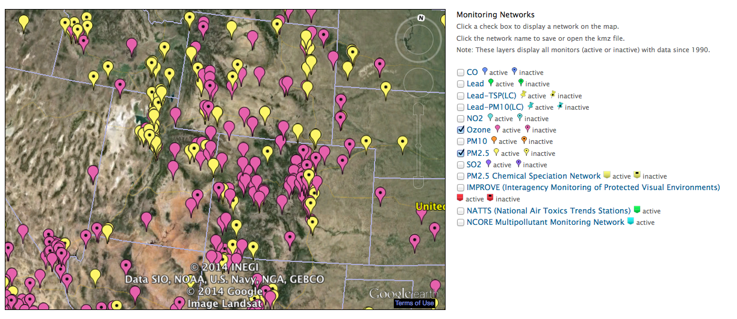

Figure ‑. Locations of AIRS O3 (pink) and FRM PM2.5 mass (yellow) monitoring sites in the three state region showing active and inactive (with black dot) sites (source: <http://www.epa.gov/airquality/airdata/ad_maps.html>).

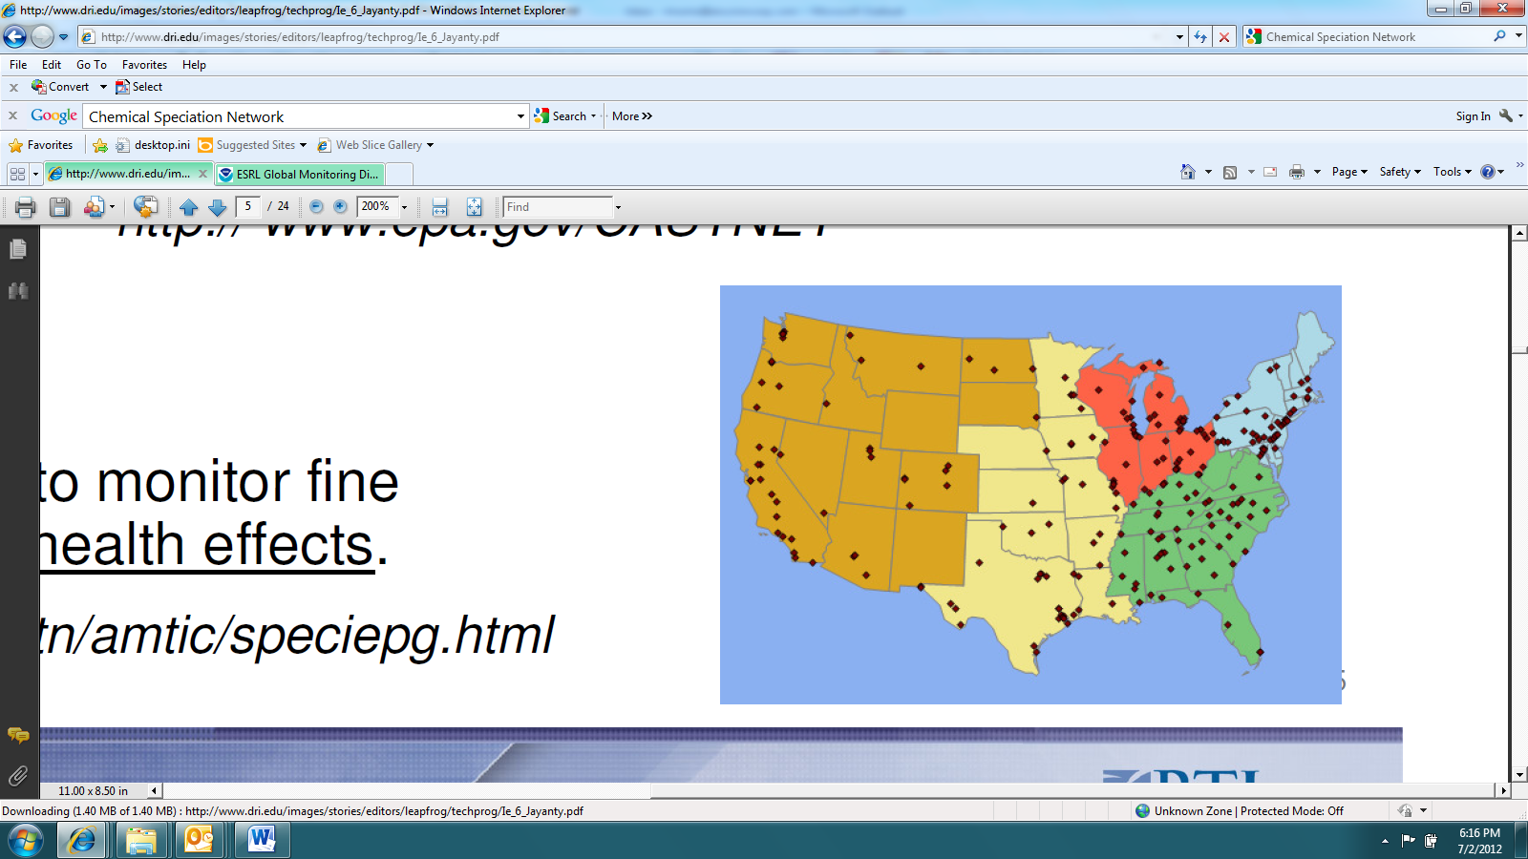

Figure ‑. Locations of CSN speciated PM2.5 monitoring sites (source: <http://www.epa.gov/ttn/amtic/speciepg.html>).

IMPROVE Monitoring Network: The Interagency Monitoring of Protected Visual Environments (IMPROVE[5]) network collects 24-hour average PM2.5 and PM10 mass and speciated PM2.5 concentrations (with the exception of ammonium) using a 1:3 day sampling frequency. IMPROVE monitoring sites are mainly located at more rural Class I area sites that correspond to specific National Parks, Wilderness Areas and Fish and Wildlife Refuges across the U.S. with a large number of sites located in the western U.S. Although there are also some IMPROVE protocol sites that can be more urban-oriented. Figure 3‑4 shows the locations of the approximately 150 IMPROVE and IMPROVE protocol sites across the U.S.

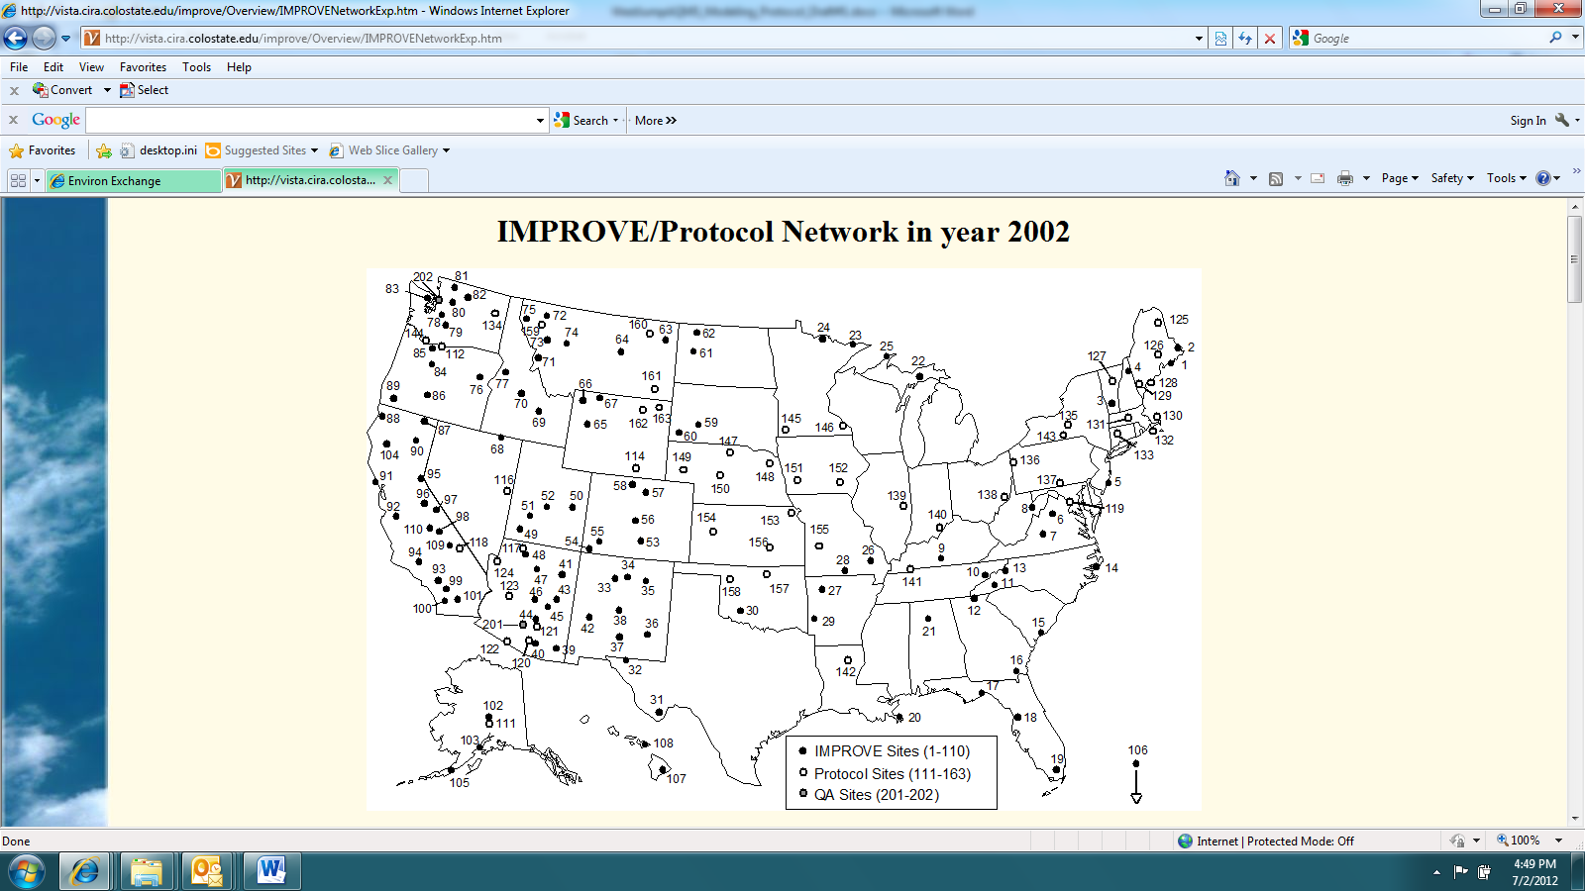

Figure ‑. Locations of IMPROVE monitoring sites (source: <http://vista.cira.colostate.edu/IMPROVE/>)

CASTNet Monitoring Network: The Clean Air Status and Trends Network (CASTNet[6]) operates approximately 80 monitoring sites in mainly rural areas across the U.S. CASTNet sites typically collected hourly ozone, temperature, wind speed and direction, sigma theta, solar radiation, relative humidity, precipitation and surface wetness. CASTNet also collects weekly (Tuesday to Tuesday) samples of speciated PM2.5 sulfate, nitrate, ammonium and other relevant ions and weekly gaseous SO2 and nitric acid (HNO3). Figure 3‑5 displays the locations of the ~80 CASTNet sites across the U.S.

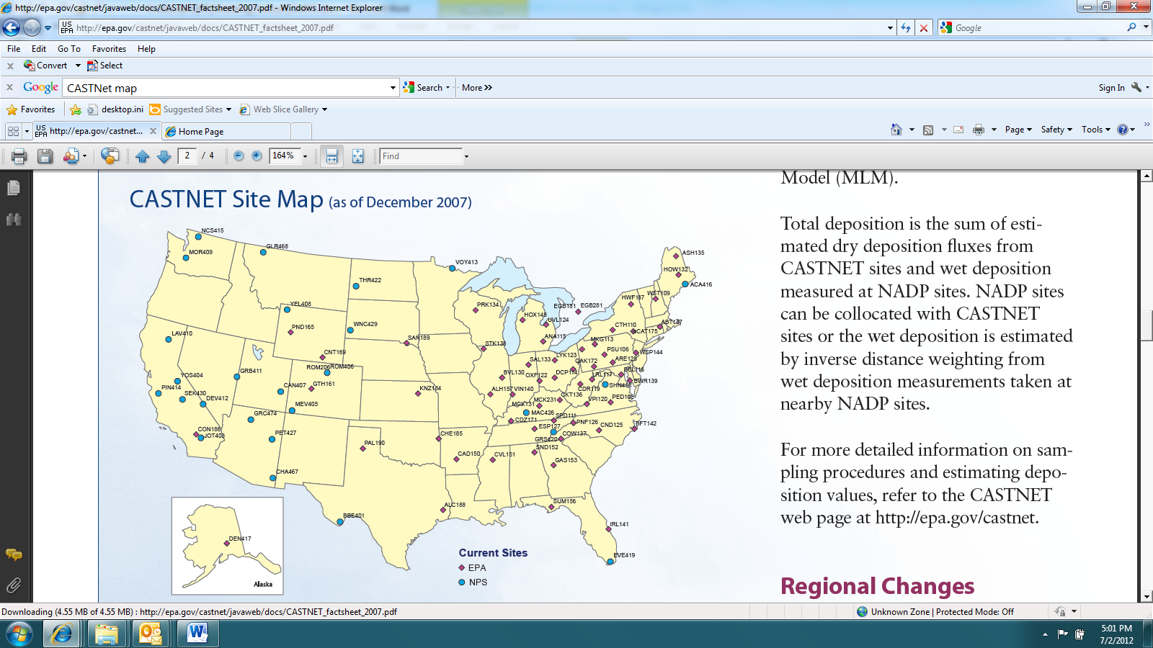

Figure ‑. Locations of CASTNet monitoring sites (source: <http://epa.gov/castnet/javaweb/index.html>).

NADP Network: The National Acid Deposition Program (NADP[7]) collects weekly samples of SO4, NO3 and NH4 in precipitation (wet deposition) in their National Trends Network (NTN) at over a 100 sites across the U.S. that are mainly located in rural areas away from big cities and major point sources. Seven NADP sites also collect daily wet deposition measurements (AIRMON) when precipitation occurs. Over 20 of the NADP sites also collect weekly mercury (MDN) samples. Figure 3‑6 shows the locations of the NADP NTN, AIRMoN and MDN monitoring sites. Note that observed sulfate and nitrate dry deposition can be estimated at CASTNet sites using concentrations and a micro-meteorological model that produces a deposition velocity. But these are not true observations, but model estimates of the observations.

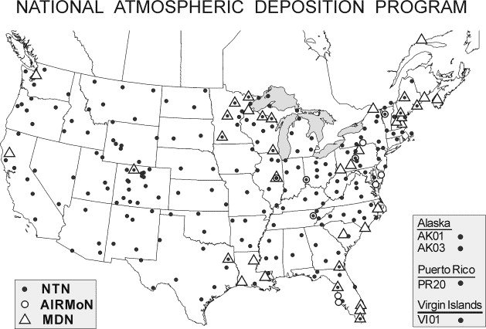

Figure ‑. Locations of NADP monitoring sites (source: <http://nadp.sws.uiuc.edu/>).

Ozonesonde Network: The NOAA Earth Systems Research Laboratory (ESRL) operates several ozonesonde sites[8] throughout the world that measure the vertical structure of ozone concentrations throughout the troposphere and into the lower stratosphere. Ozonesonde monitoring sites within the 3SAQS modeling domain include: (1) Trinidad Head on the coast in northern California; (2) Boulder, Colorado; and (3) at the University of Alabama at Huntsville.

Upper Green River Winter Ozone Study (UGRWOS): The Wyoming Department of Environmental Quality – Air Quality Division (WY AQD) sponsored a multi-year monitoring study of the conditions leading to elevated winter ozone levels in the Upper Green River Basin. The 2011 UGRWOS field campaign focused on studying the vertical distribution of ozone and precursors in the region. Seven permanent monitoring sites provide continuous surface air quality and meteorological measurements (Figure 3‑7). The Boulder site also had a mini-Sodar. A 73-m tower and a tethered balloon collected air quality and meteorological data on the vertical structure of the atmosphere. During the 2011 UGRWOS there were 13 ozone exceedance days recorded during February and March with the three highest observed daily maximum 8-hour ozone concentrations of 123, 121 and 121 ppb occurring on March 2, 3 and 12, 2011, respectively.

Uintah Basin Winter Ozone Study (UBWOS): This study was conducted during the winters of 2012-2014 to gain a better understanding of wintertime ozone formation within the Uintah Basin. Some objectives of this field campaign included creating a long-term record of atmospheric chemistry and meteorology, and understand the meteorological and chemical processes active in wintertime ozone production in the Uinta Basinh (Utah DEQ, 2013). Although the observational period of UBWOS does not correspond to the 2011 modeling year presented in this MPE, there are useful insights into the chemical and physical drivers of winter ozone formation from this measurement campaign that can be applied to 2011.

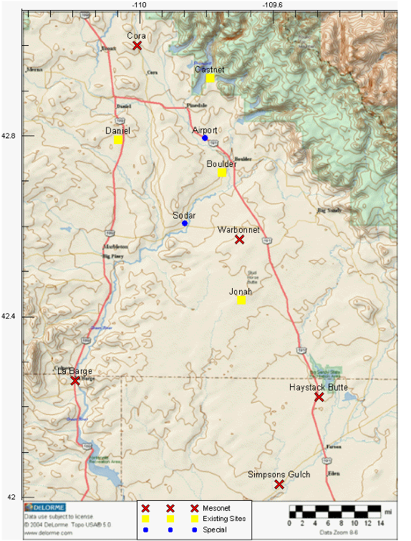

Figure ‑. Locations of UGRWOS monitoring sites (source: <http://deq.state.wy.us/aqd/Upper%20Green%20Winter%20Ozone%20Study.asp>)

Ammonia Monitoring Network (AMoN): Operated by the National Atmospheric Deposition Network, AMoN is the only source of routine standardized ambient, gas-phase ammonia measurements in the U.S. The objective of AMoN is to measure NH3 concentrations in a spatially dense, cost-efficient network with data of defined high quality. The AMoN began as a special study in the fall of 2007. The AMoN was approved as an official NADP network in October 2010. The network currently consists of approximately 50 sites, and additional sites are encouraged to join[9]. Figure 3‑8 shows the location of AMoN sites in the 3SAQS 4-km modeling domain. Note that not all of these sites were operating in 2011. In fact, only the three AMON sites at Fort Collins, CO, Navajo Lake, NM and Farmington, NM were operating during all of 2011 with additional AMON sites coming on-line at the Rocky Mountains and Grand Tetons National Parks and Salt Lake City during 2011.

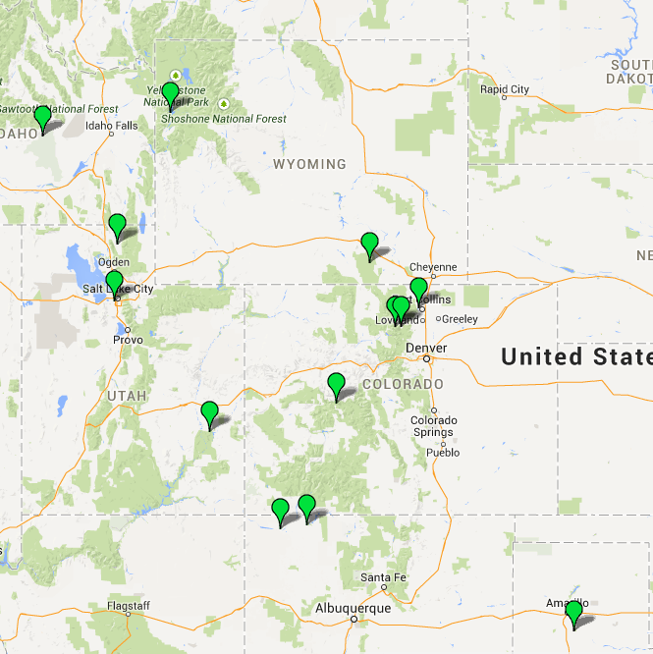

Figure ‑. Locations of AMoN monitoring sites in the 3SAQS 4-km domain

Additional ambient monitoring data that are available for 2011 may include special field study data collected in the three-state region. The initial focus of the model performance evaluation will be on the standard regional networks described above. As other data become available we will integrate these into the evaluation of the 3SAQS 2011 CAMx simulation.

### Atmospheric Model Evaluation Tool (AMET)

The Atmospheric Model Evaluation Tool (AMET) (Appel et al., 2013) is a suite of software designed to facilitate the analysis and evaluation of meteorological and air quality models.

AMET matches the model output for particular locations to the corresponding observed values from one or more networks of monitors. These pairings of values (model and observation) are then used to statistically and graphically analyze the model’s performance. AMET version 2.1 (AMETv1.2) was the primary tool used to generate the performance statistics and plots used to conduct the model performance evaluation.

## CAMx Post-processing and Model-Observations Pairing

This section details how we processed and compared the CAMx output data to ambient air quality observations. The general procedure involved the following steps:

1. Convert the CAMx average (avrg) and wet deposition (wdep) hourly output files from UAM to I/O API-netCDF format with the utility camx2ioapi. This utility is available from <http://www.camx.com>.
2. Run the program Combine to post-process the model output species. One function of Combine is to simply convert the units of the gas-phase model species from ppmV to ppbV. Combine also calculates lumped species, such as total volatile organic compounds and NOx. Finally Combine is used to calculate the model PM species for comparison to observations. Combine is distributed with the CMAQ air quality model package available from <http://www.cmaq-model.org>.
3. Run the programs sitecmp, cmp_airs, and cmp_castnet to pair in space and time the model output data from Combine with the surface monitoring networks described in Section 3.2.2. The programs cmp_airs and cmp_castnet also compute daily maximum 8-hour average ozone (MDA8) values for comparison to the reported MDA8 concentrations in the observational databases. These programs are distributed with AMET available from <http://www.cmascenter.org>.
4. Load the paired model-observations tables output from sitecmp, cmp_airs, and cmp_castnet into the AMET database using the scripts provided with AMET
5. Run the AMET analysis scripts to calculate the model performance statistics and create plots of the performance results

Appendix A includes the expressions used for post-processing and pairing the CAMx concentration and deposition output species. Section A.1 includes the Combine expressions that normalize the CAMx output species with the concentration variables reported by the monitoring networks. Section A.2 lists the pairing expressions used by AMET to match reported observations with model outputs.

## Model Performance Statistics, Goals and Criteria

For over two decades, ozone model performance has been compared against EPA’s 1991 ozone modeling guidance performance goals as follows (EPA, 1991):

* Unpaired Peak Accuracy (UPA) ≤ ±20%
* Mean Normalized Bias (MNB) ≤ ±15%

Mean Normalized Gross Error (MNGE) ≤ 35%

In EPA’s 1991 ozone modeling guidance, these performance metrics were for hourly ozone concentrations. The UPA compared the daily maximum 1-hour predicted and observed ozone concentration that was matched by day, but not necessarily by location and by hour of the day. Since a photochemical grid model predicts ozone concentrations everywhere and the observed ozone is limited to a monitoring network, it would be fortuitous that the actual highest hourly ozone concentration in a region occurred at a monitoring site, so one would expect a perfect model to have an overestimation tendency for the UPA performance metric.

The MNB uses hourly predicted and observed ozone concentrations paired by time and location and is defined as the difference between the predicted and the observed hourly ozone divided by the observed hourly ozone concentrations averaged over all predicted/observed pairs (see Table 3‑4) within a given region and for a given time period (e.g., by day, month or modeling period). The MNGE is defined similarly only it uses the absolute value of the difference between the predicted and observed hourly ozone concentrations so is an unsigned metric. As the MNB/MNGE performance metrics divide by the observed hourly ozone concentration, the metric is calculated just using the predicted and observed hourly ozone pairs for which the observed hourly ozone concentration is above a threshold concentration.

For PM species a separate set of model performance statistics and performance goals and criteria have been developed as part of the regional haze modeling performed by several Regional Planning Organizations (RPOs). EPA’s modeling guidance notes that PM models might not be able to achieve the same level of model performance as ozone models. Indeed, PM2.5 species definitions are defined by the measurement technology used to measure them and different measurement technologies can produce very different PM2.5 concentrations. Given this, several researchers have developed PM model performance goals and criteria that are less stringent than the ozone goals as shown in Table 3‑3 (Boylan, 2004; Morris et al., 2009a,b). However, unlike the 1991 ozone model performance goals that use the MNB and MNGE performance metrics, for PM species the Fractional Bias (FB) and Fractional Error (FE) are utilized with no observed concentration threshold screening. The FB/FE differ from the MNB/MNGE in that the difference in the predicted and observed concentrations are divide by the average of the predicted and observed values, rather than just the observed value as in the MNB/MNGE. This results in the FB being bounded by -200% to +200% and the FE being bounded by 0% to +200%. There are additional statistical performance metrics that evaluate correlation, scatter as well as bias and error and a full suite of model performance metrics will be calculated for all species as given in Table 3‑4.

Table ‑. PM model performance goals and criteria.

|  |  |  |
| --- | --- | --- |
| **Fractional**  **Bias (FB)** | **Fractional**  **Error (FE)** | **Comment** |
| ≤±15% | ≤35% | Ozone model performance goal that would be considered very good model performance for PM species |
| ≤±30% | ≤50% | PM model performance Goal, considered good PM performance |
| ≤±60% | ≤75% | PM model performance Criteria, considered average PM performance. Exceeding this level of performance for PM species with significant mass may be cause for concern. |

It should be pointed out that these model performance goals and criteria are not used to assign passing or failing grades to model performance, but rather to help interpret the model performance and intercompare across locations, species, time periods and model applications. As noted in EPA’s current modeling guidance: “By definition, models are simplistic approximations of complex phenomena” (EPA, 2007, pg. 98). The model inputs to the air quality models vary hourly, but tend to represent average conditions that do not account for unusual or extreme conditions. For example, an accident or large event could cause significant increases in congestion and motor vehicle emissions that are not accounted for in the average emissions inputs used in the model. This is seen in PM modeling at some monitoring sites that fail to capture the high PM concentrations on July 4 due to fireworks and other activities associated with this holiday (traffic and BBQ) that increase PM emissions.

More recently, EPA compiled and interpreted the model performance from 69 PGM modeling studies in the peer-reviewed literature between 2006 and March 2012 and developed recommendations on what should be reported in a model performance evaluation (Simon, Baker and Phillips, 2012). Although these recommendations are not official EPA guidance, they are useful for consideration in the 3SAQS model performance evaluation:

1. PGM MPE studies should at a minimum report the Mean Bias (MB) and Error (ME or RMSE), and Normalized Mean Bias (NMB) and Error (NME) and/or Fractional Bias (FB) and Error (FE). Both the MNB and FB are symmetric around zero with the FB bounded by -200% to +200%.
2. Use of the Mean Normalized Bias (MNB) and Gross Error (MNGE) is not encouraged because they are skewed toward low observed concentrations and can be misinterpreted due to the lack of symmetry around zero.
3. Given this recommendation the MNB/MNGE should just be calculated for ozone using an appropriate observed ozone cut-off concentration (e.g., 60 or 40 ppb).
4. The model evaluation statistics should be calculated for the highest resolution temporal resolution available and for important regulatory averaging times (e.g., daily maximum 8-hour ozone).
5. It is important to report processing steps in the model evaluation and how the predicted and observed data were paired and whether data are spatially/temporally averaged before the statistics are calculated.
6. Predicted values should be taken from the grid cell that contains the monitoring site, although bilinear interpolation to the monitoring site point can be used for higher resolution modeling (< 12 km).
7. PM2.5 should also be evaluated separately for each major component species (e.g., SO4, NO3, NH4, EC, OC and Other PM2.5).
8. Evaluation should be performed for subsets of the data including, high observed concentrations (e.g., ozone > 60 ppb), by subregions and by season or month.
9. Evaluation should include more than just ozone and PM2.5, such as SO2, NO2 and CO.
10. Spatial displays should be used in the model evaluation to evaluate model predictions away from the monitoring sites. Time series of predicted and observed concentrations at a monitoring site should also be used.
11. It is necessary to understand measurement artifacts in order to make meaningful interpretation of the model performance evaluation.

We incorporated the recommendations of Simon, Baker and Philips (2012) into the 3SAQS model performance evaluation. This included just using the FB/FE and MNB/MNE bias/error statistics and not the MNB/MNE bias/error performance statistics recommended in the EPA 1991 guidance and also calculating bias and error statistics with and without a 60 ppb observed ozone cut-off concentration. The 3SAQS evaluation products will include qualitative and quantitative evaluation for the following model output species:

* Maximum daily 1-hour (MDA1) and maximum daily 8-hour average (MDA8) ozone, including MDA8 with a 60 ppb threshold
* Carbon monoxide, sulfur dioxide, NO2
* Total PM2.5, elemental carbon, organic carbon, sulfate, nitrate, and ammonium
* Total sulfur and total nitrogen wet deposition

Table ‑. Model performance evaluation statistical measures used to evaluate the CTMs.

| **Statistical**  **Measure** | **Mathematical**  **Expression** | **Notes** |
| --- | --- | --- |
| Accuracy of paired peak (Ap) |  | Comparison of the peak observed value (Opeak) with the predicted value at same time and location |
| Coefficient of determination (r2) |  | Pi = prediction at time and location i;  Oi = observation at time and location i;  = arithmetic average of Pi, i=1,2,…, N;  = arithmetic average of Oi, i=1,2,…,N |
| Normalized Mean Error (NME) |  | Reported as % |
| Root Mean Square Error (RMSE) |  | Reported as % |
| Fractional Gross Error (FE) |  | Reported as % and bounded by 0% to 200% |
| Mean Error (ME) |  | Reported as concentration (e.g., µg/m3) |
| Mean Normalized Gross Error (MNGE) |  | Reported as % |
| Mean Bias (MB) |  | Reported as concentration (e.g., µg/m3) |
| Mean Normalized Bias (MNB) |  | Reported as % |
| Mean Fractionalized Bias (Fractional Bias, FB) |  | Reported as %, bounded by -200% to +200% |
| Normalized Mean Bias (NMB) |  | Reported as % |
| Bias Factor (BF) |  | Reported as BF:1 or 1: BF or in fractional notation (BF/1 or 1/BF). |

# 2011 Model Performance Evaluation

## Ozone and Precursors Model Performance

Given the complexity of the terrain and heterogeneity of the emissions sources in the Western U.S., ozone model performance evaluation should focus on smaller regions and targeted time-periods. This section first presents regional ozone performance across the entire 12-km and 4-km modeling domains, without any evaluation of precursor species or trends at specific monitors. More detailed performance metrics for the 3SAQS 4-km 2011 Base version A (3SAQS04_CAMx_B11a) simulation, including precursor species, are then presented for sites in Colorado, Utah, and Wyoming.

### 3SAQS 12-km Domain Model Performance

The 3SAQS 12-km domain-wide ozone model performance meets the performance goals for both daily maximum 1-hour (MDA1) and 8-hour O3 (MDA8). Table 4‑1 includes bias and error metrics for observed ozone and gas-phase species at sites averaged across the 12-km modeling domain. The rows labeled AQS and CNET are performance statistics for hourly O3 at the AQS and CASTNet monitors, respectively. The rows labeled AQS MDA1 and CNET MDA1 are statistics for daily maximum 1 hour O3 at each network; AQS MDA8 and CNET MDA8 are daily maximum 8-hour average O3. Values in red indicate performance metrics that miss the model performance goals. Several key points of CAMx O3 model performance across the 12-km domain include:

* Fractional bias (FB=16.7%), fractional error (FE=44.9%), Normalized Mean Bias (NMB=17.4%), and Normalized Mean Error (NME=36.1%) for AQS hourly O3 are the only ozone performance metrics that miss the performance goals, although they are within the performance criteria.
* On an annual, domain-wide average, CAMx has a positive bias for hourly O3, MDA1, and MDA8 at both the AQS and CASTNet sites; the overall performance (lower bias and error) is better at the CASTNet sites than the AQS sites.
* When a 60 ppb observed O3 concentration threshold is applied, the model biases switch from positive to negative. The model performance improves at the AQS sites and degrades at the CASTNet sites at higher ozone values but still achieves the ozone performance goals.
* Model performance for O3 degrades slightly during the ozone season (June-August), relative to the annual performance, at the AQS sites. CAMx has a positive bias during this period.

Figure 4‑1 includes annual scatter plots (CAMx vs. observations) for all AQS and CASTNet sites in the 12-km domain. The figure includes both MDA1 and MDA8 O3 with and without a 60 ppb concentration threshold applied to the observations. CAMx has a positive bias in predicting the observed values at both networks; with higher fractional bias at the AQS sites (MDA1: 9.5%, MDA8: 13.6%) compared to the CASTNet sites (MDA1: 3.0%, MDA8: 5.5%). On the days with elevated O3 measurements (>60 ppb), CAMx has a negative bias, with lower fractional bias at the AQS sites (MDA1: -5.2%, MDA8: -3.8%) compared to the CASTNET sites (MDA1: -9.7%, MDA8: -9.1%).

The Q-Q plots shown in Figure 4‑2 illustrate that CAMx overestimates the observations across all concentrations at the AQS sites. At the CASTNet sites, CAMx overestimates the low observed values and underestimates high observed values.

Figure 4‑3 and Figure 4‑4 show the monthly CAMx model performance for MDA8. CAMx biases are lowest during the spring months at both the AQS sites and the CASTNet sites. The CAMx performance is well within the performance goals for all months at the CASTNet sites. Model performance is marginal at the AQS sites in January, July, August, November, and December, with the model missing the goals but meeting the performance criteria.

Table ‑. 12-km domain ozone performance indicators

|  |  |  |  |  |  |  |  |  |  |
| --- | --- | --- | --- | --- | --- | --- | --- | --- | --- |
| Species | Network | FB | FE | MB | ME | NMB | NME | Mean Obs | Mean Mod |
|  | Units | (%) | (%) | (ppb) | (ppb) | (%) | (%) | (ppb) | (ppb) |
| O3 | AQS Hourly | 16.70 | 44.9 | 5.62 | 11.70 | 17.40 | 36.1 | 32.3 | 38.0 |
| CNET Hourly | 12.60 | 22.3 | 3.78 | 8.25 | 9.04 | 19.70 | 41.80 | 45.60 |
| AQS MDA1 | 9.51 | 18.5 | 3.93 | 9.19 | 7.95 | 18.6 | 49.5 | 53.4 |
| CNET MDA1 | 3.04 | 13.1 | 0.92 | 6.70 | 1.76 | 12.9 | 52.0 | 52.9 |
| AQS MDA8 | 13.60 | 20.8 | 5.46 | 9.23 | 12.30 | 20.8 | 44.40 | 49.90 |
| CNET MDA8 | 5.51 | 13.9 | 2.07 | 6.56 | 4.23 | 13.4 | 49.0 | 51.0 |
| W126 | 46.1 | 57.9 | 7.01 | 9.22 | 52.5 | 69.0 | 13.4 | 20.4 |
| O3 > 60 ppb | AQS MDA1 | -5.21 | 13.3 |  |  | -4.80 | 13.5 |  |  |
| CNET MDA1 | -9.66 | 13.2 |  |  | -9.20 | 12.7 |  |  |
| AQS MDA8 | -3.83 | 12.1 |  |  | -3.40 | 12.3 |  |  |
| CNET MDA8 | -9.06 | 12.1 |  |  | -8.60 | 11.7 |  |  |
| June-August O3 | AQS Hourly | 21.50 | 40.0 | 7.40 | 13.20 | 20.20 | 35.9 | 36.9 | 44.3 |
| CNET Hourly | 14.57 | 24.5 | 4.69 | 9.90 | 10.37 | 21.73 | 45.70 | 50.40 |
| AQS MDA1 | 11.09 | 20.7 | 5.33 | 11.90 | 9.38 | 20.9 | 57.0 | 62.3 |
| CNET MDA1 | 2.48 | 14.5 | 0.63 | 8.45 | 1.11 | 14.23 | 59.5 | 60.1 |
| AQS MDA8 | 15.63 | 22.5 | 7.40 | 11.70 | 14.57 | 23.03 | 50.87 | 58.27 |
| CNET MDA8 | 5.65 | 15.0 | 2.38 | 8.11 | 4.37 | 14.73 | 55.3 | 57.6 |
|  | | | | | | | | | |

|  |  |  |
| --- | --- | --- |
|  | **All Days** | **Days with Obs > 60 ppb** |
| **Daily Max O3** |  |  |
| **Daily Max 8-hr Average O3 (MDA8)** |  |  |

Figure ‑. CAMx 3SAQS 2011 base case model performance for MDA1 (top) and MDA8 (bottom) O3 concentrations for all AQS (red) and CASTNet (blue) sites in the 12-km domain with (right) and without (left) using a 60 ppb observed ozone cut-off threshold.

|  |  |
| --- | --- |
|  |  |

Figure ‑.Q-Q plots of CAMx 3SAQS 2011 MDA8 for the 12-km modeling domain and the AQS (left) and CASTNet (right) monitoring networks

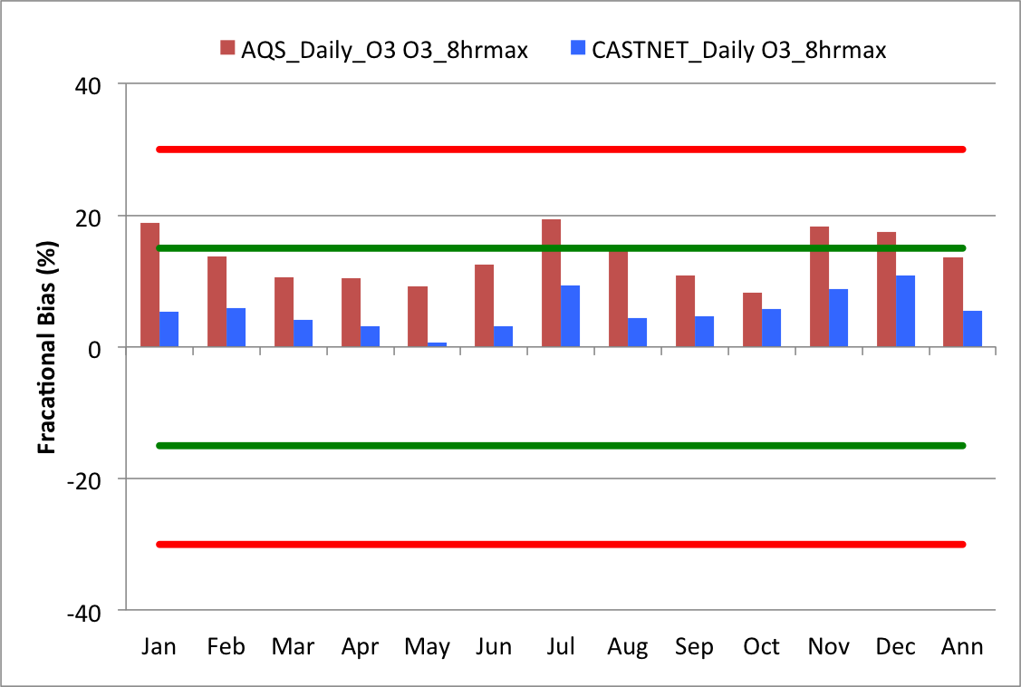

Figure ‑. CAMx mean monthly FB in MDA8 at all AQS (red) and CASTNet (blue) sites in the 12-km modeling domain

|  |  |  |
| --- | --- | --- |
|  | **1-hr Daily Max O3** | **8-hr Daily Max O3** |
| **AQS** |  |  | |
| **CASTNET** |  |  | |

Figure ‑. CAMx 3SAQS 2011 base case monthly model performance for MDA1 (left) and MDA8 (right) O3 for all AQS (top) and CASTNet (bottom) sites in the 12-km domain.

### 3SAQS 4-km Domain Model Performance

The 3SAQS 4-km domain-wide ozone model performance meets the performance goals for hourly O3, MDA1 O3, and MDA8 O3. Table 4‑2 includes bias and error metrics for observed ozone species at sites averaged across the 4-km modeling domain. Several key points of CAMx O3 model performance across the 4-km domain include:

* All of the bias and error metrics for hourly, MDA1, and MDA8 O3 meet the performance goals. Moderate to low annual biases indicate that CAMx tends to overestimate the observations across the year. Several of the error metrics approach the middle to upper end of the performance goal (35%), indicating that there are compensating biases in the model that are suppressing the averaged bias metrics.
* On an annual, domain-wide average CAMx has a positive bias for hourly O3, MDA1, and MDA8 at both the AQS and CASTNet sites; overall, the model performs better at the CASTNet sites, with lower average errors and biases compared to the AQS sites
* When a 60 ppb observed O3 concentration threshold is applied, the model biases increase and switch from positive to negative.
* Model performance for O3 improves at the AQS sites and degrades slightly at the CASTNet sites in the ozone season (June-August) relative to the full year.

Figure 4‑5 includes annual scatter plots (CAMx vs. observations) for all AQS and CASTNet sites in the 4-km domain. The figure includes both MDA1 and MDA8 O3 with and without a 60 ppb concentration threshold applied to the observations. CAMx has a positive bias for both networks; with higher fractional bias at the AQS sites (MDA1: 2.1%, MDA8: 4.4%) compared to the CASTNet sites (MDA1: 0.2%, MDA8: 1.4%). On the days with elevated O3 measurements (>60 ppb), CAMx has a negative bias, with lower fractional bias at the AQS sites (MDA1: -7.2%, MDA8: -6.9%) compared to the CASTNET sits (MDA1: -7.8%, MDA8: -7.6%).

The Q-Q plots shown in Figure 4‑6 illustrate the trend that CAMx underestimates high observed values, particularly at the AQS sites. The inability of CAMx to reproduce MDA8 values greater than 100 ppb at the AQS sites is attributable to winter ozone events. For this initial 2011 modeling effort, we did not configure WRF and CAMx to simulate winter ozone events and we will address winter ozone model performance in later stages of the 3SAQS. This tail at the high observed MDA8 values is not seen in the 12-km Q-Q plot (Figure 4‑2) because areas of high predicted ozone (California) are included in the 12-km domain. The model does not estimate MDA8 values at any locations/time-periods in the 4-km domain that are of the same magnitude as the values observed during winter ozone episodes.

Figure 4‑7 compares the monthly mean and annual mean MDA8 fractional bias for the AQS and CASTNet sites in the 4-km domain. This figure shows that averaged across all sites in the 4-km domain, CAMx has low biases in all months and that the model tends to overestimate MDA8 in both networks in most months. Exceptions include negative biases for both networks in January and for CASTNet in March-June.

Figure 4‑8 includes soccer plots with the monthly CAMx model performance for MDA1 and MDA8 at the AQS and CASTNet sites in the 4-km domain. Again, CAMx meets the performance goals for bias and error in all months at both networks. At the AQS sites, CAMx biases are lowest during the first and second quarters and highest in November and December. At the CASTNet sites, CAMx biases are lowest January-April and highest May-July.

Table ‑. 4-km domain ozone performance indicators

|  |  |  |  |  |  |  |  |  |  |
| --- | --- | --- | --- | --- | --- | --- | --- | --- | --- |
| Species | Network | FB | FE | MB | ME | NMB | NME | Mean Obs | Mean Mod |
|  | Units | (%) | (%) | (ppb) | (ppb) | (%) | (%) | (ppb) | (ppb) |
| O3 | AQS Hourly | 7.36 | 33.7 | 2.02 | 10.10 | 5.47 | 27.2 | 37.0 | 39.0 |
| CNET Hourly | 3.62 | 12.5 | 1.44 | 5.78 | 3.06 | 12.3 | 47.1 | 48.6 |
| AQS MDA1 | 2.06 | 12.7 | -0.47 | 7.45 | -0.90 | 14.3 | 52.0 | 51.5 |
| CNET MDA1 | 0.20 | 9.4 | -0.01 | 5.16 | -0.02 | 9.52 | 54.2 | 54.2 |
| AQS MDA8 | 4.39 | 13.7 | 0.67 | 7.11 | 1.41 | 14.9 | 47.6 | 48.3 |
| CNET MDA8 | 1.35 | 9.2 | 0.60 | 4.78 | 1.16 | 9.23 | 51.8 | 52.4 |
| W126 | 17.0 | 33.0 | 2.58 | 4.70 | 18.1 | 33.1 | 14.2 | 16.8 |
| O3 > 60 ppb | AQS MDA1 | -7.19 | 12.1 |  |  | -8.1 | 13.0 |  |  |
| CNET MDA1 | -7.80 | 11.3 |  |  | -7.2 | 10.8 |  |  |
| AQS MDA8 | -6.86 | 11.4 |  |  | -8.1 | 12.6 |  |  |
| CNET MDA8 | -7.57 | 10.5 |  |  | -7.0 | 9.9 |  |  |
| June-August O3 | AQS Hourly | 11.19 | 27.8 | 2.95 | 11.17 | 6.88 | 25.7 | 43.4 | 46.3 |
| CNET Hourly | 4.30 | 14.3 | 1.84 | 7.11 | 3.81 | 13.9 | 51.2 | 53.0 |
| AQS MDA1 | 0.58 | 11.9 | -1.57 | 8.85 | -2.50 | 14.2 | 62.4 | 60.8 |
| CNET MDA1 | -0.98 | 10.0 | -0.64 | 6.10 | -0.90 | 9.96 | 61.0 | 60.4 |
| AQS MDA8 | 3.69 | 11.7 | 0.37 | 8.07 | 0.66 | 14.2 | 56.8 | 57.2 |
| CNET MDA8 | 0.57 | 9.4 | 0.31 | 5.44 | 0.69 | 9.40 | 57.6 | 57.9 |
|  | | | | | | | | | |

|  |  |  |
| --- | --- | --- |
|  | **All Days** | **Days with Obs > 60 ppb** |
| **Daily Max O3** |  |  |
| **Daily Max 8-hr Average O3 (MDA8)** |  |  |

Figure ‑. CAMx 3SAQS 2011 base case model performance for MDA1 (top) and MDA8 (bottom) O3 for all AQS (red) and CASTNet (blue) sites in the 4-km domain with (right) and without (left) using a 60 ppb observed ozone cut-off threshold.

|  |  |
| --- | --- |
|  |  |

Figure ‑.Q-Q plots of CAMx 3SAQS 2011 MDA8 for the 4-km modeling domain for the AQS (left) and CASTNet (right) monitoring networks

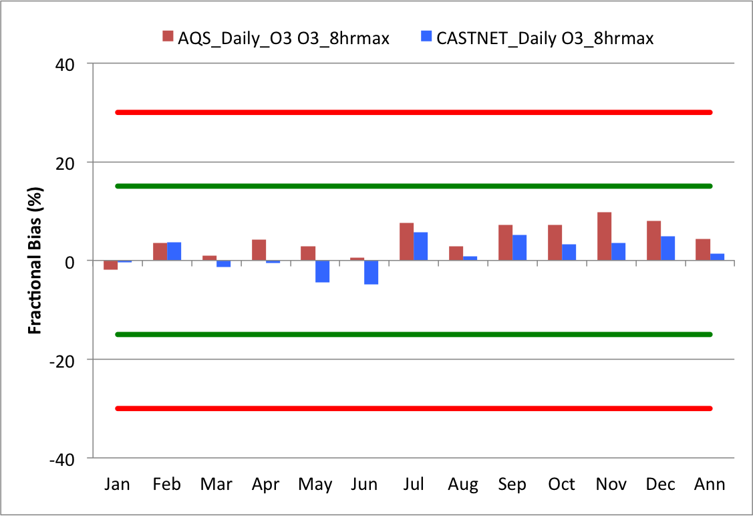

Figure ‑. CAMx mean monthly bias in MDA8 at all AQS (red) and CASTNet (blue) sites in the 4-km modeling domain

|  |  |  |
| --- | --- | --- |
|  | **1-hr Daily Max O3** | **8-hr Daily Max O3** |
| **AQS** |  |  | |
| **CASTNET** |  |  | |

Figure ‑. CAMx 3SAQS 2011 base case monthly model performance for MDA1 (left) and MDA8 (right) O3 for all AQS (top) and CASTNet (bottom) sites in the 4-km domain.

### Colorado Model Performance

The CAMx O3 estimates for Colorado easily meet the bias (NMB: 1.6-6.6%) and error (NME: 10.1-26.0%) performance goals on an annual basis for hourly, MDA1, and MDA8 O3. Table 4‑3 shows the CAMx 3SAQS Base2011a 4-km grid resolution performance metrics for O3 and other gas-phase species at monitoring locations in Colorado. The rows labeled AQS and CNET in Table 4‑3 are performance statistics for hourly O3 at the AQS and CASTNet monitors, respectively. The rows labeled AQS MDA1 and CNET MDA1 are statistics for daily maximum 1 hour O3 at each network; AQS MDA8 and CNET MDA8 are daily maximum 8-hour average O3. Several key points of CAMx model performance for O3 include:

* CAMx has an overall positive O3 bias across all of the Colorado monitors in both the AQS and CASTNet networks. The Q-Q plot in Figure 4‑9 shows that CAMx has a positive bias in the middle and negative bias at the bottom and top ends of the observed concentrations ranges at the AQS sites. At the Colorado CASTNet sites CAMx has positive biases except for the upper end of the observed concentration range.
* CAMx exhibits lower bias but higher errors predicting *hourly* O3 at the AQS sites relative to the CASTNet sites, indicating that there are compensating biases in the predicted concentrations across all of the AQS monitoring locations.
* CAMx performs better at predicting MDA1 and MDA8 O3 at the CASTNet sites than it does at the AQS sites. Although the bias differences are small between these networks, there are significant differences in the model errors.
* CAMx performance at predicting concentrations at the AQS sites improves (lower FE and NME) on days with elevated O3 (> 60 ppb) relative to all days. Figure 4‑10 illustrates that on elevated O3 days CAMx has negative biases in the range of -4.5% to -5.5% with slightly better performance at the AQS sites compared to the CASTNet sites.
* The change in CAMx performance at the AQS sites during the ozone season (June-August) relative to the full year is mixed, with some metrics showing improvements and other showing degradations.
* CAMx performance degrades during the ozone season at the CASTNet sites.

The CAMx monthly and site-specific O3 performance at the AQS and CASTNet sites is shown in Figure 4‑11 through Figure 4‑14. In terms of CAMx exhibiting better skill during one season relative to another, there doesn’t appear to be a seasonal pattern in the model performance. The model has a positive bias in all months at the AQS sites except January and December. CAMx has a positive bias in all months at the CASTNet sites except for May and June. Figure 4‑13 shows the CAMx MDA8 monthly normalized mean bias (NMB) at all of the CASTNet sites in the 4-km domain. The negative biases in May and June are not unique to the Colorado sites and may indicate the influence of stratosphere-troposphere exchange on regional background O3. This hypothesis is not supported by the performance at the AQS sites, which show a strong positive bias in May, although these sites tend to be more influenced by local emissions than regional transport. Further analysis is needed to investigate this trend in the model performance.

The O3 performance bias goal of ±15% is met in all months and across all sites in Colorado. Figure 4‑12 shows CAMx MDA8 monthly NMB at each of the Colorado AQS monitors. Similar to the performance trends seen in the 3SAQS 2008 modeling, the CSU monitor in Ft. Collins (FTCO: 80691004) misses the simple bias threshold in almost every month due to a too high overestimation bias. Figure 4‑15 shows the annual MDA8 time series comparing the CAMx 12-km and 4-km modeling results to observations at the FTCO monitor. The time series plot illustrates the systematic positive bias of CAMx at this site and a very slight improvement in performance in the 4-km results relative to the 12-km results. The time series plot shows that there are either missing or bad data in the first half of September at this site. These data are skewing the bias high for September as seen in the NMB outlier for this monitor in Figure 4‑12. The September 2011 data for the FTCO monitor should be either corrected or removed in future 2011 MPE efforts.

Located on the side of a road and near a rail line, the FTCO monitor is likely in a VOC-limited chemical regime and is heavily impacted by local NOx emissions sources. The consistent positive ozone bias at the FTCO monitor is an indication that CAMx is systematically underestimating NOx at this location. The fine scale impacts of the local NOx sources on the ozone readings at the FTCO monitor are most likely being diluted in the model grid cells even using a 4-km grid resolution. Figure 4‑16 is a time series plot of the nearby Ft. Collins West (FTCW: 80690011) monitor. More removed from local emissions sources, this monitor serves as a better indicator of model performance. Figure 4‑16 illustrates that CAMx is much closer at simulating MDA8 on most days at FTCW compared to FTCO. Additional evidence that the model is performing as expected for O3 in this part of the modeling domain is seen in the mean bias at the two sites. The 4-km domain annual mean bias at the FTCW monitor is 1.21% compared to 8.44% at the FTCO monitor.

The only other monitor that consistently misses the 15% bias threshold is the commercial Denver Animal Shelter (DMAS: 80310025) site. Similar to FTCO this is a population exposure monitor that is sited between a major highway and a rail line. The model performance issues at the DMAS monitor are also related to the inability of the model to resolve the effects of the fine scale impacts of large surface emissions sources in the proximity of the monitor using a 4-km grid resolution.

The suburban Welby (WBY: 80013001) site, north of Denver in Adams County is consistently one of the most underestimated AQS sites in Colorado for O3. Figure 4‑12 shows that the NMB for this site approaches -30% in January and also misses or nearly misses the performance goal in all of the fall and winter months. Figure 4‑17 shows hourly O3 and NO2 model-obs time series for Welby along with a satellite image of the site location. Although the site is immediately surrounded by agricultural, open land and suburban tracts, it is in close proximity to a rail line, major highways, and industrial areas. The time series plots for this site show that this location is more urban than the immediate site location seems to indicate. The site exhibits clear VOC-limited behavior with the hourly observed O3 peaks anti-correlated with the NO2 observations. Outside of about 11 days in the month where the model badly underestimates the O3 observations (e.g. January 4-6), CAMx simulates both the O3 and NO2 at this location remarkably well. On the days with the worst model performance, the observed NO2 approaches zero, a key trend that is missed in the model. The fact that the model performs so well on several days of the month suggests that the emissions sources around this site are generally well represented in the model. The performance at this monitor may possibly be suffering from deficiencies in either the wind fields or the dynamics in the meteorology inputs. Additional investigation into the wind directions and speeds on the poor O3 and NO2 performance days is recommended.

Figure 4‑13 shows monthly MDA8 O3 performance at the rural CASTNet sites. Key trends in these data for the Colorado sites include:

* All Colorado CASTNet sites have negative biases in May and June
* Gothic, Mesa Verde, and Rocky Mountain National Park EPA (206) have positive biases in almost every month; Rocky Mountain National Park NPS (406) has negative biases in every month but July
* In all seasons other than fall, the Gothic monitor exhibits the worst model performance of all of the CO CASTNet sites. Figure 4‑18 is a time series of annual 2011 MDA8 O3 at Gothic. While CAMx seems to capture the seasonal trend quite well, it does not capture the day-to-day variability at this location. The model predicts peaks that are either of higher magnitude than the observations or do not exist in the observations at all. Note that there appears to be bad observational data in late May/early June 2011 at the Gothic monitor. In the past the Gothic site has had documented stratospheric ozone intrusion events that are difficult to simulate using a PGM.

Figure 4‑19 shows monthly CAMx performance for hourly O3, NO2, CO, and SO2 at the Colorado AQS sites with annual performance statistics given in Table 4-3. The hourly AQS model performance shows some distinct seasonal patterns.

* The hourly O3 performance is within the performance goal for all months other than December, where the NME barely exceeds the ≤35% ozone performance goal for error.
* The spring and summer months have the lowest NME for hourly O3
* There is a distinct seasonal pattern to the NO2 performance; CAMx has the lowest biases and errors in the winter and the highest in summer.
* There are known artifacts in the FRM NOx and NO2 measurements that bias the observations high by as much as 50% and on average by about 20% (Dunlea et al., 2007). The CAMx NO2 concentrations have been adjusted to match the AQS observations. CAMx overestimates NO2 at the Colorado monitors in all seasons, particularly in the summer and fall.
* There is a seasonal pattern to the CO performance; the summer and spring months are clustered between ± 30% NMB and within about 60% NME; the fall and winter months all have positive biases and, with the exception of October, have NMEs of > 75%.
* SO2 performance is poor with severe overestimates and high errors during all months; the SO2 errors are so high that most months exceed 125% so the symbols are only seen for two months in Figure 4-19.

Figure 4‑20 through Figure 4‑23 provide additional detail on the performance of CAMx in predicting these other gas-phase pollutants. Figure 4‑20 shows monthly NO2 NMB and average concentrations for hourly observations at the Colorado AQS monitors. The figure shows monthly average NMB overlaid with monthly average model and observed NO2 concentrations. Although CAMx consistently overestimates NO2 in all months, with the NMB for NO2 only below 15% in January and December, CAMx reproduces the seasonal pattern in the observations well. As described above, NO2 measurement artifacts bias the AQS observations high. Some of the NOy species that are being incorrectly measured as NO2 (e.g. PAN and HNO3) are photochemical products and will have more of an impact on the measurements during the months of higher photochemical activity. Figure 4‑20 shows that there is a decline in model performance when the simulated NO2 is adjusted to account for the additional NOy species in the measurements. Adjusting the NO2 concentrations by adding nitric acid and organic nitrate concentrations per Dunlea et al. (2007) exacerbates the positive biases, particularly in the summer months (see NO2_adj labels in the Figure).

Figure 4‑21 shows monthly nitric acid NMB and average concentrations for daily observations at the Colorado CASTNet monitors. CAMx overestimates nitric acid in all months, with the highest biases and errors in the fall and winter. Like with NO2, CAMx reproduces the seasonal pattern in the nitric acid concentrations reasonably well. As a sink for reactive nitrogen and the OH radical, nitric acid accumulates at night and during cooler temperatures when photochemistry declines. Nitric acid concentrations can also build up during the more active photochemical warm season when there are insufficient VOC concentrations to compete for the OH radical. While there a relationship between the over estimates of NO2 and nitric acid (NO2 is a precursor of nitric acid), the combination of positive biases in all months of the year and higher biases in the colder months indicates possible deficiencies in the model dynamics. The model may not be sufficiently venting the nocturnal boundary layer, allowing nitric acid concentrations to accumulate in the first layer rather than be transported aloft.

Figure 4‑22 shows monthly carbon monoxide (CO) NMB and average concentrations for hourly observations at the Colorado AQS monitors. CAMx underestimates CO in the warmer months of the year (May-September) and overestimates CO in the cooler months. The positive biases are particularly bad in November and December, with December NMB exceeding 80%. As seen in the mean monthly simulated and observed CO concentrations, CAMx does a decent job at reproducing the seasonal pattern in CO concentrations; the model is missing the magnitudes of the observations. The dynamics issues already discussed in the NO2 and nitric acid evaluation will also impact the CO performance. The negative biases in the warm months are possibly due to missing or underestimated regional sources of CO, such as wildfires.

Figure 4‑23 presents monthly SO2 NMB and average concentrations at the hourly AQS and daily CASTNet sites in Colorado. The SO2 observations between the more urban AQS and rural CASTNet sites differ by an order of magnitude. The high AQS SO2 NMB values are an artifact of a flaw in this metric that results from dividing by low concentration observations. About 32% of the 2011 hourly AQS SO2 observations are reported as 0.0 ppb, skewing the mean observation value low and impacting the statistical metrics that are normalized by the observations (like NMB). If the zero observation values are removed from the NMB calculation, the annual average NMB for AQS SO2 changes from 86.1% to 32.1%. In March 2011 68% of the AQS SO2 observations are reported as 0.0. If these zero values are removed from the NMB calculation, the March average NMB for SO2 changes from 253% to 33.3%. The 2011 AQS hourly SO2 observational data needs to be reviewed and possibly scrubbed of questionable values (such 0.0 ppb observations) before they can be used for this MPE. Despite these issues the model tracks the seasonality of the observations pretty well.

The CAMx SO2 performance at the CASTNet sites shows biases that never exceed 50%. The CAMx NMBs are positive from July through the winter; negative biases peak in May and June. There does not appear to be any seasonal pattern to the CASTNet SO2 observations. CAMx simulates the lowest concentrations in May and high concentrations in October while the observations stay relatively flat through the year. A comparison of the concentration plots in Figure 4‑23 with the emissions time series in Figure 4‑24 clearly shows the origin of the temporal variability in the simulated SO2 concentrations. The urban AQS sites are influenced by the onroad mobile and non-EGU point sector emissions that both exhibit peaks in the summer. The rural CASTNet sites are clearly most influenced by electricity generating units (EGUs), which are the largest regional SO2 sources. The shape of the CAMx SO2 concentration time series closely mirrors the shape of the EGU emissions time series.

Figure 4‑25 shows ozone season (June-August) average diurnal profiles for O3 and NO2 across all AQS sites in Colorado. CAMx tends to perform better during the middle of the day (1100 – 1500) than at night, with particularly poor performance before sunrise. The hours of better O3 performance generally correspond to the hours of better NO2 performance, although the afternoon and evening NO2 performance is poor and does not correspond to the relatively good O3 performance during the same period. In contrast to the 2008 NO2 model performance that showed underestimates of NO2 overnight, in 2011 CAMx is building up too much NO2 at night (consistent in both the 12-km and 4-km results). While dynamics is certainly playing a role in the poor nighttime NO2 performance, Figure 4‑25 and several other MPE plots in this section indicate that the NO2 emissions in Colorado are overestimated. Note that the CAMx NO2 in this Figure has been adjusted to account for the AQS NO2 measurement artifacts.

Table ‑. Colorado ozone and gas-phase species performance indicators for 3SAQS 4-km CAMx Base 2011a simulation results

|  |  |  |  |  |  |  |  |  |  |
| --- | --- | --- | --- | --- | --- | --- | --- | --- | --- |
| Species | Network | FB | FE | MB | ME | NMB | NME | Mean Obs | Mean Mod |
|  | Units | (%) | (%) | (ppb) | (ppb) | (%) | (%) | (ppb) | (ppb) |
| O3 | AQS Hourly | 2.29 | 37.0 | 2.07 | 9.42 | 5.71 | 26.0 | 36.2 | 38.3 |
| CNET Hourly | 7.21 | 14.1 | 3.13 | 6.61 | 6.60 | 14.0 | 47.3 | 50.5 |
| AQS MDA1 | 1.78 | 13.5 | 0.88 | 6.68 | 1.65 | 12.6 | 53.0 | 53.9 |
| CNET MDA1 | 2.42 | 10.0 | 1.23 | 5.62 | 2.23 | 10.20 | 55.2 | 56.4 |
| AQS MDA8 | 4.14 | 14.9 | 1.99 | 6.43 | 4.16 | 13.5 | 47.8 | 49.8 |
| CNET MDA8 | 3.77 | 9.9 | 1.90 | 5.30 | 3.62 | 10.10 | 52.5 | 54.4 |
| W126 | 13.40 | 21.1 | 2.25 | 3.77 | 11.5 | 19.4 | 19.5 | 21.7 |
| O3 > 60 ppb | AQS MDA1 | -4.73 | 10.3 |  |  | -4.70 | 10.1 |  |  |
| CNET MDA1 | -4.82 | 10.0 |  |  | -4.50 | 9.8 |  |  |
| AQS MDA8 | -4.72 | 9.3 |  |  | -4.50 | 9.1 |  |  |
| CNET MDA8 | -5.51 | 9.0 |  |  | -5.20 | 8.6 |  |  |
| June-August O3 | AQS Hourly | 9.53 | 27.6 | 3.43 | 10.22 | 7.61 | 22.6 | 45.3 | 48.7 |
| CNET Hourly | 12.03 | 18.2 | 5.46 | 9.01 | 11.09 | 18.0 | 50.4 | 55.9 |
| AQS MDA1 | -0.72 | 11.5 | -0.90 | 7.86 | -1.35 | 11.5 | 68.8 | 67.9 |
| CNET MDA1 | 2.40 | 10.9 | 1.26 | 6.92 | 2.09 | 11.01 | 62.8 | 64.0 |
| AQS MDA8 | 3.14 | 11.5 | 1.61 | 6.99 | 2.60 | 11.4 | 61.3 | 62.9 |
| CNET MDA8 | 4.37 | 10.4 | 2.41 | 6.18 | 4.26 | 10.57 | 58.6 | 61.0 |
| CO | AQS Hourly | -7.50 | 53.7 | 44.60 | 236.0 | 13.10 | 69.6 | 340.0 | 384.0 |
| NO2 | AQS Hourly | 36.90 | 62.1 | 6.53 | 9.59 | 48.50 | 71.3 | 13.50 | 20.00 |
| SO2 | AQS Hourly | 16.40 | 80.7 | 1.56 | 2.88 | 86.00 | 159.0 | 1.81 | 3.37 |
| CNET Hourly | 4.37 | 37.3 | 0.02 | 0.08 | 11.20 | 38.8 | 0.19 | 0.22 |
| HNO3 | CNET Hourly | 39.60 | 47.7 | 0.14 | 0.19 | 35.00 | 47.3 | 0.39 | 0.53 |

|  |  |
| --- | --- |
|  |  |

Figure ‑. Q-Q plots of CAMx 3SAQS 2011 MDA8 for CO sites and the AQS (left) and CASTNet (right) monitoring networks

|  |  |  |
| --- | --- | --- |
|  | **All Days** | **Days with Obs > 60 ppb** |
| **Daily Max. O3** |  |  |
| **Daily Max. 8-hr Average O3 (MDA8)** |  |  |

Figure ‑. CAMx 3SAQS 2011 base case model performance for MDA1 (top) and MDA8 (bottom) O3 for all AQS (red) and CASTNET (blue) sites in Colorado with (right) and without (left) using a 609 ppb observed ozone cut-off threshold.

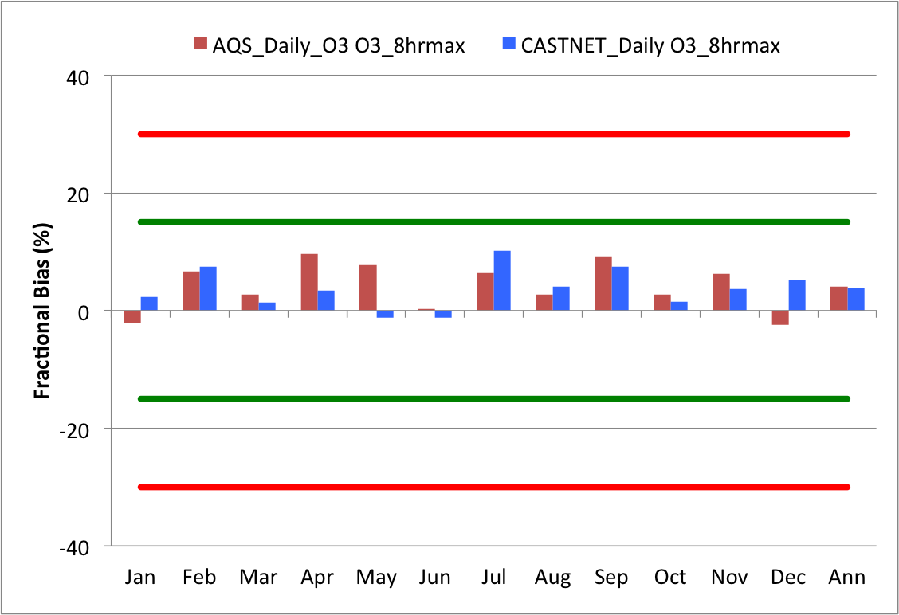

Figure ‑. CAMx mean monthly bias in MDA8 at Colorado AQS (red) and CASTNet (blue) sites.

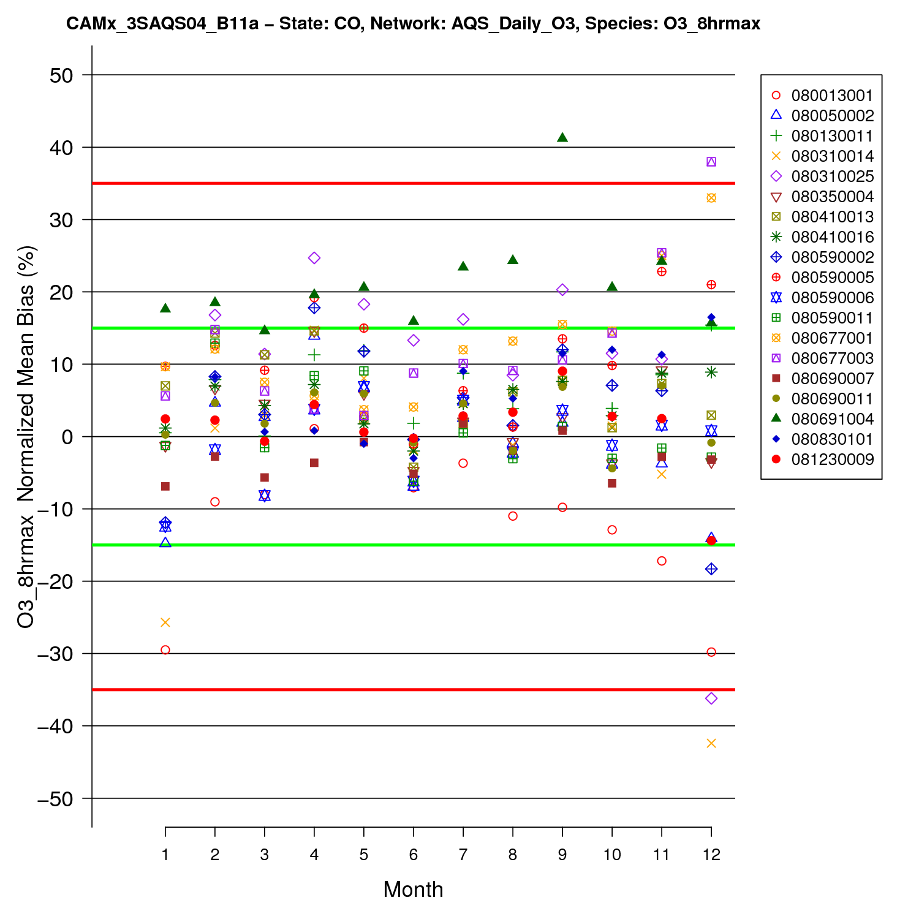

Figure ‑. Colorado AQS site-specific monthly MDA8 NMB performance.

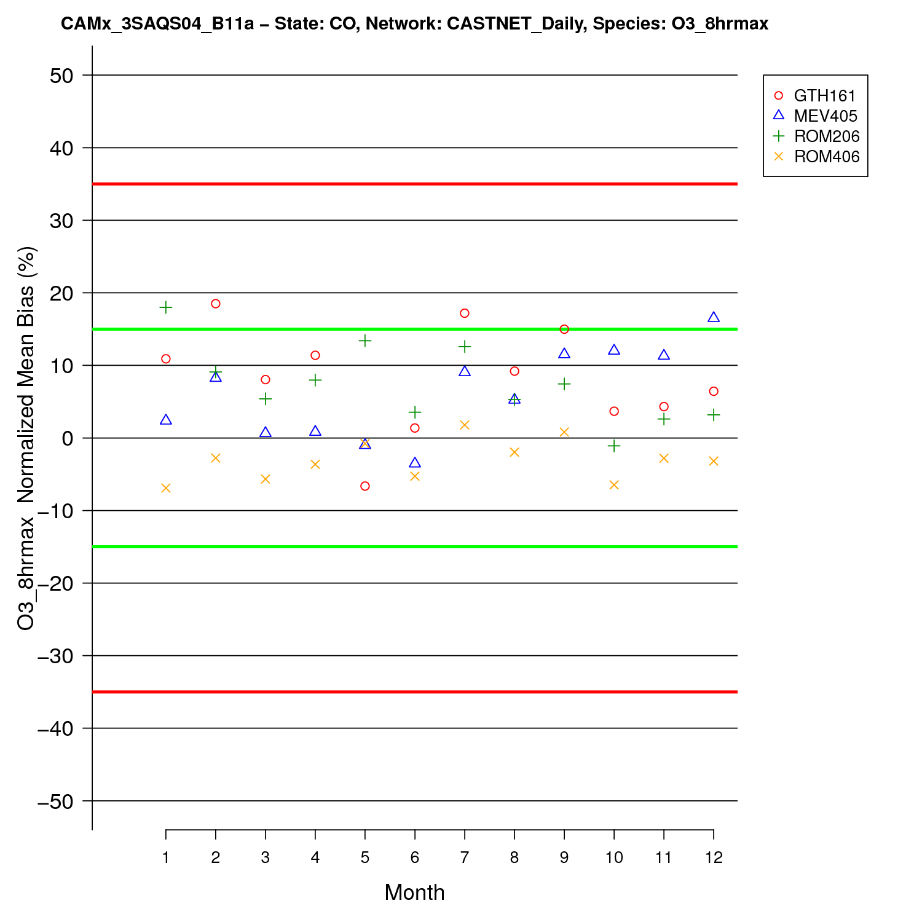

Figure ‑. CO CASTNet site-specific monthly MDA8 NMB performance

|  |  |  |
| --- | --- | --- |
|  | **1-hr Daily Max O3** | **8-hr Daily Max O3** |
| **AQS** |  |  |
| **CASTNET** |  |  |

Figure ‑. CAMx 3SAQS 2011 base case monthly model performance for MDA1 (left) and MDA8 (right) O3 for all AQS (top) and CASTNET (bottom) sites in Colorado.

|  |
| --- |
|  |

Figure ‑. Annual 2011 MDA8 O3 time series at the AQS Ft. Collins, CO CSU (FTCO) monitor; 4-km (red) and 12-km (blue) CAMx results

|  |
| --- |
|  |

Figure ‑. Annual 2011 MDA8 O3 time series at the AQS Ft. Collins, CO West (FTCW) monitor; 4-km (red) and 12-km (blue) CAMx results

|  |
| --- |
|  |
|  |
|  |

Figure ‑. January 2011 hourly O3 (top) and NO2 (middle) at the Welby, CO AQS monitor (shown in the bottom Google Earth imagery).

|  |
| --- |
|  |

Figure ‑. Annual 2011 MDA8 O3 time series at the CASTNet Gothic, CO monitor

|  |  |
| --- | --- |
|  |  |
|  |  |

Figure ‑. CAMx 3SAQS 2008 base case monthly model performance for hourly O3 (UL), NO2 (UR), CO (LL), and SO2 (LR) at AQS sites in Colorado.

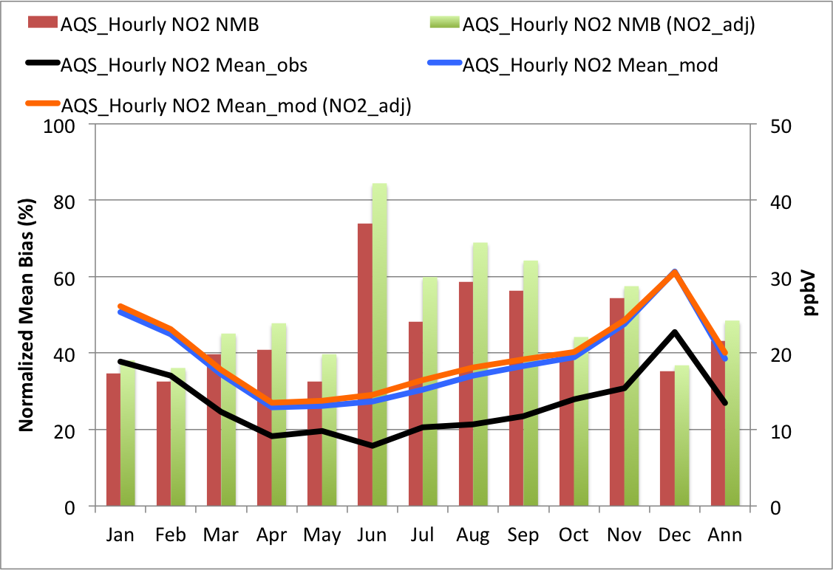

Figure ‑. CAMx 3SAQS 2011 base case monthly mean NO2 NMB and concentrations at AQS sites in Colorado.

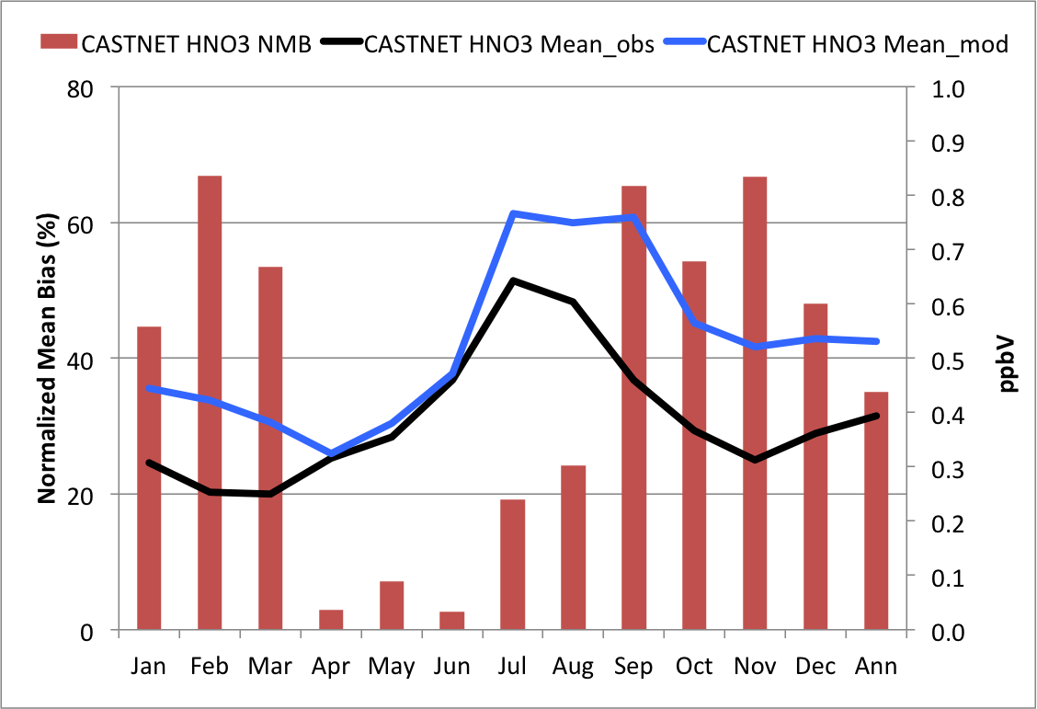

Figure ‑. CAMx 3SAQS 2011 base case monthly mean nitric acid NMB and concentrations at CASTNet sites in Colorado.

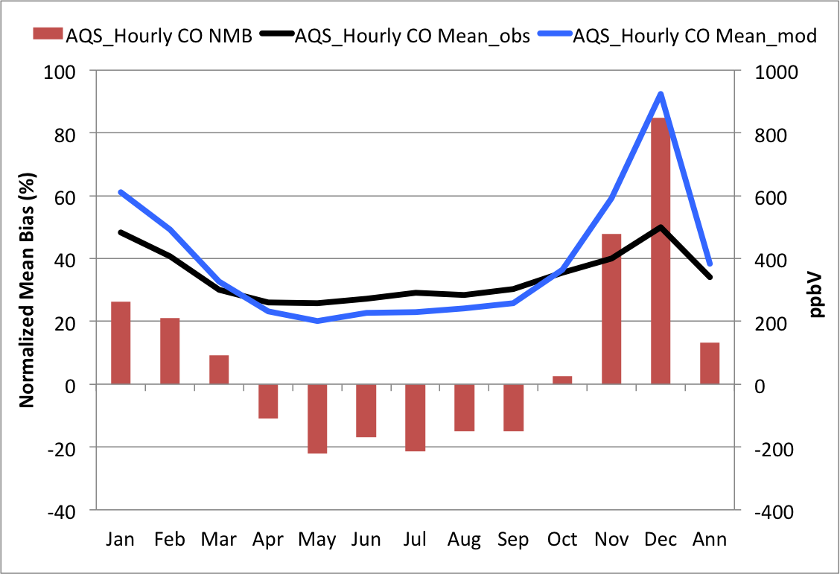

Figure ‑. CAMx 3SAQS 2011 base case monthly mean carbon monoxide NMB and concentrations at AQS sites in Colorado.

|  |  |
| --- | --- |
|  |  |

Figure ‑. CAMx 3SAQS 2011 base case monthly mean SO2 NMB and concentrations at AQS sites (left) and CASTNet sites (right) in Colorado.

|  |  |  |
| --- | --- | --- |
|  |  |  |

Figure ‑. 4-km domain daily total 2011 SO2 emissions from the onroad (left), non-EGU point (middle), and EGU point (right) sectors.

|  |  |
| --- | --- |
|  |  |

Figure ‑. CAMx 3SAQS 2008 base case ozone season (June-August) average diurnal hourly O3 (left) and NOx (right) time series for AQS sites in Colorado.

### Utah Model Performance

The CAMx O3 estimates for Utah are within the bias (NMB: 1.1-7.6%) and error (NME: 8.9-26.4%) performance goals on an annual basis for hourly, MDA1, and MDA8 O3. Table 4‑4 shows the performance metrics for O3 and other gas-phase species at monitoring locations in Utah. Several key points of CAMx model performance for Utah O3 include:

* When comparing the predicted and observed cumulative distributions CAMx has a positive MDA8 bias for concentrations up to about 50 ppb at the AQS monitors and a negative bias for higher MDA8 O3 concentrations. The Q-Q plot in Figure 4‑26 shows that CAMx has particularly strong negative biases (underestimates) at the AQS sites for observed values above 70 ppb. These negative biases are primarily driven by winter O3 episodes in Duchesne and Uintah Counties.
* CAMx shows a similar pattern for MDA8 O3 performance, albeit less extreme biases, at the Utah CASTNet site (Canyonlands), which is not influenced by winter ozone events.
* For daily maximum O3 and MDA8, CAMx performance degrades on days with elevated O3 (>60 ppb) relative to all days and the bias changes signs from positive to negative, but still achieves the ozone performance goals. Figure 4‑27 illustrates that on elevated O3 days CAMx has negative NMB in the range of –6.0% to -13.1% with similar performance between the CASTNet site and the AQS sites.
* With the exception of hourly O3, CAMx performance declines slightly during the ozone season (June-August) relative to the full year at AQS sites. The NMB for MDA8 O3 at the Utah AQS sites is 1.43% for the full year and -1.82% for the ozone season.
* CAMx performance improves during the ozone season for all hourly and daily O3 species at the CASTNet site.

The CAMx monthly and seasonal O3 performance at the AQS and CASTNet sites is shown in Figure 4‑28 through Figure 4‑31. The biases at the AQS sites are low during the first three quarters of the year. The O3 performance goal of ±15% is exceeded at the AQS sites only in December. CAMx has a low bias (NMB and FB <7.5%) in all months at the CASTNet site except for December. Figure 4‑29 shows monthly mean MDA8 NMB for every Utah AQS site that was active in 2011. Outside of the summer months several sites consistently exceed the bias thresholds that is mainly due to an overestimation bias. Logan #4 (L4: 49005004), Ogden #2 (O2: 490570002), and North Provo (NP: 490490002) have high positive biases in the winter; Myton in Duchesne County (490137011) and Whiterocks in Uintah County (490477002) have high negative biases in January and February. The AQS sites L4 (FB > 60%), NP (FB > 30%), and O2 (FB > 30%) drive the high positive December average bias shown in Figure 4‑28.

Figure 4‑31 displays monthly MDA1 and MDA8 ozone model performance across AQS and CASTNet sites in Utah. With the exception of December, the MDA1 and MDA8 ozone performance achieves the ozone model performance goals for all months for the AQS and CASTNet sites in Utah. In December, the model exhibits an ozone overestimation bias that exceeds the ≤±15% ozone bias performance goal for both the AQS and CASTNet sites in Utah.

Figure 4‑32 shows time series plots of MDA8 and NO2 at the Logan #4 AQS site in Logan, UT. CAMx exhibits positive biases > 15% at this site in January, February, and October through December. CAMx is consistently overestimating the relatively low winter O3 concentrations at this site (e.g. December average observed MDA8 = 19.5 ppbV). The December hourly O3 and NO2 time series plots in Figure 4‑32 reveal multiple issues with the model performance at this site.

* Both CAMx and the observations indicate that this site is VOC limited, which is consistent with its location in a parking lot near roads and shopping centers.
* The model and observations show drastic diurnal profiles for both the O3 and NO2.
* The diurnal and weekday-weekend temporal patterns seen in the observations, and to some extent in the CAMx simulation, reveal this site to be heavily influenced by on-road mobile sources
* While the CAMx 4-km simulation does a better job at capturing the NO2 peaks and the resulting O3 titration than the 12-km simulation, the morning NO2 overestimates in the 4-km domain suggests that the NOx emissions may be too high and/or there is insufficient dilution of the emissions and/or there is subgrid-scale variability in the observed concentrations that cannot be captured by the model using a 4-km grid resolution.
* The observations show more persistent NO2 concentrations following the morning rush hour peak than predicted by the model. The elevated midday NO2 concentrations at this site suppress the observed O3 concentrations. Missing this feature appears to be the primary cause of poor model performance at this site in December (and likely in the other winter months). The NO2 concentrations drop too quickly and drastically in CAMx, allowing the predicted O3 concentrations to build-up through the day. This site may be subject to daytime inversion layers that are driven by topography and snow cover that are not being captured by the model.

The persistence of the daytime observed NO2 concentrations indicate that this site is subject to both elevated NOx emissions and a stable wintertime boundary layer. While CAMx is capturing the high daytime NOx emissions (and possibly overestimating these emissions), it is missing the stability in the boundary layer. The estimated PBL heights are likely too high, diluting the NO2 emissions in the surface layer and limiting O3 titration. As the Logan #4 site is clearly impacted by fine-scale emissions and dynamics features it is not an ideal site to use for a model performance evaluation.

Myton, Utah is a small rural town in the middle of the oil and gas fields in the northeastern part of the state. There is an AQS monitor on the outskirts of town that is located among farms and ranches and is within 5-10 miles of producing natural gas wells in all directions. The Myton monitor is one of the sites with high winter O3 observations that are underestimated by CAMx. Literature on the conditions conducive to winter ozone formation identifies a unique combination of meteorology and chemistry (e.g. Edwards et al., 2014; Petron et al., 2012; Edwards et al., 2013) that is proving to be difficult to reproduce with CTMs. Figure 4‑33 details the January O3 and NO2 model performance at Myton, Utah. The annual time series of MDA8 at the top of Figure 4‑33 illustrates that this is a rural monitor that observes fairly low concentrations (~25-60 ppb) through most of the year. This location experienced one major and five minor high O3 events in January and February 2011. From February 12-16, 2011, the monitor reported consecutive days of MDA8 readings higher than 100 ppb and on February 14, 2011 reported a reading of 124.5 ppb. The Myton monitor observed 12 days in January and 8 days in February with MDA8 concentrations higher than 70 ppb.

The current 3SAQS CAMx configuration does not reproduce any of the elevated O3 concentrations observed at the Myton monitor in January and February 2011. The January NMB for MDA8 O3 at this site misses the performance criteria of -35%. The middle and bottom plots in Figure 4‑33 show the January 2011 hourly O3 and NO2 observations at Myton, UT. While the diurnal behavior of the observations seems to indicate that this area is NOx-limited (i.e. correlated changes in observed NO2 and O3), recent modeling studies on the atmospheric chemistry during winter ozone events in this region suggest VOC-limited conditions (Ahmadov et al., 2014; Edwards et al., 2014). A NOx-limited atmosphere is radical rich from abundant VOC oxidation, but has insufficient NOx to shift the OH/HO2 partitioning towards O3 production. NOx-limited conditions may result from high biogenic VOC emissions in rural areas or in regions impacted by industrial or oil and gas production VOC emissions.

The diurnal behavior in the 3SAQS CAMx simulation is consistent with VOC-limited conditions. The simulated January O3 and NO2 time series in Figure 4‑33 show the signature effects of NOx titration on O3 concentrations. Along with photochemistry, the dynamical and radiative features required for observed high wintertime O3 also impact CAMx performance. A stable surface layer, suppressed mixing heights and sufficient snow cover to enhance albedo and photolysis are observed features of winter O3 conditions that regional meteorology models do not reproduce without significant, targeted configuration enhancements. The poor CAMx performance in January/February 2011 at Myton and the nearby Uintah County site Whiterocks results from a combination of missing or miss-represented oil and gas VOC emissions sources and simulated meteorology data that do not capture the physical conditions that produce high O3 concentrations. Model sensitivities that better simulate the meteorology and emissions to the observed conditions in oil and gas production areas are needed to develop a model that can reproduce winter O3 formation in this region that will be investigated in later stages of the 3SAQS.

Figure 4‑34 shows monthly CAMx performance for hourly O3, NO2, CO, and SO2 at the Utah AQS sites. The hourly AQS model performance shows some distinct seasonal patterns.

* January, February, spring and summer months have the lowest normalized mean bias and errors for O3, although the low biases are the result of compensating positive and negative biases at the individual Utah AQS sites (Figure 4‑29).
* The normalized mean bias for O3 is within the simple bias threshold for the first three quarters of the year.
* As noted previously, the last quarter of the year shows particularly poor O3 performance with biases and error exceeding the performance thresholds. The reason for the poor performance is described above and is due to the influence of population exposure monitors that are impacted by fine scale emissions and dynamical features.
* NO2 is overestimated in all months with biases in the range of 5% to 75%.
* The normalized mean errors for NO2 are high (>40%) in all months.
* The NO2 overestimates are particularly bad in the spring and summer months with biases exceeding 30%.
* CO is moderately underestimated in all months with biases between -5% and -30%.
* The normalized mean errors for CO are high (>50%) in all months.
* SO2 is underestimated in all months other than January with biases between -30% and -65%.
* The normalized mean errors for SO2 are high (>50%) in all months.

Figure 4‑35 through 4-37 provide additional detail on the performance of CAMx in predicting these other gas-phase pollutants. Figure 4‑35 shows monthly NO2 NMB and average concentrations for hourly observations at the Utah AQS monitors. CAMx overestimates NO2 throughout the year, with the largest overestimates in June and July, the months with the lowest observed NO2 concentrations. Despite monthly NMBs that exceed 30% through the middle of the year, CAMx reproduces the seasonal pattern in the observations well. The monthly biases are anti-correlated with the concentrations: months with higher concentrations exhibit lower NMB (and errors). As described in the Colorado MPE section, NO2 measurement artifacts bias the AQS observations high. Adjusting the NO2 concentrations by adding nitric acid and organic nitrate concentrations per Dunlea et al. (2007) exacerbates the positive biases, particularly in the summer months (see NO2_adj labels in Figure 4-34).

Figure 4‑36 shows monthly nitric acid NMB and average concentrations for daily observations at the Utah CASTNet monitor (Canyonlands). CAMx underestimates nitric acid in the summer months (including May), and overestimate it for the rest of the year. The largest biases are in October-December and range from about 40-70%. Like with NOx, CAMx generally reproduces the seasonal pattern in the nitric acid concentrations well.

Figure 4‑37 shows monthly average carbon monoxide (CO) NMB and concentrations for hourly observations at the Utah AQS monitors. CAMx underestimates CO in all months of the year. While CAMx does a decent job at reproducing the seasonal pattern in CO concentrations, it is missing the magnitudes of the observations. The negative biases are possibly due to missing or underestimated regional sources of CO, dilution of the emissions in the 4-km modeling grid cells, or a combination of the two.

Figure 4‑38 presents monthly SO2 NMB and average concentrations at the hourly AQS and daily CASTNet sites in Colorado. The SO2 observations between the more urban AQS and rural CASTNet sites differ on average by about a factor of 5. For all months other than January, CAMx is underestimating SO2 at the AQS sites. While the model follows the observation of elevated SO2 concentrations in January, CAMx predicts concentrations that are about 50% too high in that month. CAMx also fails to capture a summertime bump in concentrations observed by the AQS monitors. Model performance at the Utah CASTNet is very similar to the performance seen in the Colorado CASTNet monitors. CAMx is underestimating SO2 in the spring and overestimating later in the year. Like in Colorado, the predicted SO2 at the Utah CASTNet site appears to follow the temporal pattern of the 4-km domain total EGU emissions (Figure 4‑24). The influence of the Utah SO2 sources, particularly point sources, on the simulated concentrations needs to be investigated further. It appears that the model may be underestimating urban SO2 emissions, possibly from non-EGU point sources, in simulation Base2011a.

Figure 4‑39 shows ozone season (June-August) average diurnal profiles for O3 and NO2 across all AQS sites in Utah. CAMx simulates the diurnal pattern well from the middle of the day to early evening (1100 – 1900); the model exhibits particularly poor performance before sunrise. Counterintuitive to the O3 results, the simulated median NO2 concentrations match the observations from the early morning to midday (0000-1100), the exact opposite of the period of good O3 performance.

Table ‑. Utah ozone and gas-phase species performance indicators

|  |  |  |  |  |  |  |  |  |  |  |  |  |  |  |  |  |  |
| --- | --- | --- | --- | --- | --- | --- | --- | --- | --- | --- | --- | --- | --- | --- | --- | --- | --- |
| Species | Network | | FB | | FE | | MB | | ME | | NMB | | NME | | Mean Obs | | Mean Mod |
|  | | Units | | (%) | | (%) | | (ppb) | | (ppb) | | (%) | | (%) | | (ppb) | (ppb) |
| O3 | AQS Hourly | | 7.52 | | 34.0 | | 2.82 | | 9.84 | | 7.57 | | 26.4 | | 37.2 | | 40.0 |
| CNET Hourly | | 3.08 | | 11.3 | | 1.31 | | 5.33 | | 2.76 | | 11.2 | | 47.5 | | 48.8 |
| AQS MDA1 | | 0.30 | | 13.6 | | -0.60 | | 6.77 | | -1.13 | | 12.9 | | 52.6 | | 52.0 |
| CNET MDA1 | | 1.88 | | 8.8 | | 0.80 | | 4.71 | | 1.51 | | 8.86 | | 53.1 | | 53.9 |
| AQS MDA8 | | 2.97 | | 14.3 | | 0.69 | | 6.28 | | 1.43 | | 13.0 | | 48.1 | | 48.8 |
| CNET MDA8 | | 2.72 | | 9.4 | | 1.23 | | 4.76 | | 2.41 | | 9.33 | | 51.0 | | 52.2 |
| W126 | | -8.53 | | 26.9 | | -1.06 | | 3.18 | | -8.50 | | 25.7 | | 12.4 | | 11.4 |
| O3 > 60 ppb | AQS MDA1 | | -13.80 | | 16.1 | |  | |  | | -12.90 | | 15.1 | |  | |  |
| CNET MDA1 | | -7.27 | | 10.9 | |  | |  | | -6.70 | | 10.3 | |  | |  |
| AQS MDA8 | | -14.40 | | 16.4 | |  | |  | | -13.10 | | 15.1 | |  | |  |
| CNET MDA8 | | -6.61 | | 10.6 | |  | |  | | -6.00 | | 10.0 | |  | |  |
| June-August O3 | AQS Hourly | | 5.52 | | 28.6 | | 2.10 | | 10.03 | | 5.02 | | 23.5 | | 42.9 | | 44.9 |
| CNET Hourly | | 1.83 | | 10.4 | | 1.01 | | 5.56 | | 2.00 | | 10.4 | | 53.2 | | 54.2 |
| AQS MDA1 | | -4.71 | | 12.3 | | -3.06 | | 7.56 | | -4.85 | | 12.2 | | 61.9 | | 58.8 |
| CNET MDA1 | | 0.92 | | 9.4 | | 0.51 | | 5.73 | | 1.07 | | 9.46 | | 60.1 | | 60.6 |
| AQS MDA8 | | -1.83 | | 11.1 | | -1.09 | | 6.23 | | -1.82 | | 11.1 | | 56.5 | | 55.4 |
| CNET MDA8 | | 2.05 | | 9.1 | | 1.24 | | 5.31 | | 2.30 | | 9.24 | | 57.3 | | 58.5 |
| CO | AQS Hourly | | -19.30 | | 56.5 | | -63.70 | | 255.00 | | -14.90 | | 59.8 | | 426.00 | | 363.00 |
| NO2 | AQS Hourly | | 20.90 | | 59.5 | | 2.91 | | 7.97 | | 23.50 | | 64.2 | | 12.40 | | 15.30 |
| SO2 | AQS Hourly | | -67.00 | | 96.9 | | -0.47 | | 1.14 | | -34.30 | | 83.5 | | 1.36 | | 0.90 |
| CNET Hourly | | -0.67 | | 29.0 | | 0.01 | | 0.07 | | 4.33 | | 30.0 | | 0.24 | | 0.25 |
| HNO3 | CNET Hourly | | 9.48 | | 30.8 | | 0.06 | | 0.20 | | 9.24 | | 31.0 | | 0.64 | | 0.70 |

|  |  |
| --- | --- |
|  |  |

Figure ‑. Q-Q plots of CAMx 3SAQS 2011 MDA8 O3 for UT sites in the AQS (left) and CASTNet (right) monitoring networks

|  |  |  |
| --- | --- | --- |
|  | **All Days** | **Days with Obs > 60 ppb** |
| **Daily Max. O3** |  |  |
| **Daily Max. 8-hr Average O3 (MDA8)** |  |  |

Figure ‑. CAMx 3SAQS 2011 base case model performance for MDA1 (top) and MDA8 (bottom) O3 for all AQS (red) and CASTNET (blue) sites in Utah with (right) and without (left) using a 60 ppb observed ozone cut-off threshold.

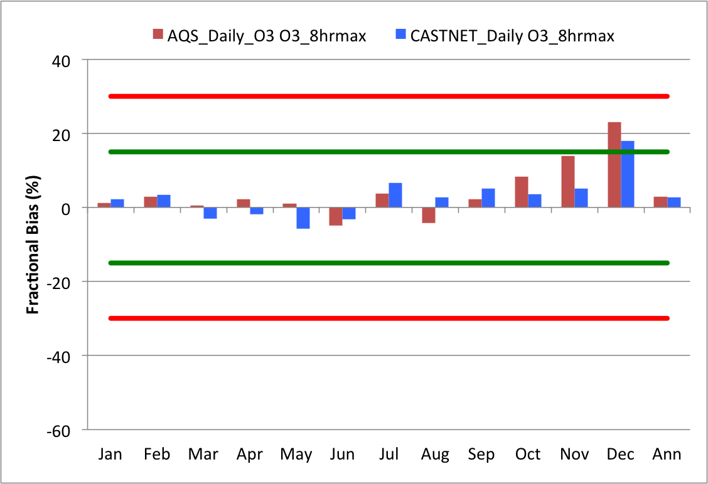

Figure ‑. CAMx mean monthly bias in MDA8 O3 at Utah AQS (red) and CASTNet (blue) sites.

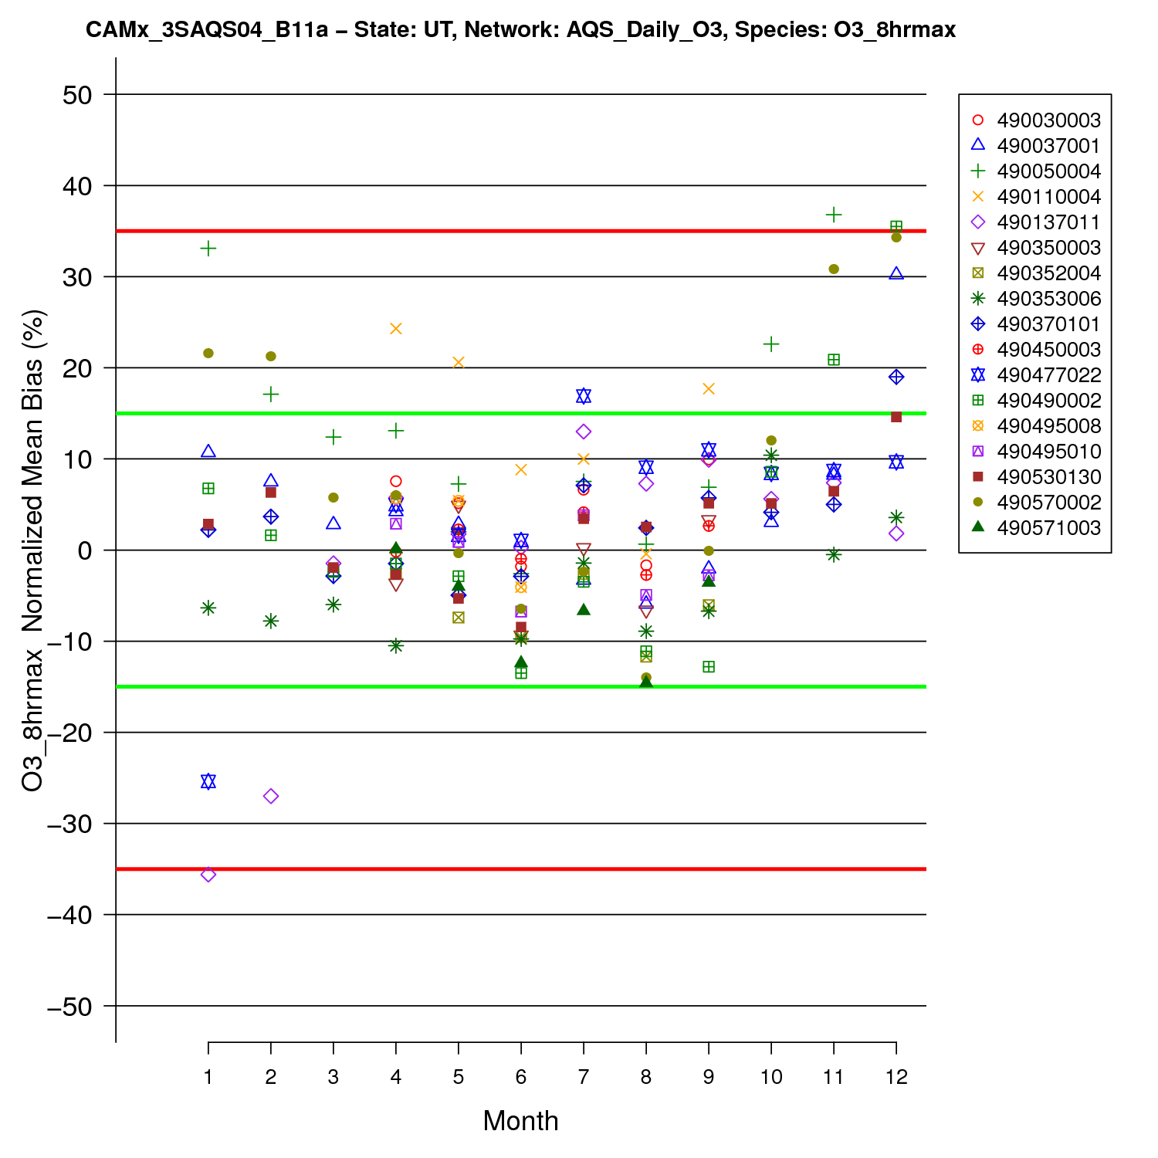

Figure ‑. Utah AQS site-specific monthly MDA8 O3 NMB performance.

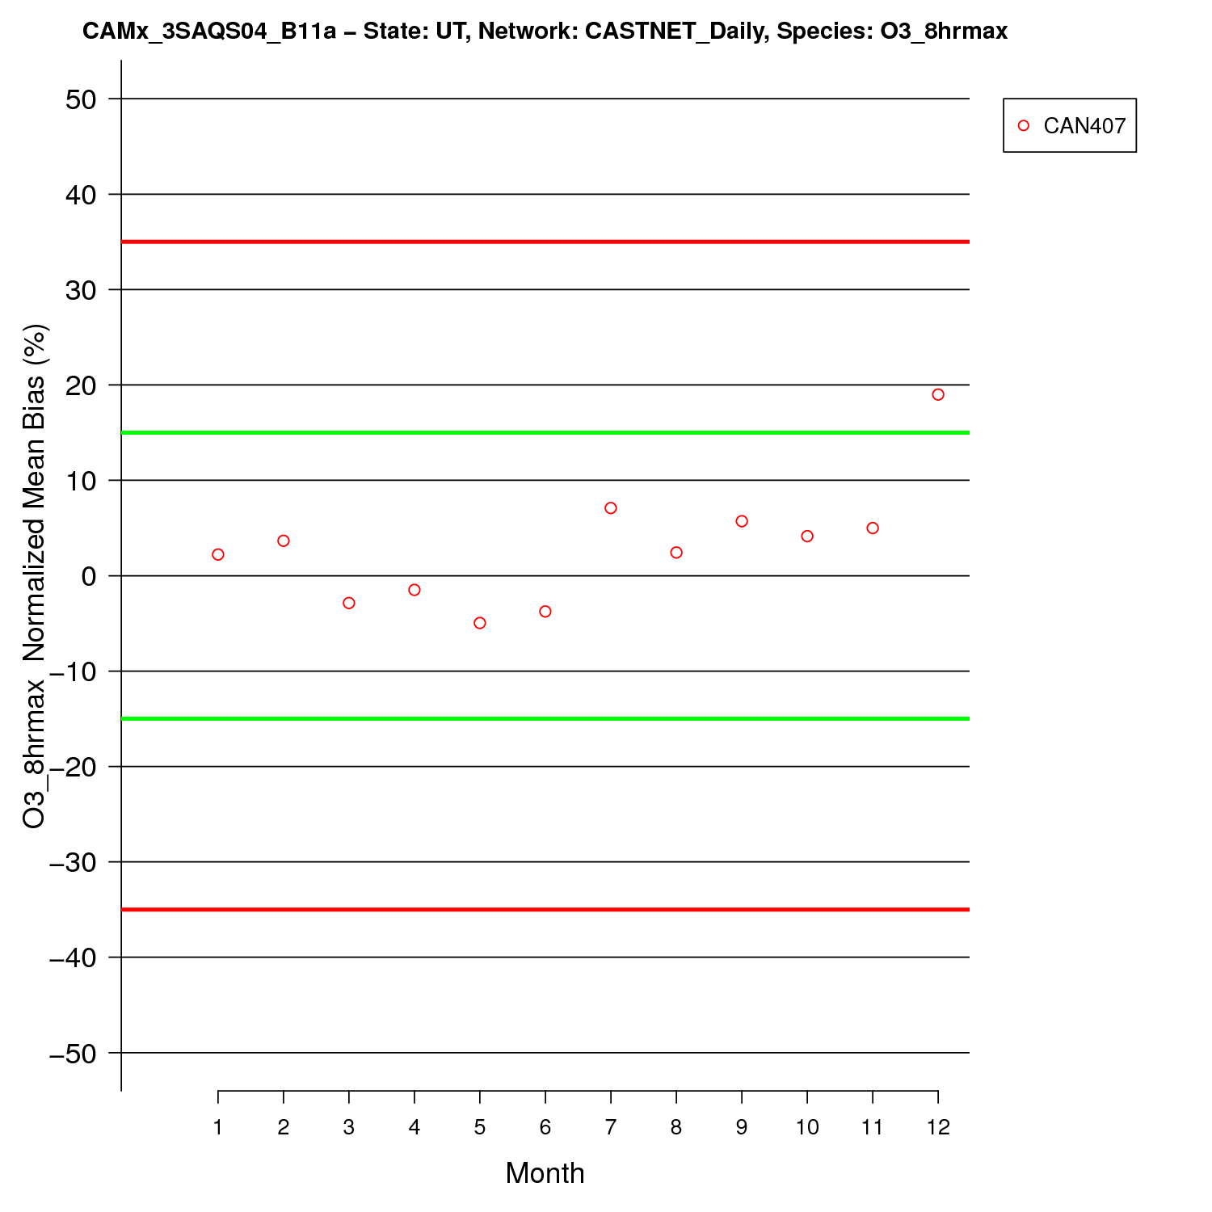

Figure ‑. Utah CASTNet site-specific monthly MDA8 O3 NMB performance.

|  |  |  |
| --- | --- | --- |
|  | **1-hr Daily Max O3** | **8-hr Daily Max O3** |
| **AQS** |  |  |
| **CASTNET** |  |  |

Figure ‑. CAMx 3SAQS 2011 base case monthly model performance for MDA1 (left) and MDA8 (right) O3 for all AQS (top) and CASTNET (bottom) sites in Utah.

|  |
| --- |
|  |
|  |
|  |

Figure ‑. Logan #4 AQS Site annual MDA8 (top), December MDA8 (middle), and December NO2 (bottom) CAMx and observed time series.

|  |
| --- |
|  |
|  |
|  |

Figure ‑. Myton (Duchesne County) AQS Site annual MDA8 (top), January MDA8 (middle), and January NO2 (bottom) CAMx and observed time series.

|  |  |
| --- | --- |
|  |  |
|  |  |

Figure ‑. CAMx 3SAQS 2011 base case monthly model performance for hourly O3 (top left), NO2 (top right), CO (bottom left), and SO2 (bottom right) at AQS sites in Utah.

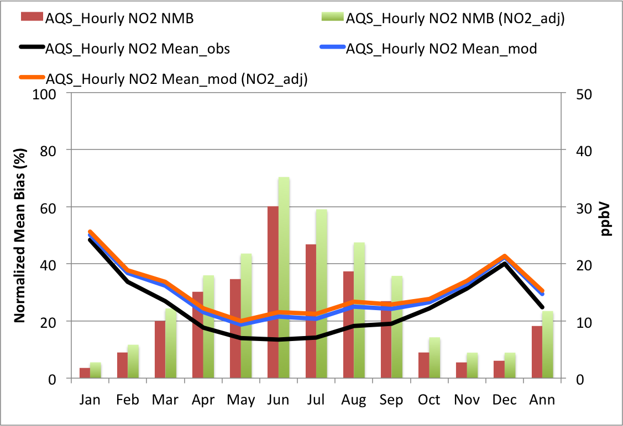

Figure ‑. CAMx 3SAQS 2011 base case monthly NO2 NMB and mean concentrations at AQS sites in Utah.

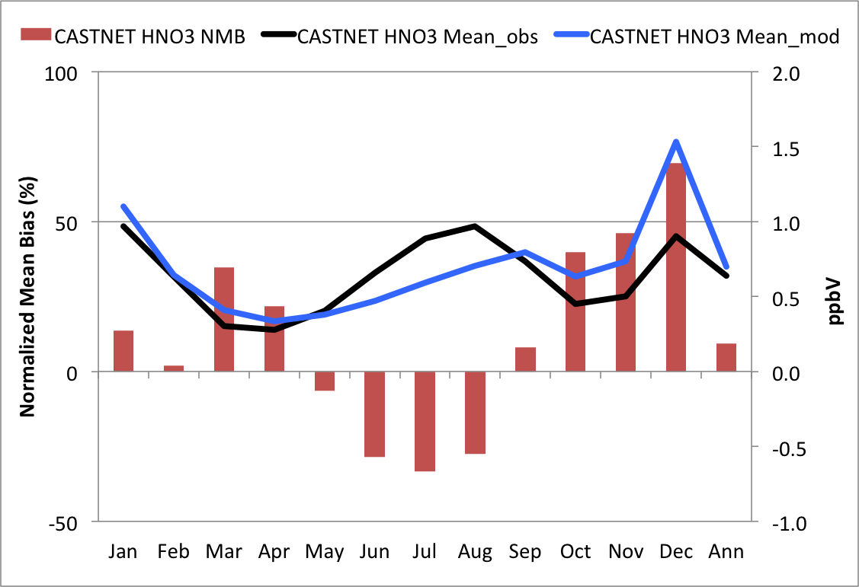

Figure ‑. CAMx 3SAQS 2011 base case monthly mean nitric acid NMB and concentrations at CASTNet sites in Utah.

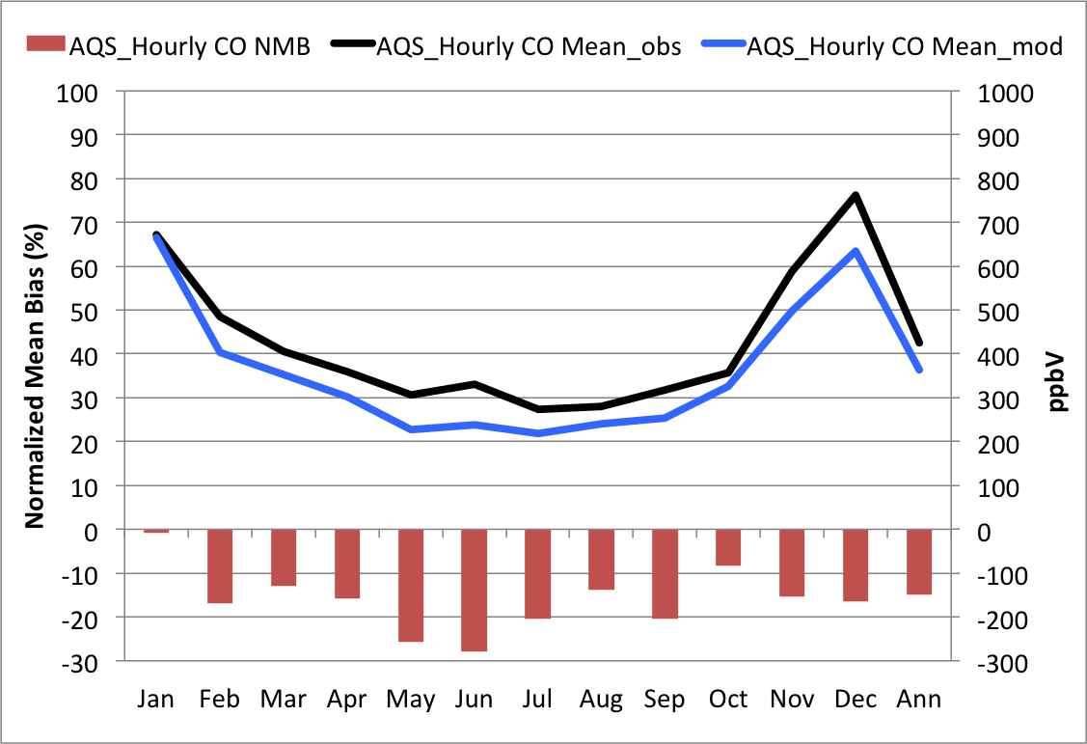

Figure ‑. CAMx 3SAQS 2011 base case monthly mean carbon monoxide NMB and concentrations at AQS sites in Utah.

|  |  |
| --- | --- |
|  |  |

Figure ‑. CAMx 3SAQS 2011 base case monthly mean SO2 NMB and concentrations at AQS (left) and CASTNet (right) sites in Utah.

|  |  |
| --- | --- |
|  |  |

Figure ‑. CAMx 3SAQS 2011 base case ozone season (June-August) average diurnal hourly O3 (left) and NO2 (right) time series for AQS sites in Utah.

### Wyoming Model Performance

The CAMx O3 estimates for Wyoming are within the bias (NMB: 0.36-7.93%) and error (NME: 8.4-18.6%) performance goals on an annual basis for hourly, MDA1, and MDA8 O3. Table 4‑5 shows the performance metrics for O3 and other gas-phase species at monitoring locations in Wyoming. Several key points of CAMx model performance for Wyoming O3 include:

* For the overall daily maximum average O3 (both MDA1 and MDA8) concentrations, CAMx has a positive bias at the Wyoming AQS sites and a negative bias at the Wyoming CASTNet sites.
* Comparisons of cumulative frequency distributions reveals that CAMx has a positive MDA8 bias for concentrations up to about 70 ppb at the AQS monitors and a negative bias for higher MDA8 concentrations. The Q-Q plot in Figure 4‑40 shows that CAMx has a particularly strong negative bias at the AQS sites for observed MDA8 values above about 80 ppb.
* CAMx has positive biases below and negative biases above about 40 ppb at the CASTNet monitors in Wyoming.
* For daily maximum O3 and MDA8, CAMx performance degrades on days with elevated O3 (> 60 ppb) relative to all days and the bias changes signs from positive to negative. Figure 4‑41 illustrates that on elevated O3 days CAMx has negative NMB in the range of 10.0-17.8% with better performance at the CASTNet sites compared to the AQS sites.
* CAMx performance degrades slightly during the ozone season (June-August) relative to the full year at AQS sites. The NMB for daily maximum O3 at the Wyoming AQS sites is 0.32% for the full year and 1.54% for the ozone season. A comparison of this positive biases during the summer months with the Q-Q plot in Figure 4‑40, which shows overall negative biases at higher O3 concentrations, reveals that the elevated O3 concentrations at the Wyoming AQS sites were observed outside of the ozone season.
* CAMx performance improves during the ozone season for hourly O3 and declines for the daily maximum O3 species at the Wyoming CASTNet sites.

The CAMx monthly and seasonal O3 performance at the AQS and CASTNet sites is shown in Figure 4‑42 through Figure 4‑46. With a few exceptions, the CAMx biases are generally lowest during the spring and summer months at the AQS sites and during the summer at the CASTNet sites. CAMx tends to under-predict O3 in winter and spring and over-predict O3 in the summer and fall at both networks. CAMx meets the MDA8 performance goals across both networks in Wyoming for every month. Figure 4‑43 shows monthly mean MDA8 NMB for every active 2011 AQS site in Wyoming. Four sites approach or exceed the ±15% performance threshold at least one month of the year. Performance at the Boulder (560350099) monitor in Sublette County misses the ≤±15% bias threshold in February and March due to a too high underestimation bias. Daniel South (560350100), also in Sublette County about 16 miles northwest of the Boulder monitor, has biases between -10% and -15% in the same months. The underestimation bias at Boulder and South Daniel in February and March is due to the winter ozone events that will be addressed later in the 3SAQS. Two sites in Campbell County in northeast WY exhibit poor or marginal performance. The Thunder Basin monitor (560050123) has a fairly strong negative bias in January and positive bias in November. The Campbell County monitor (560050456) is over-predicted in all months other than January and misses the performance goal in November.

Figure 4-43 displays soccer plots of monthly MDA1 and MDA8 ozone model performance across all Wyoming AQS and CASTNet sites. Although there is a slight overestimation bias in the warmer and underestimation bias in the cooler months, the CAMx ozone model performance achieves the ozone performance goals for all months in Wyoming.

Figure 4‑46 shows annual and February time series plots of CAMx and observed MDA8, hourly O3, and hourly NO2, at the Boulder, WY site. Located in the western foothills of the Wind River Mountain Range among irrigated agricultural land, the Boulder monitor is within 3 miles of the concentrated gas production sites of the Pinedale Anticline. The top plot in Figure 4‑46 shows annual MDA8 observations at the Boulder, WY monitor. Like the Duschene and Uinta Counties, Utah monitors, this site experiences near background O3 concentrations for most of the year. However, in January through March 2011, Boulder observed multiple high winter O3 episodes. On March 2, 2011 the Boulder monitor observed an MDA8 O3 concentration of 123.5 ppb, the highest reading among a total of 13 days in January through February at this site with MDA8 concentrations higher than 70 ppb. Similar trends and concentrations are seen at the nearby Daniel South monitor, indicating that these ozone episodes impacted the entire area around the Jonah-Pinedale Anticline Development (JPAD) area gas fields.

The current 3SAQS CAMx configuration does not reproduce any of the elevated O3 concentrations observed at the Boulder and Daniel South monitors in winter 2011. The February and March NMB for MDA8 O3 at the Boulder site miss the performance goal of -15%. The middle and bottom plots in Figure 4‑46 show the February 2011 hourly O3 and NO2 observations at the Boulder, WY AQS site. Elevated, short duration (1-2 hour) spikes in NO2 concentrations occur just after sunrise on most of the days that experience high O3 concentrations. These NO2 concentration spikes titrate the observed O3 and are followed by rapid rises in O3 concentrations as the NO2 falls off. The high O3 spikes also correspond with moderate rises in observed NO2. CAMx does not simulate the NO2 spikes at either grid resolution and underestimates both the hourly O3 and NO2 at the Boulder and Daniel South monitors. The high concentration, short duration NO2 spikes are an interesting trend at the Wyoming sites that may indicate episodic activity in the NOx emission sources that is not included in the model. As with the gas development regions in Utah, these sites in Sublette County, Wyoming are influenced by a unique combination of meteorology, chemistry, and emissions that the 3SAQS WRF and CAMx modeling platforms are not currently configured to simulate.

Figure 4‑47 shows monthly CAMx performance for hourly O3, NO2, CO, and SO2 at the Wyoming AQS sites. The hourly AQS model performance shows some distinct seasonal patterns.

* The winter and spring months all fall within the ≤±15% bias threshold for hourly O3. The summer and autumn months are all biased high and clustered close to 15% NMB performance goal.
* NO2 is badly overestimated in all months, with the best performance in terms of bias in the last quarter of the year.
* CO is underestimated in all months with data; the CO observations for 2011 are missing for the winter and spring months (and July).
* The normalized mean errors for SO2 are very high (>100%) in all months with all months exceeding the 125% error boundary on the soccer plot.

Figure 4‑48 through Figure 4‑50 provide additional detail on the performance of CAMx in predicting these other gas-phase pollutants. Figure 4‑48 shows monthly NO2 NMB and average concentrations for hourly observations at the Wyoming AQS monitors. The figure shows monthly average NMB overlaid with monthly average model and observed NO2 concentrations. CAMx overestimates NO2 throughout the year, with the largest overestimates in April through June. Despite monthly NMBs that exceed 120% through the middle of the year, CAMx reproduces the seasonal pattern in the observations reasonably well. As described in the Colorado MPE section, NO2 measurement artifacts bias the AQS observations high. Adjusting the NO2 concentrations by adding nitric acid and organic nitrate concentrations per Dunlea et al. (2007) exacerbates the positive biases, particularly in the summer months (see NO2_adj labels in the Figure). The NO2 biases in Wyoming are the highest of the three states.

Figure 4‑49 shows monthly nitric acid NMB and average concentrations for daily observations at the Wyoming CASTNet monitors. CAMx overestimates nitric acid in all months of the year. The largest biases are in October-December and range from about 105-130%. The nitric acid overestimates are consistent with the NO2 performance. The months with the highest NO2 overestimates (April-June) correspond to the months with the lowest nitric acid overestimates.

Figure 4‑50 presents monthly SO2 NMB and average concentrations at the hourly AQS and daily CASTNet sites in Wyoming. The SO2 observations between the more urban AQS and rural CASTNet sites differ on average by about a factor of 4. For all months other than April, CAMx is overestimating SO2 at the AQS sites. CAMx fails to capture a bump in the April SO2 concentrations observed by the Wyoming AQS monitors. At the Wyoming CASTNet monitors CAMx is underestimating SO2 in all months other than November. The influence of the Wyoming SO2 sources, particularly point sources, on the simulated concentrations needs to be investigated further. It appears that the model may be overestimating urban SO2 emissions.

Figure 4‑51 shows ozone season (June-August) average diurnal profiles for O3 and NO2 across all AQS sites in Wyoming. Consistent with the Colorado and Utah diurnal trends, CAMx tends to perform better during the middle of the day (1100 – 1500) than at night for both pollutants, with particularly poor performance before sunrise. The hours of better O3 performance generally correspond to the hours of better NOx performance. Both O3 and NO2 are under-predicted by the model, indicating possible problems with both the emissions inputs and/or mixing during the summer months.

Table ‑. Wyoming ozone and gas-phase species performance indicators

|  |  |  |  |  |  |  |  |  |  |
| --- | --- | --- | --- | --- | --- | --- | --- | --- | --- |
| Species | Network | FB | FE | MB | ME | NMB | NME | Mean Obs | Mean Mod |
|  | Units | (%) | (%) | (ppb) | (ppb) | (%) | (%) | (ppb) | (ppb) |
| O3 | AQS Hourly | 9.95 | 20.2 | 3.11 | 7.29 | 7.93 | 18.6 | 39.2 | 42.3 |
| CNET Hourly | 1.45 | 10.8 | 0.45 | 5.00 | 0.95 | 10.6 | 47.1 | 47.5 |
| AQS MDA1 | 0.32 | 10.7 | -0.18 | 5.57 | -0.36 | 11.0 | 50.5 | 50.4 |
| CNET MDA1 | -1.29 | 9.0 | -0.83 | 4.83 | -1.57 | 9.08 | 53.1 | 52.3 |
| AQS MDA8 | 2.37 | 10.6 | 0.91 | 5.07 | 1.93 | 10.7 | 47.3 | 48.3 |
| CNET MDA8 | -0.39 | 8.3 | -0.33 | 4.27 | -0.64 | 8.37 | 51.0 | 50.6 |
| W126 | 6.72 | 26.4 | 0.54 | 2.81 | 5.30 | 27.9 | 10.1 | 10.6 |
| O3 > 60 ppb | AQS MDA1 | -15.2 | 17.8 |  |  | -14.8 | 17.3 |  |  |
| CNET MDA1 | -10.8 | 12.9 |  |  | -10.0 | 12.2 |  |  |
| AQS MDA8 | -18.9 | 20.2 |  |  | -17.8 | 19.0 |  |  |
| CNET MDA8 | -10.9 | 12.6 |  |  | -10.0 | 11.7 |  |  |
| June-August O3 | AQS Hourly | 16.97 | 22.0 | 5.77 | 8.12 | 14.17 | 19.9 | 40.9 | 46.6 |
| CNET Hourly | 0.67 | 11.7 | 0.05 | 5.72 | 0.21 | 11.3 | 50.8 | 50.8 |
| AQS MDA1 | 1.54 | 8.4 | 0.81 | 4.72 | 1.46 | 8.4 | 56.3 | 57.1 |
| CNET MDA1 | -3.01 | 8.6 | -1.77 | 4.99 | -2.91 | 8.43 | 58.9 | 57.1 |
| AQS MDA8 | 4.18 | 8.8 | 2.16 | 4.64 | 4.15 | 8.8 | 52.6 | 54.8 |
| CNET MDA8 | -1.74 | 7.8 | -1.01 | 4.33 | -1.69 | 7.73 | 55.9 | 54.9 |
| CO | AQS Hourly | -59.1 | 59.4 | -94.1 | 94.70 | -47.3 | 47.6 | 199.0 | 105.0 |
| NO2 | AQS Hourly | 30.50 | 68.7 | 2.87 | 4.03 | 102.0 | 143.0 | 2.81 | 5.68 |
| SO2 | AQS Hourly | -135.0 | 136.0 | 0.34 | 1.48 | 50.20 | 222.0 | 0.67 | 1.00 |
| CNET Hourly | -51.3 | 71.2 | -0.12 | 0.16 | -44.8 | 61.7 | 0.26 | 0.14 |
| HNO3 | CNET Hourly | 46.00 | 52.5 | 0.14 | 0.15 | 59.40 | 64.6 | 0.23 | 0.36 |

|  |  |
| --- | --- |
|  |  |

Figure ‑. Q-Q plots of CAMx 3SAQS 2011 MDA8 for WY sites in the AQS (left) and CASTNet (right) monitoring networks

|  |  |  |
| --- | --- | --- |
|  | **All Days** | **Days with Obs > 60 ppb** |
| **Daily Max. O3** |  |  |
| **Daily Max. 8-hr Average O3 (MDA8)** |  |  |

Figure ‑. CAMx 3SAQS 2011 base case model performance for MDA1 (top) and MDA8 (bottom) O3 for all AQS (red) and CASTNET (blue) sites in Wyoming with (right) and without (left) using a 60 ppb observed ozone cut-off threshold.

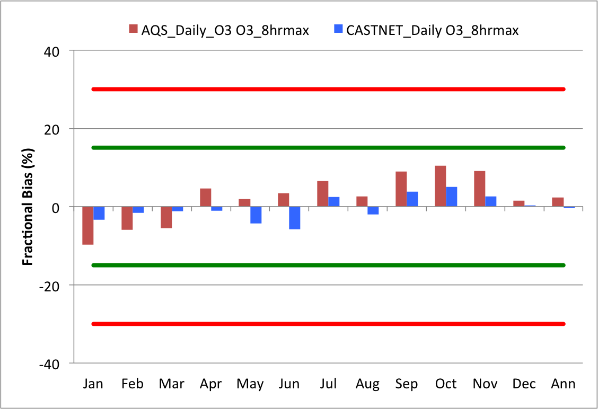

Figure ‑. CAMx mean monthly bias in MDA8 O3 at Wyoming AQS (red) and CASTNet (blue) sites

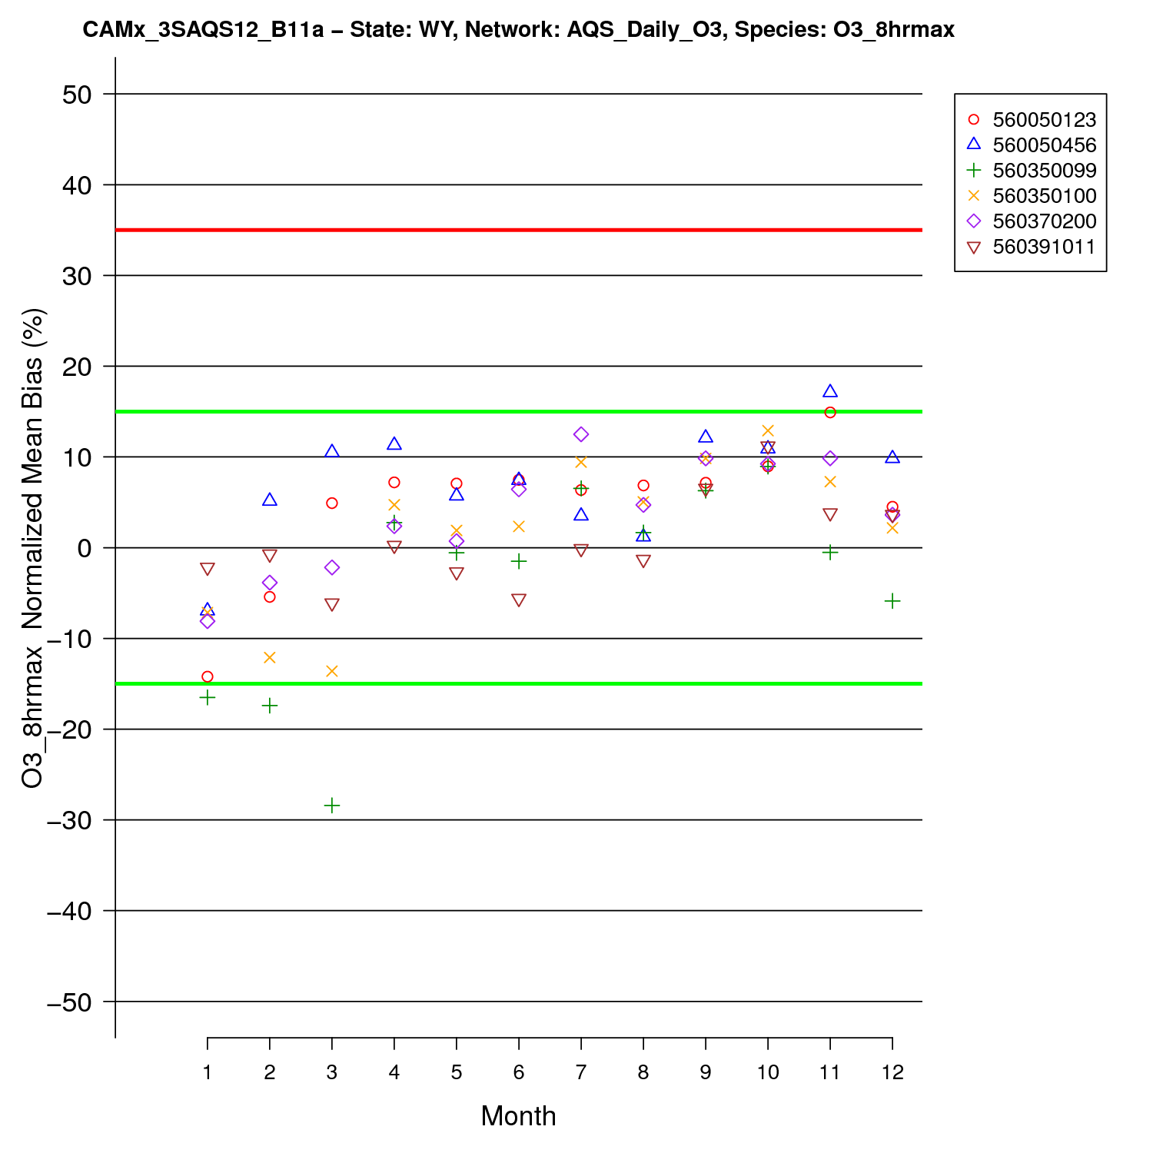

Figure ‑. Wyoming AQS site-specific monthly MDA8 O3 NMB performance.

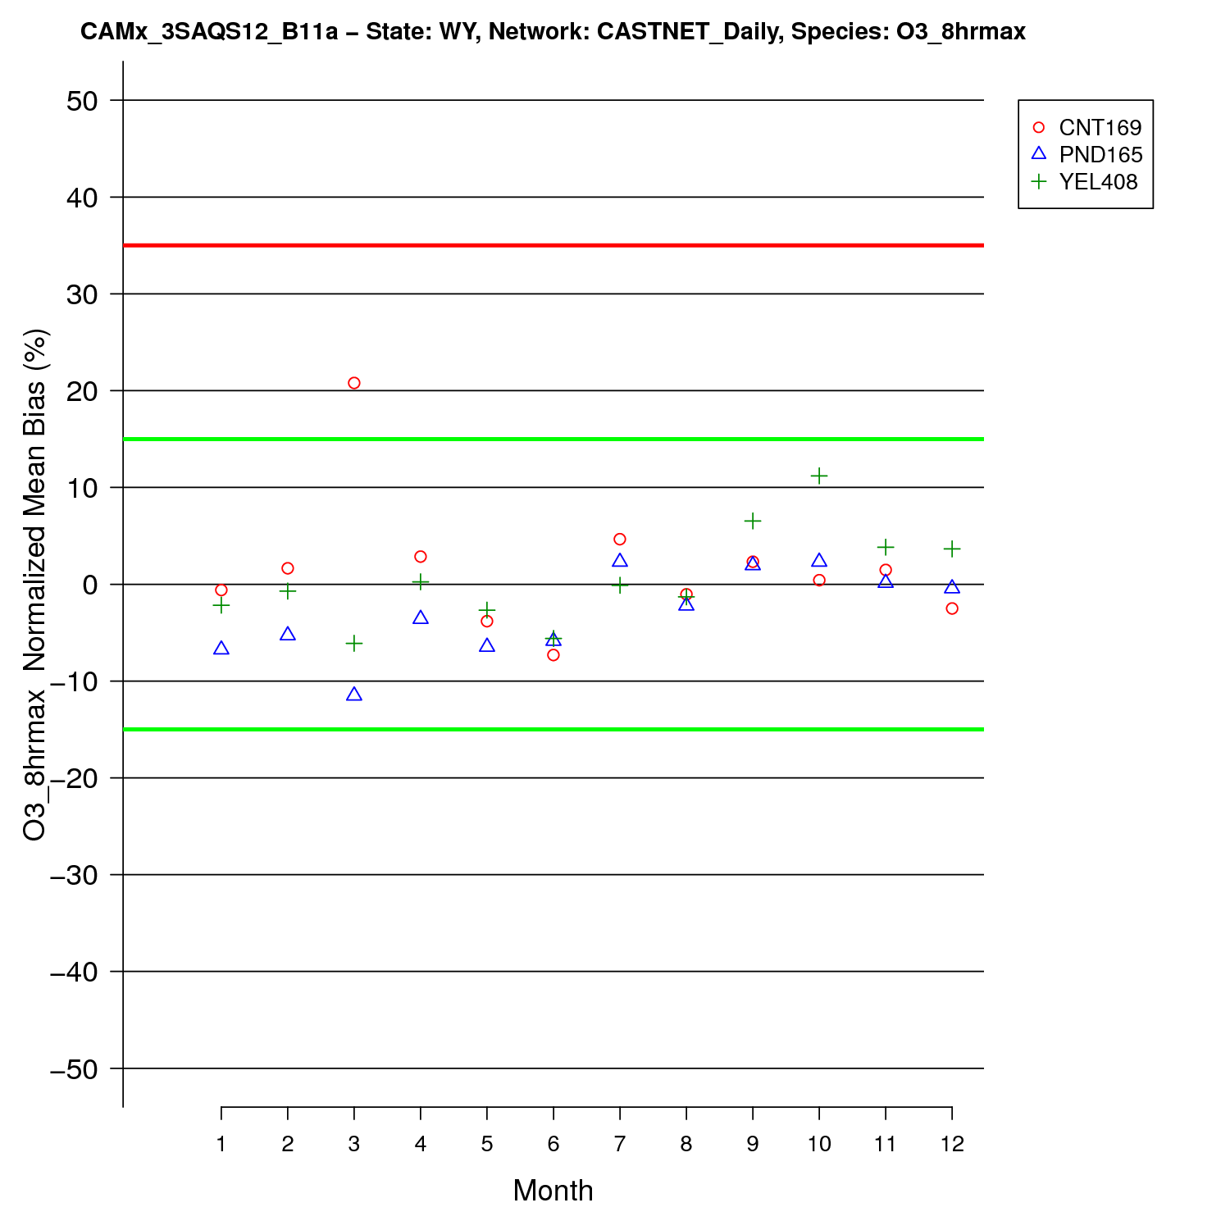

Figure ‑. Wyoming CASTNet site-specific monthly MDA8 O3 NMB performance.

|  |  |  |
| --- | --- | --- |
|  | **1-hr Daily Max O3** | **8-hr Daily Max O3** |
| **AQS** |  |  |
| **CASTNET** |  |  |

Figure ‑. CAMx 3SAQS 2008 base case monthly model performance for MDA1 (left) and MDA8 O3 (right) for all AQS (top) and CASTNET (bottom) sites in Wyoming.

|  |
| --- |
|  |
|  |
|  |

Figure ‑. Annual (top) and February 2011 MDA8 (middle) and NO2 (bottom) time series at the AQS Boulder, WY monitor

|  |  |
| --- | --- |
|  |  |
|  |  |

Figure ‑. CAMx 3SAQS 2011 base case monthly model performance for hourly O3 (top left), NO2 (top right), CO (bottom left), and SO2 (bottom right) at AQS sites in Wyoming.

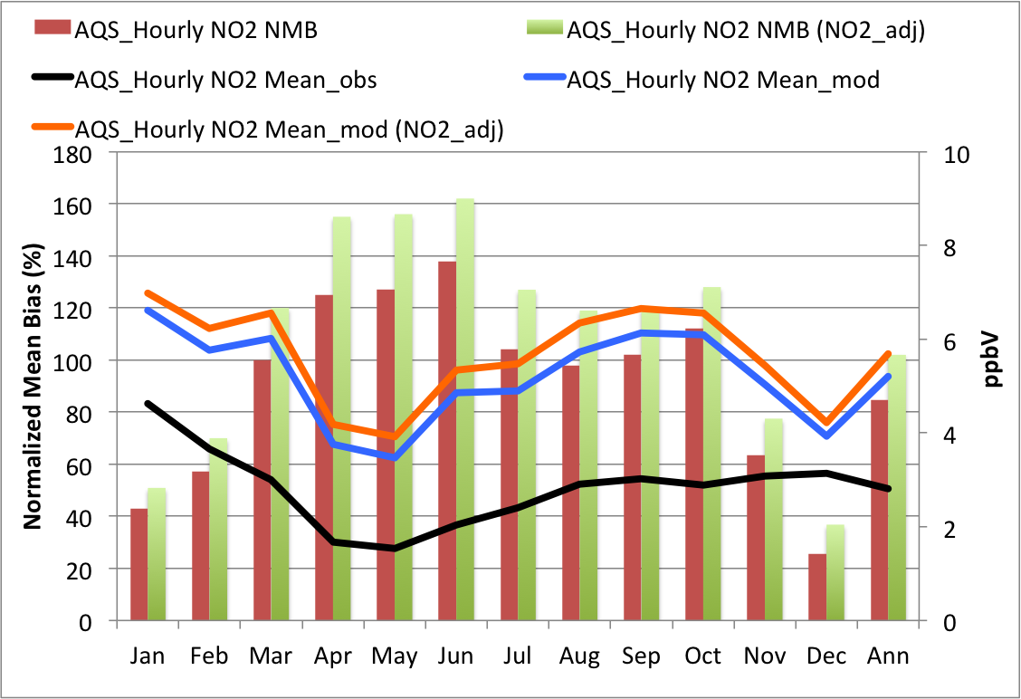

Figure ‑. CAMx 3SAQS 2011 base case monthly NO2 NMB and mean concentrations at AQS sites in Wyoming.

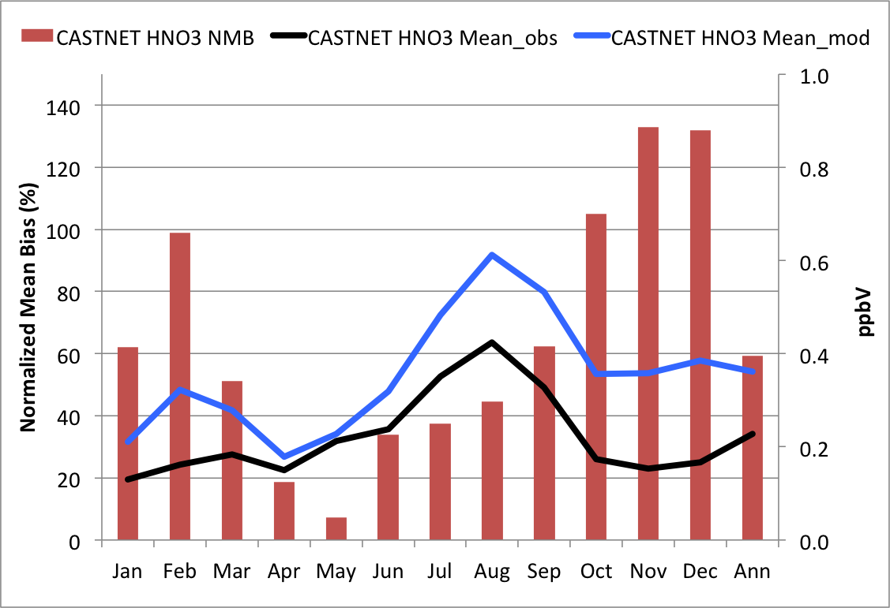

Figure ‑. CAMx 3SAQS 2011 base case monthly mean nitric acid NMB at CASTNet sites in Wyoming.

|  |  |
| --- | --- |
|  |  |

Figure ‑. CAMx 3SAQS 2011 base case monthly SO2 NMB and concentrations at AQS sites (left) and CASTNet sites (right) in Wyoming.

|  |  |
| --- | --- |
|  |  |

Figure ‑. CAMx 3SAQS 2011 base case ozone season (June-August) average diurnal hourly O3 (left) and NO2 (right) time series for AQS sites in Wyoming.

Particulate Matter Model Performance

Table 4‑6 and Table 4‑7 summarize annual particulate matter (PM) performance by monitoring network at all sites in the 12-km and 4-km 3SAQS modeling domains, respectively. These results show that on annual domain-wide basis, CAMx misses the PM performance criteria for bias (≤±60%) and error (≤±75%) for total PM2.5 and organic carbon (OC). CAMx tends to do better at predicting the inorganic species (SO4, NO3, NH4) compared to the organic species (EC, OC). Additional analyses of the spatial, temporal and chemical patterns in the CAMx PM model performance for the 3SAQS base 2011 simulation are shown in this section.

Table ‑. 12-km modeling domain particulate matter species performance indicators

|  |  |  |  |  |  |  |  |  |  |
| --- | --- | --- | --- | --- | --- | --- | --- | --- | --- |
| Species | Network | FB | FE | MB | ME | NMB | NME | Mean Obs | Mean  Mod |
|  | Units | (%) | (%) | (µg/m3) | (µg/m3) | (%) | (%) | (µg/m3) | (µg/m3) |
| SO4 | IMPROVE | 18.70 | 50.40 | 0.05 | 0.35 | 7.08 | 51.20 | 0.67 | 0.72 |
| CASTNET | -3.59 | 38.00 | -0.12 | 0.34 | -12.90 | 37.70 | 0.89 | 0.78 |
| CSN | 11.90 | 47.50 | 0.13 | 0.69 | 10.60 | 55.90 | 1.24 | 1.37 |
| NO3 | IMPROVE | 30.70 | 82.50 | 0.10 | 0.32 | 29.90 | 93.50 | 0.34 | 0.44 |
| CASTNET | -12.10 | 74.10 | -0.05 | 0.32 | -9.06 | 63.90 | 0.51 | 0.46 |
| CSN | -29.90 | 75.30 | -0.36 | 1.08 | -22.10 | 66.30 | 1.63 | 1.27 |
| EC | IMPROVE | 16.00 | 56.70 | 0.06 | 0.12 | 40.60 | 87.20 | 0.14 | 0.19 |
| CSN | 51.40 | 67.10 | 0.69 | 0.82 | 103.00 | 123.00 | 0.67 | 1.36 |
| OC | IMPROVE | -2.63 | 57.70 | 0.12 | 0.59 | 15.60 | 77.10 | 0.77 | 0.89 |
| CSN | 63.70 | 77.60 | 2.46 | 2.88 | 130.00 | 152.00 | 1.90 | 4.36 |
| NH4 | IMPROVE | -15.40 | 51.80 | -0.05 | 0.18 | -14.40 | 51.30 | 0.35 | 0.30 |
| CASTNET | -6.53 | 40.70 | -0.01 | 0.15 | -4.34 | 43.40 | 0.34 | 0.33 |
| CSN | 26.00 | 63.70 | 0.06 | 0.50 | 8.04 | 69.90 | 0.71 | 0.77 |
| PM2.5 | IMPROVE | 50.40 | 62.10 | 7.27 | 9.19 | 71.60 | 90.50 | 10.20 | 17.40 |
| CSN | 61.40 | 71.30 | 3.02 | 3.71 | 77.90 | 95.70 | 3.88 | 6.90 |
| TC | IMPROVE | -6.52 | 56.40 | 0.14 | 1.10 | 9.01 | 72.30 | 1.52 | 1.66 |
| CSN | 60.80 | 73.90 | 3.15 | 3.65 | 123.00 | 142.00 | 2.57 | 5.72 |

Table ‑. 4-km modeling domain particulate matter species performance indicators

|  |  |  |  |  |  |  |  |  |  |
| --- | --- | --- | --- | --- | --- | --- | --- | --- | --- |
| Species | Network | FB | FE | MB | ME | NMB | NME | Mean Obs | Mean  Mod |
|  | Units | (%) | (%) | (µg/m3) | (µg/m3) | (%) | (%) | (µg/m3) | (µg/m3) |
| SO4 | IMPROVE | 20.50 | 51.5 | 0.04 | 0.31 | 6.30 | 54.0 | 0.57 | 0.60 |
| CASTNET | -0.99 | 37.1 | -0.07 | 0.24 | -11.00 | 37.6 | 0.64 | 0.57 |
| CSN | 14.80 | 45.60 | 0.13 | 0.41 | 18.30 | 55.90 | 0.73 | 0.86 |
| NO3 | IMPROVE | 32.70 | 84.3 | 0.05 | 0.26 | 20.80 | 101.0 | 0.26 | 0.31 |
| CASTNET | -9.22 | 72.8 | -0.06 | 0.22 | -18.60 | 69.5 | 0.32 | 0.26 |
| CSN | -51.10 | 74.00 | -0.62 | 0.96 | -41.30 | 63.50 | 1.50 | 0.88 |
| EC | IMPROVE | 17.70 | 58.7 | 0.06 | 0.12 | 46.80 | 95.3 | 0.13 | 0.19 |
| CSN | 52.90 | 66.00 | 0.99 | 1.08 | 151.00 | 164.0 | 0.66 | 1.65 |
| OC | IMPROVE | -1.48 | 59.4 | 0.14 | 0.61 | 19.20 | 84.0 | 0.72 | 0.86 |
| CSN | 83.90 | 94.20 | 3.72 | 3.95 | 272.0 | 289.0 | 1.37 | 5.09 |
| NH4 | IMPROVE | -17.50 | 52.60 | -0.07 | 0.15 | -23.10 | 53.50 | 0.29 | 0.22 |
| CASTNET | -11.50 | 38.7 | -0.04 | 0.10 | -18.00 | 41.6 | 0.25 | 0.20 |
| CSN | 8.55 | 54.10 | -0.09 | 0.38 | -15.80 | 63.30 | 0.60 | 0.50 |
| PM2.5 | IMPROVE | 64.10 | 74.2 | 2.91 | 3.67 | 83.40 | 105.0 | 3.49 | 6.41 |
| CSN | 60.80 | 71.90 | 9.31 | 10.70 | 112.00 | 129.00 | 8.33 | 17.60 |
| TC | IMPROVE | -5.68 | 58.2 | 0.17 | 1.12 | 11.70 | 78.5 | 1.43 | 1.59 |
| CSN | 76.00 | 86.10 | 4.69 | 4.97 | 232.00 | 247.00 | 2.02 | 6.71 |

The plots below compare the error and bias statistics of CAMx model performance in comparison to network observations for the base 2011 simulation in the 12-km and 4-km modeling domains over the four seasons: Winter (January, February, and December), Spring (March – May), Summer (June –August) and Fall (September – November). These plots provide an understanding of regional biases in the model relative to the networks, and the possible sources that might contribute to these differences.

Figure 4‑52 displays the fractional bias (FB) percentage over the 12-km domain in PM2.5 in the four seasons. The 12-km simulation is exhibits an overestimation bias in the Northwest in all seasons. In the four corners states in winter spring, and fall. In summer it tends to slightly underestimate PM2.5 in parts of the Southwest and upper Midwest, but performs well overall. Except for slight improvements in specific sites (e.g., South Dakota) these biases are also seen in the 4-km simulation.

|  |  |  |
| --- | --- | --- |
| Winter |  |  |
| Spring |  |  |
| Summer |  |  |
| Fall |  |  |

Figure ‑. Spatial distribution of PM2.5 fractional bias (%) from the 12-km (left) and 4-km (right) simulations

To get a sense of the contributing species, Figure 4‑53 through Figure 4‑57 display FB for SO4, NH4, NO3, EC and OC over the two domains. In these plots, all the inorganic species (SO4, NH4 and NO3) show a negative bias over the Southern half of the domain in the summer season; the bias is somewhat reduced in spring and fall, and positive in the Northwest. The 4-km domain shows similar biases to those of the 12-km domain in the inorganic species. Slight improvements in the SO4 performance are seen in the Three States and S. Dakota in winter, and in Idaho and Wyoming in the fall, compared to the 12-km simulation. NH4 shows a low bias in almost all seasons in the four corners states, which is most pronounced in summer. The spring low bias in NH4 is not reflected in the NO3 performance in the two domains, both of which show a moderate positive bias domain-wide, except in Southern California and in the southeastern sites. There is also a bias between networks, with CSN and IMPROVE showing opposite biases within the three states. This is further examined on a monthly basis in subsequent figures.

In contrast to the inorganic species, EC concentrations are positively biased in much of the 12-km domain in the winter and spring; the bias changes sign in the other seasons, especially in the southern half of the domain. However, the performance in the four corners states is well within performance criteria in all seasons, and is reflected in the 4-km simulations. OC performance shows a low bias at several monitored sites in the domain in nearly every season in the 12-km domain. The performance improves somewhat in the 4-km domain, especially in the summer, although the greatest underestimation bias is seen in this season in both domains.

Overall, Figure 4‑52 through Figure 4‑57 indicate that the total PM2.5 biases (positive) may have contributions from sulfate, nitrate and EC in winter and spring, and from EC and other PM sources in the fall. Summertime performance is reasonable in both domains, but all species may contribute to some of the summertime underprediction in the Southwest. Sources of other aerosol species, such as dust may also have a role in the spring and fall PM2.5 overpredictions. To better understand these biases, the model perfomance in the 4-km CAMx simulation for CO, UT, and WY is explored further in subsequent sections.

|  |  |  |
| --- | --- | --- |
| Winter |  |  |
| Spring |  |  |
| Summer |  |  |
| Fall |  |  |

Figure ‑. Spatial distribution of SO4 fractional bias (%) from the 12-km (left) and   
4-km (right) simulations.

|  |  |  |
| --- | --- | --- |
| Winter |  |  |
| Spring |  |  |
| Summer |  |  |
| Fall |  |  |

Figure ‑. Spatial distribution of NH4 fractional bias (%) from the 12-km (left) and   
4-km (right) simulations.

|  |  |  |
| --- | --- | --- |
| Winter |  |  |
| Spring |  |  |
| Summer |  |  |
| Fall |  |  |

Figure ‑. Spatial distribution of NO3 fractional bias (%) from the 12-km (left) and   
4-km (right) simulations.

|  |  |  |
| --- | --- | --- |
| Winter |  |  |
| Spring |  |  |
| Summer |  |  |
| Fall |  |  |

Figure ‑. Spatial distribution of ECfractional bias (%) from the 12-km (left) and   
4-km (right) simulations.

|  |  |  |
| --- | --- | --- |
| Winter |  |  |
| Spring |  |  |
| Summer |  |  |
| Fall |  |  |

Figure ‑. Spatial distribution of OCfractional bias (%) from the 12-km (left) and   
4-km (right) simulations.

### Correlations of Model Performance by Season

Figure 4‑58 through Figure 4‑61 show seasonal PM2.5 model performance for winter (January, February, and December), spring (March – May), summer (June –August) and fall (September – November) from the 3SAQS Base2011a 4-km modeling. The figures display the scatter of model-observed correlations for each of the following regions: the 4-km modeling domain and CO, WY, and UT for total PM2.5 against the IMPROVE and CSN networks; note that Figure 4‑61 for WY only displays the correlation of modeled vs. IMPROVE concentrations, as CSN network measurements are not available in that state. Figure 4‑58 shows the model overpredicting observations from both networks in excess of performance criteria (i.e., FB > 60%; FE > 75%) in the 4-km domain, in all seasons other than summer. The overprediction is greatest in the winter at the IMPROVE sites. CAMx PM2.5 performance at both network sites is well within the performance goals in the summer. Figure 4‑59 through Figure 4‑61 show similar results for CO, WY and UT, indicating that the model biases in the three states are representative of the 4-km modeling domain as a whole. The performance at the CSN network sites is as good or better than at IMPROVE sites in UT, CO and the 4-km domain, in most seasons except in the fall.

|  |  |
| --- | --- |
|  |  |
|  |  |

Figure ‑. Modeled-vs.-observed PM2.5 correlation for the 4-km domain in Winter (top left),   
Spring (top right), Summer (bottom left) and Fall (bottom right).

|  |  |
| --- | --- |
|  |  |
|  |  |

Figure ‑. Modeled-vs.-observed PM2.5 correlation for Colorado domain in Winter (top left),   
Spring (top right), Summer (bottom left) and Fall (bottom right).

|  |  |
| --- | --- |
|  |  |
|  |  |

Figure ‑. Modeled-vs.-observed PM2.5 correlation for Utah domain in Winter (top left),   
Spring (top right), Summer (bottom left) and Fall (bottom right).

|  |  |
| --- | --- |
|  |  |
|  |  |

Figure ‑. Modeled-vs.-observed PM2.5 correlation for Wyoming domain in Winter (top left), Spring (top right), Summer (bottom left) and Fall (bottom right).

### Performance Metrics of Monthly PM2.5

In this section we further examine the monthly variability of the performance metrics for PM2.5 and its constituents in the 4-km domain and in the three states. Figure 4‑62 through Figure 4‑73 present the monthly-averaged FB and FE for PM2.5 and its major constituents (SO4, NO3, NH4, EC and OC) for the 4-km domain, CO, WY and UT. The green lines in these figures indicate performance goals, and red lines show the performance criteria. Figure 4‑62 and Figure 4‑63 show the trends of the positive bias in the modeled PM2.5 in the winter months, declining gradually to a summertime low, and a tendency of the bias to build up through the fall; the overestimated bias exceeds performance criteria in the late fall, winter and spring months at the IMPROVE sites in the 4-km domain and the three states, but remains within performance criteria for both networks from June through October. The model predictions of PM2.5 in the summer are within the performance goal everywhere.

In Figure 4‑64 –Figure 4‑69, all the inorganic species show a similar trend to that of PM2.5 with alow bias in the summer months. The model performance is the best for SO4, exceeding the criteria in January and December in Colorado at the CSN sites, and in January in all three states at the IMPROVE sites. The exceedance in December appears to be an outlier and needs further investigation. It can be attributed to the spike in December in the fractional bias of all the inorganic species in Colorado. NO3 shows a positive bias relative to IMPROVE in the 4-km domain and the three states outside of the summer months. It shows a negative bias relative to CSN in all months, with the exception of Colorado in December, when the bias is strongly positive. NO3 is underestimated with strong negative bias at the CSN sites in the summer, with a gradual decrease in the magnitude of the bias through the fall and winter to a springtime minimum. NH4 shows a negative bias relative to IMPROVE observations in the 4-km domain and the three states in most months, and a positive bias relative to CSN in those same months, but stays within the performance goals except in winter. Note that NH4 is not measured at the IMPROVE sites so instead derived NH4 is used in the evaluation assuming that SO4 and NO3 are completely neutralized by NH4. Since this may not be always true, the derived NH4 is an upper bound estimate of actual atmospheric NH4 concentrations and we expect the model to underestimate NH4 at the IMPROVE monitoring sites.

Figure 4‑70 through Figure 4‑73 show a strong positive bias in EC and OC in most months at the CSN sites, the exception being the summer months; the bias exceeds performance criteria in most months. This trend supports previous conclusions that the PM2.5 overestimated bias is likely caused by over-estimates in primary emissions of carbonaceous and other PM species or their precursors, and in rural sources of SO2 and NOx in the late fall and winter. In the case of SO4, NO3 and OC it also indicates a possible role of chemistry and meteorology in the overestimated bias.

|  |  |
| --- | --- |
|  | |
|  |  |
|  |  |

Figure ‑. PM2.5 fractional bias (%) compared to IMPROVE (red) and CSN (blue) observations for 4-km domain (top left), CO (top right), WY (bottom left) and UT (bottom right).

|  |  |
| --- | --- |
|  |  |
|  |  |

Figure ‑. PM2.5 fractional error (%) comparisons as for Figure 4‑62.

|  |  |
| --- | --- |
|  | |
|  |  |
|  |  |

Figure ‑. SO4 fractional bias (%) compared to IMPROVE and CSN observations for 4-km domain (top left), CO (top right), WY (bottom left) and UT (bottom right).

|  |  |
| --- | --- |
|  |  |
|  |  |

Figure ‑. SO4 fractional error (%) comparisons as for Figure 4‑64.

|  |  |
| --- | --- |
|  | |
|  |  |
|  |  |

Figure ‑. NO3 fractional bias (%) compared to IMPROVE and CSN observations for 4-km domain (top left), CO (top right), WY (bottom left) and UT (bottom right).

|  |  |
| --- | --- |
|  |  |
|  |  |

Figure ‑. NO3 fractional error (%) comparisons as for Figure 4‑66.

|  |  |
| --- | --- |
|  | |
|  |  |
|  |  |

Figure ‑. NH4 fractional bias (%) compared to IMPROVE and CSN observations for 4-km domain (top left), CO (top right), WY (bottom left) and UT (bottom right).

|  |  |
| --- | --- |
|  |  |
|  |  |

Figure ‑. NH4 fractional error (%) comparisons as for Figure 4‑68.

|  |  |
| --- | --- |
|  | |
|  |  |
|  |  |

Figure ‑. ECfractional bias (%) compared to IMPROVE and CSN observations for 4-km domain (top left), CO (top right), WY (bottom left) and UT (bottom right).

|  |  |
| --- | --- |
|  |  |
|  |  |

**Figure 4‑71. ECfractional error (%) comparisons as for** Figure 4‑70**.**

|  |  |
| --- | --- |
|  | |
|  |  |
|  |  |

Figure ‑. OCfractional bias (%) compared to IMPROVE and CSN observations for 4-km domain (top left), CO (top right), WY (bottom left) and UT (bottom right).

|  |  |
| --- | --- |
|  |  |
|  |  |

**Figure 4‑73. OCfractional error (%) comparisons as for Figure 4‑72.**

### Monthly Average PM Performance Over the Domain

To better understand the bias vs. error relationships for PM2.5 and its constituents in the 4-km domain and the contributions to these from the three states, the model performance by month for these species are summarized in soccer plots (Figure 4‑74 through Figure 4‑79) across the IMPROVE and CSN sites. Applying the performance goal and criteria for FB and FE from Table 3‑3 to NMB and NME respectively, data points in these plots that are within the box defined by (±30%, 50%) meet or exceed the performance goal, and data points within the coordinates (±60%, 75%) meet or exceed the performance criteria. Even though both networks show good to acceptable performance in the summer months over the whole 4-km domain, poor PM2.5 performance, i.e., performance outside the plot range (±80%, 125%) is seen from November to March. PM2.5 performance is acceptable to good in UT at CSN sites July through September, but in December and January it falls outside the acceptable range, and outside the plot range from late winter to early summer. In general, the urban (CSN) sites with higher PM concentrations show better performance than do the remote sites in CO and UT.

Figure 4‑75 shows that SO4 is a possible contributor to the monthly overestimate bias seen in PM2.5 at urban and rural sites. Figure 4‑76 shows that NO3 is also a possible contributor to the PM2.5 overestimated bias in the spring and fall at IMPROVE sites, including those in CO and UT, but rarely at the CSN sites.Figure 4‑76 and Figure 4‑77 show that the NO3 performance is not well linked to that of NH4 over the 4-km domain. Among the three states NH4 performance is best for the CO and UT IMPROVE sites in the summer and early fall. Figure 4‑77 clearly shows that NH4 contributes little to the PM2.5 overestimated bias, with the exception of the urban Colorado sites in the fall.

Figure 4‑78 shows acceptable performance for EC through most of the year at IMPROVE sites, but shows large positive biases except in the summer at CSN sites in the 4-km domain, with the paired NMB and NME values being outside of the plot range in CO and UT. The emissions magnitudes of primary urban sources of EC (e.g., mobile) should be examined to identify the cause of the high bias.

Figure 4‑79 and Figure 4‑80 show similar performance for OC and OA, with the performance being slightly better overall for OC. The comparisons of Figure 4‑80 against observed OC were made by using a factor of x = 1.57 in the following equation to derive modeled OC from other modeled species:

PM25_OC = POA/x + (SOA1 + SOA2)/2.0 + (SOA3 + SOA4)/1.6 + (SOA5 + SOA6)/1.4 + SOA7/2.1 + (SOPA + SOPB)/2.1

The comparisons of Figure 4‑80 were made by multiplying the observed OC from IMPROVE by 1.8 and that from CSN by 1.4 to obtain the observed OA, and comparing directly against the modeled OA = (POA + SOA1 + SOA2 + SOA3 + SOA4 + SOA5 + SOA6 + SOA7+ SOPA + SOPB).

The three states show a negative bias for OC, but better than acceptable performance in almost all months at IMPROVE sites. The model is positively biased at the CSN sites in the summer, but much higher biases occur in other months, particularly in winter, and fall outside the plot range at these sites; the wintertime errors are not likely to be caused by biomass burning. The chemistry of anthropogenic precursors is more likely to be the cause of the poor performance at CSN sites.

|  |  |  |
| --- | --- | --- |
|  | **IMPROVE** | **CSN** |
| **4-km Domain** |  |  |
| **CO** |  |  |
| **UT** |  |  |
| **WY** |  | **N/A** |

Figure ‑. NME (%) vs. NMB (%) for PM2.5

|  |  |  |
| --- | --- | --- |
|  | **IMPROVE** | **CSN** |
| **4-km Domain** |  |  |
| **CO** |  |  |
| **UT** |  |  |
| **WY** |  | **N/A** |

Figure ‑. NME (%) vs. NMB (%) for SO4

|  |  |  |
| --- | --- | --- |
|  | **IMPROVE** | **CSN** |
| **4-km Domain** |  |  |
| **CO** |  |  |
| **UT** |  |  |
| **WY** |  | **N/A** |

Figure ‑. NME (%) vs. NMB (%) for NO3

|  |  |  |
| --- | --- | --- |
|  | **IMPROVE** | **CSN** |
| **4-km Domain** |  |  |
| **CO** |  |  |
| **UT** |  |  |
| **WY** |  | **N/A** |

Figure ‑. NME (%) vs. NMB (%) for NH4

|  |  |  |
| --- | --- | --- |
|  | **IMPROVE** | **CSN** |
| **4-km Domain** |  |  |
| **CO** |  |  |
| **UT** |  |  |
| **WY** |  | **N/A** |

Figure ‑. NME (%) vs. NMB (%) for EC

|  |  |  |
| --- | --- | --- |
|  | **IMPROVE** | **CSN** |
| **4-km Domain** |  |  |
| **CO** |  |  |
| **UT** |  |  |
| **WY** |  | **N/A** |

Figure ‑. NME (%) vs. NMB (%) for OC

|  |  |  |
| --- | --- | --- |
|  | **IMPROVE** | **CSN** |
| **4-km Domain** |  |  |
| **CO** |  |  |
| **UT** |  |  |
| **WY** |  | **N/A** |

Figure ‑. NME (%) vs. NMB (%) for OA

### Comparisons of PM2.5 Composition in Urban and Rural Sites

To further examine the relative roles of PM species on the total PM2.5, Figure 4‑81 through Figure 4‑84 compare the modeled composition against the PM species observed at IMPROVE and CSN monitors in the 4-km domain and in CO, WY and UT. In these plots, it should be noted that Other PM in the model is calculated as PM2.5 – (SO4 + NH4 + NO3 + EC + OC). Further, NH4 is not available in the IMPROVE observations, and is calculated from SO4, assuming full neutralization. This can lead to an underestimation of NH4 in the model, as this assumption may not hold everywhere.

Figure 4‑81 shows reasonably good agreement in total PM2.5 compared to observations at IMPROVE, but over-prediction at the CSN sites in winter; constituent mass fractions are also in poorer agreement at these sites as compared to IMPROVE. The poorest agreement among the PM constituents is seen in OC and EC in winter, particularly at the CSN sites, with the OC and EC mass fraction being over-predicted by factors of 4 and 3, respectively. The model performance dramatically improves in the summer, when the modeled OC mass fraction is within 5% of CSN, but degrades again to a factor of 3 discrepancy in the fall. EC is also tends to be over-predicted in most seasons at both networks, although EC mass fractions are much smaller than those of OC.

Among the other species, Other PM shows the second highest concentration, and second worst agreement in mass fractions in the 4-km domain. In the spring the model under-predicts this species at the CSN sites. The CAMx Other PM mass fraction is displayed as a negative number in many of the plots, due to the mass being calculated as a difference between PM2.5 and the other constituents. CAMx is in good agreement with IMPROVE observations for Other PM except in summer, when most of the constituents are under-predicted. Other PM concentrations in the spring may be attributable to Asian dust transport; this source should be examined as a potential contributor to the underestimation bias. Other site-specific dust and non-dust sources may contribute to the negative bias in Other PM in the fall, but these underestimations are much more likely to be due to the method of calculating Other PM in CAMx, as they correlate strongly with overestimations in OC.

Overall, despite a wintertime overestimation bias, SO4 exhibits the best agreement with observations, followed by NH4. The underestimates seen in NH4 at IMPROVE sites reflect the earlier discussion about the assumptions on which IMPROVE calculates these concentrations. The NO3 mass fraction is almost always underestimated in the 4‑km domain, with the worst performance at the CSN network sites in the winter. An examination of the gas ratio, namely the molar ratio of free ammonia to nitrate, will help diagnose the chemical regimes and emission sources that could be responsible for this under-prediction.

Figure 4‑81 through Figure 4‑84 indicate that Other PM is the most dominant contributor to the PM mass fraction at the CSN sites except in winter, when OC and NO3 fractions are comparable, or even larger. At the CSN sites, Other PM, along with OC and EC is strongly overestimated bias in CO in winter, while a severe under-prediction of Other PM is seen in winter and spring in UT, and in spring and fall in CO. CAMx tends to under-predict Other PM at CO and WY IMPROVE sites in the winter and over-predict it in the summer. This suggests different sources of Other PM being responsible for the biases in the urban and rural sites.

In summary, in the winter months the predicted PM composition shows the largest discrepancies in CAMx relative to observations, especially at the CSN sites, in large part due to an overestimation bias in OC, and a related underestimation bias in Other PM. The agreement tends to be best in the summer and fall at the IMPROVE sites, with good performance for SO4 and NH4. The pronounced absence of the OC overestimation in summer at the CSN sites suggests an urban semi-volatile VOC (SVOC) source overestimation in all seasons except summer or from a better model of SVOC species partitioning to particles during the warm months. Figure 4‑79 and Figure 4‑80 support the concept that the overestimation bias is worse for OA than for OC. An overestimation of this partitioning would be more pronounced at lower temperatures and would be greater for OA from that for OC (OC is a derived quantity, scaled down from the OA mass as described in Section 4.2.3). The acceptable performance seen for OC at the IMPROVE sites, where the concentrations are low, suggests that different production pathways dominate OC at these sites, as compared to the urban CSN sites. As the 2008 model simulations did not show such high biases in OC, a thorough examination of the SVOC partitioning coefficients and vapor pressures used in CAMx for 2011 vs. 2008 is recommended. The different photochemical mechanisms used in the 2008 (CB05) and 2011 (CB6r2) CAMx simulations should also be investigated as potential sources of difference in modeled OC concentrations and performance between these simulations.

|  |  |  |  |
| --- | --- | --- | --- |
|  | **IMPROVE** | **CSN** |  |
| **Winter** |  |  |  |
| **Spring** |  |  |  |
| **Summer** |  |  |  |
| **Fall** |  |  |  |

Figure ‑. Seasonal average PM2.5 composition comparisons for the 4-km domain

|  |  |  |  |
| --- | --- | --- | --- |
|  | **IMPROVE** | **CSN** |  |
| **Winter** |  |  |  |
| **Spring** |  |  |  |
| **Summer** |  |  |  |
| **Fall** |  |  |  |

**Figure 4‑82. Seasonal average PM2.5 composition comparisons for Colorado.**

|  |  |  |  |
| --- | --- | --- | --- |
|  | **IMPROVE** | **CSN** |  |
| **Winter** |  |  |  |
| **Spring** |  |  |  |
| **Summer** |  |  |  |
| **Fall** |  |  |  |

**Figure 4‑83. Seasonal average PM2.5 composition comparisons for Utah.**

|  |  |  |  |
| --- | --- | --- | --- |
|  |  | **IMPROVE** |  |
|  | **Winter** |  |  |
|  | **Spring** |  |  |
|  | **Summer** |  |  |
|  | **Fall** |  |  |

**Figure 4‑84. Seasonal average PM2.5 composition comparisons for Wyoming.**

Wet Deposition Model Performance

The model performance for wet deposition was examined through comparison against the National Atmospheric Deposition Program (NADP) network measurements. The available measurements are for SO4, NO3 and NH4. Following the approaches of Appel et al (2011), we both normalized the CAMx deposition species to match the observations and we adjusted the model results to account for biases in the modeled precipitation. The normalized CAMx SO4 deposition estimates include 150% of the estimated SO2 deposition (based on the ratio of the molecular weights) because the SO2 is fully oxidized to SO4 in the NADP bucket by the time the measurements are collected. Similarly, the NH4 deposition estimates include 106% of the CAMx NH3 deposition and the NO3 deposition estimates include 98.4% of the CAMx HNO3 deposition. Table A.1 shows the expressions that we used to normalize the CAMx output deposition species with the NADP observations.

To account for the fact that some of the biases in the CAMx deposition estimates are due to biases in the simulated precipitation, we adjusted the CAMx annual and seasonal accumulated deposition results at each NADP monitor by the ratio of the observed to modeled accumulated precipitation over the same period. For example, the Niwot Saddle monitor in Boulder County CO (NADP Site ID CO02) measured 2011 annual total SO4 deposition of 5.3 kg/ha and precipitation of 1774 mm. Over the same period and location the model estimated SO4 deposition of 1.9 kg/ha and precipitation of 822 mm. Applying the precipitation adjustment of 2.16 (obs/model = 1774/822) to the CAMx results yields an adjusted deposition estimate of 4.1 kg/ha. As described by Appel et al (2011) this adjustment does not assume that there is a linear relationship between precipitation and deposition species. Rather that there is a linear relationship between the errors in the simulated precipitation and deposition values. The effectiveness of the adjustment is highly dependent on the precipitation predictions in the model: sites impacted by particularly poor simulated meteorology estimates respond most favorably to the adjustment.

In general the 3SAQS SO4 deposition performance shows the most favorable response (lower bias and error) to the precipitation adjustment, while NO3 and NH4 do not respond as well. These trends are consistent with the results of Appel et al. (2011) and indicate that the biases in NO3 and NH4 performance are strongly influenced by errors in other model parameters. The NO3 performance is likely impacted by poor predictions of lightning NO and NH4 performance by surface NH3 emissions. Additional details of the simulated deposition performance are provided in this section.

Table 4‑8 through Table 4‑11 summarize annual wet deposition performance by monitoring network at all sites in the 12-km 3SAQS modeling domain and at sites in only the states of Colorado, Utah, and Wyoming. All of the wet deposition performance metrics shown here are from the 12-km CAMx modeling results. The performance indicators in these tables include the impacts of the precipitation adjustments described above. On an annual basis, the model is underestimating deposition for all species. Sulfate deposition shows the best performance across all sites in the 12-km domain (NMB: -13.1%), followed by nitrate (NMB: -37.8%) and ammonium (-48.3%). Although model performance in Colorado is the best of the three states, the model is still underestimating deposition at the NADP sites for all species. The coefficients of determination (r2) for each species indicate different performance issues in each of the three states. High r2 values for SO4 and NO3 in Colorado and Wyoming suggest that CAMx is a good model of wet deposition for these species in these states (i.e. it captures the key deposition parameters for these species); bias in one or more of these parameters is causing the model to be biased low. Utah has similarly high r2 values for NH4 and NO3. The low r2 values for NH4 in Colorado and Wyoming and for SO4 in Utah indicate the model is missing or misrepresenting one or more key parameters influencing wet deposition for these species in these states.

The scatter plots in Figure 4‑85 through Figure 4‑90 show the accumulated annual and seasonal wet deposition performance across all NADP sites in the 12-km domain for SO4, NO3, and NH4. Each point on these plots represents the accumulated deposition for an individual NADP monitor. The two sets of points plotted on these figures are the unadjusted deposition estimates (red) and the precipitation adjusted estimates (blue). The important features of these plots include:

* All of these plots show relatively high r2 values for the adjusted model, meaning that CAMx is generally a good model for wet deposition and accounts for a high percentage of the variance in the observations
* For all species and all time periods, the adjusted model produces significant improvements to the r2 value (5%-35% increases), indicating that biases in the modeled precipitation have large impacts on the deposition performance and correcting for these biases improves the outlook of the model performance for deposition
* Large negative biases in the deposition estimates indicate that CAMx is underestimating key parameters in the deposition model. The high r2 values indicate that CAMx includes parameters that explain much of the variance in the observations but biases in these parameters are producing underestimates in predicted deposition fields
* The sulfate deposition model is performing relatively well with seasonal r2 values ranging from 0.75 to 0.9 and NMBs ranging from 1.8% (winter) to -23% (spring).
* The nitrate deposition model has seasonal r2 values that range from 0.59 to 0.85 and NMBs ranging from -32% (fall) to -37% (summer).
* The ammonium deposition model has seasonal r2 values that range from 0.54 to 0.76 and NMBs ranging from -32% (winter) to -55% (summer)

Figure 4‑91 through Figure 4‑93 show observed and CAMx 12-km accumulated monthly wet deposition at all NADP sites in Colorado, Utah, and Wyoming. Inset in each of these plots is the accumulated monthly precipitation performance at the NADP sites. The time series shape of the simulated deposition relative to the observations for the Colorado sites is encouraging. In most months the CAMx predictions follow the trends in the observations. Exceptions include September for SO4, February and May for NO3, and September for NH4. The observations and CAMx results both reflect that the months of low precipitation correspond to the months with low wet deposition. The most obvious flaws in the CAMx predictions of wet deposition in Colorado seen in Figure 4‑91 are the systematic under predictions in all months and the strong negative biases in Spring and Summer. An interesting trend in the observations that is not well represented by CAMx is the spike in NO3 and NH4 in July. Although the model simulates the observed increase in precipitation from June to July, it does not capture the magnitude of the deposition spike seen in the observations.

Figure 4‑92 also shows encouraging trends in the model time series relative to the observations at Utah NADP sites despite fairly severe underestimates in some months. Like in Colorado, CAMx simulates well the corresponding drop in precipitation and wet deposition in June and misses the magnitude of NO3 deposition spikes in July and August. Different from Colorado, the model does not reproduce a rise in precipitation at the Utah sites during these months. CAMx is also missing seasonal SO4 and NH4 deposition spikes during the late fall despite roughly capturing a rise in precipitation during these months.

In Figure 4‑93 the wet deposition performance for the NADP sites in Wyoming shows that the model is both missing the magnitudes and the temporal trends of the observations. With the exception of simulating the timing of observed springtime deposition spikes, CAMx does not simulate spikes observed in other months. With fairly good prediction of the monthly accumulated precipitation, the model is being biased low by underestimates of other deposition parameters.

Further diagnostic evaluation of the model chemistry and emission magnitudes of SO2, NH3 and NOx will be needed to understand the systematic underestimates of wet deposition species by CAMx. Some clues to the deposition performance issues can be found in the evaluation plots of gas-phase SO2 and particulate NO3, NH4, and SO4 in each of the three states. Low or negative biases in predicted particulate NO3, SO4, and NH4 correspond to periods with larger deposition biases. Examples include:

* Summertime particulate SO4 underestimates in Colorado correspond to the period with the highest biases in SO4 deposition (April-August).
* Negative particulate NO3 biases in February, the spring months, and the summer months in Colorado correspond to months with large negative NO3 deposition biases
* Underestimates of particulate NH4 in the spring and summer months at Colorado IMPROVE sites correspond to a period with the largest negative biases in NH4 deposition.
* SO2 is underestimated in all months in Utah
* Particulate SO4 at sites in Utah has the largest negative bias in April, the month with the largest negative bias in SO4 deposition.
* Particulate NO3 and NH4 are underestimated in almost all months at all sites in Utah
* Particulate SO4 is underestimated in the late spring to early summer at WY IMPROVE sites, corresponding with a period of large negative biases in SO4 deposition.

Other trends in the deposition performance are not supported by the performance trends in the PM2.5 species and need additional investigation.

Table ‑. Accumulated annual wet deposition species performance indicators at all NADP sites in the 12-km modeling domain

|  |  |  |  |  |  |  |  |  |  |  |  |
| --- | --- | --- | --- | --- | --- | --- | --- | --- | --- | --- | --- |
| Species | R2 | NMB | NME | | FB | | FE | | Mean Obs | | Mean  Mod |
| Units |  | % | % | % | | % | | kg/ha | | kg/ha | |
| NH4 | 0.71 | -48.3 | 52.0 | -70.2 | | 78.8 | | 1.17 | | 0.61 | |
| NO3 | 0.77 | -37.8 | 39.6 | -57.7 | | 59.7 | | 2.59 | | 1.61 | |
| SO4 | 0.84 | -13.1 | 28.7 | -32.6 | | 46.4 | | 1.97 | | 1.71 | |

Table ‑. Accumulated annual wet deposition species performance indicators at all CO NADP sites (12-km modeling)

|  |  |  |  |  |  |  |  |
| --- | --- | --- | --- | --- | --- | --- | --- |
| Species | R2 | FB | FE | NMB | NME | Mean Obs | Mean  Mod |
| Units |  | % | % | % | % | kg/ha | kg/ha |
| NH4 | 0.38 | -59.4 | 59.4 | -86.3 | 86.3 | 1.08 | 0.44 |
| NO3 | 0.82 | -53.2 | 53.2 | -76.1 | 76.1 | 3.86 | 1.81 |
| SO4 | 0.84 | -33.7 | 34.8 | -49.0 | 50.% | 2.14 | 1.42 |

Table ‑. Accumulated annual wet deposition species performance indicators at all UT NADP sites (12-km modeling)

|  |  |  |  |  |  |  |  |
| --- | --- | --- | --- | --- | --- | --- | --- |
| Species | R2 | FB | FE | NMB | NME | Mean Obs | Mean  Mod |
| Units |  | % | % | % | % | kg/ha | kg/ha |
| NH4 | 0.80 | -72.0 | 72.0 | -126.7 | 126.7 | 0.86 | 0.24 |
| NO3 | 0.94 | -57.2 | 57.2 | -98.4 | 98.4 | 1.64 | 0.70 |
| SO4 | 0.38 | -58.1 | 58.1 | -105.8 | 105.8 | 1.11 | 0.47 |

Table ‑. Accumulated annual wet deposition species performance indicators at all WY NADP sites (12-km modeling)

|  |  |  |  |  |  |  |  |
| --- | --- | --- | --- | --- | --- | --- | --- |
| Species | R2 | FB | FE | NMB | NME | Mean Obs | Mean  Mod |
| Units |  | % | % | % | % | kg/ha | kg/ha |
| NH4 | 0.36 | -67.2 | 67.2 | -103.2 | 103.2 | 0.92 | 0.30 |
| NO3 | 0.95 | -62.9 | 62.9 | -105.6 | 105.6 | 2.50 | 0.93 |
| SO4 | 0.84 | -49.4 | 49.4 | -86.1 | 86.1 | 1.71 | 0.87 |

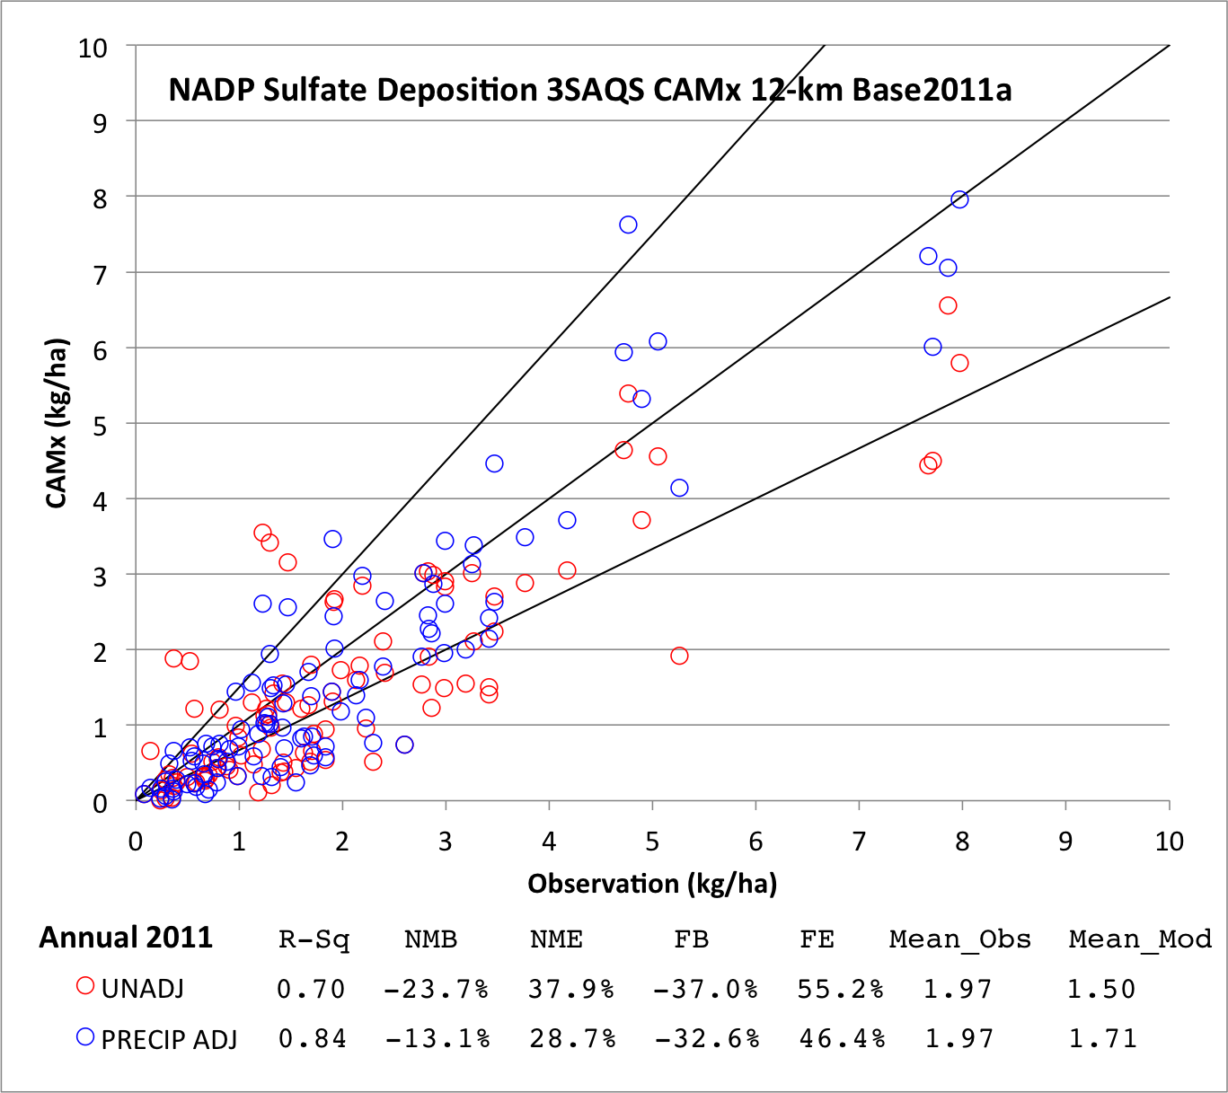

Figure ‑. CAMx 12-km domain accumulated annual sulfate wet deposition model performance

|  |  |
| --- | --- |
| **Winter** | **Spring** |
| **Summer** | **Fall** |

Figure ‑. CAMx 12-km domain accumulated seasonal sulfate wet deposition model performance

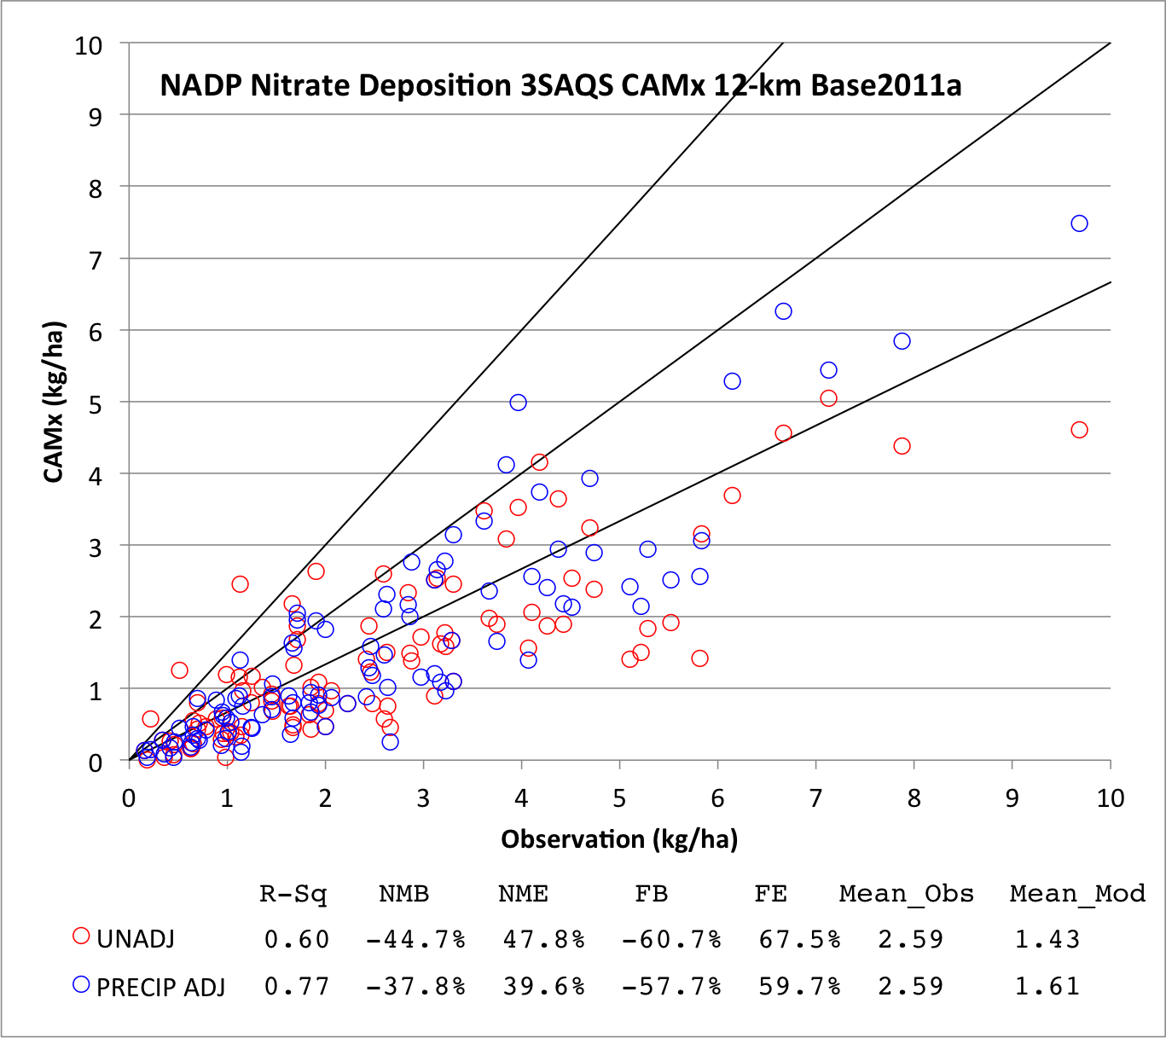

Figure ‑. CAMx 12-km domain accumulated annual nitrate wet deposition model performance

|  |  |
| --- | --- |
| **Winter** | **Spring** |
| **Summer** | **Fall** |

Figure ‑. CAMx 12-km domain accumulated seasonal nitrate wet deposition model performance

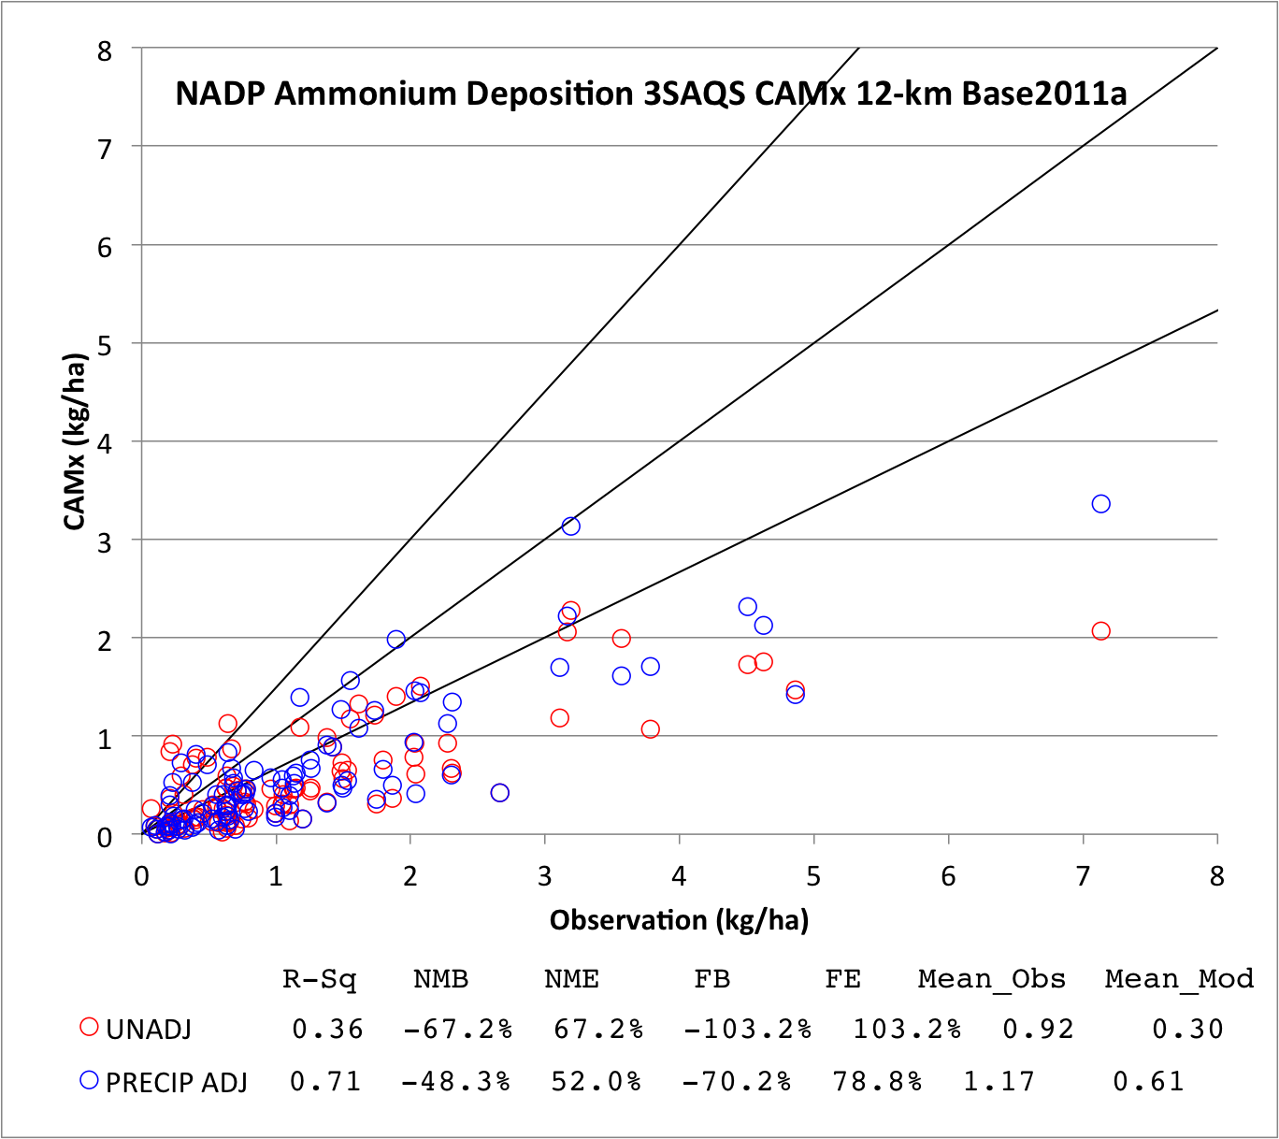

Figure ‑. CAMx 12-km domain accumulated annual ammonium wet deposition model performance

|  |  |
| --- | --- |
| **Winter** | **Spring** |
| **Summer** | **Fall** |

Figure ‑. CAMx 12-km domain accumulated seasonal ammonium wet deposition model performance

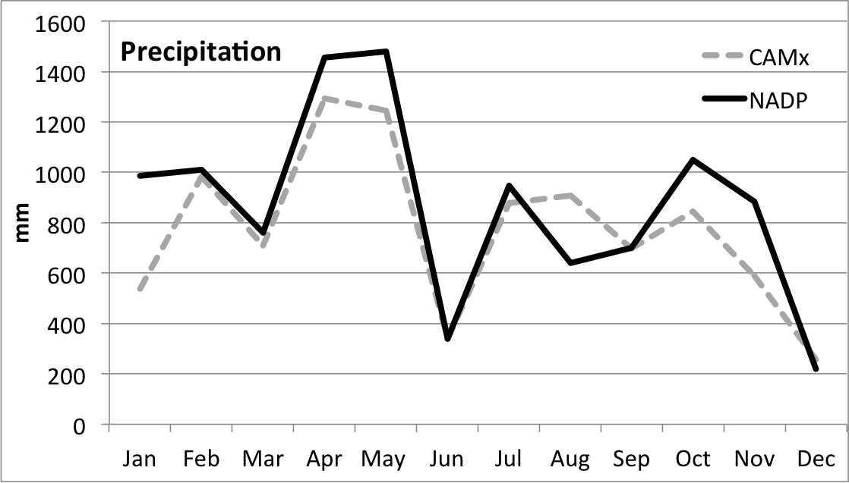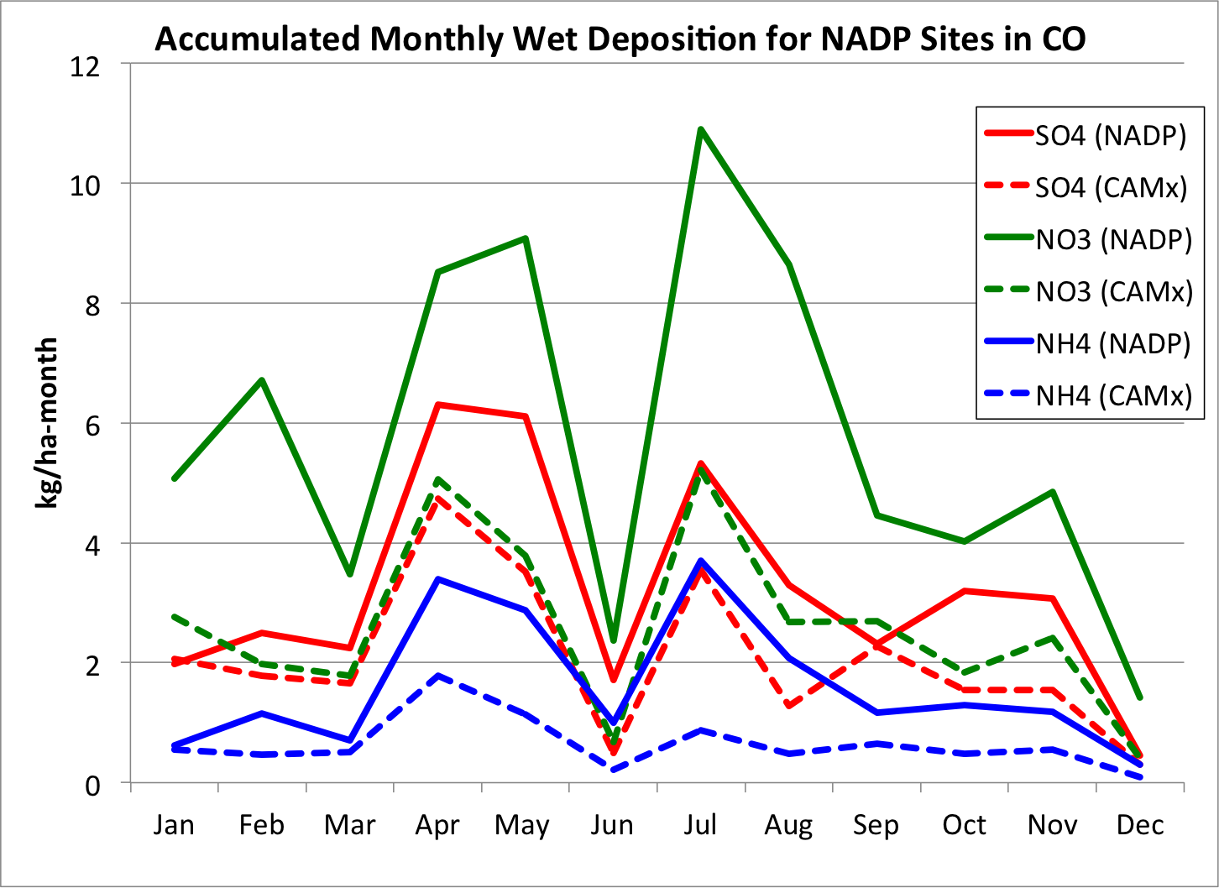

Figure ‑. Accumulated monthly wet deposition performance at NADP sites in Colorado (12-km CAMx).

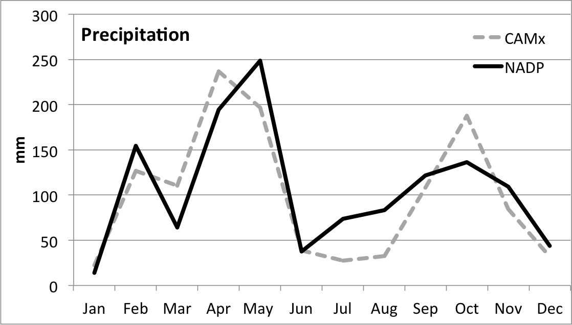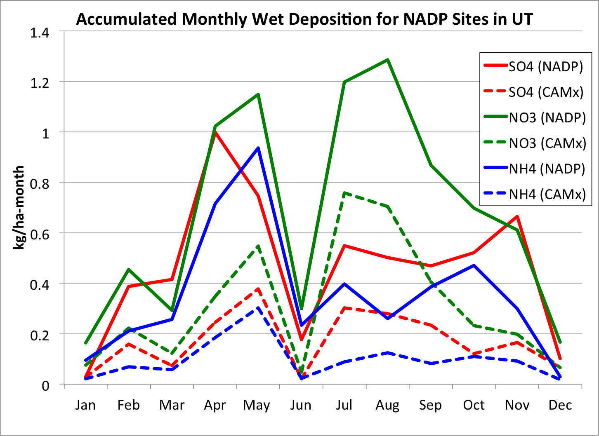

Figure ‑. Accumulated monthly wet deposition performance at NADP sites in Utah (12-km CAMx).

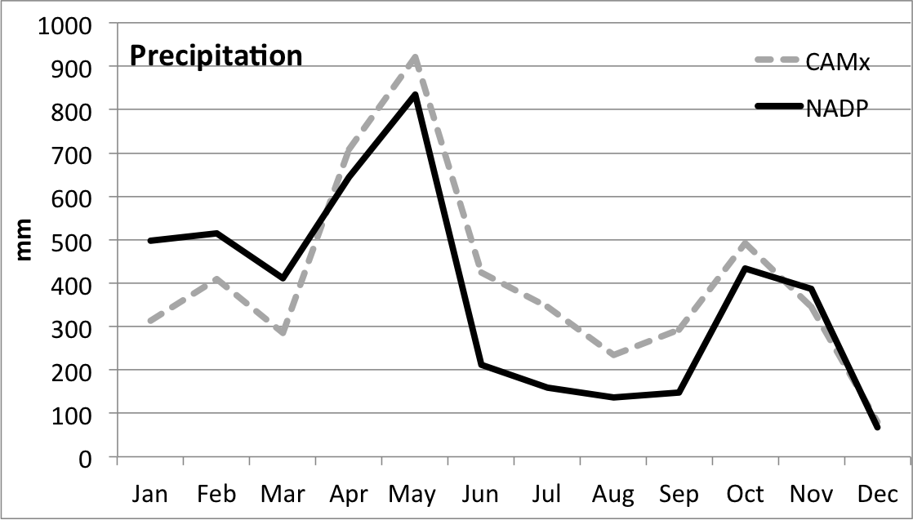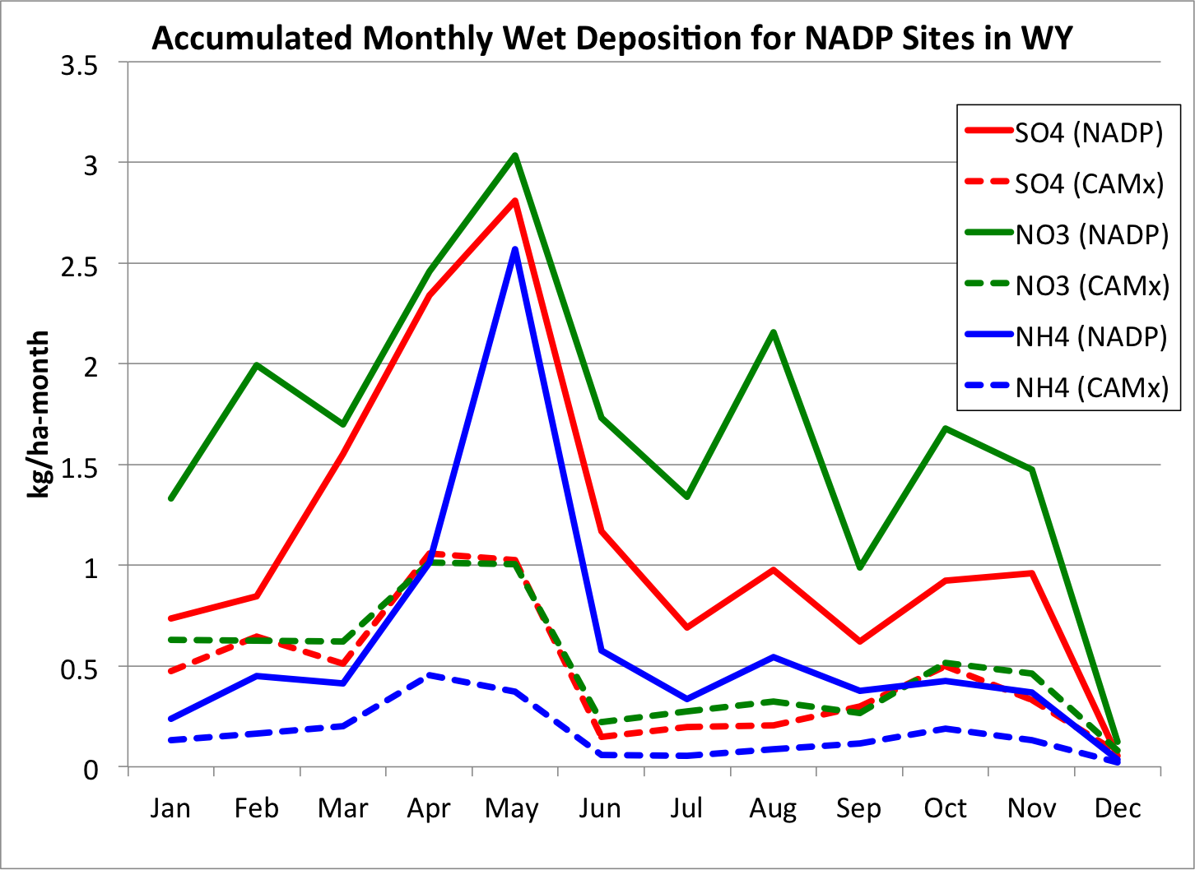

Figure ‑. Accumulated monthly wet deposition performance at NADP sites in Wyoming (12-km CAMx).

Vertical Ozone Model Performance

Vertical profiles of ozone concentrations are collected at three sites in the U.S. using ozonesondes: Trinidad Head, CA; Boulder, CO; and Huntsville, AL. The Boulder site is located in the 4-km 3SAQS domain and the TrinidadHead site is in the 12-km WESTUS domain so the vertical ozone profile comparisons focused on those two sites; the Huntsville site is located in the 36-km CONUS domain and is too far away from the primary areas of interest for this study.

Trinidad Head and Boulder both had approximately 55 days with ozonesonde measurements during 2011. We matched the CAMx vertical ozone profile estimates with the ozonesonde measurements for each sounding by using the CAMx ozone column estimates in the grid cell at the time the ozonesonde was released. That is, there was no attempt to track the horizontal path and the time lag in the ozonesonde measurements in the CAMx 3-D ozone fields as the ozonesonde moved downwind. Since horizontal ozone gradients and temporal changes in ozone are not great in the atmosphere aloft, these assumptions appear to be valid.

### Boulder, Colorado

Figure 4‑94 and Figure 4‑95 compare the observed and predicted vertical ozone profiles over Boulder, CO averaged across all ozonesonde soundings for each season in 2011. The top panel displays the predicted and observed vertical ozone profile, the middle and bottom panels show the Normalized Mean Bias (NME) and Normalized Mean Error (NME) that are compared against the ozone bias (≤±15%) and error (≤35%) performance goals, which are shown by the red lines. The heights of the ozone soundings in these figures are expressed in terms of height above mean sea level (MSL). Since Boulder is a high elevation city, then the lowest sounding is just below 2 km MSL.

In spring, the CAMx vertical ozone estimates match the average observed ozondesonde values within the ≤±15% performance goal from the surface to ~3,500 m above ground level (AGL), albeit with a slight overestimation bias (Figure 4‑94, left). Between 4,000-9,000 m AGL CAMx overestimates the spring average ozonesonde measures by 15% to 30%. At around 10,000 m AGL the CAMx ozone overestimation turns into an underestimation bias that continues to the top of the soundings.

CAMx matches the summer average ozonesonde measurements almost exactly with zero bias from the ground to 2,750 m AGL. From ~3,000 to ~7,000 m AGL there is good agreement between the predicted and observed summary average ozone concentrations (Figure 4‑94, right). From ~8,000 m AGL to ~12,000 m AGL CAMx overestimates the ozonesonde ozone concentrations with bias between 15% and 30%. At approximately 13,000 m AGL, CAMx matches the summer average ozonesonde observations almost exactly (~250 ppb). However, above 13,000 m AGL the observed ozone continues to steadily increase but the CAMx ozone only exhibits a slight additional ozone increase suggesting difficulty in simulating the stratospheric-tropospheric exchange (STE) or possibly the upper troposphere and/or stratospheric ozone is under-represented in the MOZART Boundary Conditions during the summer.

In the fall, CAMx matches the average ozonesonde measurements at Boulder well between the surface and approximately 6,500 m AGL (Figure 4‑95, left). Above 6,500 m AGL CAMx begins to overestimate the ozonesonde observations up to approximately 14,500 m AGL. For example, at 13,500 m AGL CAMx estimates 425 ppb ozone compared to 250 ppb for the ozonesonde. However, at the very highest vertical level CAMx greatly underestimates the ozonesonde observations. For example, at approximately 17,150 m AGL the fall average ozonesonde ozone observation (1,176 ppb) is over a factor of two greater than the CAMx estimate (467 ppb).

With the exception of slight underestimate (-6%) of ozone in the lowest levels of the ozonesonde profile (41 ppb observed vs. 37 ppb model) and underestimating (-40%) the very highest level (1,417 observed vs. 819 ppb model), CAMx estimates higher average ozone in the winter throughout the remainder of the entire vertical ozone profile at Boulder (Figure 4‑95, right). The CAMx winter vertical ozone concentrations are within 15% of the observed values from the surface to ~4,000 m AGL with the overestimation increasing at higher levels. Although at ~10,000 m AGL the observed and predicted average ozone in winter are nearly identical (180 ppb).

|  |  |
| --- | --- |
|  |  |
|  |  |
|  |  |

Figure ‑. Comparison of seasonal average predicted and observed vertical ozone profiles at Boulder, CO for Spring (14 days) and Summer (13 days) 2011.

|  |  |
| --- | --- |
|  |  |
|  |  |
|  |  |

Figure ‑. Comparison of seasonal average predicted and observed vertical ozone profiles at Boulder, CO for Fall (14 days) and Winter (13 days) 2011.

### Trinidad Head, California

The Trinidad Head ozonesonde site is on a peninsula that juts out into the Pacific Ocean in far northern California (north of Eureka/Arcata) away from major urban areas. The predominately westerly winds that impact this site result in ozonesonde measurements of ozone concentrations coming off of the Pacific Ocean and all points west (i.e. East Asia). Thus, the CAMx estimated ozone profiles at Trinidad Head would be primarily defined by the western Boundary Conditions from the MOZART GCM.

Figure 4‑96 and Figure 4‑97 compare the seasonal average predicted and observed vertical ozone profiles at Trinidad Head, CA. During the spring (Figure 4‑96, left), CAMx is predicting ozone concentrations in the lowest 300 m of the atmosphere (~36 ppb) that are up to 30% higher than observed. From ~500 m to ~7,000 m AGL CAMx underestimates the observed ozone concentrations by as much as 20%. Above ~7,000 m AGL the CAMx spring average vertical ozone profile overestimates the observed profile up to the top of the model (~19 km MSL or 50 mb).

The CAMx average summer vertical profile is slightly above the observed values from 0 to ~300 m AGL and then slightly below from ~300 to ~700 m AGL (Figure 4‑96, right). CAMx then matches the observed vertical ozone profile quite well up to approximately 12,000 m AGL where they begin to diverge. At the very highest level (18.5 km AGL) the CAMx ozone (816 ppb) is lower than observed (1,463 ppb).

With the exception of overestimating the observations near the surface (~25 ppb) by 10 ppb, CAMx almost exactly matches the observed vertical ozone profile up to 12,000 m AGL in the fall (Figure 4‑97, left). From ~500 m to ~7,000 m AGL there is extremely good agreement between the predicted and observed ozone concentrations that are mostly within ±5% of each other. Above ~7,000 m AGL the CAMx spring average vertical ozone profile tracks the observed profile well to almost the top of the model (~19 km MSL or 50 mb). There are two ozone soundings above 12,000 m AGL with CAMx (286 ppb) overestimating the observed value (217 ppb) at 14,300 m AGL and underestimating (860 ppb) the observed value (1,160 ppb) at 18,500 m AGL.

In the winter the CAMx ozone in the lowest 500 m at TrinidadHead (35-45 ppb) is approximately 10 ppb higher than observed (25-35 ppb) (Figure 4‑97, right). From ~600 to ~7,000 m AGL there is good agreement between the predicted and observed winter average ozone. Above ~7,000 m AGL the CAMx ozone is higher than observed with the CAMx ozone value at the top sounding at 18.5 km AGL (1,230 ppb) being fairly close to the observed value (1,289 ppb).

|  |  |
| --- | --- |
|  |  |
|  |  |
|  |  |

Figure ‑. Comparison of seasonal average predicted and observed vertical ozone profiles at Trinidad Head, CA for Spring (20 days) and Summer (11 days) 2011.

|  |  |
| --- | --- |
|  |  |
|  |  |
|  |  |

Figure ‑. Comparison of seasonal average predicted and observed vertical ozone profiles at Trinidad Head, CA for Fall (12 days) and Winter (12 days) 2011.

## Comparisons to 3SAQS 2008 CAMx Performance

In this section we compare error and bias statistics between the 3SAQS 2011 and 2008 CAMx simulations. (UNC and ENVIRON, 2014b). All results presented in this section are extracted from the 12-km domain simulations from each project. There are many sources of differences between the 3SAQS 2011 and 2008 CAMx simulations. Implicit in two simulation years are different meteorology, global boundary conditions, and emissions inventories. Each simulation also used a different version of CAMx: version 5.41 for 2008 and version 6.10 for 2011. The only constants between the two simulations were the compiler and computing platform used to build and run the model.

The reason for making this comparison is to provide context for the reliability of the 3SAQS simulations. The comparison may also reveal systematic errors in simulating air quality in the western U.S. that should be diagnosed and corrected in future modeling studies of the region.

### Ozone performance comparison

Table 4‑12 and Table 4‑13 compare the 12-km domain-wide MDA8 performance at the AQS and CASTNet monitors within each of the states of Colorado, Utah, and Wyoming. In almost all cases the 2011 simulation performs better (lower bias and error) than the 2008 simulation for the AQS and CASTNet sites in UT and WY.

Figure 4‑98 compares MDA8 NMB and NME at the AQS sites across the domain and in each of the three states. The red bars in this figure show the 2008 12-km domain performance statistics, the light blue bars show the 2011 12-km domain performance statistics, and the dark blue bars show the 2011 4-km domain performance statistics. Domain-wide the 2008 simulation had lower biases and errors in most months than the 2011 12-km simulation. The 2011 4-km simulation exhibits much better performance than the 12-km domains, indicating that 2011 performance in the three-state region is better than in 2008. The monthly NMB and NME plots for monitors in Colorado, Utah, and Wyoming shown in Figure 4‑98 support this conclusion; in most months both domains of the 2011 simulation exhibit lower bias and error than the 2008 simulation.

Table ‑. 12-km CAMx modeling performance comparison of MDA8 at AQS sites between the 3SAQS Base08b and Base11a simulations

|  |  |  |  |  |  |  |
| --- | --- | --- | --- | --- | --- | --- |
| **State** | **CO** | | **UT** | | **WY** | |
|  | **2008** | **2011** | **2008** | **2011** | **2008** | **2011** |
| NMB (%) | 9.9 | 4.2 | 5.6 | 3.6 | 3.2 | 2.0 |
| NME (%) | 16.1 | 13.8 | 14.5 | 13.4 | 13.9 | 10.7 |
| FB (%) | 11.0 | 4.1 | 7.6 | 5.8 | 3.6 | 2.5 |
| FE (%) | 17.1 | 15.3 | 15.8 | 14.8 | 13.6 | 10.5 |

Table ‑. 12-km CAMx modeling performance comparison of MDA8 at CASTNet sites between the 3SAQS Base08b and Base11a simulations

|  |  |  |  |  |  |  |
| --- | --- | --- | --- | --- | --- | --- |
| **State** | **CO** | | **UT** | | **WY** | |
|  | **2008** | **2011** | **2008** | **2011** | **2008** | **2011** |
| NMB (%) | 6.6 | 3.2 | 2.3 | 1.2 | 3.7 | -0.7 |
| NME (%) | 12.2 | 10.3 | 9.0 | 9.0 | 10.8 | 8.3 |
| FB (%) | 6.4 | 3.3 | 2.2 | 1.5 | 3.6 | -0.5 |
| FE (%) | 11.8 | 10.1 | 8.7 | 9.1 | 10.6 | 8.3 |

|  |  |  |  |
| --- | --- | --- | --- |
|  | | **NMB** | **NME** |
| **Domain-wide** |  | |  |
| **CO** |  | |  |
| **UT** |  | |  |
| **WY** |  | |  |

**Figure 4‑98. AQS site MDA8 normalized mean bias and errors for the 3SAQS 2008 and 2011 CAMx simulations**

### PM Performance Comparison

Table 4‑14 and Table 4‑15 compare the 12-km domain-wide total PM2.5 performance at the IMPROVE and CSN monitors within each of the states of Colorado, Utah, and Wyoming. Note that there are no CSN monitors in Wyoming. The 2011 simulation shows sizeable increases in bias and error in all states at both networks. Total PM2.5 model performance at the more urban CSN sites degrades worse compared to the rural IMPROVE sites.

The IMPROVE site total PM2.5 monthly fractional bias and error comparisons shown in Figure 4‑99 highlight the temporal signal in the performance differences. Similar to the O3 performance comparison plots, the red bars in this figure show the 2008 12-km domain performance statistics, the light blue bars show the 2011 12-km domain performance statistics, and the dark blue bars show the 2011 4-km domain performance statistics. These plots confirm that the 2008 simulation markedly outperforms the 2011 simulation for total PM2.5; the 2011 4-km simulation has the highest bias and errors of three simulations. The sharpest decline in performance in all states occurs in April and May.

Figure 4‑100 through Figure 4‑104 expand on the total PM2.5 comparison by showing performance comparisons of the PM components at all sites in the 12-km domains for the 2008 and 2011 simulations. Key trends in the comparison of the 2008 and 2011 PM model performance include:

* The 2011 simulation shows better performance for SO4 at the CASTNet monitors, and about equivalent performance at the IMPROVE monitors.
* Although 2011 shows lower biases at the CSN monitors, the higher errors in 2011 compared to 2008 indicate compensating biases.
* The 2008 simulation underestimates SO4, while in 2011 the model overestimates SO4, particularly at low concentrations.
* The 2011 simulation shows slightly better NO3 performance at the CSN and CASTNet monitors and worse performance at the IMPROVE monitors compared to 2008.
* The 2011 simulation predicts higher NO3 concentrations than 2008 as indicated by biases that moved in the positive direction for each monitoring network.
* The 2011 simulation shows lower biases but higher errors in NH4 compared to 2008. The NH4 scatter plots shows two distinct sets of observations that are overestimated and underestimated in the 2011 simulation; the 2008 simulation only shows that the higher concentration observations are being underestimated.
* Performance degrades for the carbonaceous aerosols in the 2011 simulation compared to 2008. As with the other PM species, the model performance is dominated by overestimations of the lower concentration observations.

The tendency of the 2011 model to overestimate the carbonaceous PM species reported in Section 4.2.4 is seen in these comparisons between the two simulation years. Additional diagnostic evaluations are needed to understand and mitigate the source(s) of these biases in future iterations of the 2011 3SAQS CAMx simulation.

Table ‑. 12-km CAMx modeling performance comparison of Total PM2.5 at IMPROVE sites between the 3SAQS Base08b and Base11a simulations

|  |  |  |  |  |  |  |
| --- | --- | --- | --- | --- | --- | --- |
| **State** | **CO** | | **UT** | | **WY** | |
|  | **2008** | **2011** | **2008** | **2011** | **2008** | **2011** |
| NMB (%) | 55.6 | 81.3 | 55.9 | 104.0 | 49.2 | 85.1 |
| NME (%) | 76.4 | 95.0 | 68.9 | 112.0 | 80.6 | 102.0 |
| FB (%) | 45.5 | 65.3 | 46.7 | 69.4 | 36.7 | 70.8 |
| FE (%) | 62.9 | 72.0 | 56.2 | 74.9 | 61.9 | 79.2 |

Table ‑. 12-km CAMx modeling performance comparison of Total PM2.5 at CSN sites between the 3SAQS Base08b and Base11a simulations

|  |  |  |  |  |  |  |
| --- | --- | --- | --- | --- | --- | --- |
| **State** | **CO** | | **UT** | | **WY** | |
|  | **2008** | **2011** | **2008** | **2011** | **2008** | **2011** |
| NMB (%) | 42.5 | 142.0 | -6.2 | 71.5 |  |  |
| NME (%) | 63.2 | 151.0 | 45.2 | 96.9 |  |  |
| FB (%) | 34.5 | 62.1 | 2.5 | 52.1 |  |  |
| FE (%) | 52.6 | 69.7 | 44.4 | 96.4 |  |  |

|  |  |  |  |
| --- | --- | --- | --- |
|  | | **NMB** | **NME** |
| **Domain-wide** |  | |  |
| **CO** |  | |  |
| **UT** |  | |  |
| **WY** |  | |  |

Figure ‑. IMPROVE Total PM2.5 fractional bias and errors for the 3SAQS 2008 and 2011 CAMx simulations

|  |  |
| --- | --- |
|  |  |

Figure ‑. 3SAQS CAMx 2008 (left) and 2011 (right) SO4 annual performance summary.

|  |  |
| --- | --- |
|  |  |

Figure ‑. 3SAQS CAMx 2008 (left) and 2011 (right) NO3 annual performance summary.

|  |  |
| --- | --- |
|  |  |

Figure ‑. 3SAQS CAMx 2008 (left) and 2011 (right) NH4 annual performance summary.

|  |  |
| --- | --- |
|  |  |

Figure ‑. 3SAQS CAMx 2008 (left) and 2011 (right) EC annual performance summary.

|  |  |
| --- | --- |
|  |  |

Figure ‑. 3SAQS CAMx 2008 (left) and 2011 (right) OC annual performance summary.

# References

Ahmadov, R., et al. 2014. Understanding high wintertime ozone pollution events in an oil and natural gas producing region of the western US. *Atmos. Chem. Phys. Discuss*., 14, 20295-20343.

Appel, K. W., et al. "A multi-resolution assessment of the Community Multiscale Air Quality (CMAQ) model v4. 7 wet deposition estimates for 2002–2006." *Geoscientific Model Development* 4.2 (2011): 357-371.

Appel, W., R. Gillam, U. Shankar. 2013. Atmospheric Model Evaluation Tool (AMET) v1.2 User’s Guide. US EPA, Research Triangle Park, NC, July 2013. (<https://www.cmascenter.org/amet/documentation/1.2/AMET_Users_Guide_v1.2.1.pdf>)

Boylan, J.W. 2004. Calculating Statistics: Concentration Related Performance Goals. EPA PM Model Performance Workshop, Chapel Hill, NC. February 11.

Byun, D.W., and J.K.S. Ching. 1999. “Science Algorithms of the EPA Models-3 Community Multiscale Air Quality (CMAQ) Modeling System”, EPA/600/R-99/030.

Dunlea, E.J. et al. 2007. Evaluation of nitrogen dioxide chemiluminescence monitors in a polluted urban environment, *Atm. Chem. Phys.*, 7, 2691-2704.

Edwards, P.M. et al. 2014. High winter ozone pollution from carbonyl photolysis in an oil and gas basin, *Nature*, 514, 351-354.

Edwards, P.M. et al. 2013. Ozone photochemistry in an oil and natural gas extraction region during winter: simulations of a snow-free season in the Uintah Basin, Utah, *Atm. Chem. Phys.*, 13, 8955-8971.

ENVIRON. 2014. User’s Guide – Comprehensive Air Quality Model with Extensions – Version 6.1. ENVIRON International Corporation, Novato, California http://[www.camx.com](http://www.camx.com). April 2014.

ENVIRON, Alpine, UNC. 2013. Western Regional Air Partnership (WRAP) West-wide Jump-start Air Quality Modeling Study (WestJumpAQMS) – Final Report. ENVIRON International Corporation, Novato, California. Alpine Geophysics, LLC. University of North Carolina. September 2013. (<http://wrapair2.org/pdf/WestJumpAQMS_FinRpt_Finalv2.pdf>).

Moore, C.T. et al. 2011. “Deterministic and Empirical Assessment of Smoke’s Contribution to Ozone – Final Report. Western Governors’ Association, Denver, CO. (<https://wraptools.org/pdf/11-1-6-6_final_report_DEASCO3_project.pdf>)

Petron, G. et al. 2012. Hydrocarbon emissions characterization in the Colorado Front Range: a pliot study. *J. Geophy. Res.*, 117, D04304.

UNC and ENVIRON. 2014a. 3SAQS Final Modeling Protocol – 2011 Emissions & Air Quality Modeling Platform. University of North Carolina, Chapel Hill, NC. ENVIRON International Corporation, Novato, CA. July 2014.

UNC and ENVIRON. 2014b. 3SAQS CAMx Photochemical Grid Model Draft Model Performance Evaluation – Simulation Year 2008. University of North Carolina, Chapel Hill, NC. ENVIRON International Corporation, Novato, CA. September 2014.

UNC and ENVIRON. 2014c. 3SAQS WRF 2011 Meteorological Model Application/Evaluation. University of North Carolina, Chapel Hill, NC. ENVIRON International Corporation, Novato, CA. July 2014

# APPENDIX A

## A.1 CAMx Species Post-processing Expressions

|  |  |  |
| --- | --- | --- |
| **Output Species** | **Units** | **Formula (with CAMx species)** |
| CO | ppbV | 1000.0*CO |
| HNO3 | ppbV | 1000.0*HNO3 |
| HNO3_UGM3 | ug/m3 | 1000.0*(HNO3*2.1756*DENS) |
| NO | ppbV | 1000.0*NO |
| NO2 | ppbV | 1000.0*NO2 |
| ANO3_PPB | ppbV | (PNO3)/(DENS*(62.0/28.97)) |
| O3 | ppbV | 1000.0*O3 |
| SO2 | ppbV | 1000.0*SO2 |
| SO2_UGM3 | ug/m3 | 1000.0*(SO2*2.2118*DENS) |
| ALD2 | ppbV | 1000.0*ALD2 |
| ALDX | ppbV | 1000.0*ALDX |
| ETH | ppbV | 1000.0*ETH |
| ETHA | ppbV | 1000.0*ETHA |
| FORM | ppbV | 1000.0*FORM |
| H2O2 | ppbV | 1000.0*H2O2 |
| HONO | ppbV | 1000.0*HONO |
| IOLE | ppbV | 1000.0*IOLE |
| ISOP | ppbV | 1000.0*ISOP |
| N2O5 | ppbV | 1000.0*N2O5 |
| NH3 | ppbV | 1000.0*NH3 |
| NH3_UGM3 | ug/m3 | 1000.0*(NH3*0.5880*DENS) |
| NHX | ug/m3 | 1000.0*(NH3*0.5880*DENS)+PNH4 |
| NOX | ppbV | 1000.0*(NO+NO2+PAN) |
| NOY | ppbV | 1000.0*(NO+NO2+NO3+2*N2O5+HONO+HNO3+PAN+PANX+PNA+NTR)+ANO3_PPB |
| NTR | ppbV | 1000.0*NTR |
| OLE | ppbV | 1000.0*OLE |
| PAR | ppbV | 1000.0*PAR |
| PAN | ppbV | 1000.0*PAN |
| PANX | ppbV | 1000.0*PANX |
| SULF | ppbV | 1000.0*SULF |
| TERP | ppbV | 1000.0*TERP |
| TOL | ppbV | 1000.0*TOL |
| VOC | ppbC | 1000.0*(PAR+2.0*ETH+2.0*ETOH+2.0*OLE+7.0*TOL+8.0*XYL+FORM+2.0*ALD2+5.0*ISOP+2.0*ETHA+4.0*IOLE+2.0*ALDX+10.0*TERP) |
| XYL | ppbV | 1000.0*XYL |
| CL | ug/m3 | PCL |
| EC | ug/m3 | PEC |
| NA | ug/m3 | NA |
| NO3 | ug/m3 | PNO3 |
| NH3 | ug/m3 | PNH4 |
| POA | ug/m3 | POA |
| SO4 | ug/m3 | PSO4 |
| OA | ug/m3 | POA+SOA1+SOA2+SOA3+SOA4+SOA5+SOA6+SOA7+SOPA+SOPB |
| PM25_OTHER | ug/m3 | FPRM+FCRS |
| PM25_TOT | ug/m3 | PM25_SO4+PM25_NO3+PM25_NH4+PM25_OA+PM25_EC+PM25_NA+PM25_CL+PM25_OTHER |
| PMC_TOT | ug/m3 | CPRM+CCRS |
| TNO3 | ug/m3 | 2175.6*(HNO3*DENS)+PNO3 |
| WDEP_NHX | kg/ha | 0.001*PNH4_WD + 0.017*1.059*NH3_WD |
| WDEP_TNO3 | kg/ha | 0.001*PNO3_WD + 0.063*0.984*HNO3_WD |
| WDEP_TSO4 | kg/ha | 0.001*PSO4_WD + 0.064*1.5*SO2_WD |

## A.2 AMET Model to Observations Pairing Expressions

|  |  |  |  |  |  |
| --- | --- | --- | --- | --- | --- |
| **IMPROVE** | | | | | |
| **Observation Species** | **Input Unit** | **CAMx/Combine Species** | | **Output Unit** | **Output Species** |
| SO4f_val | ug/m3 | SO4 | | ug/m3 | SO4 |
| NO3f_val | ug/m3 | NO3 | | ug/m3 | NO3 |
| 0.2903*NO3f_val+0.375*SO4f_val | ug/m3 | NH4 | | ug/m3 | NH4 |
| MF_val | ug/m3 | PM25_TOT | | ug/m3 | PM25_TOT |
| OCf_val | ug/m3 | OA | | ug/m3 | OC |
| ECf_val | ug/m3 | EC | | ug/m3 | EC |
| OCf_val+ECf_val | ug/m3 | OA+EC | | ug/m3 | TC |
| **CSN** | | | | | |
| **Observation Species** | **Input Unit** | **CAMx/Combine Species** | | **Output Unit** | **Output Species** |
| m_so4 | ug/m3 | SO4 | | ug/m3 | SO4 |
| m_no3 | ug/m3 | NO3 | | ug/m3 | NO3 |
| m_nh4 | ug/m3 | NH4 | | ug/m3 | NH4 |
| oc_adj | ug/m3 | OA | | ug/m3 | OC |
| ec_niosh | ug/m3 | EC | | ug/m3 | EC |
| oc_adj+ec_niosh | ug/m3 | OA+EC | | ug/m3 | TC |
| FRM PM2.5 Mass | ug/m3 | PM25_TOT | | ug/m3 | PM25_TOT |
| **CASTNET** | | | | | |
| **Observation Species** | **Input Unit** | **CAMx/Combine Species** | | **Output Unit** | **Output Species** |
| tso4 | ug/m3 | SO4 | | ug/m3 | SO4 |
| tno3 | ug/m3 | NO3 | | ug/m3 | NO3 |
| tnh4 | ug/m3 | NH4 | | ug/m3 | NH4 |
| tno3+nhno3 | ug/m3 | NO3+HNO3_UGM3 | | ug/m3 | TNO3 |
| ozone | ppb | O3 | | ppb | O3 |
| **NADP** | | | | | |
| **Observation Species** | **Input Unit** | **CAMx/Combine Species** | | **Output Unit** | **Output Species** |
| NH4 | kg/ha | WDEP_NHX | | kg/ha | NH4_dep |
| NO3 | kg/ha | WDEP_TNO3 | | kg/ha | NO3_dep |
| SO4 | kg/ha | WDEP_TSO4 | | kg/ha | SO4_dep |
| **AQS** | | | | | |
| **Observation Species** | **Input Unit** | **CAMx/Combine Species** | **Output Unit** | | **Output Species** |
| O3 | ppb | O3 | ppb | | O3 |
| NOY | ppb | NOY | ppb | | NOY |
| NO | ppb | NO | ppb | | NO |
| NO2 | ppb | NO2+PAN+PANX+HNO3 | ppb | | NO2 |
| NOX | ppb | NO+NO2+PAN+PANX+HNO3 | ppb | | NOX |
| CO | ppb | CO | ppb | | CO |
| SO2 | ppb | SO2 | ppb | | SO2 |
| PM25 | ug/m3 | PM25_TOT | ug/m3 | | PM25_TOT |

1. <http://www.acd.ucar.edu/wrf-chem/mozart.shtml>
2. <http://ozoneaq.gsfc.nasa.gov/>
3. <http://cprm.acd.ucar.edu/Models/TUV/>
4. <http://www.epa.gov/ttn/airs/airsaqs/aqsweb/>
5. <http://vista.cira.colostate.edu/IMPROVE/>
6. <http://java.epa.gov/castnet/>
7. <http://nadp.sws.uiuc.edu/NADP/>
8. <http://www.esrl.noaa.gov/gmd/ozwv/ozsondes/index.html>
9. http://nadp.sws.uiuc.edu/amon/