[](http://www.google.com/url?sa=i&rct=j&q=Colorado&source=images&cd=&cad=rja&docid=9HsJRB726NMKGM&tbnid=-OvmEThHImkF1M:&ved=0CAUQjRw&url=http://girlsjustwannahaveguns.com/2013/03/outdoor-channel-to-withdraw-from-colorado-if-gun-bills-signed-into-law/&ei=80KBUen-M8GviQKXtoHYAw&bvm=bv.45921128,d.cGE&psig=AFQjCNFvd10xlIxKC7QLD_XYPV56czAWSg&ust=1367512169679180)[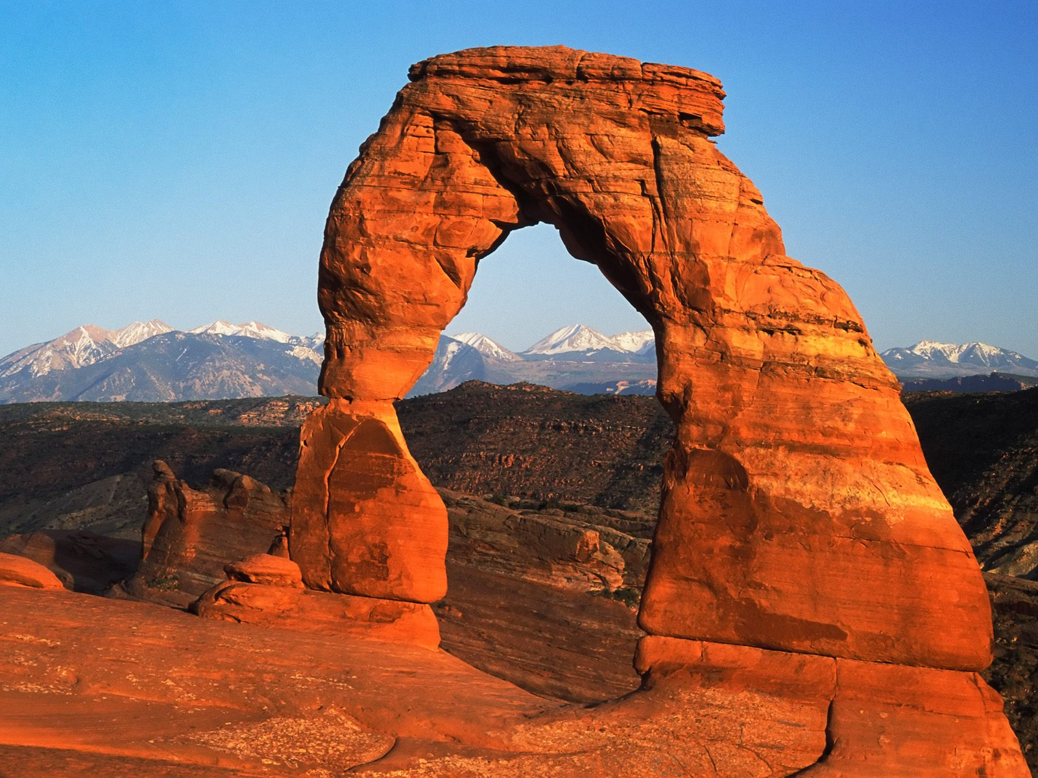](http://www.google.com/url?sa=i&rct=j&q=Utah&source=images&cd=&cad=rja&docid=8gE-lpt-9PWiHM&tbnid=HmFoI55Anvx3_M:&ved=0CAUQjRw&url=http://suhodgepodge.blogspot.com/p/top-ten.html&ei=kESBUeSHGuaEiwLG1IBo&bvm=bv.45921128,d.cGE&psig=AFQjCNEU5BaLtKC-93coV9WgThQxWH_LOQ&ust=1367512579570883)[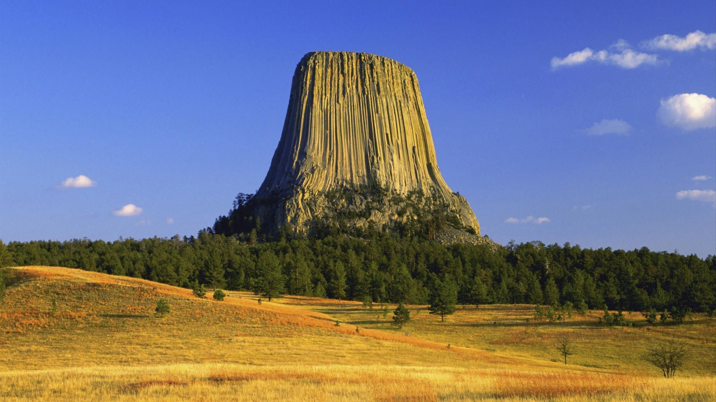](http://www.google.com/url?sa=i&rct=j&q=Wyoming&source=images&cd=&cad=rja&docid=lFMDwKJ_Z1BTvM&tbnid=_kR_l96hSyMVUM:&ved=0CAUQjRw&url=http://mytraveljob.com/wyoming/attachment/wyoming-travel-devils-tower&ei=8kSBUeSoGq7TigKk24HIBA&bvm=bv.45921128,d.cGE&psig=AFQjCNHSquJxvmF_j1UB7wSdLYG1tbmo9g&ust=1367512679215355)

[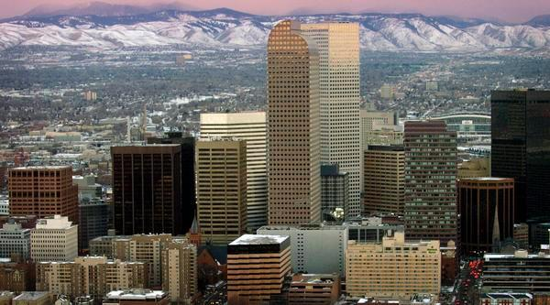](http://www.google.com/url?sa=i&rct=j&q=Denver&source=images&cd=&cad=rja&docid=XHgJBJSq0UARlM&tbnid=ZRgUOWnObsh3JM:&ved=0CAUQjRw&url=http://www.denverpost.com/breakingnews/ci_11578103&ei=1UWBUYfxOcaJjAK4j4CgBQ&bvm=bv.45921128,d.cGE&psig=AFQjCNEngbW62DcDFiSwRoRwawUhfm55_Q&ust=1367512866712083)[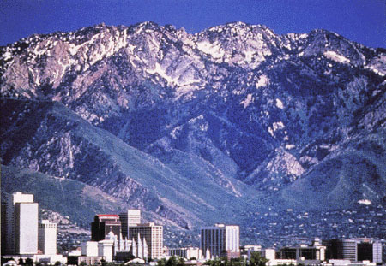](http://www.google.com/url?sa=i&rct=j&q=Sal+Lake+City&source=images&cd=&cad=rja&docid=gGXgSoyZDknj_M&tbnid=gFYscnvs028FpM:&ved=0CAUQjRw&url=http://www.nahrepslc.org/&ei=t0SBUbz5DKi1igLvqIGIDg&bvm=bv.45921128,d.cGE&psig=AFQjCNEFeEd1gctr9yARw3h9ZDNtWw8dBA&ust=1367512625644796)[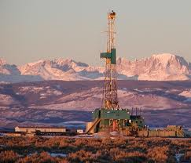](http://www.google.com/url?sa=i&rct=j&q=wyoming+oil+and+gas&source=images&cd=&cad=rja&docid=YPIGQnj--JXn2M&tbnid=LP8eu8C2rGpfmM:&ved=0CAUQjRw&url=http://wyomingoutdoorcouncil.org/blog/2010/06/08/new-fracking-rules-approved/&ei=gUWBUa-mA-ahiAKkrYD4DQ&bvm=bv.45921128,d.cGE&psig=AFQjCNEfKMNpM2Q9mj0GYQ_2wpdK_xDbUw&ust=1367512817298284)

|  |  |
| --- | --- |
| **Three-State Air Quality Modeling Study (3SAQS)**  **Weather Research Forecast (WRF)**  **Meteorological Model**  **Draft Modeling Protocol** | |
| Prepared by:  ENVIRON International Corporation  773 San Marin Drive, Suite 2115  Novato, California, 94945  415-899-0700  University of North Carolina  Institute for the Environment  137 E. Franklin St., Room 665  Campus Box 6116  Chapel Hill, NC 27599-6116  May 2013 |

CONTENTS

1.0 INTRODUCTION 4

1.1 Background 4

1.2 Air Quality Standards and Air Quality Related Values 4

1.3 Objective 6

1.4 Organization of the Modeling Protocol 8

1.5 Project Participants 9

1.6 Related Studies 9

1.7 Overview of Modeling Approach 12

2.0 MODEL SELECTION 13

2.1 Justification and Overview of Selected Meteorolological Model 13

2.2 Description of WRF 14

3.0 EPISODE SELECTION 15

3.1 Episode Selection Criteria 15

3.2 Summary of Air Quality Data 16

3.3 Episode Selection Results 23

4.0 METEOROLOGICAL MODELING 24

4.1 Model Selection and Application 24

4.2 WRF Domain Definition 24

4.3 Topographic Inputs 25

4.4 Vegetation Type and Land Use Inputs 25

4.5 Atmospheric Data Inputs 29

4.6 Water Temperature Inputs 29

4.7 Time Integration 29

4.8 Diffusion Options 29

4.9 Lateral Boundary Conditions 29

4.10 Top and Bottom Boundary Conditions 29

4.11 Sea Surface Temperature Inputs 30

4.12 FDDA Data Assimilation 30

4.13 WRF Physics Options 30

4.14 WRF Output Variables 30

4.15 WRF Application Methodology 30

5.0 METEOROLOGICAL MODEL PERFORMANCE EVALUATION 32

5.1 Quantitative Evaluation using Surface Meteorological Observations 32

5.2 Quantitative Evaluation using ALOFT Meteorological Observations 38

5.3 Qualitative Model Performance Evaluation 38

6.0 REFERENCES 41

**TABLES**

Table 1-1. Key contacts in the 3SAQS meteorological modeling. 9

Table 4-1. 37 Vertical layer interface definition for 3SAQS WRF meteorological model simulations. 28

Table 4-2. Physics options used in the WestJumpAQMS WRF simulation that would be used as starting configuration for 3SAQS WRF runs 31

Table 5-1. Meteorological model performance benchmarks for simple and complex conditions. 37

**FIGURES**

Figure 1-1. Current ozone nonattainment areas under the March 2008 8-hour ozone 0.075 ppm NAAQS. 6

Figure 1-2. Counties that are violating the 1997 15.0 µg/m3 PM2.5 NAAQS and additional counties that would violate a 13.0 µg/m3 (dark green) and the new December 2012 12.0 µg/m3 PM2.5 NAAQS based on 2008-2010 observations (source: http://www.epa.gov/pm/actions.html#jun12). 7

Figure 1-3. 156 mandatory Class I areas in the contiguous U.S. 8

Figure 3-1a. Trends in maximum and average 8-hour ozone Design Values in Colorado for 2001-2011. 17

Figure 3-1b. Trends in maximum and average 8-hour ozone Design Values in Utah for 2001-2011. 18

Figure 3-1c. Trends in maximum and average 8-hour ozone Design Values in Wyoming for 2001-2011. 19

Figure 3-2a. Trends in maximum and average annual PM2.5 Design Values in Colorado for 2001-2011. 20

Figure 3-2b. Trends in maximum and average annual PM2.5 Design Values in Utah for 2001-2011. 21

Figure 3-3a. Trends in maximum and average 24-hour PM2.5 Design Values in Colorado for 2001-2011. 22

Figure 3-3b. Trends in maximum and average 24-hour PM2.5 Design Values in Utah for 2001-2011. 23

Figure 4-1a. Proposed WRF 36/12/4 km grid structure for the 3SAQS meteorological modeling using the WestJumpAQMS 4 km IMWD domain. 26

Figure 4-1b. Proposed WRF 36/12/4 km grid structure for the 3SAQS meteorological modeling using a smaller 4 km domain designed for the 3SAQS. 27

Figure 5-1. Locations of MADIS surface meteorological modeling sites with the WRF 36 km CONUS modeling domain. 33

Figure 5-2. Locations of MADIS surface meteorological modeling sites with the WRF 12 km WESTUS modeling domain. 34

Figure 5-3. Locations of MADIS surface meteorological modeling sites with the WRF 4 km IMWD modeling domain used in the WestJumpAQMS (definition of the 4 km domain for the 3SAQS is under study). 35

Figure 5-4. Example quantitative model performance evaluation display using soccer plots that compare monthly temperature performance (colored symbols) across the 36 km CONUS (top left), 12 km WESTUS (top right) and 4 km IMWD (bottom) domains with the simple and complex model performance benchmarks (rectangles). 38

Figure 5-5. Example comparison of CPC analysis (left) and WRF modeling (right) monthly total precipitation amounts across the continental U.S. for the months of January (top) and July (bottom) from the WestJumpAQMS 2008 WRF simulation. 39

1.0 INTRODUCTION

1.1 Background

The Three-State Air Quality Study (3SAQS) includes cooperators from U.S. Environmental Protection Agency (EPA), United States Forest Service (USFS), Bureau of Land Management (BLM), National Park service (NPS), and the state air quality management agencies of Colorado, Utah, and Wyoming. The 3SAQS is intended to facilitate air resource analyses for federal and state agencies in the states of Wyoming, Colorado, and Utah toward improved information for the public and stakeholders as a part of the National Environmental Policy Act (NEPA) and potentially other studies. Funded by the Environmental Protection Agency (EPA), Bureau of Land Management (BLM), and the U.S. Forest Service (USFS) and with in-kind support from the National Park Service (NPS) and Colorado, Utah, and Wyoming state air agencies, by working closely with cooperators and overseeing the various agreements, the main focus of the study is on assessing the environmental impacts of sources related to oil and gas development and production. In particular, the cooperators will use photochemical grid models (PGMs) to quantify the impacts of proposed oil and gas development projects within the 3SAQS region on current and future air quality, including ozone and visibility levels in the National Parks and Wilderness Areas.

Air pollutant emissions data analysis and modeling expertise and skills are an integral need of the 3SAQS participants to support routine application of PGMs by the end of 2013. The 3SAQS has hired the University of North Carolina (UNC) at Chapel Hill, who are in the process of adding ENVIRON International Corporation (ENVIRON) to the team, to assist in developing the technical data needed to perform the 3SAQS as well as populate the Three State Data Warehouse (3SDW). UNC/ENVIRON will work closely with the NPS and other cooperators to develop technical capacity and expertise, and train NPS staff.

A key component for the 3SAQS PGM modeling is the meteorological inputs. Meteorological inputs for PGMs are generated using prognostic meteorological models. This document is a Modeling Protocol for the 3SAQS meteorological modeling. It lays out the models, episodes, modeling domains, model options, evaluation methodology, etc. for the 3SAQS meteorological modeling for review and approval of the 3SAQS cooperators prior to conducting the meteorological modeling.

1.2 AIR QUALITY STANDARDS AND AIR QUALITY RELATED VALUES

The United State (U.S.) Environmental Protection Agency (EPA) sets National Ambient Air Quality Standards (NAAQS) for six regulated air quality pollutants: ozone (O3), particulate matter (PM), sulfur dioxide (SO2), nitrogen dioxide (NO2), carbon monoxide (CO) and lead (Pb). After promulgation of a NAAQS, EPA designates nonattainment areas (NAAs) and States are required to submit State Implementation Plans (SIPs) to EPA that contain emission control plans and a demonstration that the NAA will achieve the NAAQS by the required date.

In 1997, EPA promulgated the first 8-hour ozone National Ambient Air Quality Standard (NAAQS) with a threshold of 0.08 ppm (84 ppb). On March 12, 2008, EPA promulgated a more stringent 0.075 ppm (75 ppb) 8-hour ozone NAAQS. Figure 1-1 displays the locations of ozone nonattainment areas under the 2008 ozone NAAQS. EPA is currently re-evaluating the ozone NAAQS and will likely promulgate a new 8-hour ozone NAAQS in 2014 with a threshold that will likely be in the range of 0.060 ppm to 0.070 ppm. Under more stringent ozone NAAQS there would likely be many more areas in the U.S., including the western U.S., that would be in nonattainment.

On December 14, 2012, EPA revised the PM2.5 primary NAAQS by lowering the annual PM2.5 NAAQS threshold from 15.0 µg/m3 to a 12.0 µg/m3 range[1]. EPA is retaining the 24-hour PM2.5 primary NAAQS at 35 µg/m3. The 24-hour coarse PM NAAQS (PM10) is also retained at 150 µg/m3. EPA considered the adoption of a secondary PM2.5 NAAQS to protect against visibility impairment in urban areas with a proposed threshold in the 28 to 30 deciview range and an averaging time in the range of 4 to 24 hours. However, EPA determined that the 35 µg/m3 24-hour PM2.5 secondary NAAQS provides visibility protection equal to or better than a 30 deciview (dv) standard. Figure 1-2 displays counties that are violating the old 15.0 µg/m3 annual PM2.5 NAAQS and the additional counties that would violate a proposed 13.0 and the new 12.0 µg/m3 annual PM2.5 NAAQS based on 2008-2010 measurements. There would be no new PM2.5 nonattainment counties in the western U.S. under the new annual PM2.5 NAAQS 12 µg/m3 level based on 2008-2010 air quality observations.

In February 2010 EPA issued a new 1-hour NO2 NAAQS with a threshold of 100 ppb and a new 1-hour SO2 NAAQS was promulgated in June 2010 with a threshold of 75 ppb. EPA has not yet designated the nonattainment areas for the 1-hour NO2 and 1-hour SO2 NAAQS. As of September 27, 2010 all NAAs for Carbon Monoxide have been redesignated as maintenance areas. A new lead NAAQS was issued in 2008 and, except for Los Angeles, all of the NAAs reside in the eastern or central U.S or Alaska.

The Clean Air Act Amendments (CAAA) designated 156 Class I areas consisting of National Parks and Wilderness Areas that are offered special protection for air quality and air quality related values (AQRVs). The Class I areas, compared to Class II areas, have lower Prevention of Significant Deterioration (PSD) air quality increments that new sources may not exceed, and are protected against excessive increases in several AQRVs including visibility impairment, acid (sulfur and nitrogen) deposition and nitrogen eutrophication. The Regional Haze Rule (RHR) has a goal of natural visibility conditions by 2064 at Class I areas, and States must submit RHR SIPs that demonstrate progress towards that goal. Figure 1-3 displays the locations of the 156 mandatory Class I areas, most of which are in the western U.S., including the states of Colorado, Utah and Wyoming.

|  |
| --- |
|  |
| Figure 1-1. Current ozone nonattainment areas under the March 2008 8-hour ozone 0.075 ppm NAAQS. |

1.3 Objective

One of the objectives of the 3SAQS is to develop a 2011 photochemical grid model (PGM) modeling platform to address air quality and AQRV issues in the western U.S. A key component of the 2011 PGM database is the three-dimensional meteorological inputs. To generate such meteorological inputs, prognostic meteorological models are used. This document presents the Modeling Protocol for meteorological modeling to develop the 2011 PGM modeling database for the 3SAQS.

|  |
| --- |
|  |
| Figure 1-2. Counties that are violating the 1997 15.0 µg/m3 PM2.5 NAAQS and additional counties that would violate a 13.0 µg/m3 (dark green) and the new December 2012 12.0 µg/m3 PM2.5 NAAQS based on 2008-2010 observations (source: http://www.epa.gov/pm/actions.html#jun12). |

|  |
| --- |
|  |
| Figure 1-3. 156 mandatory Class I areas in the contiguous U.S. |

1.4 Organization of the Modeling PROTOCOL

This document represents the 3SAQS Modeling Protocol for meteorological modeling to develop photochemical grid model inputs for the 2011 calendar year and western U.S. The 3SAQS meteorological modeling will leverage the meteorological modeling for 2008 conducted for the West-wide Jump-start Air Quality Modeling Study (WestJumpAQMS). Details of the WestJumpAQMS technical approach can be found in the Modeling Protocol (ENVIRON, Alpine and UNC, 2013) and in the WRF Application/Evaluation report for the 2008 meteorological modeling (ENVIRON and Alpine, 2012). Although the 3SAQS modeling analysis is not currently being performed to fill any particular regulatory requirement, such as a State Implementation Plan (SIP) attainment demonstration or an Environmental Impact Statement (EIS) or Resource Management Plan (RMP) as part of the National Environmental Policy Act (NEPA), it is being conducted with the same level of technical rigor as a SIP-type analysis and may ultimately be used as a basis for regulatory air quality modeling. This 3SAQS meteorological Modeling Protocol has the following sections:

1. Introduction: Presents a summary of the background, purpose and objectives of the study.
2. Model Selection: Introduces the model selected for the study.
3. Episode Selection: Describes the modeling period for the study.
4. Meteorological Modeling: Describes how the meteorological modeling will be conducted including modeling domains, model options and application strategy.
5. Meteorological Model Performance Evaluation: Provides the procedures for conducting the model performance evaluation of the meteorological model.
6. References: References cited in the document.

1.5 PROJECT PARTICIPANTS

The 3SAQS is conducted by the states of Colorado, Utah and Wyoming, several Federal agencies including National Park Service, (NPS), United States Forest Service (USFS) and Bureau of Land Management (BLM) and several contractors. The 3SAQS meteorological modeling is being conducted by the University of North Carolina at Chapel Hill (UNC) Institute for the Environment and ENVIRON International Corporation. Key contacts and their roles in the 3SAQS meteorological modeling are listed in Table 1-1.

Table 1-1. Key contacts in the 3SAQS meteorological modeling.

|  |  |  |
| --- | --- | --- |
| **Name** | **Role** | **Organization/Contact** |
| Tom Moore | Manager 3SAQS Data Warehouse | Western Regional Air Partnership (WRAP)  c/o CSU/CIRA  1375 Campus Delivery  Fort Collins, CO 80523  (970) 491-8837  tmoore@westgov.org |
| Zac Adelman | UNC Lead | University of North Carolina  Center for Environmental Modeling for Policy Development  137 E. Franklin St, CB 6116  Chapel Hill, NC 27599-6116  (919) 302-8471  zac@unc.edu |
| Ralph Morris | ENVIRON Lead | ENVIRON International Corporation  773 San Marin Drive, Suite 2115  Novato, CA 94998  (415) 899-0708  rmorris@environcorp.com |

1.6 Related Studies

There are numerous meteorological, emissions and air quality modeling and data analysis studies related to the 3SAQS meteorological modeling whose results will be incorporated into the study. In addition, EPA has promulgated several national rules that may affect emissions in the western states.

1.6.1 Federal Regional Regulatory Air Quality Programs

The federal government has implemented standards and actions to improve air quality across the entire country. These standards have largely involved mobile sources, whereas as many of the national rules address large stationary point sources. Federal standards include: the Tier 2 Vehicle Standards, the heavy-duty gasoline and diesel highway vehicle standards, the non-road spark-ignition engines and recreational engine standards, and the large non-road diesel engine rule. The federal government has also implemented regional control strategies for major stationary sources focusing on the eastern U.S. and intends to extend the program to the western U.S. The following is a list of federal regulatory actions that would likely lead to emission reductions in the western U.S.

* Tier 2 Vehicle Standards
* Heavy-duty Gasoline and Diesel Highway Vehicle Standards
* Non-Road Spark-ignition Engines and Recreational Engines Standards
* Large Non-Road Diesel Engine Rule
* Mercury and Air Toxics Standards (MATS)
* VOC MACT
* Federal Reformulated Gasoline
* Federal Non-Road Spark-Ignition Engines and Equipment
* Locomotive Engines and Marine Compression-Ignition Engines Final Rule
* Clean Air Act Title IV - Acid Rain Program
* Low-Sulfur Fuels
* Clean Air Visibility Rule (CAVR)

Oil and Gas New Source Performance Standards (NSPS, August 16, 2012)

1.6.2 2003 Denver EAC SIP Modeling

The Denver EAC SIP modeling performed 36/12/4/1.33 km grid spacing photochemical modeling of the Denver Metropolitan Area (DMA) using the MM5 meteorological, EPS3 emissions and CAMx photochemical grid models and a summer 2002 period. The Denver EAC SIP made 2007 ozone projections. Details on the 2003 Denver EAC SIP modeling can be found at:

<http://raqc.org/sip/more/category/ozone_8-hour_standard/>

1.6.3 2008 Denver Ozone SIP Modeling

As was used in the 2003 Denver EAC SIP modeling, the 2008 Denver ozone SIP modeling used the MM5 meteorological and the CAMx photochemical grid models, but SMOKE and CONCEPT were used for the emissions modeling. The CONCEPT model was interfaced with link-based Vehicle Miles Traveled (VMT) and other mobile source activity data (e.g., speeds, fleet mix, temporal variations, etc.) from a Traffic Demand Model (TDM) operated by DRCOG, on-road emission factors from the MOBILE6 model, and hourly meteorological data from MM5 to generate detailed on-road mobile source emissions for the DMA. Other emission inputs were generated using SMOKE. The MM5/SMOKE/CONCEPT/CAMx modeling system was applied to the June-July 2006 period and used to demonstrate that the DMA/NFR region would attain the 1997 8-hour ozone NAAQS by 2010. Details on the 2008 Denver 8-hour ozone SIP modeling can be found at:

<http://www.colorado.gov/airquality/documents/deno308/>

1.6.4 Current Denver Modeling of a 2008 Episode

The RAQC is currently conducting a modeling study using the same WRF meteorological, SMOKE emissions and CAMx photochemical grid models as WestJumpAQMS and the May through August 2008 portion of the WestJumpAQMS 2008 modeling year. As in the 2008 Denver Ozone SIP, on-road mobile sources in the Denver area were estimated using CONCEPT MV with link-based TDM data, except the MOVES mobile source emissions factor model was used instead of MOBILE6. The Modeling Protocol and preliminary model performance evaluation (MPE) results for the current 2008 Denver ozone modeling can be found at:

<http://www.ozoneaware.org/postfiles/documentsandpresentations/modeling/documents/Denver_Model_Protocol_Draft3_080211.pdf>

<http://raqc.org/postfiles/ozone_modeling/modeling_forum/Denver_2008_Prelim_MPE_080912.pdf>

1.6.5 WRAP Regional Modeling Center Modeling

In 2002, Five Regional Planning Organizations (RPOs) were formed to perform regional haze modeling using photochemical, ozone, and PM models, to support the development of regional haze SIPs due in December 2007. The Western Regional Air Partnership (WRAP) is the RPO for the western states. The modeling was conducted by the WRAP Regional Modeling Center (RMC) that consisted of the University of California at Riverside (UCR), ENVIRON International Corporation, and the University of North Carolina (UNC). The RMC conducted modeling for the 2002 annual period, and continental U.S. using a 36 km grid and the MM5 meteorological (Kemball-Cook et al., 2005a), SMOKE emissions, and CMAQ and CAMx photochemical models. CMAQ was run for a 2002 base case, a 2018 future base-year, and a 2018 control scenarios to predict visibility projections in Federal Class I areas. The WRAP RMC has a website where modeling results can be obtained. Some of the modeling results have been implemented in the WRAP Technical Support System (TSS) website where users can analyze data and modeling results. Pertinent WRAP RMC websites are at:

<http://pah.cert.ucr.edu/aqm/308/index.shtml>

<http://vista.cira.colostate.edu/tss/>

<http://www.wrapair.org/>

<http://www.wrapair2.org/>

1.6.6 Four Corners Air Quality Task Force

The Four Corners Air Quality Task Force (FCAQTF) conducted emissions and photochemical grid modeling for the four corners region to provide information regarding ozone, visibility, and deposition impacts in the region. The states of Colorado and New Mexico were active participants in the FCAQTF study. The MM5 meteorological, SMOKE emissions, and CAMx air quality models were applied for the 2005 year on a 36/12/4 km grid with the 4 km grid focused on northwest New Mexico, southwest Colorado and small portions of southeast Utah and northeast Arizona. This region not only includes the San Juan Basin oil and gas development area, but also several large coal-fired power plants (e.g., Four Corners and San Juan). The FCAQTF performed 2005 base case modeling, as well as 2018 future-year modeling and 2018 sensitivity modeling for several mitigation scenarios. More details on the FCAQTF modeling can be found at:

<http://www.nmenv.state.nm.us/aqb/4C/PublicReview.html>

1.67 Environmental Impact Statements (EISs) and Resource Management Plans (RMPs)

Photochemical grid models are also being applied in the Rocky Mountain States as part of the development of Environmental Impact Statements (EISs) for oil and gas development projects and Resource Management Plans (RMPs) for Bureau of Land Management (BLM) Field Offices. Most of these EIS/RMP studies have been or are being performed by the BLM under the National Environmental Policy Act (NEPA), although the United States Forest Service (USFS) and Tribes have also led some EISs. The main focus of these activities is on the air quality and air quality related value (AQRV; i.e., visibility and deposition) impacts due to oil and gas development activities, although RMPs can also address mining, grazing, off-highway vehicles and other activities. Such EIS/RMP activities have occurred or are undergoing air quality modeling for projects in Colorado, New Mexico, Utah and Wyoming with more information found on the BLM websites:

<http://www.blm.gov/co/st/en.html>

<http://www.blm.gov/nm/st/en.html>

<http://www.blm.gov/ut/st/en.html>

<http://www.blm.gov/wy/st/en.html>

1.6.8 RoMANS

The National Park Service (NPS), CDPHE/APCD and others performed the Rocky Mountain Atmospheric Nitrogen and Sulfur Study (RoMANS) to study nitrogen deposition and potential mitigation scenarios at Rocky Mountains National Park (RMNP). The Rocky Mountain Initiative includes data collection, data analysis, modeling and the development of a nitrogen deposition reduction plan. Much of the analysis of RoMANS was for the 2006 period and they plan to do additional modeling for 2009. Details on the RoMANS study can be found at:

http://www.colorado.gov/cs/Satellite?c=Page&childpagename=CDPHE-AP%2FCBONLayout&cid=1251594862555&pagename=CBONWrapper

<http://www.nature.nps.gov/air/studies/romans.cfm>

1.6.9 WestJumpAQMS

The West-wide Jump-start Air Quality Modeling Study (WestJumpAQMS) is conducting meteorological, emissions and photochemical grid modeling of the western U.S. for the 2008 calendar year to investigate source-receptor relationships for ozone, particulate matter, visibility and deposition. WRF meteorological and SMOKE emissions modeling was conducted for a 36 km continental U.S., 12 km western U.S., and 4 km inter-mountain west domain. Ozone and PM source apportionment modeling was also conducted with CAMx to examine state-specific and source category-specific air quality impacts. Details on the WestJumpAQMS can be found at:

<http://www.wrapair2.org/WestJumpAQMS.aspx>

1.7 Overview of Modeling Approach

The procedures for the 3SAQS meteorological modeling followed those performed for the WestJumpAQMS, but for the 2011 calendar year instead of 2008, and using some updated options in the meteorological model (to account for the latest version and lessons learned from the WestJumpAQMS meteorological modeling). A summary of the 3SAQS meteorological modeling approach is given below, with more details provided in the Chapters of this Modeling Protocol.

* The 2011 calendar year was selected for the 3SAQS meteorological modeling period.
* A 36 km continental U.S. (CONUS), 12 km western U.S. (WESTUS) and 4 km domain that covers the 3SAQS region will be used.
* Meteorological modeling is based on the Weather Research and Forecasting (WRF) modeling.
* Model evaluation is being conducted using surface meteorological observations, spatial maps of precipitation based on observations, rawinsonde measurements of conditions aloft, and satellite observations of clouds.

2.0 MODEL SELECTION

This section discusses the selection of the meteorological model for the 3SAQS. The selection methodology follows EPA’s guidance for regulatory modeling in support of ozone and PM2.5 attainment demonstration modeling and showing reasonable progress with visibility goals (EPA, 2007). EPA recommends that models be selected for regulatory ozone, PM and visibility studies on a “case-by-case” basis with appropriate consideration being given to the candidate models’:

* Technical formulation, capabilities and features;
* Pertinent peer-review and performance evaluation history;
* Public availability; and

Demonstrated success in similar regulatory applications.

2.1 justification and Overview of Selected METEOROLOGOCAL Model

There are two prognostic meteorological models that are routinely used in the U.S. in photochemical grid modeling studies:

* The fifth generation Mesoscale Model (MM5); and

The Weather Research and Forecasting (WRF) model.

Both MM5 and WRF were developed by the National Center for Atmospheric Research (NCAR) collaborating with several government agencies, with inputs and contributions from the community. NCAR also has been providing coordination and support of these models. For many years, the MM5 model was widely used by both the meteorological research as well as the air quality modeling community. Starting around the year 2000, the WRF model started to be developed as a technical improvement and replacement to MM5, and today NCAR no longer supports MM5. Based on the four selection criteria, the WRF model was selected as the 3SAQS meteorological model for the following reasons:

* Technical: WRF is based on more recent physics and computing techniques and represents a technical improvement over MM5. WRF has numerous new capabilities and features not available in MM5 and, unlike MM5, it is supported by NCAR.
* Performance: Because it has been around longer, MM5 has had a longer history of performance than WRF. However, WRF is being used by thousands of users and has been subjected to a community peer-reviewed development process using the latest algorithms and physics. In general, it appears that the WRF is better able to reproduce the observed meteorological variables, and so performs better. WRF is amassing a rich publication and application history.
* Public Availability: WRF is publicly available and can be downloaded from the WRF website with no costs or restrictions[2].

Demonstrated Success: The recent Denver ozone modeling of the 2008 episode using WRF has produced better meteorological and ozone model performance than achieved in past Denver ozone modeling efforts of 2002 and 2006, which used MM5 (Morris et al., 2012a,b).

2.2 Description of WRF[3]

The non-hydrostatic version of the Advanced Research version of the Weather Research and Forecast (WRF-ARW[4]) model (Skamarock et al. 2004; 2005; 2006; Michalakes et al. 1998; 2001; 2004) is a three-dimensional, limited-area, primitive equation, prognostic model that has been used widely in regional air quality model applications. The basic model has been under continuous development, improvement, testing and open peer-review for more than 10 years. It has been used world-wide by hundreds of scientists for a variety of mesoscale studies, including cyclogenesis, polar lows, cold-air damming, coastal fronts, severe thunderstorms, tropical storms, subtropical easterly jets, mesoscale convective complexes, desert mixed layers, urban-scale modeling, air quality studies, frontal weather, lake-effect snows, sea-breezes, orographically induced flows, and operational mesoscale forecasting. WRF is a next-generation mesoscale prognostic meteorological model routinely used for urban- and regional-scale photochemical, fine particulate and regional haze regulatory modeling studies. Developed jointly by the National Center for Atmospheric Research and the National Centers for Environmental Prediction, WRF is maintained and supported as a community model by researchers and practitioners around the globe. The code supports two modes: the Advanced Research WRF (ARW) version and the Non-hydrostatic Mesoscale Model (NMM) version. WRF-ARW has become the new standard model used in place of the older Mesoscale Meteorological Model (MM5) for regulatory air quality applications in the U.S. It is suitable for use in a broad spectrum of applications across scales ranging from hundreds of meters to thousands of kilometers.

3.0 EPISODE SELECTION

EPA’s ozone, PM2.5, and visibility SIP modeling guidance (EPA, 2007)[5] contains recommended procedures for selecting modeling episodes, while also referencing EPA’s 1-hour ozone modeling guidance for episode selection (EPA, 1991)[6]. This Chapter presents the modeling period selected for performing the 3SAQS and the justification and rationale for its selection.

3.1 Episode Selection Criteria

EPA’s modeling guidance lists primary criteria for selecting episodes for ozone, PM2.5,and visibility SIP modeling along with a set of secondary criteria that should also be considered.

3.1.1 Primary Episode Selection Criteria

EPA’s modeling guidance (EPA, 2007) identifies four specific criteria to consider when selecting episodes for use in demonstrating attainment of the 8-hour ozone or PM2.5 NAAQS:

1. A variety of meteorological conditions should be covered, including the types of meteorological conditions that produce 8-hour ozone and 24-hour PM2.5 exceedances in the western U.S.;
2. Choose episodes having days with monitored 8-hour daily maximum ozone and 24-hour PM2.5 concentrations close to the ozone and PM2.5 Design Values;
3. To the extent possible, the modeling data base should include days for which extensive data bases (i.e. beyond routine aerometric and emissions monitoring) are available; and
4. Sufficient days should be available such that relative response factors (RRFs) for ozone projections can be based on several (i.e., > 10) days with at least 5 days being the absolute minimum.

3.1.2 Secondary Criteria

EPA also lists four “other considerations” to bear in mind when choosing potential 8-hour ozone episodes including:

1. Choose periods which have already been modeled;
2. Choose periods that are drawn from the years upon which the current Design Values are based;
3. Include weekend days among those chosen; and
4. Choose modeling periods that meet as many episode-selection criteria as possible in the maximum number of nonattainment areas as possible.

EPA suggests that modeling an entire summer ozone season for ozone or an entire year for PM2.5 would be a good way to assure that a variety of meteorological conditions are captured and that sufficient days are available to construct robust relative response factors (RRFs) for the 8-hour ozone and PM2.5 Design Value projections.

3.2 summary of air quality data

Figures 3-1 through 3-3 display trends in ozone and PM2.5 Design Values in Colorado, Utah and Wyoming (ozone only) from 2001 to 2011. The three-year Design Values are plotted on the ending year and trends are based on a least-squares fit to the rolling three-year Design Values. The trends in maximum and average Design Values across the states are plotted and summarized at the bottom of the plot. The trends are based on long-term monitoring sites that have valid Design Values in at least 9 out of the 11 years. This eliminates any spurious signals associated with new monitoring sites (e.g., new hot spots) that can skew the trends, and so excludes many new monitoring sites. This includes the sites that measure elevated winter ozone concentrations in southwestern Wyoming and Uinta Basin Utah that do not have a long-term record so can’t be used for trends.

For ozone, Colorado fails to achieve the ozone NAAQS for all years, Utah is just achieving the ozone NAAQS in the most recent years, and Wyoming has been below the ozone NAAQS during the period of record. However, these trends do not include the recent winter high ozone monitoring sites in southwest Wyoming and in the Uinta Basin in Utah that exceed the NAAQS. There is a downward trend in ozone over the last decade in all three states. In Colorado there is a slight downward trend in the maximum Design Value (-0.43 ppb per year) but they are still above the 0.075 ppm NAAQS in 2011. Utah has more downward trends in maximum ozone Design Values (-0.85 ppb per year) and attained the ozone NAAQS in 2009, 2010 and 2011. Wyoming has a slight (-0.05 ppb per year) downward trend in maximum ozone Design Values.

The trend in the PM2.5 Design Values is also downward in Colorado and Utah (Figures 3-2 and 3-3). Looking at the three most recent years (2009-2011) there does not appear to be any large anomalies in the Design Values in relationship to the trends. The 2010 Colorado maximum ozone Design Value is a little lower than the trend, and the 2010 and 2011 PM Design Values may also be a little lower than the trend except for the Utah 24-hour PM2.5 Design Value that is a little higher.

Note that ozone in 2009 was much lower than the surrounding years in the three-state area. Because Design Values are based on three-year averages this is difficult to see in the Design Value trends. The reason why ozone was lower in the three-state region during 2009 include: (1) lower than typical summer temperatures; (2) lower than usual incident of contributions from stratospheric ozone; and (3) reduced emissions due to the economic recession. Thus, 2009 would be a poor choice for the modeling episode in the 3SAQS.

|  |
| --- |
|  |
| Figure 3-1a. Trends in maximum and average 8-hour ozone Design Values in Colorado for 2001-2011. |

|  |
| --- |
|  |
| Figure 3-1b. Trends in maximum and average 8-hour ozone Design Values in Utah for 2001-2011. |

|  |
| --- |
|  |
| Figure 3-1c. Trends in maximum and average 8-hour ozone Design Values in Wyoming for 2001-2011. |

|  |
| --- |
|  |
| Figure 3-2a. Trends in maximum and average annual PM2.5 Design Values in Colorado for 2001-2011. |

|  |
| --- |
|  |
| Figure 3-2b. Trends in maximum and average annual PM2.5 Design Values in Utah for 2001-2011. |

|  |
| --- |
|  |
| Figure 3-3a. Trends in maximum and average 24-hour PM2.5 Design Values in Colorado for 2001-2011. |

|  |
| --- |
|  |
| Figure 3-3b. Trends in maximum and average 24-hour PM2.5 Design Values in Utah for 2001-2011. |

3.3 Episode Selection Results

The 2011 calendar year was selected for the 3SAQS modeling because it satisfies more of the primary and secondary episode-selection criteria listed above than other recent years:

1. Modeling the entire 2011 year will capture a variety of conditions that lead to elevated ozone and PM2.5 concentrations in the western U.S.
2. An annual simulation will assure sufficient days are available to analyze ozone and PM2.5 impacts. Annual simulations also allow the assessment of annual AQ/AQRV issues such as sulfur and nitrogen deposition, annual average NAAQS and annual average evaluation using NADP, CASTNet and other observation networks.
3. With an annual run, all weekend days in a year are included.
4. 2011 is the most recent year that corresponds with a triennial National Emissions Inventory (NEI) year.
5. 2011 air quality is consistent with the trends in air quality over the last decade.

4.0 METEOROLOGICAL MODELING

The WRF meteorological model will be applied for the 2011 calendar year using a 36/12/4 km domain structure.

4.1 Model Selection and Application

The latest publicly available version of WRF (version 3.5 released April 18, 2013) will be used in the 3SAQS meteorological modeling. The WRF preprocessor programs including GEOGRID, UNGRIB, and METGRID will be used to develop model inputs.

4.2 WRF Domain Definition

The WRF computational grid was designed so that it can generate CAMx/CMAQ meteorological inputs for the same 36 km CONUS and 12 km WESTUS as used in the WestJumpAQMS. The WestJumpAQMS WRF modeling used a very large 4 km Inter-Mountain West Domain (IMWD) that was very computationally intensive and it would be advantageous for the 3SAQS to use a smaller more computationally efficient domain if possible. The WRF modeling domain was defined to be slightly larger than the CAMx/CMAQ PGM modeling domains to eliminate boundary artifacts in the meteorological fields used as input to CAMx/CMAQ. Such boundary artifacts can occur as the boundary conditions (BCs) for the meteorological variables come into dynamic balance with WRF’s atmospheric equations and numerical methods for down-scaling from coarser to finer-resolution domains. Figure 4-1 depicts proposed WRF horizontal modeling domains to be used in the 3SAQS. The outer 36 km continental U.S. (CONUS) domain (D01) has 165 x 129 grid cells, selected to be consistent with the existing Regional Planning Organization (RPO) and EPA modeling CONUS domain. The projection is Lambert Conformal with the “national RPO” grid projection center of 40o, -97o with true latitudes of 33o and 45o. The 12 km western U.S. (WESTUS) domain has 256 × 253 grid cells with offsets from the 36 km grid of 15 columns and 26 rows.

We are currently considering two potential 4 km domains. The first is the same Inter-Mountains West Domain (IMWD) used in the WestJumpAQMS and covers the inter-mountain west and is shown in Figure 4-1a. The WestJumpAQMS IMWD 4 km domain spans from Mexico/Texas in the south to Canada in the north and from Nevada in the west to Dakotas/Nebraska in the east. Figure 4-1b includes the same 36 km CONUS and 12 km WESTUS domains but has a proposed revised 4 km domain that is tailored for the 3SAQS. The 4 km domain in Figure 4-1b has a similar east-west span as the WestJumpAQMS 4 km IMWD, but focused on the three-state region in the north-south direction. One issue in the WestJumpAQMS meteorological modeling was the WRF run times that compromised the schedule. The revised 4 km domain in Figure 4-1b is a little over half of the WestJumpAQMS 4 km IMWD so the WRF runs times, although still quite extensive, should be more manageable. Note that the emissions and air quality 4 km domain using the WRF 4 km domain in Figure 4-1b would cut off a small portion of the southwest corner of Utah due to the need to offset the air quality model domain from the WRF domain by a few grid cells. However, there are not a lot of emissions in this portion of Utah, the key receptor area in southwest Utah (Zion National Park) would still be in the 4 km domain and emissions in southwest Utah would still be considered, just at 12 km resolution. A key early on decision for the 3SAQS will be the size of the WRF 4 km modeling domain. The three nests will be run together with continuous updating, but without feedback from the 12 km to 36 km or from the 4 km to 12 km domains (“one-way” nesting).

The WRF model will be set up with 37 vertical layers using sigma-pressure surfaces as defined in Table 4-1.

4.3 Topographic Inputs

Topographic information for the WRF modeling will be developed using the standard WRF terrain databases available from the National Center for Atmospheric Research (NCAR).[7] The 36 km CONUS domain was based on the 10 min. (~18 km) global data. The 12 km WESTUS domain will be based on the 2 min. (~4 km) data. The 4 km IMWD will be based on the 30 sec. (~900 m) data.

4.4 Vegetation Type and Land Use Inputs

Vegetation type and land use information will be developed using the USGS 24-category land use database from the most recently released WRF databases provided with the WRF distribution. Standard WRF surface characteristics corresponding to each land use category will be employed.

|  |
| --- |
|  |
| Figure 4-1a. Proposed WRF 36/12/4 km grid structure for the 3SAQS meteorological modeling using the WestJumpAQMS 4 km IMWD domain. |

|  |
| --- |
|  |
| Figure 4-1b. Proposed WRF 36/12/4 km grid structure for the 3SAQS meteorological modeling using a smaller 4 km domain designed for the 3SAQS. |

Table 4-1. 37 Vertical layer interface definition for 3SAQS WRF meteorological model simulations.

|  |  |  |  |  |
| --- | --- | --- | --- | --- |
| WRF Meteorological Model | | | | |
| WRF Layer | Sigma | Pressure (mb) | Height (m) | Thickness  (m) |
| 37 | 0.0000 | 50.00 | 19260 | 2055 |
| 36 | 0.0270 | 75.65 | 17205 | 1850 |
| 35 | 0.0600 | 107.00 | 15355 | 1725 |
| 34 | 0.1000 | 145.00 | 13630 | 1701 |
| 33 | 0.1500 | 192.50 | 11930 | 1389 |
| 32 | 0.2000 | 240.00 | 10541 | 1181 |
| 31 | 0.2500 | 287.50 | 9360 | 1032 |
| 30 | 0.3000 | 335.00 | 8328 | 920 |
| 29 | 0.3500 | 382.50 | 7408 | 832 |
| 28 | 0.4000 | 430.00 | 6576 | 760 |
| 27 | 0.4500 | 477.50 | 5816 | 701 |
| 26 | 0.5000 | 525.00 | 5115 | 652 |
| 25 | 0.5500 | 572.50 | 4463 | 609 |
| 24 | 0.6000 | 620.00 | 3854 | 461 |
| 23 | 0.6400 | 658.00 | 3393 | 440 |
| 22 | 0.6800 | 696.00 | 2954 | 421 |
| 21 | 0.7200 | 734.00 | 2533 | 403 |
| 20 | 0.7600 | 772.00 | 2130 | 388 |
| 19 | 0.8000 | 810.00 | 1742 | 373 |
| 18 | 0.8400 | 848.00 | 1369 | 271 |
| 17 | 0.8700 | 876.50 | 1098 | 177 |
| 16 | 0.8900 | 895.50 | 921 | 174 |
| 15 | 0.9100 | 914.50 | 747 | 171 |
| 14 | 0.9300 | 933.50 | 577 | 84 |
| 13 | 0.9400 | 943.00 | 492 | 84 |
| 12 | 0.9500 | 952.50 | 409 | 83 |
| 11 | 0.9600 | 962.00 | 326 | 82 |
| 10 | 0.9700 | 971.50 | 243 | 82 |
| 9 | 0.9800 | 981.00 | 162 | 41 |
| 8 | 0.9850 | 985.75 | 121 | 24 |
| 7 | 0.9880 | 988.60 | 97 | 24 |
| 6 | 0.9910 | 991.45 | 72 | 16 |
| 5 | 0.9930 | 993.35 | 56 | 16 |
| 4 | 0.9950 | 995.25 | 40 | 16 |
| 3 | 0.9970 | 997.15 | 24 | 12 |
| 2 | 0.9985 | 998.58 | 12 | 12 |
| 1 | 1.0000 | 1000 | 0 |  |

4.5 Atmospheric Data Inputs

The first guess fields will be taken from either the ERA-Interim Daily reanalysis product available from the ECMWF Data Portal website[8] or the 12 km (Grid #218) North American Model (NAM) archives available from the National Climatic Data Center (NCDC) NOMADS server. Sensitivity tests will be performed to see which one performs best.

4.6 Water Temperature Inputs

The water temperature data will be taken from the NCEP RTG global one-twelfth degree analysis.[9]

4.7 Time Integration

Third-order Runge-Kutta integration will be used (rk_ord = 3). The maximum time step, defined for the outer-most domain (36 km) only, should be set by evaluating the following equation:

$$dt=\frac{6dx}{F_{map}}$$

Where *dx* is the grid cell size in km, *Fmap* is the maximum map factor (which can be found in the output from REAL.EXE), and *dt* is the resulting time-step in seconds. For the case of the 36 km RPO domain, *dx* = 36 and *Fmap* = 1.08, so *dt* should be taken to be less than 200 seconds. Longer time steps risk CFL errors, associated with large values of vertical velocity, which tend to occur in areas of steep terrain (especially during very stable conditions typical of winter).

For the current modeling, adaptive time stepping will be used to decrease total runtime for the annual simulation. We suggest using target_cfl = 0.8, starting_time_step = -1, and min_time_step = -1 (for each domain). The max_time_step = 180, 60, 20 should be used, with the default values for max_step_increase_pct. Any initializations that fail due to CFL errors should be re-run with use_adaptive_time_step = .false., with time_step set to 180 or 120 seconds.

4.8 Diffusion Options

Horizontal Smagorinsky first-order closure (km_opt = 4) with sixth-order numerical diffusion and suppressed up-gradient diffusion (diff_6th_opt = 2) will be used.

4.9 Lateral Boundary Conditions

Lateral boundary conditions will be specified from the initialization dataset on the 36 km domain with continuous updates nested from the 36 km domain to the 12 km domain and from the 12 km domain to the 4 km domain, using one-way nesting (feedback = 0).

4.10 Top and Bottom Boundary Conditions

The top boundary condition will be selected as an implicit Rayleigh dampening for the vertical velocity. Consistent with the model application for non-idealized cases, the bottom boundary condition will be selected as physical, not free-slip.

4.11 Sea Surface Temperature Inputs

The sea surface temperature data will be taken from the National Centers for Environmental Prediction (NCEP) Real Time Global (RTG) global one-twelfth degree analysis[10].

4.12 FDDA Data Assimilation

The WRF model will be run with a combination of analysis and observational nudging (i.e., Four Dimensional Data assimilation [FDDA]). Analysis nudging will be used on the 36 km and 12 km domain. For winds and temperature, analysis nudging coefficients of 5x10-4 and 3.0x10-4 will be used on the 36 km and 12 km domains, respectively. For mixing ratio, an analysis nudging coefficient of 1.0x10-5 will be used for both the 36 km and 12 km domains. The nudging uses both surface and aloft nudging with nudging for temperature and mixing ratio not performed in the lower atmosphere (i.e., within the boundary layer). Observational nudging will be performed on the 4 km grid domain using the Meteorological Assimilation Data Ingest System (MADIS)[11] observation archive. The MADIS archive includes the National Climatic Data Center (NCDC)[12] observations and the National Data Buoy Center (NDBC) Coastal-Marine Automated Network C-MAN[13] stations. The observational nudging coefficients for winds, temperatures and mixing ratios will be 1.0x10-4, 1.0x10-4, and 1.0x10-5, respectively and the radius of influence will be set to 50 km.

4.13 WRF Physics Options

The WRF model contains many different physics options. WRF physics options for an initial 2011 calendar year 36/12/4 km WRF simulation is based on our experience with WRF modeling of the Rocky Mountain region. Table 4-2 lists the recommended WRF physics options for the initial 2011 WRF application. Sensitivity tests may be performed to test alternative physics options and see whether improved WRF model performance can be achieved.

4.14 WRF OUTPUT VARIABLES

The WRF model will be configured to output additional variables in order to support air quality modeling with the Community Multiscale Air Quality Model (CMAQ). The following fields will be activated in the WRF output history files for the 3SAQS: fractional land use (LANDUSEF), aerodynamic resistance (RA), stomatal resistance (RS), vegetation fraction in the Pleim-Xiu LSM (VEGF_PX), roughness length (ZNT), inverse Monin-Obukhov length (RMOL)

4.15 WRF application Methodology

The WRF model will be executed in 5-day blocks initialized at 12Z every 5.5 days. Model results will be output every 60 minutes and output files will be split at 12 hour intervals. Twelve (12) hours of spin-up will be included in each 5-day block before the data will be used in the subsequent evaluation. WRF will be configured to run in distributed memory parallel mode.

Table 4-2. Physics options used in the WestJumpAQMS WRF simulation that would be used as starting configuration for 3SAQS WRF runs

| WRF Treatment | Option Selected | Notes |
| --- | --- | --- |
| Microphysics | Thompson scheme | New with WRF 3.1. |
| Longwave Radiation | RRTMG | Rapid Radiative Transfer Model for GCMs includes random cloud overlap and improved efficiency over RRTM. |
| Shortwave Radiation | RRTMG | Same as above, but for shortwave radiation. |
| Land Surface Model (LSM) | NOAH | Four-layer scheme with vegetation and sub-grid tiling. |
| Planetary Boundary Layer (PBL) scheme | YSU | Yonsie University (Korea) Asymmetric Convective Model with non-local upward mixing and local downward mixing. |
| Cumulus parameterization | Kain-Fritsch in the 36 km and 12 km domains, with KF trigger option 2 or 3. None in the 4 km domain. | 4 km can explicitly simulate cumulus convection so parameterization not needed. |
| Analysis nudging | Nudging applied to winds, temperature and moisture in the 36 km and 12 km domains | Temperature and moisture nudged above PBL only. |
| Observation Nudging | Nudging applied to surface wind only in the 4 km domain | Surface temperature and moisture observation nudging can introduce instabilities. |
| Initialization Dataset | ERA-Interim Daily reanalysis product or 12 km NAM | WestJumpAQMS used 12 km North American Model (NAM) |

5.0 METEOROLOGICAL MODEL PERFORMANCE EVALUATION

The WRF model evaluation approach will be based on a combination of qualitative and quantitative analyses. The qualitative approach compares the spatial distribution of the model-estimated monthly total precipitation with the monthly Center for Prediction of Climate (CPC) or Parameter-elevation Regressions on Independent Slopes Model (PRISM[14]) precipitation analysis fields based on observations using graphical outputs and a comparison of the WRF estimated cloud cover with satellite observations. The quantitative approach calculates model performance statistics using predicted and observed surface meteorological variables and compares them with performance benchmarks and compare WRF and observed upper-air meteorological observations..

5.1 Quantitative Evaluation using Surface Meteorological Observations

The statistical evaluation approach examines tabulations and graphical displays of the model bias and error for surface wind speed, wind direction, temperature, and mixing ratio (humidity) and compares the performance statistics to benchmarks developed based on a history of meteorological modeling as well as past meteorological model performance evaluations. Interpretation of bulk statistics over a continental or regional scale domain is problematic, and it is difficult to detect if the model is missing important sub-regional features. For this analysis the statistics will be performed on a state-by-state basis, a Regional Planning Organization (RPO) basis, and on a domain-wide basis for the 36 km CONUS, 12 km WESTUS, and 4 km modeling domains. In addition, separate evaluation will also conducted at each meteorological modeling station in the 4 km domain. The WRF evaluation procedures used by WestJumpAQMS study will be used in the 3SAQS (ENVIRON and Alpine, 2012[15]).

The observed database for winds, temperature, and water mixing ratio to be used in this analysis are the National Oceanic and Atmospheric Administration (NOAA) Earth System Research Laboratory (ESRL) Meteorological Assimilation Data Ingest System (MADIS). The locations of the MADIS monitoring sites within the 36, 12 and 4 km IMWD[16] WRF modeling domains are shown in Figures 5-1 through 5-3.

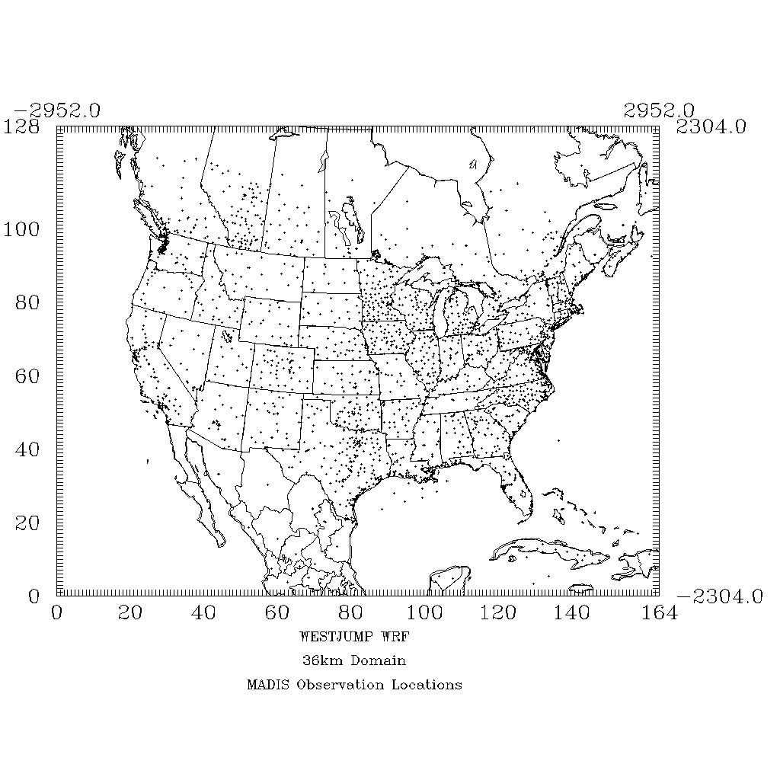

Figure 5-1. Locations of MADIS surface meteorological modeling sites with the WRF 36 km CONUS modeling domain.

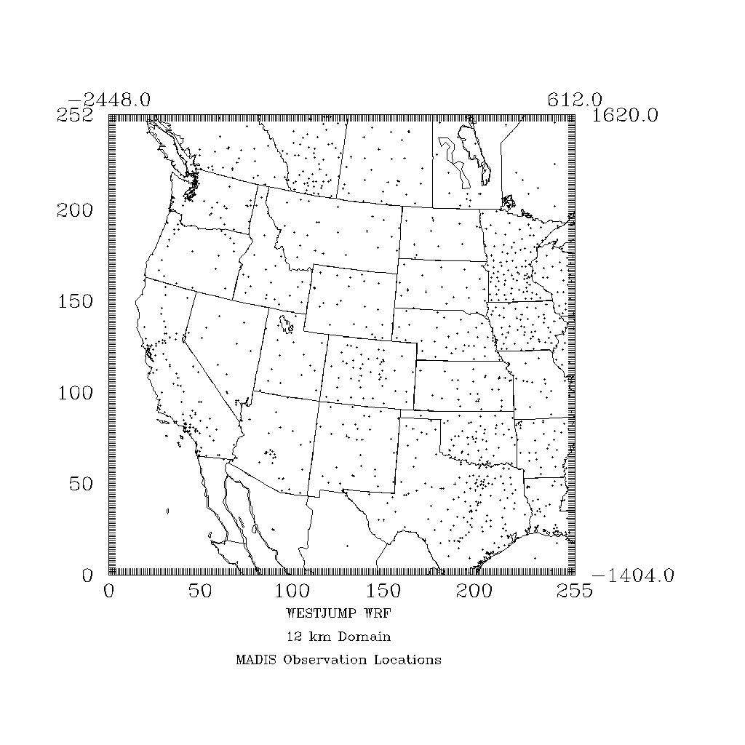

Figure 5-2. Locations of MADIS surface meteorological modeling sites with the WRF 12 km WESTUS modeling domain.

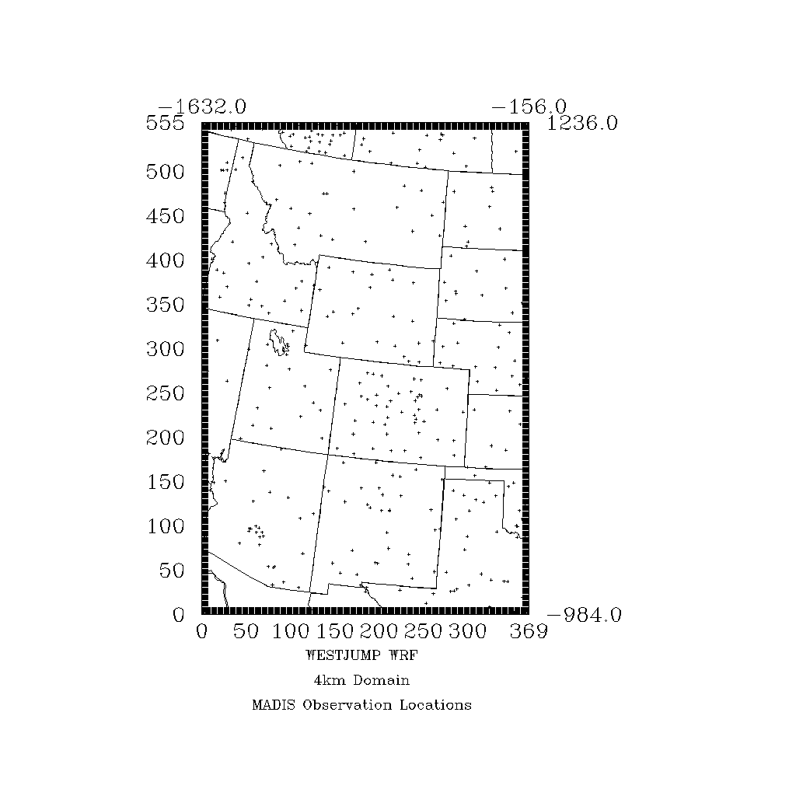

Figure 5-3. Locations of MADIS surface meteorological modeling sites with the WRF 4 km IMWD modeling domain used in the WestJumpAQMS (definition of the 4 km domain for the 3SAQS is under study).

The quantitative model performance evaluation of WRF using surface meteorological measurements will be performed using the publicly available METSTAT[17] and AMET[18] evaluation tools. Both tools calculate statistical performance metrics for bias, error, and correlation for surface winds, temperature, and mixing ratio and can produce time series of predicted and observed meteorological variables and performance statistics. A full annual model evaluation is very difficult to summarize in a single document, especially a simulation that could be used for many different purposes. With this in mind, the WRF model evaluation will present results for several subregions and even at the individual site level within the three-state area, leaving potential data users to independently judge the adequacy of the model simulation. Overall comparisons are offered to judge the model efficacy, but this review does not necessarily cover all potential user needs and applications.

Statistical metrics will be presented for each state, for each RPO, and for the United States portion of the 36 km, 12 km, and 4 km modeling domains. To evaluate the performance of the WRF 2011 simulation for the U.S., a number of performance benchmarks for comparison will be used. Emery et al.[19] derived and proposed a set of daily performance “benchmarks” for typical meteorological model performance. These standards were based upon the evaluation of about 30 MM5 and RAMS meteorological simulations of limited duration (multi-day episodes) in support of air quality modeling study applications performed over several years. These were primary ozone model applications for cities in the eastern and Midwestern U.S. and Texas that were primarily simple (flat) terrain and simple (stationary high pressure causing stagnation) meteorological conditions. More recently these benchmarks have been used in annual meteorological modeling studies that include areas with complex terrain and more complicated meteorological conditions; therefore, they must be viewed as being applied as *guidelines* and not *bright-line* numbers. That is, the purpose of these benchmarks is not to give a passing or failing grade to any one particular meteorological model application, but rather to put its results into the proper context of other models and meteorological data sets. Recognizing that these simple conditions benchmarks may not be appropriate for more complex conditions, McNally[20] analyzed multiple annual runs that included complex terrain conditions and suggested an alternative set of benchmarks for temperature under more complex conditions. As part of the WRAP meteorological modeling of the western U.S., including the Rocky Mountain Region, as well as the complex conditions up in Alaska, Kemball-Cook (2005b[21]) also came up with meteorological model performance benchmarks for complex conditions. Table 5-1 lists the meteorological model performance benchmarks for simple (Emery et al., 2001) and complex conditions, where we have adopted the complex benchmarks from Kemball-Cook et al., (2005b) since they covered more of the meteorological parameters.

The key to the benchmarks is to understand how well the model performs in this case, relative to other model applications run for the U.S. These benchmarks include bias and error in temperature, wind direction and mixing ratio as well as the wind speed bias and Root Mean Squared Error (RMSE) between the models and databases. The benchmark for each variable to judge whether predictions from a meteorological model are on par with previous meteorological modeling studies are as follows:

Table 5-1. Meteorological model performance benchmarks for simple and complex conditions.

|  |  |  |
| --- | --- | --- |
| **Parameter** | **Simple** | **Complex** |
| Temperature Bias | ≤ ±0.5 K | ≤ ±2.0 K |
| Temperature Error | ≤ 2.0 K | ≤ 3.5 K |
| Mixing Ratio Bias | ≤ ±1.0 g/kg | NA |
| Mixing Ratio Error | ≤ 2.0 g/kg | NA |
| Wind Speed Bias | ≤ ±0.5 m/s | ≤ ±1.5 m/s |
| Wind Speed RMSE | ≤ 2.0 m/s | ≤ 2.5 m/s |
| Wind Direction Bias | ≤ ±10 degrees | NA |
| Wind Direction Error | ≤ 30 degrees | ≤ 55 degrees |

The equations for bias and error are given below, with the equation for the Root Mean Squared Error (RMSE) similar to the unsigned error metric only being the square of the differences between the prediction and observation and a square root is taken of the entire quantity.

Bias = 

Error = 

Figure 5-4 displays an example model performance soccer plot graphic from the WestJumpAQMS 2008 WRF run for monthly temperature performance within the 36 km CONUS, 12 km WESTUS and 4 km IMWD domains. Shown in the “soccer plot” is the monthly temperature bias (x-axis) versus error (y-axis) as colored symbols with the simple and complex performance benchmarks[22] represented by the rectangles. When the WRF monthly performance achieves the benchmark, it falls within the rectangle (i.e., scores a goal). In this example we see the 2008 WRF simulation always achieves the complex benchmark in the 36 km domain and achieves the complex benchmark in 11 of 12 months over the 12 km domain, with just December falling just outside of the benchmark due to too warm temperatures. Across the 4 km domain, 7 of the 12 months achieve the complex benchmarks with 5 months failing due to overestimated temperatures.

|  |  |
| --- | --- |
|  |  |
|  | |
| Figure 5-4. Example quantitative model performance evaluation display using soccer plots that compare monthly temperature performance (colored symbols) across the 36 km CONUS (top left), 12 km WESTUS (top right) and 4 km IMWD (bottom) domains with the simple and complex model performance benchmarks (rectangles). | |

5.2 Quantitative Evaluation using ALOFT Meteorological Observations

The Atmospheric Model Evaluation Tool (AMET)[23] will be used to compare WRF predictions to aloft observations of winds, temperature, and humidity. Data from the NOAA Wind profiler network[24] will be used to evaluate the u and v wind components from the surface to the tropopause. Upper air profile data from the RAwindonse Observations (RAOB) network, which includes approximately 100 measurement sites in North America, will be used to evaluate potential temperature, relative humidity, and the wind components from the surface to the model top.

5.3 Qualitative Model Performance Evaluation

The qualitative model performance evaluation of the 3SAQS 2011 WRF simulation will compare spatial maps of WRF estimated precipitation with spatial maps precipitation based on observations from either the CPC retrospective analysis data or the PRISM data. When comparing the CPC/PRISM and WRF precipitation data, note that the CPC/PRISM analysis covers only the Continental U.S. and does not extend offshore or into Canada or Mexico. The WRF fields, on the other hand, cover the entire 36 km domain. Also note that the CPC analysis is based on a 0.25 x 0.25 degree (~25 km resolution[25]) grid that is based on an analysis of precipitation measurements at monitoring sites, while the WRF is based on either a 36 × 36 km, 12 × 12 km grid, or 4 × 4 km resolution. As the precipitation monitoring sites tend to be located at lower elevations (e.g., airports), the CPC analysis fields may not capture the enhanced precipitation at high elevations due to orographic effects that could be present in the WRF simulations. Note that the PRISM analysis fields do account for some of these orographic effects.

Figure 5-5 displays example precipitation comparisons of WRF and CPC fields from the WestJumpAQMS 2008 WRF simulations for the months of January and July and the continental U.S. For the 3SAQS 2011 WRF modeling all months would be compared, for each of the 36, 12 and 4 km domains.

|  |  |
| --- | --- |
| 0801 | 20080101-20080131 |
| 0807 | 20080701-20080731 |
| Figure 5-5. Example comparison of CPC analysis (left) and WRF modeling (right) monthly total precipitation amounts across the continental U.S. for the months of January (top) and July (bottom) from the WestJumpAQMS 2008 WRF simulation. | |

The WRF spatial distribution of clouds will be compared with satellite observations as another qualitative evaluation approach.

6.0 REFERENCES

Boylan, J.W. 2004. Calculating Statistics: Concentration Related Performance Goals. EPA PM Model Performance Workshop, Chapel Hill, NC. February 11.

Byun, D.W., and J.K.S. Ching. 1999. “Science Algorithms of the EPA Models-3 Community Multiscale Air Quality (CMAQ) Modeling System”, EPA/600/R-99/030.

Coats, C.J., 1995. Sparse Matrix Operator Kernel Emissions (SMOKE) Modeling System, MCNC Environmental Programs, Research Triangle Park, NC.

Emery, C.A., E. Tai, E., R. E. Morris, G. Yarwood. 2009a. Reducing Vertical Transport Over Complex Terrain in CMAQ and CAMx; AWMA Guideline on Air Quality Models Conference, Raleigh, NC, October 26-30, 2009.

Emery, C.A., E. Tai, R.E. Morris, G. Yarwood. 2009b. Reducing Vertical Transport Over Complex Terrain in Photochemical Grid Models; 8th Annual CMAS Conference, Chapel Hill, NC, October 19-21, 2009.ENVIRON. 2011a. User’s Guide – Comprehensive Air Quality Model with Extensions – Version 5.40. ENVIRON International Corporation, Novato, California. September. ([www.camx.com](http://www.camx.com)).

ENVIRON. 2011a. User’s Guide – Comprehensive Air Quality Model with Extensions – Version 5.40. ENVIRON International Corporation, Novato, California http://[www.camx.com](http://www.camx.com). September.

ENVIRON. 2011b. Western Regional Air Partnership (WRAP) West-wide Jump-start Air Quality Modeling Study (WestJumpAQMS) Scope of Work. ENVIRON International Corporation, Novato, California. June 20. (<http://www.wrapair2.org/pdf/WestJumpAQMS_SoW_July20_2011revision.pdf>).

ENVIRON. 2012a. Western Regional Air Partnership (WRAP) West-wide Jump-start Air Quality Modeling Study (WestJumpAQMS) Modeling Plan. ENVIRON International Corporation, Novato, California. January 23. (<http://www.wrapair2.org/pdf/WestJumpAQMS_Modeling_Plan_Final_Jan23_2012.pdf>).

ENVIRON and Alpine. 2012. Western Regional Air Partnership (WRAP) West-wide Jump-start Air Quality Modeling Study (WestJumpAQMS) – WRF Application/Evaluation. ENVIRON International Corporation, Novato, California. Alpine Geophysics, LLC. University of North Carolina. February 29. (<http://www.wrapair2.org/pdf/WestJumpAQMS_2008_Annual_WRF_Final_Report_February29_2012.pdf>).

EPA. 1991. Guideline on the Regulatory Application of the Urban Airshed Model. U.S. Environmental Protection Agency, Office of Air Quality Planning and Standards, technical Support Division, Source Receptor Analysis Branch, Research Triangle Park, North Carolina. July. (<http://www.epa.gov/ttn/scram/guidance/guide/uamreg.pdf>).

EPA. 2007. Guidance on the Use of Models and Other Analyses for Demonstrating Attainment of Air Quality Goals for Ozone, PM2.5 and Regional Haze. U.S. Environmental Protection Agency, Research Triangle Park, NC. EPA-454/B-07-002. April. (<http://www.epa.gov/ttn/scram/guidance/guide/final-03-pm-rh-guidance.pdf>).

Gebhart, K.A., B.A. Schichtel, M.G. Barna, M.A. Rodriguez and J. Hand. 2007. Meteorological Issues Associated with Nitrogen and Sulfur Deposition at Rocky Mountain National Park, Colorado. National Park Service, Air Resources Division, Fort Collins, Colorado. Presented at Air and Waste Management Association Meeting, Pittsburgh, PA, Paper No. 492. June.

Kemball-Cook, S., Y. Jia, C. Emery, R. Morris, Z. Wang and G. Tonnesen. 2005a. Annual 2002 MM5 Meteorological Modeling to Support Regional Haze Modeling of the Western United States. ENVIRON International Corporation, Novato, California. March. (<http://pah.cert.ucr.edu/aqm/308/reports/mm5/DrftFnl_2002MM5_FinalWRAP_Eval.pdf>).

Kemball-Cook, S., Y. Jia, C. Emery and R. Morris. 2005b. “Alaska MM5 Modeling for the 2002 Annual Period to Support Visibility Modeling” Prepared for Western Regional Air Partnership (WRAP). Prepared by Environ International Corporation. September. <http://pah.cert.ucr.edu/aqm/308/docs/alaska/Alaska_MM5_DraftReport_Sept05.pdf>

McNally, D. E., 2009. “12km MM5 Performance Goals.” Presentation to the Ad-Hoc Meteorology Group. 25-June. <http://www.epa.gov/scram001/adhoc/mcnally2009.pdf>

Michalakes, J., J. Dudhia, D. Gill, J. Klemp and W. Skamarock. 1998. Design of a Next-Generation Regional Weather Research and Forecast Model. Mesoscale and Microscale Meteorological Division, National Center for Atmospheric Research, Boulder, CO. (<http://www.mcs.anl.gov/~michalak/ecmwf98/final.html>).

Michalakes, J., S. Chen, J. Dudhia, L. Hart, J. Klemp, J. Middlecoff and W. Skamarock. 2001. Development of a Next-Generation Regional Weather Research and Forecast Model. Developments in Teracomputing: Proceedings of the 9th ECMWF Workshop on the Use of High Performance Computing in Meteorology. Eds. Walter Zwieflhofer and Norbet Kreitz. World Scientific, Singapore. Pp. 269-276. (<http://www.mmm.ucar.edu/mm5/mpp/ecmwf01.htm>).

Michalakes, J., J. Dudhia, D. Gill, T. Henderson, J. Klemp, W. Skamarock and W. Wang. 2004. The Weather Research and Forecast Model: Software Architecture and Performance. Proceedings of the 11th ECMWF Workshop on the Use of High Performance Computing in Meteorology. October 25-29, 2005, Reading UK. Ed. George Mozdzynski. (<http://wrf-model.org/wrfadmin/docs/ecmwf_2004.pdf>).

Skamarock, W. C. 2004. Evaluating Mesoscale NWP Models Using Kinetic Energy Spectra. *Mon. Wea. Rev.*, Volume 132, pp. 3019-3032. December. (<http://www.mmm.ucar.edu/individual/skamarock/spectra_mwr_2004.pdf>).

Skamarock, W. C., J. B. Klemp, J. Dudhia, D. O. Gill, D. M. Barker, W. Wang and J. G. Powers. 2005. A Description of the Advanced Research WRF Version 2. National Center for Atmospheric Research (NCAR), Boulder, CO. June. (<http://www.mmm.ucar.edu/wrf/users/docs/arw_v2.pdf>)

Skamarock, W. C. 2006. Positive-Definite and Monotonic Limiters for Unrestricted-Time-Step Transport Schemes. *Mon. Wea. Rev.*, Volume 134, pp. 2241-2242. June. (<http://www.mmm.ucar.edu/individual/skamarock/advect3d_mwr.pdf>).

1. <http://www.epa.gov/pm/actions.html#jun12>
2. <http://wrf-model.org/users/users.php>
3. <http://www.wrf-model.org/index.php>
4. All references to WRF in this document refer to the WRF-ARW
5. <http://www.epa.gov/ttn/scram/guidance/guide/final-03-pm-rh-guidance.pdf>
6. <http://www.epa.gov/ttn/scram/guidance/guide/uamreg.pdf>
7. <http://dss.ucar.edu/>
8. <http://www.ecmwf.int/products/data/archive/descriptions/ei/index.html>
9. http://polar.ncep.noaa.gov/sst
10. Real-time, global, sea surface temperature (RTG-SST) analysis. <http://polar.ncep.noaa.gov/sst/oper/Welcome.html>
11. Meteorological Assimilation Data Ingest System. <http://madis.noaa.gov/>
12. National Climatic Data Center. <http://lwf.ncdc.noaa.gov/oa/ncdc.html>
13. National Data Buoy Center. <http://www.ndbc.noaa.gov/cman.php>
14. <http://www.prism.oregonstate.edu/>
15. <http://www.wrapair2.org/pdf/WestJumpAQMS_2008_Annual_WRF_Final_Report_February29_2012.pdf>
16. Note that the decision to use the 4 km IMWD or 4 km domain tailored for the 3SAQS has not been made, the use of the IMWD in Figure 5-3 is for illustrative purposes only.
17. <http://www.camx.com/down/support.php>
18. http://www.cmascenter.org
19. Emery, C., E. Tai, and G. Yarwood, 2001. “Enhanced Meteorological Modeling and Performance Evaluation for Two Texas Ozone Episodes.” Prepared for the Texas Natural Resource Conservation Commission, prepared by ENVIRON International Corporation, Novato, CA. 31-August. <http://www.tceq.texas.gov/assets/public/implementation/air/am/contracts/reports/mm/EnhancedMetModelingAndPerformanceEvaluation.pdf>
20. McNally, D. E., 2009. “12km MM5 Performance Goals.” Presentation to the Ad-Hoc Meteorology Group. 25-June. <http://www.epa.gov/scram001/adhoc/mcnally2009.pdf>
21. Kemball-Cook, S., Y. Jia, C. Emery and R. Morris. 2005. “Alaska MM5 Modeling for the 2002 Annual Period to Support Visibility Modeling” Prepared for Western Regional Air Partnership (WRAP). Prepared by Environ International Corporation. September. <http://pah.cert.ucr.edu/aqm/308/docs/alaska/Alaska_MM5_DraftReport_Sept05.pdf>
22. Note that Figure 5-4 is using the McNally (2009) versions of the complex benchmark for temperature whereas we have adopted the Kemball-Cook (2005b) versions for the temperature and wind benchmarks.
23. http://www.cmascenter.org/conference/2005/abstracts/6_1.pdf
24. http://www.profiler.noaa.gov/npn/aboutNpnProfilers.jsp
25. Latitude/longitude coordinate system is an irregular grid with a 0.25 by 0.25 degree grid corresponding to a grid resolution of 18 to 28 km over the U.S.