3-States Air Quality Study Network Evaluation:

Summary of 31 January 2014 WOrking Group Conference Call

Representatives from CDPHE, UDAQ, WYDEQ, WY BLM, UT BLM, USFS, NPS and U.S. EPA attended the call (see table below) along with Tom Moore and Till Stoeckenius. The discussion focused on incorporation of new information gathered since last week’s call into a set of draft 3-State Air Quality Study (3SAQS) network configuration and funding recommendations to be delivered to the 3SAQS Steering Committee by 21 February.
Till will prepare a draft of the recommendations to be given to the Steering Committee over the next week and send it out to the Working Group for comment. We will then convene a follow-up conference call with the Working Group at 12:30 MST on 11 February to discuss the draft recommendations.
31 January 2014 Call Participants
Colorado Dept. of Health and Environment (CDPHE) | Gordon Pierce  Greg Harshfield
U.S. Environmental Protection Agency (EPA) | Gail Tonnesen  Rebecca Matichuk
National Park Service (NPS) | Mike George
Wyoming Bureau of Land Management (WY BLM) | Charis Tuers
Utah Bureau of Land Management (UT BLM) | Collin Schwartz
Utah Division of Air Quality (UDAQ) | Patrick Barickman
Wyoming Dept. of Environmental Quality (WYDEQ) | Cara Keslar
U.S. Forest Service (USFS) | Debbie Miller

Locations of monitoring sites discussed below are depicted in the attached map. All monitoring sites will have instrumentation for continuous measurement of ambient ozone concentrations. Meteorological parameters and other trace gasses may be monitored in addition to ozone at some sites as funding allows. Several of the USFS sites will only operate seasonally (roughly April – October depending on location).
Specific action items identified during the call are listed in italics.

New sites at Douglas Pass, Kremmling and Medicine Bow NF
Assuming resources are available at currently anticipated levels, the USFS is planning on opening new POM sites at Douglas Pass, Kremmling and Medicine Bow NF this year. Exact locations still need to be determined.
Debbie to confirm with John Korfmacher that USFS will be able to establish and operate the new sites without additional outside funding;
Decisions on which sites will be year-round vs. seasonal still need to be made;
Need to confirm mechanism for data upload to AQS.
USFS plans to close the Dutch John and Norwood sites (the later after confirming with other interested parties) and may also close Trout Creek Pass. Decision to maintain Silt-Collbran and Grand Mesa is subject to further review. USFS anticipates keeping all other sites in their current Colorado network in operation (Briggsdale, Goliath Peak, Flattops, Ripple Creek, Sunlight Mountain, McClure Pass, Kenosha Pass, Weminuche (Shamrock), Little Mountain, Pawnee Buttes (new site opening 2014) and Deadman Pass (new site).

Dinosaur East and Lay Peak
Lay Peak (operated by CDPHE via contract with ARS using funding from the 3SAQS Pilot Study) could be closed as early as the end of 2014. The Working Group feels that closure of this site is warranted if it means that monitoring can be conducted at a new location in northwestern Colorado such as the proposed Dinosaur East site. If not, CDPHE has indicated that they may be able to continue operating Lay Peak through 2015 or even 2016 without additional 3SAQS funding. CDPHE has also indicated that they may be able to pay cost of moving the Lay Peak site to a new location.
There is agreement among Working Group members that a new site in the Dinosaur East area would be very desirable. However, considerable logistical challenges will have to be overcome to make this happen. Options for monitoring include a seasonal POM (which could be solar powered), a winterized POM (which might require grid power) or a complete FEM site. Year-round monitoring is desirable given the potential location with respect to the Uinta Basin. Monitoring equipment from Lay Peak could be used to establish a permanent FEM site at Dinosaur East if sufficient infrastructure is available.
Barkley Sive (NPS) will check with contacts at Dinosaur NM regarding availability of power at the eastern end of the NM.
Debbie will talk to John Korfmacher regarding feasibility of providing a winterized POM at the proposed location and determine in conjunction with NPS/CDPHE if infrastructure exits to support it.

Paradox
Establishment of a new monitor in the vicinity of the town of Paradox in southwestern Colorado near the Utah state line was identified as a “medium” priority objective by the Working Group as a whole, a priority ranking lower than that for the other monitoring sites in Colorado discussed above (Douglas Pass, Kremmling, Dinosaur East, and Medicine Bow). Setup and operation of a monitor at this location would be expensive given the distance from other sites. The Working Group has not reached a recommendation regarding this potential site.

Walden
Closure of the Walden site after conclusion of the FRAPPE study in October, 2014 is being considered by the USFS. If this year-round site with multiple monitoring parameters other than ozone is closed, it might be possible to use the equipment at the proposed Dinosaur East site. Tom made the point that the site is useful for model performance since it is well-instrumented (including NOx, CO, SO2 and a met. package).
Debbie will discuss disposition of the Walden site with USFS management.

Other New Sites
During previous conference calls, Debbie M. and John K. indicated that the USFS is planning to open a new Holy Cross monitoring site near Vail, CO as a replacement for the former Wilson site and a new site at Deadman Pass northwest of Fort Collins, CO. A third new USFS site is planned for Snowbird, UT. In addition, the Desert Research Institute has announced plans to begin ozone monitoring at its Storm Peak high altitude observatory at Steamboat Springs.

Fruitland, Price and Escalante
There is agreement among Working Group members that continued monitoring at Fruitland, Price and Escalante would be of high value to the 3SAQS. Fruitland and Price are currently being operated by UDAQ using (at least in part) 3SAQS Pilot Study funding. Based on discussions between NPS, UT BLM and UDAQ, operations at all three sites could be continued via a combination of contractor assistance and some agency funding provided by 3SAQS and in-kind resources provided by UT BLM and UDAQ. Under this arrangement, site operations would be taken over by UT BLM: UT BLM would conduct monthly site visits and perform at least weekly data downloads and QA checks. UDAQ would continue to provide rent, utilities and data links that they have been paying for up to this point. UDAQ would provide UT BLM with technical support and advice, especially during the transition period. UDAQ would also audit each site at least once per year and provide equipment maintenance services supported by 3SAQS funding. Any required unscheduled site visits would be jointly coordinated between UDAQ and UT BLM. A contractor would be engaged by NPS to perform data uploading to AQS.

Converse County, WY
WDEQ has been conducting monitoring in Converse County using a mobile trailer via agreement with University of Wyoming. This arrangement is currently scheduled to continue through August, 2014. Data meets FEM criteria but is not being reported to AQS. WDEQ and WY BLM anticipate that air quality monitoring will continue in this area beyond August given the need to monitor impact of existing and planned future development. The Working Group anticipates that continued monitoring will not require 3SAQS funding. WDEQ and WY BLM have agreed to provide monitoring data to the 3SAQS.

Hiawatha
Current funding for Hiawatha may end in March, 2014 pending final budget vote by the Wyoming legislature. The Working Group feels that continued monitoring at Hiawatha is a high priority. Given the uncertainty about future funding by WY DEQ, the Working Group has decided that the 3SAQS budget should include a contingency calling for monitoring to be continued at Hiawatha in lieu of 3SAQS funding for a different monitoring location included in the final recommendations.

VOC Monitoring at Wamsutter
WYDEQ has sufficient funding to continue VOC monitoring at Wamsutter through March 2015. A decision about continuation of this monitoring activity can be made at a later date based on available funding, results of a review of data collected thus far and evaluation of other monitoring priorities.

Riverton
Current uncertainties regarding tribal land jurisdictions preclude additional monitoring in the Riverton area by WY DEQ or federal agencies. The Working Group suggests that the best avenue towards siting an ozone monitor in this area would be to work with the tribes to add ozone to their current air monitoring activities.
Gail Tonnesen will seek further information on future tribal monitoring plans.

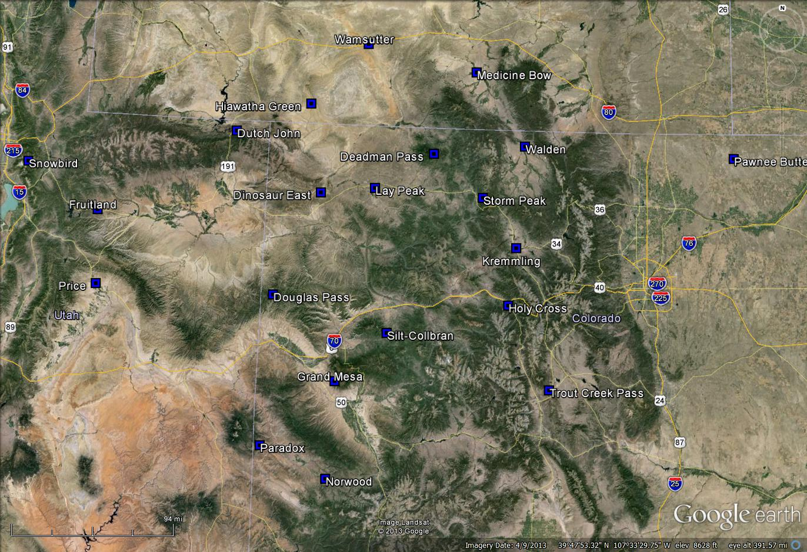Existing/potential monitoring site locations mentioned in this memo.

