|  |  |
| --- | --- |
| **Three-State Air Quality Modeling Study**  **CAMx Photochemical Grid Model**  **Draft Model Performance Evaluation**  **Simulation Year 2008**  Prepared by:  **Z. Adelman, U. Shankar, D. Yang**  University of North Carolina  Institute for the Environment  Chapel Hill, NC 27599-6116  R. Morris  ENVIRON International Corporation  773 San Marin Drive, Suite 2115  Novato, California, 94945  September 2014 | http://extras.mnginteractive.com/live/media/site36/2009/0129/20090129__DOWNTOWN_CM01~p1.jpgcolorado-flag.jpghttp://www.nahrepslc.org/Resources/Pictures/SaltLakeCity.jpgUtah Flag.GIF  http://t2.gstatic.com/images?q=tbn:ANd9GcTiWyKMQy1f6qdUtlC4h3RcXR894AGLyZEvnDYfBAlBfchPYY8anunst083.gif |

CONTENTS

1 Executive Summary 6

2 Introduction 9

2.1 Background 9

2.2 Overview 9

3 Approach 11

3.1 CAMx Science and Input Data Configuration 11

3.2 Model Performance Evaluation Procedures 14

3.2.1 Overview of Model Performance Evaluation 14

3.2.2 Available Aerometric Data for the Model Evaluation 14

3.2.3 Atmospheric Model Evaluation Tool (AMET) 21

3.3 CAMx Post-processing and Model-Observations Pairing 21

3.4 Model Performance Statistics, Goals and Criteria 22

4 2008 Model Performance Evaluation 27

4.1 Ozone and Precursors Model Performance 27

4.1.1 3SAQS 12-km Domain Model Performance 27

4.1.2 Colorado Model Performance 31

4.1.3 Utah Model Performance 39

4.1.4 Wyoming Model Performance 47

4.2 Particulate Matter Model Performance 56

4.2.1 Correlations of Model Performance by Season 60

4.2.2 Performance Metrics of Monthly PM2.5 65

4.2.3 Monthly Average PM Performance Over the Domain 72

4.2.4 Comparisons of PM2.5 Composition in Urban and Rural Sites 79

4.3 Wet Deposition Model Performance 84

4.4 Comparisons to WestJumpAQMS CAMx Performance 88

4.4.1 Ozone performance comparison 88

4.4.2 PM Performance Comparison 92

5 References 96

APPENDIX A A-1

A.1 CAMx Species Post-processing Expressions A-1

A.2 AMET Model to Observations Pairing Expressions A-2

**TABLES**

Table 3–1. Projection parameters for the 3SAQS modeling domains. 11

Table 3–2. CAMx (Version 5.41) model configurations for 3SAQS 13

Table 3–3. PM model performance goals and criteria. 23

Table 3–4. Definition of model performance evaluation statistical measures used to evaluate the CTMs. 25

Table 4–1. 12-km domain ozone and gas-phase species performance indicators 28

Table 4–2. Colorado ozone and gas-phase species performance indicators 34

Table 4–3. Utah ozone and gas-phase species performance indicators 41

Table 4–4. Wyoming ozone and gas-phase species performance indicators 49

Table 4–5. 12-km modeling domain particulate matter species performance indicators 56

Table 4–6. 12-km modeling domain deposition species performance indicators 84

Table 4–7. 12-km CAMx modeling performance comparison of MDA8 at AQS sites between the WestJumpAQMS and 3SAQS projects 89

Table 4–8. 12-km CAMx modeling performance comparison of MDA8 at CASTNet sites between the WestJumpAQMS and 3SAQS projects 89

Table 4–9. 12-km CAMx modeling performance comparison of Total PM2.5 at IMPROVE sites between the WestJumpAQMS and 3SAQS projects 92

Table 4–10. 12-km CAMx modeling performance comparison of Total PM2.5 at CSN sites between the WestJumpAQMS and 3SAQS projects 92

**FIGURES**

Figure 3–1. 36 km CONUS and 12 km WESTUS processing domain used for developing PGM emission inputs. 11

Figure 3–2. Locations of AIRS O3 (pink) and FRM PM2.5 mass (yellow) monitoring sites in the three state region showing active and inactive (with black dot) sites (source: http://www.epa.gov/airquality/airdata/ad_maps.html). 15

Figure 3–3. Locations of CSN speciated PM2.5 monitoring sites (source: http://www.epa.gov/ttn/amtic/speciepg.html). 16

Figure 3–4. Locations of IMPROVE monitoring sites (source: http://vista.cira.colostate.edu/IMPROVE/) 17

Figure 3–5. Locations of CASTNet monitoring sites (source: http://epa.gov/castnet/javaweb/index.html). 18

Figure 3–6. Locations of NADP monitoring sites (source: http://nadp.sws.uiuc.edu/). 19

Figure 3–7. Locations of UGRWOS monitoring sites (source: http://deq.state.wy.us/aqd/Upper%20Green%20Winter%20Ozone%20Study.asp) 20

Figure 4–1. CAMx 3SAQS 2008 base case model performance for daily maximum 1-hr and 8-hr ozone concentrations for all AQS (red) and CASTNet (blue) sites in the 12-km domain. 29

Figure 4–2.Q-Q plots of CAMx 3SAQS 2008 MDA8 for the 12-km modeling domain; (L) AQS and (R) CASTNet 30

Figure 4–3. CAMx mean monthly bias in MDA8 at all AQS and CASTNet sites in the 12-km modeling domain 30

Figure 4–4. CAMx 3SAQS 2008 base case monthly model performance for daily maximum 1-hr (left) and 8-hr ozone (right) concentrations for all AQS (top) and CASTNet (bottom) sites in the 12-km domain. 31

Figure 4–5. Q-Q plots of CAMx 3SAQS 2008 MDA8 for CO sites; (L) AQS and (R) CASTNet 34

Figure 4–6. CAMx 3SAQS 2008 base case model performance for daily maximum 1-hr and 8-hr ozone concentrations for all AQS (red) and CASTNET (blue) sites in Colorado. 35

Figure 4–7. CAMx mean monthly bias in MDA8 at Colorado AQS and CASTNet sites (left); Colorado AQS site-specific monthly MD8A NMB (right). 36

Figure 4–8. CAMx 3SAQS 2008 base case monthly model performance for MDA1 (left) and MDA8 (right) concentrations for all AQS (top) and CASTNET (bottom) sites in Colorado. 36

Figure 4–9. Annual 2008 MDA8 timeseries at the AQS South Mason St. Ft. Collins, CO monitor; satellite imagery of pink site marker shown in right panel 37

Figure 4–10. Annual 2008 MDA8 timeseries at the CASTNet Gothic, CO monitor 37

Figure 4–11. CAMx 3SAQS 2008 base case monthly model performance for hourly O3 (UL), NOx (UR), CO (LL), and SO2 (LR) at AQS sites in Colorado. 38

Figure 4–12. CAMx 3SAQS 2008 base case ozone season (June-August) average diurnal hourly O3 (left) and NOx (right) timeseries for AQS sites in Colorado. 39

Figure 4–13. Q-Q plots of CAMx 3SAQS 2008 MDA8 for UT sites; (L) AQS and (R) CASTNet 42

Figure 4–14. CAMx 3SAQS 2008 base case model performance for daily maximum 1-hr and 8-hr ozone concentrations for all AQS (red) and CASTNET (blue) sites in Utah. 43

Figure 4–15. CAMx mean monthly bias in MDA8 at Utah AQS and CASTNet sites (left); Utah AQS site-specific monthly MD8A NMB (right). 44

Figure 4–16. CAMx 3SAQS 2008 base case monthly model performance for MDA1 (left) and MDA8 (right) concentrations for all AQS (top) and CASTNET (bottom) sites in Utah. 44

Figure 4–17. Hawthorne AQS Site (Salt Lake City, UT) MD8 (left) and NOx (right) CAMx and observed timeseries for November (top) and annual 2008 (bottom). The annual plots have two panes: concentrations on the top and bias on the bottom 45

Figure 4–18. CAMx 3SAQS 2008 base case monthly model performance for hourly O3 (UL), NOx (UR), CO (LL), and SO2 (LR) at AQS sites in Utah. 46

Figure 4–19. CAMx 3SAQS 2008 base case ozone season (June-August) average diurnal hourly O3 (left) and NOx (right) timeseries for AQS sites in Utah. 47

Figure 4–20. Q-Q plots of CAMx 3SAQS 2008 MDA8 for WY sites; (L) AQS and (R) CASTNet 50

Figure 4–21. CAMx 3SAQS 2008 base case model performance for daily maximum 1-hr and 8-hr ozone concentrations for all AQS (red) and CASTNET (blue) sites in Wyoming. 51

Figure 4–22. CAMx mean monthly bias in MDA8 at Wyoming AQS and CASTNet sites (left); Wyoming AQS site-specific monthly MD8A NMB (right). 52

Figure 4–23. Annual (top) and February (bottom) 2008 MDA8 timeseries at the AQS Boulder, WY monitor 53

Figure 4–24. CAMx 3SAQS 2008 base case monthly model performance for hourly O3 (UL), NOx (UR), CO (LL), and SO2 (LR) at AQS sites in Wyoming. 54

Figure 4–25. CAMx 3SAQS 2008 base case ozone season (June-August) average diurnal hourly O3 (left) and NOx (right) timeseries for AQS sites in Wyoming. 55

Figure 4–26. Spatial distribution of PM2.5 fractional bias (%): UL – Winter; UR – Spring; LL – Summer; LR – Fall. 57

Figure 4–27. Spatial distribution of SO4 fractional bias (%): UL – Winter; UR – Spring; LL – Summer; LR – Fall. 58

Figure 4–28. Spatial distribution of NH4 fractional bias (%): UL – Winter; UR – Spring; LL – Summer; LR – Fall. 58

Figure 4–29. Spatial distribution of NO3 fractional bias (%): UL – Winter; UR – Spring; LL – Summer; LR – Fall. 59

Figure 4–30. Spatial distribution of ECfractional bias (%): UL – Winter; UR – Spring; LL – Summer; LR – Fall 59

Figure 4–31. Spatial distribution of OCfractional bias (%): UL – Winter; UR – Spring; LL – Summer; LR – Fall. 60

Figure 4–32. Modeled-vs.-observed PM2.5 correlation for the 12-km domain: UL – Winter; UR – Spring; LL – Summer; LR – Fall. 61

Figure 4–33. Modeled-vs.-observed PM2.5 correlation for the Colorado: UL – Winter; UR – Spring; LL – Summer; LR – Fall. 62

Figure 4–34. Modeled-vs.-observed PM2.5 correlation for the Utah: UL – Winter; UR – Spring; LL – Summer; LR – Fall. 63

Figure 4–35. Modeled-vs.-observed PM2.5 correlation for the Wyoming: UL – Winter; UR – Spring; LL – Summer; LR – Fall. 64

Figure 4–36. PM2.5 fractional bias (%) compared to IMPROVE and CSN observations for : UL – 12-km domain; UR – CO; LL – WY; LR – UT. 66

Figure 4–37. PM2.5 fractional error (%) comparisons as for Figure 4–36. 66

Figure 4–38. SO4 fractional bias (%) compared to IMPROVE and CSN observations for : UL – 12-km domain; UR – CO; LL – WY; LR – UT. 67

Figure 4–39. SO4 fractional error (%) comparisons as for Figure 4–38. 67

Figure 4–40. NO3 fractional bias (%) compared to IMPROVE and CSN observations for : UL – 12-km domain; UR – CO; LL – WY; LR – UT. 68

Figure 4–41. NO3 fractional error (%) comparisons as for Figure 4–40. 68

Figure 4–42. NH4 fractional bias (%) compared to IMPROVE and CSN observations for : UL – 12-km domain; UR – CO; LL – WY; LR – UT. 69

Figure 4–43. NH4 fractional error (%) comparisons as for Figure 4–42. 69

Figure 4–44. ECfractional bias (%) compared to IMPROVE and CSN observations for : UL – 12-km domain; UR – CO; LL – WY; LR – UT. 70

Figure 4–45. ECfractional error (%) comparisons as for Figure 4–44. 70

Figure 4–46. OCfractional bias (%) compared to IMPROVE and CSN observations for : UL – 12-km domain; UR – CO; LL – WY; LR – UT. 71

Figure 4–47. OCfractional error (%) comparisons as for Figure 4–46. 71

Figure 4–48. NME (%) vs. NMB (%) for PM2.5 73

Figure 4–49. NME (%) vs. NMB (%) for SO4 74

Figure 4–50. NME (%) vs. NMB (%) for NO3 75

Figure 4–51. NME (%) vs. NMB (%) for NH4 76

Figure 4–52. NME (%) vs. NMB (%) for EC 77

Figure 4–53. NME (%) vs. NMB (%) for OC. 78

Figure 4–54. Seasonal average PM2.5 composition comparisons for the 12-km domain 80

Figure 4–55. Seasonal average PM2.5 composition comparisons for Colorado. 81

Figure 4–56. Seasonal average PM2.5 composition comparisons for Utah. 82

Figure 4–57. Seasonal average PM2.5 composition comparisons for Wyoming. 83

Figure 4–58. NME (%) vs. NMB (%) for SO4 deposition from NADP monitor locations: UL – 12-km domain; UR - CO; LL - WY; LR - UT. 85

Figure 4–59. NME (%) vs. NMB (%) for NO3 deposition from NADP monitor locations: UL – 12-km domain; UR - CO; LL - WY; LR - UT. 86

Figure 4–60. NME (%) vs. NMB (%) for NH4 deposition from NADP monitor locations: UL – 12-km domain; UR - CO; LL - WY; LR - UT. 87

Figure 4–61. 3SAQS vs WestJumpAQMS 12-km domain wide hourly ozone comparisons at sites in the AQS (left) and CASTNet (right) networks 89

Figure 4–62. 3SAQS vs WestJumpAQMS CAMx 12-km MDA1 (left) and MDA8 (right) comparisons at sites in the AQS network 90

Figure 4–63. AQS site MDA8 fractional bias and errors for the 3SAQS and WestJumpAQMS 12-km CAMx modeling results 91

Figure 4–64. 3SAQS vs WestJumpAQMS CAMx 12-km total PM2.5 comparisons at the IMPROVE (left) and CSN (right) monitoring networks 93

Figure 4–65. IMPROVE Total PM2.5 fractional bias and errors for the 3SAQS and WestJumpAQMS 12-km CAMx modeling results 94

Figure 4–66. 3SAQS vs WestJumpAQMS CAMx 12-km PM species comparisons at sites in the PM monitoring networks. 95

# Executive Summary

The 3SAQS project performed photochemical grid modeling (PGM) for the year 2008 using the Comprehensive Air Quality Model with Extensions (CAMx) version 5.41. The 3SAQS 2008 Modeling Protocol details the CAMx configuration and justification for why it was chosen for the 3SAQS. This document presents the CAMx 2008 model performance evaluation (MPE) for the 3SAQS 2008 base year simulation version B (CAMx_3SAQS_Base08b). We conducted the MPE for ozone, fine particulate matter (PM2.5), and wet deposition species. We evaluated the performance of hourly ozone as well as daily maximum 1-hour (MDA1) and daily maximum 8-hour average (MDA8) ozone. In addition to ozone, we also included carbon monoxide (CO), nitrogen oxides (NOx), and sulfur dioxide (SO2) gas-phase species in the evaluation. We did not include volatile organic compounds (VOC) or ammonia (NH3) in the evaluation because observational data for these species were either not readily available or sparse in the Three-State Region. The PM2.5 evaluation includes total PM2.5 along with the component species sulfate (SO4), nitrate (NO3), ammonium (NH4), elemental carbon (EC), organic carbon (OC), and other PM (PM Other). The deposition evaluation focused on total sulfur and oxidized and reduced nitrogen species. We did not include dry deposition species or visibility metrics in the MPE.

We evaluated the 3SAQS 2008 base case model performance against concurrent measured ambient concentrations using graphical displays of model performance and statistical model performance measures. We compared these measures against established model performance goals and criteria, following the procedures recommended in EPA’s photochemical modeling guidance documents. The evaluation included sub-regional evaluations for Colorado, Utah, and Wyoming, and evaluations by month and season.

The 3SAQS 12-km domain-wide ozone model performance meets the performance goals for both MDA1 and MDA8. CAMx has a positive bias for ozone at both the AQS and CASTNet networks; with higher fractional bias at the AQS sites (1-hour: 7.8%, MDA8: 12.6%) compared to the CASTNet sites (1-hour: 4.15%, MDA8: 6.5%). On days with elevated O3 measurements (> 60 ppb), CAMx has a negative bias, with lower fractional bias at the AQS sites (1-hour: -8.8%, MDA8: -7.4%) compared to the CASTNET sites (1-hour: -11.7%, MDA8: -11.0%).

The CAMx O3 estimates for Colorado meet the bias (NMB: 6.0-14.2%) and error (NME: 12.0-30.3%) performance goals on an annual basis for hourly O3, MDA1, and MDA8. The CAMx biases for Colorado are lowest during the spring and summer months at the AQS sites and during the winter and spring at the CASTNet sites. The simple O3 performance bias goal of ±15% is exceeded in September-December for the AQS sites and in September for the CASTNet sites. In general, CAMx performance at the Colorado AQS monitors is better during periods of elevated ozone.

The CAMx O3 estimates for Utah are within the bias (NMB: 0.2-17.6%) and error (NME: 9.0-30.3%) performance goals on an annual basis for hourly O3, MDA1, and MDA8. Like at the Colorado sites, the CAMx biases are lowest during the spring and summer months at the Utah AQS sites and during the winter and spring at the CASTNet sites. The simple O3 performance bias goal of ±15% is exceeded at the AQS sites in January, October, and December; the criteria bias of ±35% is exceeded in November. CAMx has a low bias (NMB and FB <8%) in all months at the CASTNet site.

The CAMx O3 estimates for Wyoming are within the bias (NMB: 0.26-11.4%) and error (NME: 10.8-22.8%) performance goals on an annual basis for hourly O3, MDA1, and MDA8. The CAMx biases are lowest during the summer months at the Wyoming AQS sites and during the winter and summer at the CASTNet sites. The simple MDA8 performance bias goal of ±15% is only exceeded February at the AQS sites; CAMx meets the performance goals at the Wyoming CASTNet sites in every month. The CAMx MDA8 underestimates at the Boulder site, along with the two other Sublette County sites (Jonah and Daniel South) in February, indicate winter O3 formation related to oil and gas operations. The 3SAQS Base 2008 CAMx modeling platform is not configured to simulate the conditions that lead to winter O3 formation. Additional work on the components of the modeling platform is required to reproduce the radiative, dynamic, and emissions that to lead to high wintertime O3 concentrations.

Modeled PM2.5 meets or exceeds the performance goal in the summer months over the 12-km domain relative to IMPROVE and CSN, but falls outside the criteria at the IMPROVE sites in the winter. The performance is within the criteria in UT at CSN sites in all months. In general, the urban (CSN) sites, where PM concentrations are larger, show better performance than in the remote sites in the 12-km domain, and in CO and UT. Spatially across the 12-km modeling domain CAMx is overbiased in the western part of the domain and the four corners states in the winter and spring, and in most of these regions in the fall. The model tends to be underbiased in summer in some of these same regions, as well as in the upper Midwest. On a seasonal basis, CAMx significantly overpredicts observations from both the IMPROVE and CSN networks across the 12-km domain, in all seasons except for the summer. The overprediction is greatest in the winter at the IMPROVE sites, and much less in the summer at the CSN sites.

Domain-wide, sulfate wet deposition model performance is outside the performance criteria for all but the spring months, and moderately overbiased. In CO, the fall months show an underbias in SO4, but are within the performance criteria; the fall and winter months are overbiased, with the latter being beyond the plot range. The errors are smaller in WY and UT; overall SO4 performance in UT appears to be the best of the three states. Nitrate deposition performance for the 12-km domain shows an underbias in most of the year, although the bias and error values fall within the performance criteria except in December. The performance for NH4 wet deposition shows the model being underbiased in several months in the 12-km domain as a whole, and in the three states although the performance in UT is within the acceptable range in the spring and fall. Exceptions to the underbias are the late fall and early winter in the 12-km domain, and May, June and October in CO, wherein the overbias falling outside the plot range. WY also shows sporadic occurrences of NME outside the performance criteria.

# Introduction

## Background

The Three-State Air Quality Study (3SAQS) includes cooperators from U.S. Environmental Protection Agency (EPA), United States Forest Service (USFS), Bureau of Land Management (BLM), National Park service (NPS), and the state air quality management agencies of Colorado, Utah, and Wyoming. The 3SAQS is intended to facilitate air resource analyses for federal and state agencies in the states of Wyoming, Colorado, and Utah toward improved information for the public and stakeholders as a part of the National Environmental Policy Act (NEPA) and potentially other studies. Funded by the Environmental Protection Agency (EPA), Bureau of Land Management (BLM), and the U.S. Forest Service (USFS) and with in-kind support from the National Park Service (NPS) and Colorado, Utah, and Wyoming state air agencies, by working closely with cooperators and overseeing the various agreements, the main focus of the study is on assessing the environmental impacts of sources related to oil and gas development and production. In particular, the cooperators will use photochemical grid models (PGMs) to quantify the impacts of proposed oil and gas development projects within the 3SAQS region on current and future air quality, including ozone and visibility levels in the National Parks and Wilderness Areas.

Air pollutant emissions data analysis and modeling expertise and skills are an integral need of the 3SAQS participants to support routine application of PGMs by the end of 2013. The 3SAQS Cooperators have hired the University of North Carolina (UNC) at Chapel Hill and ENVIRON International Corporation (ENVIRON) to assist in developing the technical data needed to perform the 3SAQS as well as populate the Three State Data Warehouse (3SDW). UNC/ENVIRON will work closely with the NPS and other cooperators to develop technical capacity and expertise, and train NPS staff.

## Overview

The 3SAQS project performed photochemical grid modeling (PGM) for the year 2008 using the Comprehensive Air Quality Model with Extensions (CAMx) version 5.41 (ENVIRON, 2011a). The 3SAQS 2008 Modeling Protocol (UNC and ENVIRON, 2013) details the CAMx configuration and justification for why it was chosen for the 3SAQS. This document presents the CAMx 2008 model performance evaluation (MPE) for the 3SAQS 2008 base year simulation version B (3SAQS_CAMx_Base08b). As the 3SAQS 2008 modeling platform is being used as a bridge database while year 2011 base modeling results are prepared, the 3SAQS cooperators chose to keep the scope of the modeling study limited. This platform includes only CAMx results for 36-km and 12-km modeling domains; the 3SAQS 2008 platform includes neither a Community Multiscale Air Quality (CMAQ) model simulation nor a 4-km modeling domain. The 3SAQS 2008 platform was derived from the West-wide Jumpstart Air Quality Modeling Study (WestJumpAQMS) final 2008 modeling platform (ENVIRON, Alpine, and UNC, 2013) and differs only in targeted changes to the emissions data in the states of Colorado, Utah, and Wyoming (herein referred to as the Three-State Region).

With the 3SAQS focused on the Three-State Region, this model performance evaluation (MPE) focuses on CAMx performance at monitors in these three states. Chapter 3 presents the approach used for the modeling and MPE, including the final CAMx software configuration, descriptions of the statistics used for the MPE, and the model performance goals. Chapter 4 presents the results the 3SAQS_CAMx_Base08b model performance for ozone and ozone precursors, particulate matter and acid deposition. This section also includes a comparison of performance metrics between the 3SAQS and WestJumpAQMS.

# Approach

## CAMx Science and Input Data Configuration

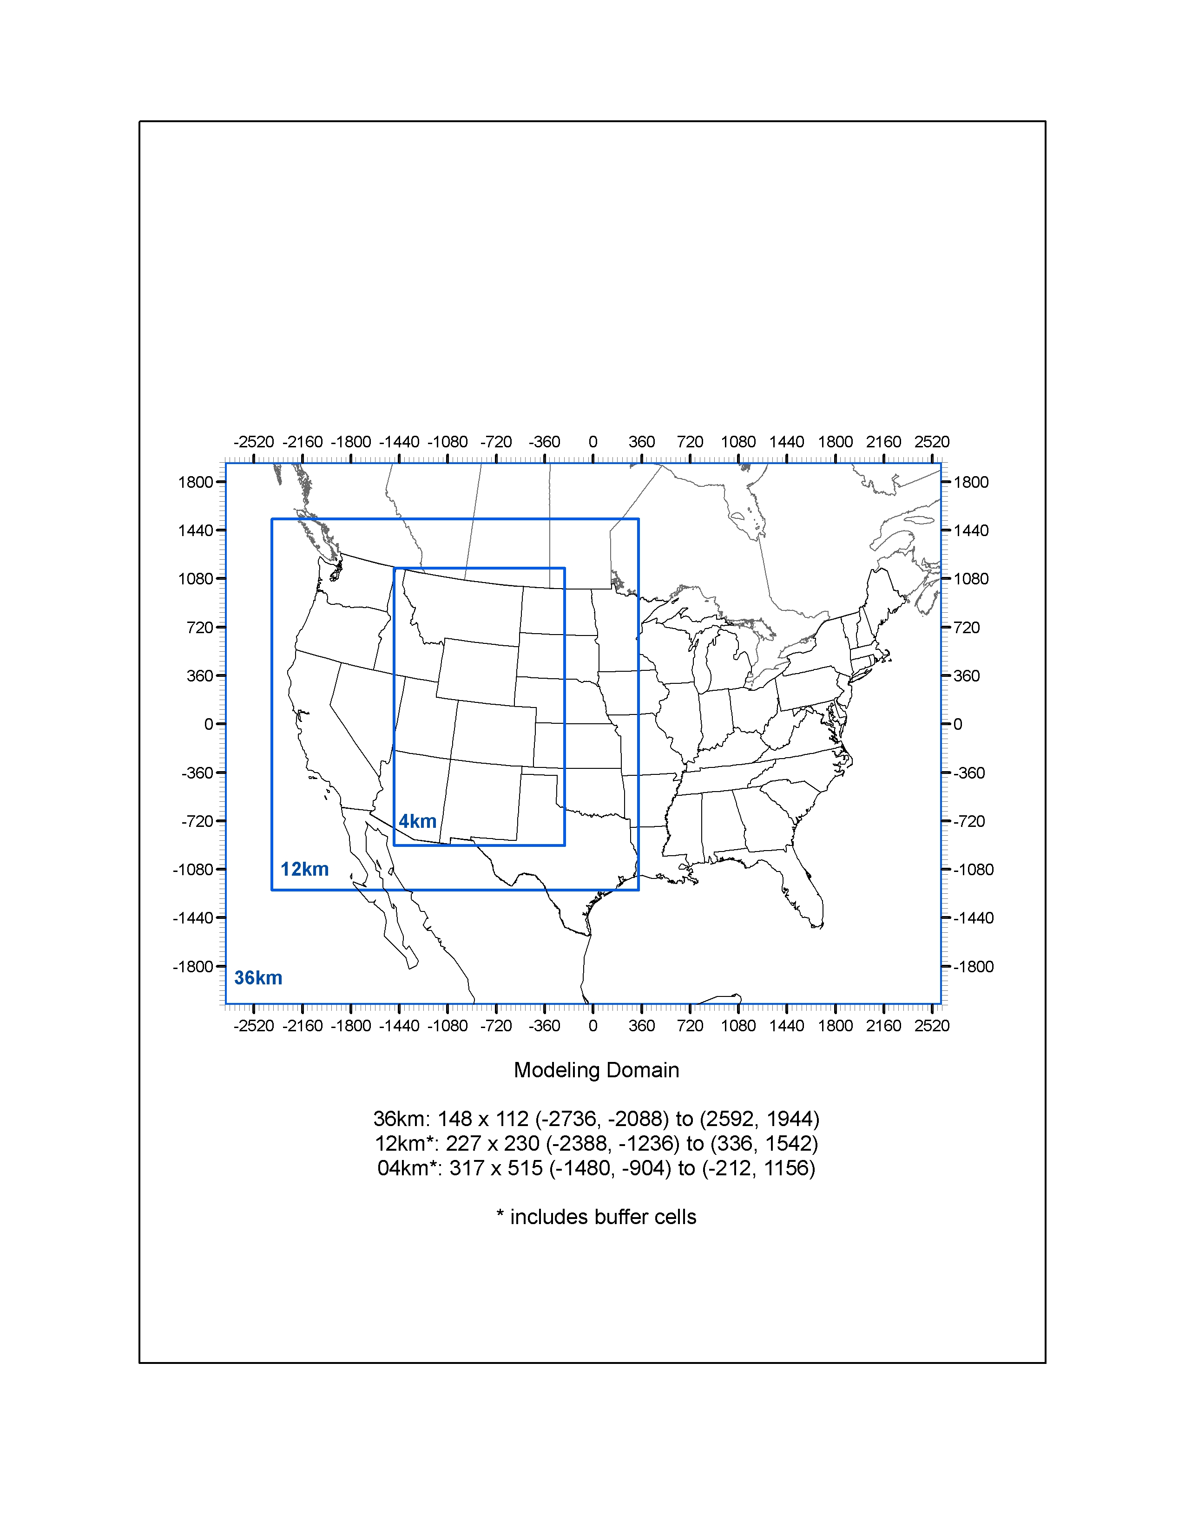

Figure –. 36 km CONUS and 12 km WESTUS processing domain used for developing PGM emission inputs.

Table –. Projection parameters for the 3SAQS modeling domains.

|  |  |
| --- | --- |
| Parameter | Value |
| Projection | Lambert-Conformal |
| 1st True Latitude | 33 degrees N |
| 2nd True Latitude | 45 degrees N |
| Central Longitude | -97 degrees W |
| Central Latitude | 40 degrees N |

Table 3–2 summarizes the CAMx version 5.41 (released November 2012) science configurations and options used for the 3SAQS 2008 modeling. CAMx V5.41 included several updates that were used in the 3SAQS, such as the CB05 chemical mechanism and the capability to simulate point source fire emission inventories developed under the Joint Fire Sciences Forum DEASCO3 project (Moore et al., 2011). CAMx was configured to predict both ozone and PM species.

We configured CAMx with the PPM advection solver for horizontal transport (Colella and Woodward, 1984) along with the spatially varying (Smagorinsky) horizontal diffusion approach. We also used K-theory for vertical diffusion using the CMAQ-like vertical diffusivities from WRFCAMx. The CB05 gas-phase chemical mechanism was selected for CAMx because it includes the latest chemical kinetic rates and represents improvements over the other alternative CB05 and SAPRC chemical mechanisms. With the exception of the emissions input files, all of the CAMx inputs were taken from the WestJumpAQMS:

Meteorological Inputs: The WRF-derived meteorological fields were processed to generate CAMx meteorological inputs using the WRFCAMx processor.

Initial/Boundary Conditions: The boundary conditions (BCs) for the 36 km CONUS domain simulation were based on the MOZART[1] global chemistry model. Existing programs were used to interpolate from the MOZART horizontal and vertical coordinate system to the CAMx LCP coordinate system and vertical layer structure and to map the MOZART chemical species to the chemical mechanisms being used by CAMx.

Photolysis Rates: Day-specific ozone column data were based on the Total Ozone Mapping Spectrometer (TOMS) data measured using the satellite-based Ozone Monitoring Instrument (OMI[2]). Albedo was based on land use data. For CAMx there is an ancillary snow cover input that overrode the land use based albedo input. Average values for typical snow cover were utilized; note that this is in contrast to the more highly reflective white snow that typically occurs during winter high ozone events in southwest Wyoming and the Uinta Basin in Utah. For CAMx, the TUV[3] photolysis rateprocessor was used. If there are periods of more than a couple of days where daily TOMS data are unavailable, the TOM measurements were interpolated between the days with valid data; in the case large periods of TOMS data are missing monthly average TOMS data were used. CAMx was configured to use the in-line TUV to adjust for cloud cover and account for the effects aerosol loadings have on photolysis rates; this latter effect on photolysis may be especially important in adjusting the photolysis rates due to the occurrence of PM concentrations associated with emissions from fires.

Landuse: We used landuse fields based on USGS GIRAS data.

Spin-Up Initialization: We used a 15-day spin period on the 36 km CONUS domain before adding the 12 nested domain for the last two days of 2007 before the start of the 2008 calendar year (January 1, 2008).

Table –. CAMx (Version 5.41) model configurations for 3SAQS

| Science Options | Configuration | Details |
| --- | --- | --- |
| Model Codes | CAMx V5.41 – November 2012 Release | Newer version may become available during the course of the study and will be considered for use at that time. |
| Horizontal Grid Mesh | 36/12 km | Many CAMx runs done using just 36/12 km grids |
| 36 km grid | 148 x 112 cells | 36 km CONUS domain |
| 12 km grid | 239 x 206 cells | 12 km WESTUS domain |
| Vertical Grid Mesh | 25 vertical layers, defined by WRF | Layer 1 thickness ~24- m. Model top at ~19-km above MSL |
| Grid Interaction | 36/12 km two-way nesting for CAMx |  |
| Initial Conditions | 10 day spin-up on 36 km grid | Clean initial conditions |
| Boundary Conditions | 36 km from global chemistry model | Currently only MOZART data available for 2008. |
| Emissions |  |  |
| Baseline Emissions Processing | SMOKE, MOVES and MEGAN |  |
| Sub-grid-scale Plumes | Plume-in-Grid for major NOX sources in CAMx |  |
| Chemistry |  |  |
| Gas Phase Chemistry | CB05 in CAMx |  |
| Meteorological Processor | WRFCAMx | Compatible with CAMx V5.4 |
| Horizontal Diffusion | Spatially varying | K-theory with Kh grid size dependence |
| Vertical Diffusion | CMAQ-like in WRF2CAMx |  |
| Diffusivity Lower Limit | Kz_min = 0.1 to 1.0 m2/s or 2.0 m2/s |  |
| Deposition Schemes |  |  |
| Dry Deposition | Zhang dry deposition scheme (CAMx) | Zhang 2003 |
| Wet Deposition | CAMx-specific formulation | rain/snow/graupel/virga |
| Numerics |  |  |
| Gas Phase Chemistry Solver | Euler Backward Iterative (EBI) -- Fast Solver |  |
| Vertical Advection Scheme | Implicit scheme w/ vertical velocity update (CAMx) |  |
| Horizontal Advection Scheme | Piecewise Parabolic Method (PPM) scheme |  |
| Integration Time Step | Wind speed dependent | ~0.1-1 min (4 km), 1-5 min (1 -km), 5-15 min (36 km) |

## Model Performance Evaluation Procedures

This section describes the general model performance evaluation procedures that are designed to estimate the reliability of the CAMx model for simulating air quality, visibility and deposition in the western U.S. for the 2008 modeling period. We conducted a MPE for ozone, fine particulate matter (PM2.5), and wet deposition species. We evaluated the performance of hourly ozone as well as daily maximum 1-hour (MDA1) and daily maximum 8-hour average (MDA8) ozone. In addition to ozone, we also included carbon monoxide (CO), nitrogen oxides (NOx), and sulfur dioxide (SO2) gas-phase species in the evaluation. We did not include volatile organic compounds (VOC) or ammonia (NH3) in the evaluation because observational data for these species were either not readily available or sparse in the Three-State region. The PM2.5 evaluation includes total PM2.5 along with the component species sulfate (SO4), nitrate (NO3), ammonium (NH4), elemental carbon (EC), organic carbon (OC), and other PM (PM Other). The deposition evaluation focused on total sulfur and oxidized and reduced nitrogen species. We did not include dry deposition species or visibility metrics in the MPE.

### Overview of Model Performance Evaluation

Using the inputs and model configurations described above, we conducted a CAMx base case simulation for the 36/12 km domains and the 2008 calendar period. We evaluated the 3SAQS 2008 base case ozone, total PM2.5 mass, speciated PM2.5 concentrations, and wet deposition species against concurrent measured ambient concentrations using graphical displays of model performance and statistical model performance measures. We compared these measures against established model performance goals and criteria, following the procedures recommended in EPA’s photochemical modeling guidance documents (e.g., EPA, 1991; 2007). The evaluation included sub-regional evaluations for Colorado, Utah, and Wyoming, and evaluations by month and season.

### Available Aerometric Data for the Model Evaluation

The following routine air quality measurement data networks operating in in 2008 were used in the 3SAQS MPE:

EPA AQS Surface Air Quality Data: Data files containing hourly-averaged concentration measurements at a wide variety of state and EPA monitoring networks are available in the Air Quality System (AQS[4]) database throughout the U.S. The AQS consists of many sites that tend to be mainly located in and near major cities. Thus, outside of California they will be located mainly around the larger cities including Seattle, Portland, Salt Lake City, Denver, Phoenix and Las Vegas. These data sets will be reformatted for use in the model evaluation software tools and used in the regional evaluation of the modeling system across the western U.S. There are several types of networks within AQS that measure different species. The standard hourly AQS AIRS monitoring stations typically measure hourly ozone, NO2, NOX and CO concentration and there are thousands of sites across the U.S. The Federal Reference Method (FRM) network measures 24-hour total PM2.5 mass concentrations using a 1:3 day sampling frequency, with some sites operating on an everyday frequency. The Chemical Speciation Network (CSN) measures speciated PM2.5 concentrations including SO4, NO3, NH4, EC, OC and elements at 24-hour averaging time period using a 1:3 or 1:6 day sampling frequency. Figure 3–2 and Figure 3–3 show the locations of the AIRS, FRM, and CSN monitoring networks, respectively, in the three state region.

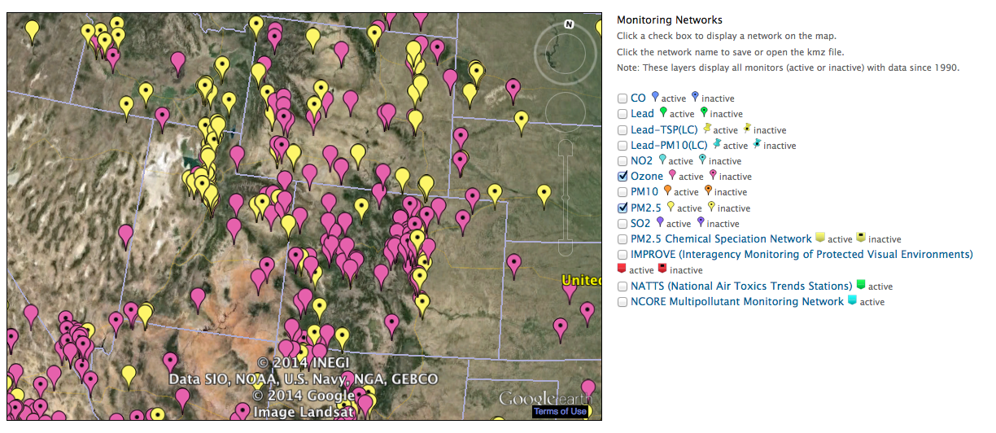

Figure –. Locations of AIRS O3 (pink) and FRM PM2.5 mass (yellow) monitoring sites in the three state region showing active and inactive (with black dot) sites (source: <http://www.epa.gov/airquality/airdata/ad_maps.html>).

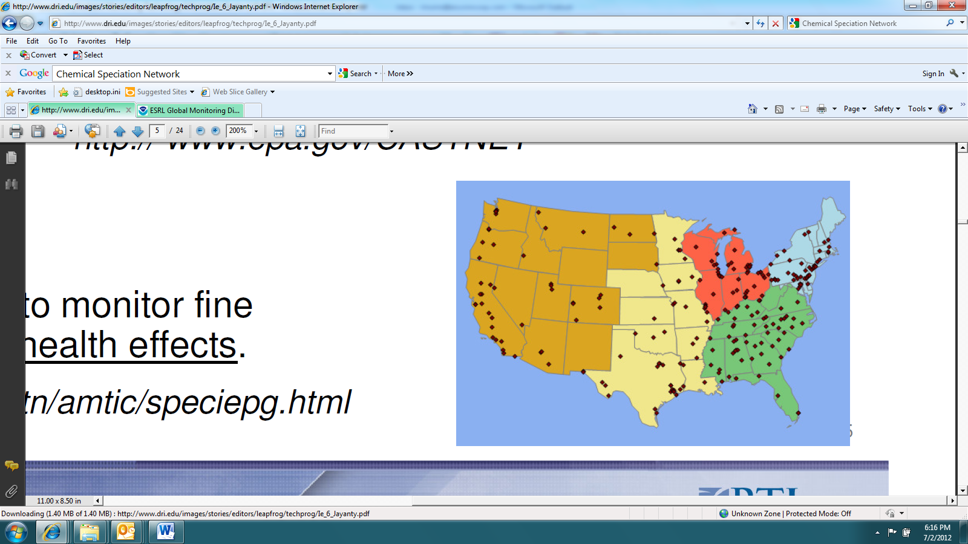

Figure –. Locations of CSN speciated PM2.5 monitoring sites (source: <http://www.epa.gov/ttn/amtic/speciepg.html>).

IMPROVE Monitoring Network: The Interagency Monitoring of Protected Visual Environments (IMPROVE[5]) network collects 24-hour average PM2.5 and PM10 mass and speciated PM2.5 concentrations (with the exception of ammonium) using a 1:3 day sampling frequency. IMPROVE monitoring sites are mainly located at more rural Class I area sites that correspond to specific National Parks, Wilderness Areas and Fish and Wildlife Refuges across the U.S. with a large number of sites located in the western U.S. Although there are also some IMPROVE protocol sites that can be more urban-oriented. Figure 3–4 shows the locations of the approximately 150 IMPROVE and IMPROVE protocol sites across the U.S.

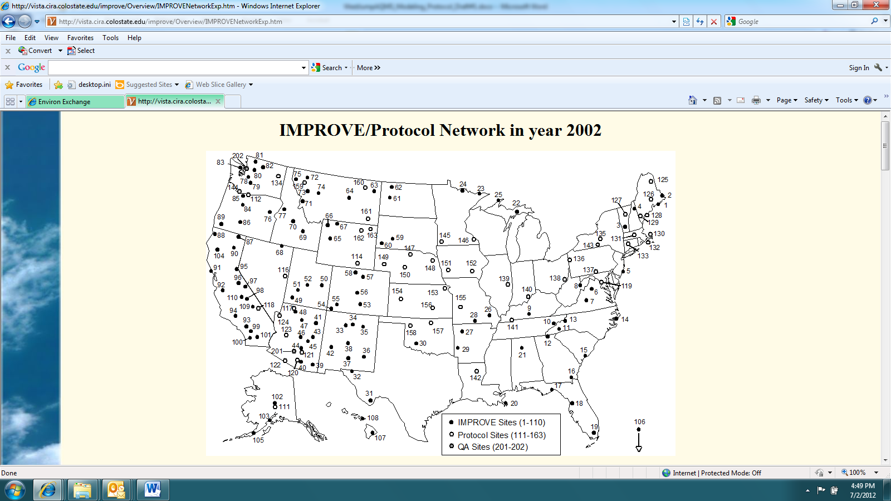

Figure –. Locations of IMPROVE monitoring sites (source: <http://vista.cira.colostate.edu/IMPROVE/>)

CASTNet Monitoring Network: The Clean Air Status and Trends Network (CASTNet[6]) operates approximately 80 monitoring sites in mainly rural areas across the U.S. CASTNet sites typically collected hourly ozone, temperature, wind speed and direction, sigma theta, solar radiation, relative humidity, precipitation and surface wetness. CASTNet also collects weekly (Tuesday to Tuesday) samples of speciated PM2.5 sulfate, nitrate, ammonium and other relevant ions and weekly gaseous SO2 and nitric acid (HNO3). Figure 3–5 displays the locations of the ~80 CASTNet sites across the U.S.

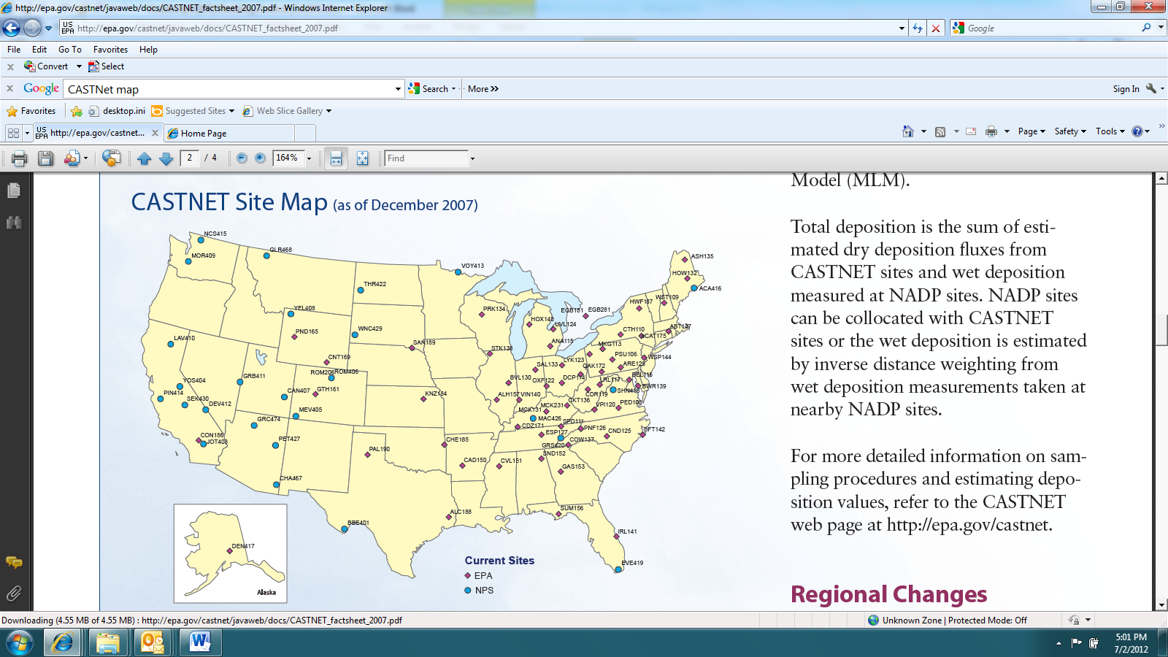

Figure –. Locations of CASTNet monitoring sites (source: <http://epa.gov/castnet/javaweb/index.html>).

NADP Network: The National Acid Deposition Program (NADP[7]) collects weekly samples of SO4, NO3 and NH4 in precipitation (wet deposition) in their National Trends Network (NTN) at over a 100 sites across the U.S. that are mainly located in rural areas away from big cities and major point sources. Seven NADP sites also collect daily wet deposition measurements (AIRMON) when precipitation occurs. Over 20 of the NADP sites also collect weekly mercury (MDN) samples. Figure 3–6 shows the locations of the NADP NTN, AIRMoN and MDN monitoring sites. Note that observed sulfate and nitrate dry deposition can be estimated at CASTNet sites using concentrations and a micro-meteorological model that produces a deposition velocity. But these are not true observations, but model estimates of the observations.

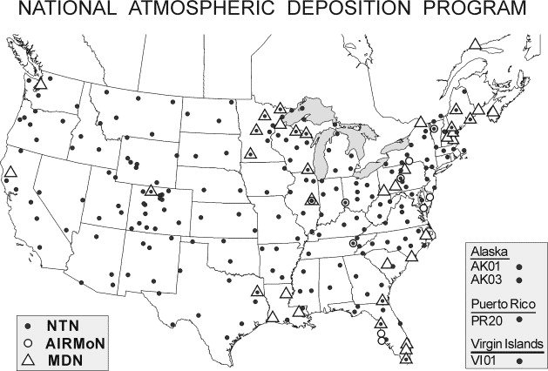

Figure –. Locations of NADP monitoring sites (source: <http://nadp.sws.uiuc.edu/>).

Ozonesonde Network: The NOAA Earth Systems Research Laboratory (ESRL) operates several ozonesonde sites[8] throughout the world that measure the vertical structure of ozone concentrations throughout the troposphere and into the lower stratosphere. Ozonesonde monitoring sites within the 3SAQS modeling domain include: (1) Trinidad Head on the coast in northern California; (2) Boulder, Colorado; and (3) at the University of Alabama at Huntsville.

Upper Green River Winter Ozone Study (UGRWOS): The Wyoming Department of Environmental Quality – Air Quality Division (WY AQD) sponsored a multi-year monitoring study of the conditions leading to elevated winter ozone levels in the Upper Green River Basin. The 2008 study consisted of routine measurements conducted throughout the winter season and intensive operating period (IOP) measurements on days with high ozone formation potential. A combination of surface and aloft boundary layer measurements of key meteorological variables, ozone, particulate matter, and volatile organic compounds were collected during January 15 – March 31, 2008. Figure 3–7 shows the locations of the UGRWOS measurement sites that operating during the 2008 field study.

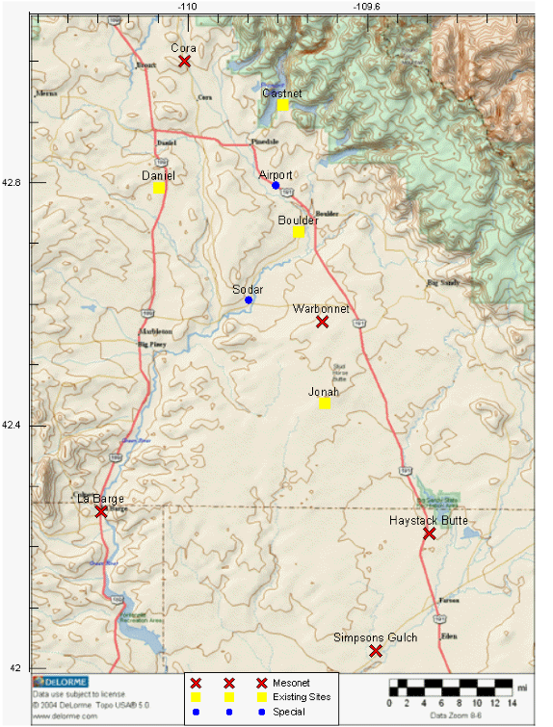

Figure –. Locations of UGRWOS monitoring sites (source: <http://deq.state.wy.us/aqd/Upper%20Green%20Winter%20Ozone%20Study.asp>)

There may be other special-study air quality or related monitoring sites that were operating during 2008 (e.g., CalNex). However, since the 3SAQS is performing a regional air quality assessment of the western U.S., the focus of the model performance evaluation will be on the standard regional networks described above. Although data were available from the ozonesonde and UGRWOS networks, we did not include these data in this MPE.

### Atmospheric Model Evaluation Tool (AMET)

The Atmospheric Model Evaluation Tool (AMET) (Appel et al., 2013) is a suite of software designed to facilitate the analysis and evaluation of meteorological and air quality models.

AMET matches the model output for particular locations to the corresponding observed values from one or more networks of monitors. These pairings of values (model and observation) are then used to statistically and graphically analyze the model’s performance. AMET version 2.1 (AMETv1.2) was the primary tool used to generate the performance statistics and plots used to conduct the model performance evaluation.

## CAMx Post-processing and Model-Observations Pairing

This section details how we processed and compared the CAMx output data to ambient air quality observations. The general procedure involved the following steps:

1. Convert the CAMx average (avrg) and wet deposition (wdep) hourly output files from UAM to I/O API-netCDF format with the utility camx2ioapi. This utility is available from <http://www.camx.com>.
2. Run the program Combine to post-process the model output species. One function of Combine is to simply convert the units of the gas-phase model species from ppmV to ppbV. Combine also calculates lumped species, such as total volatile organic compounds and NOx. Finally Combine is used to calculate the model PM species for comparison to observations. Combine is distributed with the CMAQ air quality model package available from <http://www.cmaq-mode.org>.
3. Run the programs sitecmp, cmp_airs, and cmp_castnet to pair in space and time the model output data from Combine with the surface monitoring networks described in Section 3.2.2. The programs cmp_airs and cmp_castnet also compute daily maximum 8-hour average ozone (MDA8) values for comparison to the reported MDA8 concentrations in the observational databases. These programs are distributed with AMET.
4. Load the paired model-observations tables output from sitecmp, cmp_airs, and cmp_castnet into the AMET database using the scripts provided with AMET
5. Run the AMET analysis scripts to calculate the model performance statistics and create plots of the performance results

Appendix A includes the expressions used for post-processing and pairing the CAMx concentration and deposition output species. Section A.1 includes the Combine expressions that normalize the CAMx output species with the concentration variables reported by the monitoring networks. Section A.2 lists the pairing expressions used by AMET to match reported observations with model outputs.

## Model Performance Statistics, Goals and Criteria

For over two decades, ozone model performance has been compared against EPA’s 1991 ozone modeling guidance performance goals as follows (EPA, 1991):

* Unpaired Peak Accuracy (UPA) ≤ ±20%
* Mean Normalized Bias (MNB) ≤ ±15%

Mean Normalized Gross Error (MNGE) ≤ 35%

In EPA’s 1991 ozone modeling guidance, these performance metrics were for hourly ozone concentrations. The UPA compared the daily maximum 1-hour predicted and observed ozone concentration that was matched by day, but not necessarily by location and by hour of the day. Since a photochemical grid model predicts ozone concentrations everywhere and the observed ozone is limited to a monitoring network, it would be fortuitous that the actual highest hourly ozone concentration in a region occurred at a monitoring site, so one would expect a perfect model to have an overestimation tendency for the UPA performance metric.

The MNB uses hourly predicted and observed ozone concentrations paired by time and location and is defined as the difference between the predicted and the observed hourly ozone divided by the observed hourly ozone concentrations averaged over all predicted/observed pairs (see Table 8-2) within a given region and for a given time period (e.g., by day, month or modeling period). The MNGE is defined similarly only it uses the absolute value of the difference between the predicted and observed hourly ozone concentrations so is an unsigned metric. As the MNB/MNGE performance metrics divide by the observed hourly ozone concentration, the metric is calculated just using the predicted and observed hourly ozone pairs for which the observed hourly ozone concentration is above a threshold concentration. In the 1991 EPA modeling guidance an observed hourly ozone threshold concentrations of 60 ppb is suggested. Since 1991 these ozone performance goals have been extended to 8-hour ozone concentrations and from urban to more rural areas. Given the large reductions in ozone over the last two decades and the lower ozone concentrations associated with the 8-hour ozone time averaging and rural locations, the observed ozone threshold for 8-hour ozone concentrations has been reduced, with a 40 ppb threshold frequently used. And in rural areas with lower ozone values a lower observed ozone threshold has also been used.

For PM species a separate set of model performance statistics and performance goals and criteria have been developed as part of the regional haze modeling performed by several Regional Planning Organizations (RPOs). EPA’s modeling guidance notes that PM models might not be able to achieve the same level of model performance as ozone models. Indeed, PM2.5 species definitions are defined by the measurement technology used to measure them and different measurement technologies can produce very different PM2.5 concentrations. Given this, several researchers have developed PM model performance goals and criteria that are less stringent than the ozone goals as shown in Table 8-1 (Boylan, 2004; Morris et al., 2009a,b). However, unlike the 1991 ozone model performance goals that use the MNB and MNGE performance metrics, for PM species the Fractional Bias (FB) and Fractional Error (FE) are utilized with no observed concentration threshold screening. The FB/FE differ from the MNB/MNGE in that the difference in the predicted and observed concentrations are divide by the average of the predicted and observed values, rather than just the observed value as in the MNB/MNGE. This results in the FB being bounded by -200% to +200% and the FE being bounded by 0% to +200%. There are additional statistical performance metrics that evaluate correlation, scatter as well as bias and error and a full suite of model performance metrics will be calculated for all species as given in Table 8-2.

Table –. PM model performance goals and criteria.

|  |  |  |
| --- | --- | --- |
| **Fractional**  **Bias (FB)** | **Fractional**  **Error (FE)** | **Comment** |
| ≤±15% | ≤35% | Ozone model performance goal that would be considered very good model performance for PM species |
| ≤±30% | ≤50% | PM model performance Goal, considered good PM performance |
| ≤±60% | ≤75% | PM model performance Criteria, considered average PM performance. Exceeding this level of performance for PM species with significant mass may be cause for concern. |

It should be pointed out that these model performance goals and criteria are not used to assign passing or failing grades to model performance, but rather to help interpret the model performance and intercompare across locations, species, time periods and model applications. As noted in EPA’s current modeling guidance: “By definition, models are simplistic approximations of complex phenomena” (EPA, 2007, pg. 98). The model inputs to the air quality models vary hourly, but tend to represent average conditions that do not account for unusual or extreme conditions. For example, an accident or large event could cause significant increases in congestion and motor vehicle emissions that are not accounted for in the average emissions inputs used in the model. This is seen in PM modeling at some monitoring sites that fail to capture the high PM concentrations on July 4 due to fireworks and other activities associated with this holiday (traffic and BBQ) that increase PM emissions.

More recently, EPA compiled and interpreted the model performance from 69 PGM modeling studies in the peer-reviewed literature between 2006 and March 2012 and developed recommendations on what should be reported in a model performance evaluation (Simon, Baker and Phillips, 2012). Although these recommendations are not official EPA guidance, they are useful for consideration in the 3SAQS model performance evaluation:

1. PGM MPE studies should at a minimum report the Mean Bias (MB) and Error (ME or RMSE), and Normalized Mean Bias (NMB) and Error (NME) and/or Fractional Bias (FB) and Error (FE). Both the MNB and FB are symmetric around zero with the FB bounded by -200% to +200%.
2. Use of the Mean Normalized Bias (MNB) and Gross Error (MNGE) is not encouraged because they are skewed toward low observed concentrations and can be misinterpreted due to the lack of symmetry around zero.
3. Given this recommendation the MNB/MNGE will just be calculated for ozone using an appropriate observed ozone cut-off concentration (e.g., 60 or 40 ppb).
4. The model evaluation statistics should be calculated for the highest resolution temporal resolution available and for important regulatory averaging times (e.g., daily maximum 8-hour ozone).
5. It is important to report processing steps in the model evaluation and how the predicted and observed data were paired and whether data are spatially/temporally averaged before the statistics are calculated.
6. Predicted values should be taken from the grid cell that contains the monitoring site, although bilinear interpolation to the monitoring site point can be used for higher resolution modeling (< 12 km).
7. PM2.5 should also be evaluated separately for each major component species (e.g., SO4, NO3, NH4, EC, OA and OPM2.5).
8. Evaluation should be performed for subsets of the data including, high observed concentrations (e.g., ozone > 60 ppb), by subregions and by season or month.
9. Evaluation should include more than just ozone and PM2.5, such as SO2, NO2 and CO.
10. Spatial displays should be used in the model evaluation to evaluate model predictions away from the monitoring sites. Time series of predicted and observed concentrations at a monitoring site should also be used.
11. It is necessary to understand measurement artifacts in order to make meaningful interpretation of the model performance evaluation.

We will incorporate the recommendations of Simon, Baker and Philips (2012) into the 3SAQS model performance evaluation. The 3SAQS evaluation products will include qualitative and quantitative evaluation for the following model output species:

* Maximum daily 1-hour and maximum daily 8-hour average (MDA8) ozone, including MDA8 with a 60 ppb threshold
* Carbon monoxide, sulfur dioxide, NOx
* Total PM2.5, elemental carbon, organic carbon, sulfate, nitrate, and ammonium
* Total sulfur and total nitrogen wet deposition

Table –. Definition of model performance evaluation statistical measures used to evaluate the CTMs.

| **Statistical**  **Measure** | **Mathematical**  **Expression** | **Notes** |
| --- | --- | --- |
| Accuracy of paired peak (Ap) |  | Comparison of the peak observed value (Opeak) with the predicted value at same time and location |
| Coefficient of determination (r2) |  | Pi = prediction at time and location i;  Oi = observation at time and location i;  = arithmetic average of Pi, i=1,2,…, N;  = arithmetic average of Oi, i=1,2,…,N |
| Normalized Mean Error (NME) |  | Reported as % |
| Root Mean Square Error (RMSE) |  | Reported as % |
| Fractional Gross Error (FE) |  | Reported as % and bounded by 0% to 200% |
| Mean Absolute Gross Error (MAGE) |  | Reported as concentration (e.g., µg/m3) |
| Mean Normalized Gross Error (MNGE) |  | Reported as % |
| Mean Bias (MB) |  | Reported as concentration (e.g., µg/m3) |
| Mean Normalized Bias (MNB) |  | Reported as % |
| Mean Fractionalized Bias (Fractional Bias, FB) |  | Reported as %, bounded by -200% to +200% |
| Normalized Mean Bias (NMB) |  | Reported as % |
| Bias Factor (BF) |  | Reported as BF:1 or 1: BF or in fractional notation (BF/1 or 1/BF). |

# 2008 Model Performance Evaluation

## Ozone and Precursors Model Performance

Given the complexity of the terrain and heterogeneity of the emissions sources in the West, ozone model performance evaluation should focus on smaller regions and targeted time-periods. This section first presents regional ozone performance in the 12-km modeling domain, without any evaluation of precursor species or trends at specific monitors. More detailed performance metrics for the 3SAQS 12-km Base version B (3SAQS_CAMx_B08b) simulation, including precursor species, are then presented for sites in Colorado, Utah, and Wyoming.

### 3SAQS 12-km Domain Model Performance

The 3SAQS 12-km domain-wide ozone model performance meets the performance goals for both daily maximum 1-hour (MDA1) and 8-hour O3 (MDA8). Table 4–1 includes bias and error metrics for observed ozone and gas-phase species at sites averaged across the 12-km modeling domain. The rows labeled AQS and CNET are performance statistics for hourly O3 at the AQS and CASTNet monitors, respectively. The rows labeled AQS MDA1 and CNET MDA1 are statistics for daily maximum 1 hour O3 at each network; AQS MDA8 and CNET MDA8 are daily maximum 8-hour average O3. Several key points of CAMx O3 model performance across the 12-km domain include:

* Fractional bias (FB=17.5%) and fractional error (FE=43.3%) for AQS hourly O3 are the only ozone performance metrics that miss the performance goals, although they are within the performance criteria.
* On an annual, domain-wide average CAMx has a positive bias for hourly O3, MDA1, and MDA8 at both the AQS and CASTNet sites; the biases tend to be lower that AQS sites, while the errors are lower at the CASTNet sites
* When a 60 ppb observed O3 concentration threshold is applied, the model biases increase and switch from positive to negative. This bias increase indicates that there are compensating biases that lead to lower average values when computed using the full range of observations
* Model performance for O3 also degrades slightly during the ozone season (June-August). CAMx has a positive bias during this period.

Figure 4–1 includes annual scatter plots (CAMx vs. observations) for all AQS and CASTNet sites in the 12-km domain. The figure includes both daily maximum 1-hour and 8-hour O3 with and without a 60 ppb concentration threshold applied to the observations. CAMx has a positive bias for both networks; with higher fractional bias at the AQS sites (1-hour: 7.8%, MDA8: 12.6%) compared to the CASTNet sites (1-hour: 4.15%, MDA8: 6.5%). On the days with elevated O3 measurements (> 60 ppb), CAMx has a negative bias, with lower fractional bias at the AQS sites (1-hour: -8.8%, MDA8: -7.4%) compared to the CASTNET sits (1-hour: -11.7%, MDA8: -11.0%).

The Q-Q plots shown in Figure 4–2 clearly illustrate the trend that CAMx overestimates low observed values and underestimates high observed values at both the AQS and CASTNet sites. These plots support the point above that compensating biases in the evaluation metrics which include the full range of concentrations tend to suppress the bias statistics.

Figure 4–3 and Figure 4–4 show the monthly CAMx model performance for MDA8. CAMx biases are lowest during the spring at the AQS sites and during the winter and spring at the CASTNet sites. The CAMx performance is well within the performance goals for all months at the CASTNet sites. Model performance is marginal at the AQS sites only during December, otherwise the performance is acceptable and within the goals.

Table –. 12-km domain ozone and gas-phase species performance indicators

|  |  |  |  |  |  |  |  |  |  |
| --- | --- | --- | --- | --- | --- | --- | --- | --- | --- |
| Species | Network | FB | FE | MB | ME | NMB | NME | Mean Obs | Mean Mod |
| O3 | AQS | 17.50 | 43.3 | 4.83 | 10.90 | 14.90 | 33.8 | 32.4 | 37.2 |
| CNET | 8.53 | 18.0 | 2.97 | 7.59 | 6.70 | 17.2 | 44.3 | 47.3 |
| AQS MDA1 | 3.26 | 16.6 | 0.95 | 8.40 | 1.81 | 16.0 | 52.4 | 53.3 |
| CNET MDA1 | 4.56 | 11.6 | 2.41 | 6.47 | 4.49 | 12.0 | 53.7 | 56.1 |
| AQS MDA8 | 7.93 | 18.1 | 3.00 | 7.99 | 6.43 | 17.1 | 46.7 | 49.7 |
| CNET MDA8 | 6.40 | 11.8 | 3.37 | 6.23 | 6.61 | 12.2 | 50.9 | 54.3 |
| AQS W126 | 31.30 | 79.0 | 0.01 | 0.07 | 11.80 | 70.8 | 0.1 | 0.1 |
| O3 > 60 ppb | AQS MDA1 | -8.82 | 15.1 |  |  | -8.00 | 14.5 |  |  |
| CNET MDA1 | -11.70 | 15.3 |  |  | -11.10 | 14.7 |  |  |
| AQS MDA8 | -7.43 | 13.6 |  |  | -6.60 | 13.1 |  |  |
| CNET MDA8 | -11.00 | 14.2 |  |  | -10.40 | 13.6 |  |  |
| June-August O3 | AQS | 15.08 | 35.5 | 5.29 | 12.07 | 13.51 | 30.5 | 39.7 | 45.0 |
| CNET | 12.93 | 21.5 | 5.34 | 9.88 | 11.30 | 20.8 | 47.6 | 53.0 |
| AQS MDA1 | 2.31 | 17.6 | 0.59 | 10.46 | 1.05 | 17.2 | 61.0 | 61.6 |
| CNET MDA1 | 7.45 | 15.2 | 4.22 | 9.58 | 7.01 | 15.8 | 60.7 | 64.9 |
| AQS MDA8 | 6.79 | 17.9 | 3.08 | 9.43 | 5.84 | 17.5 | 54.0 | 57.1 |
| CNET MDA8 | 11.24 | 15.7 | 6.40 | 9.23 | 11.54 | 16.6 | 55.9 | 62.4 |
|  | | | | | | | | | |

|  |  |  |
| --- | --- | --- |
|  | **All Days** | **Days with Obs > 60 ppb** |
| **Daily Max O3** |  |  |
| **Daily Max 8-hr Average O3 (MDA8)** |  |  |

Figure –. CAMx 3SAQS 2008 base case model performance for daily maximum 1-hr and 8-hr ozone concentrations for all AQS (red) and CASTNet (blue) sites in the 12-km domain.

|  |  |
| --- | --- |
|  |  |

Figure –.Q-Q plots of CAMx 3SAQS 2008 MDA8 for the 12-km modeling domain; (L) AQS and (R) CASTNet

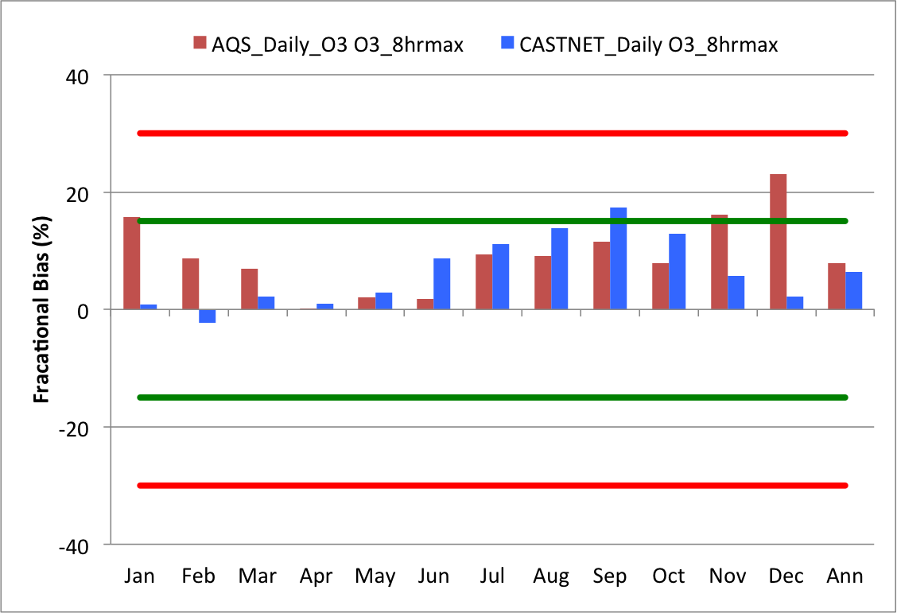

Figure –. CAMx mean monthly bias in MDA8 at all AQS and CASTNet sites in the 12-km modeling domain

|  |  |  |
| --- | --- | --- |
|  | **1-hr Daily Max O3** | **8-hr Daily Max O3** |
| **AQS** |  |  | |
| **CASTNET** |  |  | |

Figure –. CAMx 3SAQS 2008 base case monthly model performance for daily maximum 1-hr (left) and 8-hr ozone (right) concentrations for all AQS (top) and CASTNet (bottom) sites in the 12-km domain.

### Colorado Model Performance

The CAMx O3 estimates for Colorado meet the bias (NMB: 6.0-14.2%) and error (NME: 12.0-30.3%) performance goals on an annual basis for hourly and daily maximum 1-hour and 8-hour average (MDA8) O3. Table 4–2 shows the performance metrics for O3 and other gas-phase species at monitoring locations in Colorado. The rows labeled AQS and CNET in Table 4–2 are performance statistics for hourly O3 at the AQS and CASTNet monitors, respectively. The rows labeled AQS MDA1 and CNET MDA1 are statistics for daily maximum 1 hour O3 at each network; AQS MDA8 and CNET MDA8 are daily maximum 8-hour average O3. Several key points of CAMx model performance for O3 include:

* CAMx has a positive O3 bias across all of the Colorado monitors in both the AQS and CASTNet. The Q-Q plot in Figure 4–5 shows that with the exception of the highest end of the observations, CAMx is uniformly biased high for MDA8 at the AQS and CASTNet sites in Colorado
* CAMx exhibits better performance (lower bias and error) predicting *hourly* O3 at the CASTNet sites than the AQS sites.
* CAMx also performs better predicting daily maximum 1-hour and MDA8 O3 at the CASTNet sites than it does at the AQS sites, although the bias differences are small.
* CAMx performance improves on days with elevated O3 (> 60 ppb) relative to all days. Figure 4–6 illustrates that on elevated O3 days CAMx has low negative biases in the range of 1.9-4.3% with slightly better performance at the AQS sites compared to the CASTNet sites.
* CAMx performance improves during the ozone season (June-August) relative to the full year at AQS sites, particularly for daily max 1-hour O3 and MDA8
* CAMx performance degrades during the ozone season at the CASTNet sites.

Note that a combination of the ozone season and the 60 ppb concentration threshold is not shown because it’s fairly redundant; most of the elevated ozone values happen during the ozone season.

The CAMx monthly and seasonal O3 performance at the AQS and CASTNet sites is shown in Figure 4–7 and Figure 4–8. The CAMx biases are lowest during the spring and summer months at the AQS sites and during the winter and spring at the CASTNet sites. The simple O3 performance bias threshold of ±15% is exceeded in September-December for the AQS sites and in September for the CASTNet sites. In general, CAMx performance at the AQS monitors is better during periods of elevated ozone. The right panel of Figure 4–7 shows CAMx MDA8 monthly normalized mean bias (NMB) at each of the Colorado AQS monitors. The South Mason St. monitor in Ft. Collins (80691004) misses the simple bias threshold in every month. Figure 4–9 shows the annual MDA8 timeseries comparing CAMx to observations at the South Mason St. monitor. The right panel on this figure is an aerial view of the monitor location. The timeseries plot illustrates the systematic positive bias of CAMx at this site. Located on the side of a road in a suburban setting, this monitor is likely in a VOC-limited chemical regime. The consistent positive ozone bias at the South Mason St. monitor is an indication that CAMx is systematically underestimating NOx at this location.

Other monitors exceeding the 15% bias threshold during the summer months (June-August) include Pine River Valley in La Plata County (80677001), Mesa Verdi in Montezuma County (80830101), and Manitou Springs (80410016) in El Paso County. With the exception of the rural 78th Avenue monitor (80013001) in Adams County, all of the Colorado AQS monitors have positive biases in the fall months (September-November), with many of them exceeding the 15% bias threshold. There does not appear to be a pattern to the bias or errors at the monitors in November. Although all of monitors that are within the ±15% bias threshold are either rural or suburban sites, there are other rural and suburban sites that are outside of the threshold.

Environ et al (2013) documented quality control problems with the year 2008 O3 observations at the CASTNet Gothic monitor that produced measurements that were too low. Figure 4–10 shows annual timeseries of MDA8 plotted against observations at the Gothic monitor. Quality control issues with the February through June O3 observations for this site invalidate these results and would skew the model bias. As suggested by Environ et al (2013) and confirmed by these analyses of the Gothic monitor, data from the Gothic monitor are excluded from the evaluation of the 3SAQS 2008 CAMx modeling results.

Figure 4–11 shows monthly CAMx performance for hourly O3, NOx, CO, and SO2 at the Colorado AQS sites. The hourly AQS model performance shows some distinct seasonal patterns.

* The spring and summer months have the lowest normalized mean errors for O3
* The normalized mean bias for O3 is within the simple bias threshold for January – July
* All of the fall months have a higher O3 bias than the rest of the seasons.
* The normalized mean errors for NOx are high in all months; the NOx biases are within ±15% for June-September.
* The normalized mean errors for CO are high in all months; the CO biases are within ±30% in all of the spring and summer months, with the exception of May.
* SO2 performance is poor with high errors during all months.

Figure 4–12 shows ozone season (June-August) average diurnal profiles for O3 and NOx across all AQS sites in Colorado. CAMx tends to perform better during the middle of the day (1100 – 1500) than at night, with particularly poor performance before sunrise. The hours of better O3 performance generally correspond to the hours of better NOx performance. CAMx is not building up NOx concentrations overnight, likely related to too much dilution in the 12-km grid cells and underestimates of the NOx emissions.

Table –. Colorado ozone and gas-phase species performance indicators

|  |  |  |  |  |  |  |  |  |  |
| --- | --- | --- | --- | --- | --- | --- | --- | --- | --- |
| Species | Network | FB | FE | MB | ME | NMB | NME | Mean Obs | Mean Mod |
| O3 | AQS | 15.10 | 38.3 | 4.98 | 10.60 | 14.20 | 30.3 | 35.1 | 40.0 |
| CNET | 9.38 | 17.1 | 3.95 | 7.72 | 8.80 | 17.1 | 45.2 | 49.1 |
| AQS MDA1 | 7.02 | 14.9 | 3.20 | 7.58 | 6.03 | 14.3 | 53.1 | 56.3 |
| CNET MDA1 | 4.56 | 11.6 | 2.41 | 6.47 | 4.49 | 12.00 | 53.7 | 56.1 |
| AQS MDA8 | 11.00 | 17.1 | 4.77 | 7.74 | 9.92 | 16.1 | 48.1 | 52.8 |
| CNET MDA8 | 6.40 | 11.8 | 3.37 | 6.23 | 6.61 | 12.20 | 50.9 | 54.3 |
| AQS W126 | 48.50 | 78.5 | 0.04 | 0.08 | 48.60 | 82.7 | 0.09 | 0.14 |
| O3 > 60 ppb | AQS MDA1 | -2.54 | 11.0 |  |  | -2.30 | 10.9 |  |  |
| CNET MDA1 | -4.46 | 11.3 |  |  | -4.30 | 11.2 |  |  |
| AQS MDA8 | -2.30 | 10.1 |  |  | -1.90 | 9.9 |  |  |
| CNET MDA8 | -3.47 | 9.8 |  |  | -3.10 | 9.6 |  |  |
| June-August O3 | AQS | 13.96 | 30.7 | 5.36 | 11.53 | 12.64 | 26.9 | 43.37 | 48.73 |
| CNET | 18.45 | 23.5 | 8.48 | 11.18 | 18.38 | 24.1 | 46.9 | 55.4 |
| AQS MDA1 | 2.93 | 13.0 | 1.60 | 8.57 | 2.43 | 13.0 | 66.03 | 67.60 |
| CNET MDA1 | 7.45 | 15.2 | 4.22 | 9.58 | 7.01 | 15.77 | 60.7 | 64.9 |
| AQS MDA8 | 7.48 | 14.1 | 4.28 | 8.34 | 7.29 | 14.2 | 59.17 | 63.47 |
| CNET MDA8 | 11.24 | 15.7 | 6.40 | 9.23 | 11.54 | 16.57 | 55.9 | 62.4 |
| CO | AQS | -41.00 | 65.9 | -138.00 | 262.00 | -32.40 | 61.5 | 425.00 | 288.00 |
| NO2 | AQS | -8.53 | 75.6 | 3.10 | 8.63 | 27.20 | 75.7 | 11.40 | 14.50 |
| SO2 | AQS | -3.39 | 63.4 | 0.68 | 2.06 | 41.10 | 125.0 | 1.65 | 2.32 |
| CNET | -16.10 | 42.1 | -0.02 | 0.11 | -8.36 | 39.8 | 0.27 | 0.25 |

|  |  |
| --- | --- |
|  |  |

Figure –. Q-Q plots of CAMx 3SAQS 2008 MDA8 for CO sites; (L) AQS and (R) CASTNet

|  |  |  |
| --- | --- | --- |
|  | **All Days** | **Days with Obs > 60 ppb** |
| **Daily Max. O3** |  |  |
| **Daily Max. 8-hr Average O3 (MDA8)** |  |  |

Figure –. CAMx 3SAQS 2008 base case model performance for daily maximum 1-hr and 8-hr ozone concentrations for all AQS (red) and CASTNET (blue) sites in Colorado.

|  |  |
| --- | --- |
|  |  |

Figure –. CAMx mean monthly bias in MDA8 at Colorado AQS and CASTNet sites (left); Colorado AQS site-specific monthly MD8A NMB (right).

|  |  |  |
| --- | --- | --- |
|  | **1-hr Daily Max O3** | **8-hr Daily Max O3** |
| **AQS** |  |  |
| **CASTNET** |  |  |

Figure –. CAMx 3SAQS 2008 base case monthly model performance for MDA1 (left) and MDA8 (right) concentrations for all AQS (top) and CASTNET (bottom) sites in Colorado.

|  |  |
| --- | --- |
|  |  |

Figure –. Annual 2008 MDA8 timeseries at the AQS South Mason St. Ft. Collins, CO monitor; satellite imagery of pink site marker shown in right panel

|  |
| --- |
|  |

Figure –. Annual 2008 MDA8 timeseries at the CASTNet Gothic, CO monitor

|  |  |
| --- | --- |
|  |  |
|  |  |

Figure –. CAMx 3SAQS 2008 base case monthly model performance for hourly O3 (UL), NOx (UR), CO (LL), and SO2 (LR) at AQS sites in Colorado.

|  |  |
| --- | --- |
|  |  |

Figure –. CAMx 3SAQS 2008 base case ozone season (June-August) average diurnal hourly O3 (left) and NOx (right) timeseries for AQS sites in Colorado.

### Utah Model Performance

The CAMx O3 estimates for Utah are within the bias (NMB: 0.2-17.6%) and error (NME: 9.0-30.3%) performance goals on an annual basis for hourly and daily maximum 1-hour and 8-hour average (MDA8) O3. Table 4–3 shows the performance metrics for O3 and other gas-phase species at monitoring locations in Utah. Several key points of CAMx model performance for Utah O3 include:

* CAMx has a positive MDA8 bias for concentrations up to about 70 ppb at the AQS monitors and a negative bias for higher MDA8 concentrations. The Q-Q plot in Figure 4–13 shows that CAMx has a particularly strong positive bias at the AQS sites for observed MDA8 values below about 40 ppb.
* CAMx has very low or slight positive bias for all values at the one CASTNet monitor in Utah (Canyonlands).
* The CAMx performance in predicting hourly O3 at the AQS sites is marginal or outside of the performance goals. The poor performance is driven primarily by high positive biases at low concentrations.
* For daily maximum O3 and MDA8, CAMx performance degrades on days with elevated O3 (> 60 ppb) relative to all days and the bias changes signs from positive to negative. Figure 4–14 illustrates that on elevated O3 days CAMx has negative NMB in the range of 3.8-9.2% with markedly better performance at the CASTNet site compared to the AQS sites.
* With the exception of MDA8, CAMx performance degrades during the ozone season (June-August) relative to the full year at AQS sites. The NMB for daily maximum O3 at the Utah AQS sites is 0.22% for the full year and -6.23% for the ozone season.
* CAMx performance degrades during the ozone season for all hourly and daily O3 species at the CASTNet site.

The CAMx monthly and seasonal O3 performance at the AQS and CASTNet sites is shown in Figure 4–15 and Figure 4–16. Like at the Colorado sites, the CAMx biases are lowest during the spring and summer months at the AQS sites and during the winter and spring at the CASTNet sites. The simple O3 performance bias threshold of ±15% is exceeded at the AQS sites in January, October, and December; the upper bound bias of ±35% is exceeded in November. CAMx has a low bias (NMB and FB <8%) in all months at the CASTNet site. The right side of Figure 4–15 shows monthly mean MDA8 NMB for every active AQS site in Utah. Outside of the summer months, several sites consistently exceed the bias thresholds. Logan #4 (49005004) and Hawthorn (490353006) miss the bias threshold in the non-summer months and show particularly high biases in the fall and winter. North Provo (490490002) and Ogden (490570002) also have MDA8 biases exceeding 35% in the last quarter of 2008.

Figure 4–17 shows timeseries plots of MDA8 and NOx at the Hawthorne AQS site in Salt Lake City. The top two panels are November 2008 concentrations at this site for MDA8 and NOx. The plots indicate NOx titration of O3: the periods of low observed MDA8 on days 16-18 and 25-28 correspond to elevated observed NOx concentrations. CAMx does not reproduce the elevated NOx concentrations during these periods and exhibits a fairly uniform daily average NOx profile across all days in the month. The bottom panels of Figure 4–17 are annual 2008 concentrations and absolute biases (ppb) for MDA8 and NOx. These plots show that during the cooler months of the year, the likely combination of reduced mixing and less photochemical activity result in higher observed NOx concentrations and lower O3. These features are not captured by CAMx and lead to elevated biases in both MDA8 and NOx.

Figure 4–18 shows monthly CAMx performance for hourly O3, NOx, CO, and SO2 at the Utah AQS sites. The hourly AQS model performance shows some distinct seasonal patterns.

* Consistent with the MDA8 performance analysis discussed above, the spring and summer months have the lowest normalized mean bias errors for O3.
* The normalized mean bias for O3 is within the simple bias threshold for all of the spring and summer months.
* As noted previously, the last quarter of the year shows particularly poor O3 performance with biases and error exceeding the performance thresholds.
* The normalized mean errors for NOx are high (>50%) in all months; NOx is underestimated in all months with biases that never get above -30%.
* The NOx underpredictions are particularly bad in the winter months (including November) with biases clustered around -60%..
* The normalized mean errors for CO are high (>50%) in all months; CO is underestimated in all months with biases that never get above -30%.
* Although the biases and errors are high for CO in all months, there is a distinct seasonality to the model performance with better performance during the spring and summer.
* The normalized mean errors for SO2 are high (>50%) in all months; the SO2 biases are within ±15% only in January.
* For all months outside of the first quarter of the year, the SO2 biases are all clustered between about -45% and -60%.

Figure 4–19 shows ozone season (June-August) average diurnal profiles for O3 and NOx across all AQS sites in Utah. CAMx tends to perform better during the middle of the day (1100 – 1500) than at night, with particularly poor performance before sunrise. The hours of better O3 performance generally correspond to the hours of better NOx performance. CAMx is not building up NOx concentrations overnight, likely related to too much dilution in the 12-km grid cells and underestimates of the NOx emissions. CAMx is doing a slightly better job with the morning NOx peak at the Utah monitors than it did with the Colorado sites.

Table –. Utah ozone and gas-phase species performance indicators

|  |  |  |  |  |  |  |  |  |  |
| --- | --- | --- | --- | --- | --- | --- | --- | --- | --- |
| Species | Network | FB | FE | MB | ME | NMB | NME | Mean Obs | Mean Mod |
| O3 | AQS | 24.30 | 36.2 | 6.48 | 11.10 | 17.60 | 30.3 | 36.8 | 43.3 |
| CNET | -0.74 | 12.1 | -0.41 | 5.86 | -0.85 | 12.3 | 47.8 | 47.4 |
| AQS MDA1 | 1.87 | 14.5 | 0.12 | 7.72 | 0.22 | 13.8 | 55.8 | 55.9 |
| CNET MDA1 | 1.83 | 8.7 | 1.06 | 4.90 | 1.95 | 8.98 | 54.5 | 55.6 |
| AQS MDA8 | 7.65 | 15.8 | 2.84 | 7.33 | 5.62 | 14.5 | 50.6 | 53.4 |
| CNET MDA8 | 2.17 | 8.7 | 1.23 | 4.74 | 2.33 | 9.01 | 52.6 | 53.8 |
| AQS W126 | 28.80 | 72.3 | 0.02 | 0.07 | 17.90 | 69.1 | 0.1 | 0.1 |
| O3 > 60 ppb | AQS MDA1 | -9.65 | 13.1 |  |  | -9.20 | 12.6 |  |  |
| CNET MDA1 | -4.19 | 10.4 |  |  | -3.80 | 10.1 |  |  |
| AQS MDA8 | -6.53 | 10.5 |  |  | -6.20 | 10.2 |  |  |
| CNET MDA8 | -5.39 | 10.7 |  |  | -4.80 | 10.4 |  |  |
| June-August O3 | AQS | 15.80 | 28.7 | 4.65 | 10.39 | 10.96 | 24.4 | 42.8 | 47.4 |
| CNET | 3.05 | 11.1 | 1.86 | 5.85 | 3.58 | 11.2 | 52.5 | 54.4 |
| AQS MDA1 | -6.06 | 14.1 | -4.10 | 8.62 | -6.23 | 13.6 | 63.4 | 59.3 |
| CNET MDA1 | 5.21 | 8.2 | 3.18 | 5.00 | 5.42 | 8.47 | 59.0 | 62.2 |
| AQS MDA8 | -0.54 | 12.1 | -0.46 | 6.73 | -0.62 | 11.8 | 57.4 | 57.0 |
| CNET MDA8 | 6.35 | 8.6 | 3.75 | 5.09 | 6.64 | 8.99 | 56.7 | 60.5 |
| CO | AQS | -51.00 | 63.8 | -260.00 | 313.00 | -47.80 | 57.6 | 543.0 | 284.0 |
| NO2 | AQS | -41.40 | 68.1 | -5.87 | 9.98 | -31.30 | 53.2 | 18.7 | 12.9 |
| SO2 | AQS | -61.70 | 78.1 | -0.92 | 1.47 | -46.60 | 74.1 | 2.0 | 1.1 |
| CNET | -31.00 | 39.7 | -0.08 | 0.12 | -21.70 | 34.2 | 0.35 | 0.3 |

|  |  |
| --- | --- |
|  |  |

Figure –. Q-Q plots of CAMx 3SAQS 2008 MDA8 for UT sites; (L) AQS and (R) CASTNet

|  |  |  |
| --- | --- | --- |
|  | **All Days** | **Days with Obs > 60 ppb** |
| **Daily Max. O3** |  |  |
| **Daily Max. 8-hr Average O3 (MDA8)** |  |  |

Figure –. CAMx 3SAQS 2008 base case model performance for daily maximum 1-hr and 8-hr ozone concentrations for all AQS (red) and CASTNET (blue) sites in Utah.

|  |  |
| --- | --- |
|  |  |

Figure –. CAMx mean monthly bias in MDA8 at Utah AQS and CASTNet sites (left); Utah AQS site-specific monthly MD8A NMB (right).

|  |  |  |
| --- | --- | --- |
|  | **1-hr Daily Max O3** | **8-hr Daily Max O3** |
| **AQS** |  |  |
| **CASTNET** |  |  |

Figure –. CAMx 3SAQS 2008 base case monthly model performance for MDA1 (left) and MDA8 (right) concentrations for all AQS (top) and CASTNET (bottom) sites in Utah.

|  |  |
| --- | --- |
|  |  |
|  |  |

Figure –. Hawthorne AQS Site (Salt Lake City, UT) MD8 (left) and NOx (right) CAMx and observed timeseries for November (top) and annual 2008 (bottom). The annual plots have two panes: concentrations on the top and bias on the bottom

|  |  |
| --- | --- |
|  |  |
|  |  |

Figure –. CAMx 3SAQS 2008 base case monthly model performance for hourly O3 (UL), NOx (UR), CO (LL), and SO2 (LR) at AQS sites in Utah.

|  |  |
| --- | --- |
|  |  |

Figure –. CAMx 3SAQS 2008 base case ozone season (June-August) average diurnal hourly O3 (left) and NOx (right) timeseries for AQS sites in Utah.

### Wyoming Model Performance

The CAMx O3 estimates for Wyoming are within the bias (NMB: 0.26-11.4%) and error (NME: 10.8-22.8%) performance goals on an annual basis for hourly and daily maximum 1-hour and 8-hour average (MDA8) O3. Table 4–4 shows the performance metrics for O3 and other gas-phase species at monitoring locations in Wyoming. Several key points of CAMx model performance for Wyoming O3 include:

* CAMx has a positive MDA8 bias for concentrations up to about 70 ppb at the AQS monitors and a negative bias for higher MDA8 concentrations. The Q-Q plot in Figure 4–20 shows that CAMx has a particularly strong negative bias at the AQS sites for observed MDA8 values above about 80 ppb.
* CAMx has positive biases at the CASTNet monitors in Wyoming, with higher biases at either end of the observed concentration range.
* For daily maximum O3 and MDA8, CAMx performance degrades on days with elevated O3 (> 60 ppb) relative to all days and the bias changes signs from positive to negative. Figure 4–21 illustrates that on elevated O3 days CAMx has negative NMB in the range of 5.4-14.1% with markedly better performance at the CASTNet site compared to the AQS sites.
* CAMx performance degrades slightly during the ozone season (June-August) relative to the full year at AQS sites. The NMB for daily maximum O3 at the Wyoming AQS sites is 0.26% for the full year and 0.95% for the ozone season.
* CAMx performance improves during the ozone season for all hourly and daily O3 species at the Wyoming CASTNet sites.

The CAMx monthly and seasonal O3 performance at the AQS and CASTNet sites is shown in Figure 4–22 and Figure 4–23. The CAMx biases are lowest during the summer months at the AQS sites and during the winter and summer at the CASTNet sites. The simple MDA8 performance bias threshold of ±15% is only exceeded February at the AQS sites; CAMx meets the performance goals at the CASTNet sites in every month. The right side of Figure 4–22 shows monthly mean MDA8 NMB for every active AQS site in Wyoming. Six sites exceed the ±15% performance threshold at least on month of the year. Performance at the Boulder monitor in Sublette County almost hits the -35% bias threshold in February. Figure 4–23 shows annual and February time series plots of MDA8 for CAMx and observations at the Boulder site. Both panes demonstrate that where CAMx predicts minor photochemical activity in January and February, the observations report MDA8 concentrations in this period that exceed 75 ppb during five distinct episodes. Observed concentrations on February 21st reached 120 ppb while CAMx did not predict concentrations above 50 ppb.

The CAMx MDA8 underestimates at the Boulder site, along with the two other Sublette County sites (Jonah and Daniel South) in February, indicate winter O3 formation related to oil and gas operations. The 3SAQS Base 2008 CAMx modeling platform is not configured to simulate the conditions that lead to winter O3 formation. Additional work on the components of the modeling platform is required to reproduce the radiative, dynamic, and emissions that to lead to high wintertime O3 concentrations.

Figure 4–24 shows monthly CAMx performance for hourly O3, NOx, CO, and SO2 at the Wyoming AQS sites. The hourly AQS model performance shows some distinct seasonal patterns.

* The winter and summer months all fall within the ±15% bias threshold for hourly O3. The autumn months are all biased high and clustered close to 30% NMB.
* The normalized mean errors for NOx are high, with all months near or above >75%.
* NOx is underestimated in all months, with the best performance in terms of bias in the summer months and the last quarter of the year.
* The NOx underpredictions are particularly bad in January and February, with biases greater than -60%..
* Although CO is underestimated in all months, several months (January, October-December) have biases less than -30%.
* The highest biases in CO occur in the summer months, with particularly poor performance spanning May – September.
* The normalized mean errors for SO2 are very high (>100%) in all months with several months exceeding the 125% error boundary on the soccerplot.

Figure 4–25 shows ozone season (June-August) average diurnal profiles for O3 and NOx across all AQS sites in Wyoming. Consistent with the Colorado and Utah diurnal trends, CAMx tends to perform better during the middle of the day (1100 – 1500) than at night for both pollutants, with particularly poor performance before sunrise. The hours of better O3 performance generally correspond to the hours of better NOx performance. Based on the step-function appearance of the NOx diurnal timeseries plot, the NOx observations at the Wyoming AQS sites appear to be grouped into concentration bins. The light grey 5th-95th percentile bars of the NOx observation distribution also show that some of the monitors reported concentrations of 0 ppb. These trends in the NOx observations at the Wyoming AQS sites call these data into question. The CAMx NOx evaluations at the Wyoming AQS monitors should be considered preliminary and further work is needed to determine the quality of the observations.

Table –. Wyoming ozone and gas-phase species performance indicators

|  |  |  |  |  |  |  |  |  |  |
| --- | --- | --- | --- | --- | --- | --- | --- | --- | --- |
| Species | Network | FB | FE | MB | ME | NMB | NME | Mean Obs | Mean Mod |
| O3 | AQS | 13.30 | 23.7 | 4.06 | 8.87 | 10.40 | 22.8 | 39.0 | 43.0 |
| CNET | 3.33 | 13.3 | 1.20 | 6.17 | 2.61 | 13.4 | 46.0 | 47.2 |
| AQS MDA1 | 0.80 | 13.5 | 0.13 | 7.26 | 0.26 | 13.9 | 52.3 | 52.4 |
| CNET MDA1 | 2.23 | 11.1 | 1.18 | 6.04 | 2.23 | 11.40 | 52.9 | 54.1 |
| AQS MDA8 | 3.60 | 13.6 | 1.58 | 6.78 | 3.24 | 13.9 | 48.7 | 50.3 |
| CNET MDA8 | 3.64 | 10.6 | 1.87 | 5.47 | 3.70 | 10.80 | 50.6 | 52.5 |
| AQS W126 | 18.10 | 69.4 | 0.01 | 0.06 | 18.40 | 82.8 | 0.1 | 0.1 |
| O3 > 60 ppb | AQS MDA1 | -14.5 | 18.1 |  |  | -13.6 | 17.4 |  |  |
| CNET MDA1 | -7.4 | 12.8 |  |  | -6.6 | 12.2 |  |  |
| AQS MDA8 | -15.31 | 18.5 |  |  | -14.1 | 17.4 |  |  |
| CNET MDA8 | -6.16 | 10.8 |  |  | -5.4 | 10.3 |  |  |
| June-August O3 | AQS | 15.27 | 24.3 | 5.43 | 9.37 | 13.33 | 22.9 | 41.0 | 46.4 |
| CNET | 1.49 | 15.0 | 0.99 | 6.97 | 2.08 | 14.3 | 48.7 | 49.7 |
| AQS MDA1 | 0.92 | 12.3 | 0.46 | 6.82 | 0.95 | 12.2 | 56.1 | 56.6 |
| CNET MDA1 | 0.82 | 11.6 | 0.57 | 6.59 | 1.06 | 11.67 | 56.6 | 57.2 |
| AQS MDA8 | 3.89 | 12.2 | 2.05 | 6.39 | 4.03 | 12.3 | 52.4 | 54.4 |
| CNET MDA8 | 3.07 | 10.9 | 1.80 | 5.89 | 3.41 | 11.00 | 53.6 | 55.4 |
| CO | AQS | -44.50 | 47.3 | -76.10 | 82.20 | -38.90 | 42.1 | 195.00 | 119.00 |
| NO2 | AQS | -155.0 | 159.0 | -1.69 | 1.82 | -89.80 | 96.9 | 1.88 | 0.19 |
| SO2 | AQS | -59.7 | 85.2 | -1.40 | 2.52 | -42.30 | 75.8 | 3.32 | 1.92 |
| CNET | -68.9 | 115.0 | -0.71 | 1.88 | -46.60 | 123.0 | 1.53 | 0.82 |

|  |  |
| --- | --- |
|  |  |

Figure –. Q-Q plots of CAMx 3SAQS 2008 MDA8 for WY sites; (L) AQS and (R) CASTNet

|  |  |  |
| --- | --- | --- |
|  | **All Days** | **Days with Obs > 60 ppb** |
| **Daily Max. O3** |  |  |
| **Daily Max. 8-hr Average O3 (MDA8)** |  |  |

Figure –. CAMx 3SAQS 2008 base case model performance for daily maximum 1-hr and 8-hr ozone concentrations for all AQS (red) and CASTNET (blue) sites in Wyoming.

|  |  |
| --- | --- |
|  |  |

Figure –. CAMx mean monthly bias in MDA8 at Wyoming AQS and CASTNet sites (left); Wyoming AQS site-specific monthly MD8A NMB (right).

|  |  |  |
| --- | --- | --- |
|  | **1-hr Daily Max O3** | **8-hr Daily Max O3** |
| **AQS** |  |  |
| **CASTNET** |  |  |

Figure 3-2. CAMx 3SAQS 2008 base case monthly model performance for daily maximum 1-hr (left) and 8-hr ozone (right) concentrations for all AQS (top) and CASTNET (bottom) sites in Wyoming.

|  |
| --- |
|  |
|  |

Figure –. Annual (top) and February (bottom) 2008 MDA8 timeseries at the AQS Boulder, WY monitor

|  |  |
| --- | --- |
|  |  |
|  |  |

Figure –. CAMx 3SAQS 2008 base case monthly model performance for hourly O3 (UL), NOx (UR), CO (LL), and SO2 (LR) at AQS sites in Wyoming.

|  |  |
| --- | --- |
|  |  |

Figure –. CAMx 3SAQS 2008 base case ozone season (June-August) average diurnal hourly O3 (left) and NOx (right) timeseries for AQS sites in Wyoming.

Particulate Matter Model Performance

Table 4–5 summarizes annual particulate matter (PM) performance by monitoring network at all sites in the 12-km 3SAQS modeling domain. These results show that on annual domain-wide basis, CAMx meets the performance criteria for total PM2.5 and most of the speciated PM components. CAMx tends to do better at predicting the inorganic species (SO4, NO3, NH4) compared to the organic species (EC, OC). Additional analyses of the spatial, temporal and chemical patterns in the CAMx PM model performance for the 3SAQS base 2008 simulation are shown in this section.

Table –. 12-km modeling domain particulate matter species performance indicators

|  |  |  |  |  |  |  |  |  |  |
| --- | --- | --- | --- | --- | --- | --- | --- | --- | --- |
| Species | Network | FB | FE | MB | ME | NMB | NME | Mean Obs | Mean  Mod |
| SO4 | IMPROVE | -7.42 | 50.0 | -0.10 | 0.30 | -14.7 | 46.7 | 0.65 | 0.55 |
| CASTNET | -28.70 | 47.1 | -0.24 | 0.31 | -33.3 | 42.4 | 0.73 | 0.48 |
| CSN | -21.40 | 47.00 | -0.32 | 0.52 | -27.0 | 44.5 | 1.18 | 0.86 |
| NO3 | IMPROVE | 6.22 | 78.6 | -0.05 | 0.25 | -15.2 | 76.7 | 0.33 | 0.28 |
| CASTNET | -26.80 | 69.7 | -0.13 | 0.22 | -35.4 | 62.2 | 0.35 | 0.23 |
| CSN | -54.70 | 81.8 | -0.80 | 1.22 | -40.5 | 62.0 | 1.97 | 1.17 |
| EC | IMPROVE | 19.60 | 61.6 | 0.10 | 0.16 | 63.0 | 103.0 | 0.16 | 0.25 |
| CSN | 30.20 | 62.0 | 0.38 | 0.66 | 46.2 | 81.4 | 0.81 | 1.19 |
| OC | IMPROVE | 12.60 | 62.3 | 0.34 | 0.86 | 35.2 | 89.3 | 0.97 | 1.31 |
| CSN | 43.60 | 69.9 | 1.75 | 2.97 | 53.9 | 91.7 | 3.24 | 4.99 |
| NH4 | CASTNET | -33.10 | 49.6 | -0.08 | 0.12 | -31.7 | 44.9 | 0.26 | 0.18 |
| CSN | -24.80 | 60.1 | -0.32 | 0.49 | -35.9 | 54.8 | 0.89 | 0.57 |
| PM2.5 | IMPROVE | 45.50 | 62.9 | 1.60 | 2.17 | 56.6 | 76.4 | 2.83 | 4.44 |
| CSN | 26.20 | 50.7 | 2.61 | 6.26 | 23.3 | 55.9 | 11.20 | 13.80 |
| TC | IMPROVE | 13.00 | 60.6 | 0.44 | 1.00 | 39.2 | 89.7 | 1.12 | 1.56 |
| CSN | 40.90 | 65.7 | 2.16 | 3.49 | 53.8 | 86.9 | 4.02 | 6.18 |

The plots below compare the error and bias statistics of CAMx model performance in comparison to network observations for the base 2008 simulation in the 12-km modeling domain over the four seasons: Winter (January, February, and December), Spring (March – May), Summer (June –August) and Fall (September – November). These plots provide an understanding of regional biases in the model relative to the networks, and the possible sources that might contribute to these differences.

Figure 4–26 displays the fractional bias (FB) percentage over the 12-km domain in PM2.5 in the four seasons. It shows that the model is overbiased in the western part of the domain and the four corners states in the winter and spring, and in most of these regions in the fall. The model tends to be underbiased in summer in some of these same regions, as well as in the upper Midwest. To get a sense of the contributing species Figure 4–27 – Figure 4–31 display FB for SO4, NH4, NO3, EC and OC over the domain. In these plots, all the inorganic species (SO4, NH4 and NO3) show strong negative biases over much of the domain in the spring and summer seasons. The underbias is particularly pronounced for NO3 at the CSN sites over California and Colorado in the summer. SO4 sources in the Northwest, CO and UT are possible contributors of the overprediction in these regions in the winter. NO3 may be a contributor to the overbias in the Northwest, as well as CO and MT in all seasons except summer. The results are more definitive for OC and EC, both of which show strong overbiases in the Western part of the domain and the four corners states.

|  |  |
| --- | --- |
|  |  |
|  |  |

Figure –. Spatial distribution of PM2.5 fractional bias (%): UL – Winter; UR – Spring;   
LL – Summer; LR – Fall.

|  |  |
| --- | --- |
|  |  |
|  |  |

Figure –. Spatial distribution of SO4 fractional bias (%): UL – Winter; UR – Spring;   
LL – Summer; LR – Fall.

|  |  |
| --- | --- |
|  |  |
|  |  |

Figure –. Spatial distribution of NH4 fractional bias (%): UL – Winter; UR – Spring;   
LL – Summer; LR – Fall.

|  |  |
| --- | --- |
|  |  |
|  |  |

Figure –. Spatial distribution of NO3 fractional bias (%): UL – Winter; UR – Spring;   
LL – Summer; LR – Fall.

|  |  |
| --- | --- |
|  |  |
|  |  |

Figure –. Spatial distribution of ECfractional bias (%): UL – Winter; UR – Spring;   
LL – Summer; LR – Fall

|  |  |
| --- | --- |
|  |  |
|  |  |

Figure –. Spatial distribution of OCfractional bias (%): UL – Winter; UR – Spring;   
LL – Summer; LR – Fall.

Overall, Figure 4–26 – Figure 4–31 indicate that the total PM2.5 biases (positive) may have contributions from sulfate, nitrate and carbonaceous aerosol and precursor sources in winter, while all species may contribute to the summertime underprediction. Sources of other aerosol species, such as dust may have a role in the spring and fall PM2.5 overpredictions.

### Correlations of Model Performance by Season

Figure 4–32 – Figure 4–35 show seasonal average values of PM2.5 for Winter (January, February, and December), Spring (March – May), Summer (June –August) and Fall (September – November) from the 3SAQS Base2008b 12-km modeling. The figures display the scatter of model-observed correlations for each of the following regions: the 12-km modeling domain and CO, WY, and UT for total PM2.5 against the IMPROVE and CSN networks; note that Figure 4–35 for WY only displays the correlation of modeled vs. IMPROVE concentrations, as CSN network measurements are not available in that state. Figure 4–32 shows the model significantly overpredicting observations from both networks in the 12-km domain, in all seasons except for the summer. The overprediction is greatest in the winter at the IMPROVE sites, and much less in the summer in urban sites (CSN). Figure 4–33 – Figure 4–35 show similar results for CO, WY and UT, indicating that the model biases in the three states are representative of the 12-km modeling domain as a whole. In general the biases are lower in the CSN network, particularly in the summer and fall; they are slightly negative in the summer in CO, and significantly underbiased in UT.

|  |  |
| --- | --- |
|  |  |
|  |  |

Figure –. Modeled-vs.-observed PM2.5 correlation for the 12-km domain: UL – Winter;   
UR – Spring; LL – Summer; LR – Fall.

|  |  |
| --- | --- |
|  |  |
|  |  |

Figure –. Modeled-vs.-observed PM2.5 correlation for the Colorado: UL – Winter;   
UR – Spring; LL – Summer; LR – Fall.

|  |  |
| --- | --- |
|  |  |
|  |  |

Figure –. Modeled-vs.-observed PM2.5 correlation for the Utah: UL – Winter;   
UR – Spring; LL – Summer; LR – Fall.

|  |  |
| --- | --- |
|  |  |
|  |  |

Figure –. Modeled-vs.-observed PM2.5 correlation for the Wyoming: UL – Winter;   
UR – Spring; LL – Summer; LR – Fall.

### Performance Metrics of Monthly PM2.5

In this section we further examine the monthly variability of the performance metrics for PM2.5 and its constituents in the 12-km domain and in the three states. Figure 4–36 – **Figure 4–47** present the monthly-averaged FB and FE for PM2.5 and its major constituents (SO4, NO3, NH4, EC and OC) for the 12-km domain, CO, WY and UT. The green lines in these figures indicate performance goals, and red lines show the performance criteria. Figure 4–36 and Figure 4–37 show the trends of the positive bias in the modeled PM2.5 in the winter months, declining gradually to a summertime low, and a tendency of the bias to build up through the fall; the overbias exceeds performance criteria in the late fall and winter months at the IMPROVE sites in all the domains, but otherwise remains within performance goals for both networks. The underbias seen in summer everywhere is within the performance goal except in UT in July.

In Figure 4–38 –Figure 4–43, all the inorganic species, and NH4 in particular, show a negative bias relative to CSN and IMPROVE observations in most months. The exceptions are for the IMPROVE sites in late fall and winter, which show SO4 and NO3 to be overpredicted. Figure 4–44 – Figure 4–47 on the other hand show a positive bias in OC and EC in most months at both IMPROVE and CSN sites. This supports previous conclusions that the PM2.5 overbias is likely caused by over-estimates in primary emissions of carbonaceous and other PM species or their precursors, and in rural sources of SO2 and NOx in the late fall and winter. In the case of SO4, NO3 and OC it also indicates a possible role of chemistry and meteorology in the overbias.

|  |  |
| --- | --- |
|  | |
|  |  |
|  |  |

Figure –. PM2.5 fractional bias (%) compared to IMPROVE and CSN observations for : UL – 12-km domain; UR – CO; LL – WY; LR – UT.

|  |  |
| --- | --- |
|  |  |
|  |  |

Figure –. PM2.5 fractional error (%) comparisons as for Figure 4–36.

|  |  |
| --- | --- |
|  | |
|  |  |
|  |  |

Figure –. SO4 fractional bias (%) compared to IMPROVE and CSN observations for :   
UL – 12-km domain; UR – CO; LL – WY; LR – UT.

|  |  |
| --- | --- |
|  |  |
|  |  |

Figure –. SO4 fractional error (%) comparisons as for Figure 4–38.

|  |  |
| --- | --- |
|  | |
|  |  |
|  |  |

Figure –. NO3 fractional bias (%) compared to IMPROVE and CSN observations for :   
UL – 12-km domain; UR – CO; LL – WY; LR – UT.

|  |  |
| --- | --- |
|  |  |
|  |  |

Figure –. NO3 fractional error (%) comparisons as for Figure 4–40.

|  |  |
| --- | --- |
|  | |
|  |  |
|  |  |

Figure –. NH4 fractional bias (%) compared to IMPROVE and CSN observations for :   
UL – 12-km domain; UR – CO; LL – WY; LR – UT.

|  |  |
| --- | --- |
|  |  |
|  |  |

Figure –. NH4 fractional error (%) comparisons as for Figure 4–42.

|  |  |
| --- | --- |
|  | |
|  |  |
|  |  |

Figure –. ECfractional bias (%) compared to IMPROVE and CSN observations for :   
UL – 12-km domain; UR – CO; LL – WY; LR – UT.

|  |  |
| --- | --- |
|  |  |
|  |  |

**Figure 4–45. ECfractional error (%) comparisons as for** Figure 4–44**.**

|  |  |
| --- | --- |
|  | |
|  |  |
|  |  |

Figure –. OCfractional bias (%) compared to IMPROVE and CSN observations for :   
UL – 12-km domain; UR – CO; LL – WY; LR – UT.

|  |  |
| --- | --- |
|  |  |
|  |  |

**Figure 4–47. OCfractional error (%) comparisons as for** Figure 4–46**.**

### Monthly Average PM Performance Over the Domain

To better understand the bias vs. error relationships for PM2.5 and its constituents, the model performance by month for total PM2.5 and the constituents is summarized additionally in soccer plots (Figure 4–48 – Figure 4–53) at the IMPROVE and CSN sites. Applying the performance goal and criteria for FB and FE from Table 3–3 to NMB and NME respectively, data points in these plots that are within the box defined by (±30%, 50%) meet or exceed the performance goal, and data points within the coordinates (±60%, 75%) meet or exceed the performance criteria. Modeled PM2.5 meets or exceeds the performance goal in the summer months over the 12-km domain relative to IMPROVE and CSN, but falls outside the criteria at the IMPROVE sites in the winter. The performance is within the criteria in UT at CSN sites in all months. In general, the urban (CSN) sites, where PM concentrations are larger, show better performance than in the remote sites in the 12-km domain, and in CO and UT. For example, PM2.5 performance at IMPROVE sites in CO falls outside the plot range (±80%, 125%) from November – March.

Figure 4–49 – Figure 4–52 clearly show that the inorganic constituents seldom contribute to the monthly overbias seen in PM2.5, and never in the case of NH4 (Figure 4–51). The NO3 performance is closely linked to that of NH4, and seen to be best for UT at IMPROVE sites.

Figure 4–52 shows acceptable performance for EC through most of the year for CO and UT at IMPROVE sites, but large positive biases in the winter months at CSN sites in CO, and at IMPROVE sites in CO and WY. The model is outside acceptable range taken on a domain-wide basis; this indicates that sources outside the three states contribute to the poor performance.

Figure 4–53 shows similar performance for OC as for EC, indicating that modeled concentrations of these species may be dominated by the same emission sources. CO and UT show better than acceptable performance in almost all months at IMPROVE sites, and higher errors and biases at CSN sites in most months; winter model performance is outside the range of the plot for UT at these sites, and not likely to be caused by biomass burning. WY IMPROVE sites also show a high bias and error in the winter. Biogenic emissions could contribute to the wintertime bias in the three states at IMPROVE sites, but the chemistry of anthropogenic precursors is more likely to be the cause of the poor performance at CSN sites.

|  |  |  |
| --- | --- | --- |
|  | **IMPROVE** | **CSN** |
| **12-km Domain** |  |  |
| **CO** |  |  |
| **UT** |  |  |
| **WY** |  | **N/A** |

Figure –. NME (%) vs. NMB (%) for PM2.5

|  |  |  |
| --- | --- | --- |
|  | **IMPROVE** | **CSN** |
| **12-km Domain** |  |  |
| **CO** |  |  |
| **UT** |  |  |
| **WY** |  | **N/A** |

Figure –. NME (%) vs. NMB (%) for SO4

|  |  |  |
| --- | --- | --- |
|  | **IMPROVE** | **CSN** |
| **12-km Domain** |  |  |
| **CO** |  |  |
| **UT** |  |  |
| **WY** |  | **N/A** |

Figure –. NME (%) vs. NMB (%) for NO3

|  |  |  |
| --- | --- | --- |
|  | **IMPROVE** | **CSN** |
| **12-km Domain** |  |  |
| **CO** |  |  |
| **UT** |  |  |
| **WY** |  | **N/A** |

Figure –. NME (%) vs. NMB (%) for NH4

|  |  |  |
| --- | --- | --- |
|  | **IMPROVE** | **CSN** |
| **12-km Domain** |  |  |
| **CO** |  |  |
| **UT** |  |  |
| **WY** |  | **N/A** |

Figure –. NME (%) vs. NMB (%) for EC

|  |  |  |
| --- | --- | --- |
|  | **IMPROVE** | **CSN** |
| **12-km Domain** |  |  |
| **CO** |  |  |
| **UT** |  |  |
| **WY** |  | **N/A** |

Figure –. NME (%) vs. NMB (%) for OC.

### Comparisons of PM2.5 Composition in Urban and Rural Sites

To further examine the relative roles of PM species on the total PM2.5, Figure 4–54 – Figure 4–57 compares the modeled composition against those observed at IMPROVE and CSN monitors in the 12-km domain and in CO, WY and UT. The 12-km domain comparisons in Figure 4–54 show reasonably good agreement in total PM2.5 compared to observations at both networks. The poorest agreement among the PM constituents is seen in OC in winter, particularly at the CSN sites, with the mass fraction being as overpredicted by almost 2x. The overprediction improves in the warmer months, and the modeled OC mass fraction is within 5% of CSN in the summer, but degrades again to a nearly 14% discrepancy in the fall. EC is also overpredicted in all seasons at both networks, although EC mass fractions are much smaller than for OC.

Among the other species, Other PM shows the second highest concentration, and second worst agreement in the 12-km domain. SO4 exhibits the best agreement, while the volatile inorganic constituents (NO3, NH4) are almost always underpredicted, with especially large NO3 underpredictions in the winter.

Figure 4–54 –Figure 4–57 indicate that Other PM is the most dominant contributor to the PM mass fraction at the CSN sites except in winter months, when OC fractions are comparable, or even larger. The model performs reasonably well in Other PM mass fraction predictions in UT, but the 12-km domain shows a large underprediction in winter at the CSN sites. In CO and WY as well, the model tends to overpredict Other PM in the warm months, and underpredict it in the cool months. Thus in the winter months the predicted PM composition shows the largest discrepancies relative to observations, especially at the CSN sites. The agreement tends to be best in the fall at the IMPROVE sites.

|  |  |  |  |
| --- | --- | --- | --- |
|  | **IMPROVE** | **CSN** |  |
| **Winter** |  |  |  |
| **Spring** |  |  |  |
| **Summer** |  |  |  |
| **Fall** |  |  |  |

Figure –. Seasonal average PM2.5 composition comparisons for the 12-km domain

|  |  |  |  |
| --- | --- | --- | --- |
|  | **IMPROVE** | **CSN** |  |
| **Winter** |  |  |  |
| **Spring** |  |  |  |
| **Summer** |  |  |  |
| **Fall** |  |  |  |

**Figure 4–55. Seasonal average PM2.5 composition comparisons for Colorado.**

|  |  |  |  |
| --- | --- | --- | --- |
|  | **IMPROVE** | **CSN** |  |
| **Winter** |  |  |  |
| **Spring** |  |  |  |
| **Summer** |  |  |  |
| **Fall** |  |  |  |

**Figure 4–56. Seasonal average PM2.5 composition comparisons for Utah.**

|  |  |  |  |
| --- | --- | --- | --- |
|  |  | **IMPROVE** |  |
| **Winter** |  |  |  |
| **Spring** |  |  |  |
| **Summer** |  |  |  |
| **Fall** |  |  |  |

**Figure 4–57. Seasonal average PM2.5 composition comparisons for Wyoming.**

Wet Deposition Model Performance

The model performance for wet deposition was examined through comparison against the National Atmospheric Deposition Program (NADP) network measurements. The available measurements are for SO4, NO3 and NH4. Table 4–6 summarizes annual wet deposition performance by monitoring network at all sites in the 12-km 3SAQS modeling domain.

Table –. 12-km modeling domain deposition species performance indicators

|  |  |  |  |  |  |  |  |  |  |
| --- | --- | --- | --- | --- | --- | --- | --- | --- | --- |
| Species | Network | FB | FE | MB | ME | NMB | NME | Mean Obs | Mean  Mod |
| NH4 | NADP | 17.00 | 93.3 | 0.00 | 0.03 | -15.1 | 82.9 | 0.03 | 0.03 |
| NO3 | NADP | -0.91 | 79.2 | -0.01 | 0.07 | -13.7 | 74.3 | 0.10 | 0.08 |
| SO4 | NADP | 22.90 | 81.2 | 0.01 | 0.06 | 17.6 | 85.0 | 0.07 | 0.08 |

Figure 4–58 – Figure 4–60 show the comparisons of NME vs. NMB for the modeled deposition amounts for these species against NADP by season and by region (12-km domain, CO, WY and UT). Figure 4–58 displays the NME vs. NMB for SO4 wet deposition. Domain-wide, the model performance is outside the performance criteria for all but the spring months, and moderately overbiased. In CO, the fall months show an underbias in SO4, but are within the performance criteria; the fall and winter months are overbiased, with the latter being beyond the plot range. The errors are smaller in WY and UT; overall SO4 performance in UT appears to be the best of the three states.

Figure 4–59 shows the model performance for NO3 deposition compared to NADP. The performance for the 12-km domain shows an underbias in most of the year, although the bias and error values fall within the performance criteria except in December. This is reflected in the model performance in UT, but CO and WY show values outside the acceptable range in about half the months of the year, many of which coincide with the bias (positive or negative) in NH4.

The performance for NH4 (Figure 4–60) shows the model being underbiased in several months in the 12-km domain as a whole, and in the three states although the performance in UT is within the acceptable range in the spring and fall. Exceptions to the underbias are the late fall and early winter in the 12-km domain, and May, June and October in CO, wherein the overbias falling outside the plot range. WY also shows sporadic occurrences of NME outside the performance criteria. Comparing Figure 4–59 and Figure 4–60, the bias in NH4 is seen to drive that in NO3. Combined with the domain-wide underbias in the ambient concentrations, this points to a problem with the magnitude and/or timing of the ammonia emissions. Including the bidirectional flux of NH3 may add the re-emitted component currently missing in the model, and could improve the temporal allocation of emissions, so that the chemistry of the gas-particle partitioning may be better represented at all temporal scales.

|  |  |
| --- | --- |
|  |  |
|  |  |

Figure –. NME (%) vs. NMB (%) for SO4 deposition from NADP monitor locations: UL – 12-km domain; UR - CO; LL - WY; LR - UT.

|  |  |
| --- | --- |
|  |  |
|  |  |

Figure –. NME (%) vs. NMB (%) for NO3 deposition from NADP monitor locations: UL – 12-km domain; UR - CO; LL - WY; LR - UT.

|  |  |
| --- | --- |
|  |  |
|  |  |

Figure –. NME (%) vs. NMB (%) for NH4 deposition from NADP monitor locations: UL – 12-km domain; UR - CO; LL - WY; LR - UT.

## Comparisons to WestJumpAQMS CAMx Performance

In this section we compare error and bias statistics between the 3SAQS 2008 and final WestJumpAQMS 2008 CAMx simulations. (ENVIRON et al., 2013). All results presented in this section are extracted from the 12-km domain simulations from each project.

As the 3SAQS 2008 CAMx modeling platform was derived from the WestJumpAQMS 2008 CAMx platform we expect the results and performance of the two simulations to be similar. The 3SAQS platform differs from WestJumpAQMS primarily in some of the emissions inputs. Updates to the onroad mobile emissions data and improvements to the ancillary data for nonpoint, nonroad, and agricultural sources are detailed in the 3SAQS 2008 Modeling Protocol (UNC and ENVIRON, 2013). Other differences in the CAMx results are introduced by running the simulations on different computing systems.

### Ozone performance comparison

Table 4–7 and Table 4–8 compare MDA8 performance at the AQS and CASTNet monitors within each of the states of Colorado, Utah, and Wyoming. As expected, the results are similar. The 3SAQS simulation performs slightly better (lower bias and error) than the WestJumpAQMS simulation for the AQS sites in UT and WY. For the CASTNet sites, the 3SAQS simulations perform better at the CO sites.

Figure 4–61 are scatter plots comparing hourly ozone predictions at the AQS and CASTNet sites in the 12-km modeling domain between the 3SAQS and the WestJumpAQMS CAMx simulations. Across all of the sites and all hours, the 3SAQS CAMx simulation predicts slightly lower ozone concentrations (MB: -0.26%; NMB: -0.71%) at the AQS sites and slightly higher ozone (MB: 0.28%; NMB: 0.64%) at the CASTNet sites relative to the WestJumpAQMS. The AQS plot in this figure also shows that the 3SAQS simulation predicts higher ozone toward the upper end of the observations and that the lower end of the observation range skews the overall bias between the simulations. MDA1 and MDA8 comparisons in **Figure 4–62** show that while comparable, the 3SAQS simulation predicts higher values for both ozone metrics relative to the WestJumpAQMS. **Figure 4–63** shows monthly MDA8 fractional biases and errors at the AQS sites in the 12-km domain and in the states of Colorado, Utah, and Wyoming. This figure further demonstrates that the ozone performance between the two simulations is quite comparable.

Table –. 12-km CAMx modeling performance comparison of MDA8 at AQS sites between the WestJumpAQMS and 3SAQS projects

|  |  |  |  |  |  |  |
| --- | --- | --- | --- | --- | --- | --- |
| **State** | **CO** | | **UT** | | **WY** | |
|  | **WJ** | **3SAQS** | **WJ** | **3SAQS** | **WJ** | **3SAQS** |
| NMB (%) | 8.9 | 9.9 | 7.2 | 5.6 | 4.1 | 3.2 |
| NME (%) | 15.8 | 16.1 | 15.4 | 14.5 | 13.7 | 13.9 |
| FB (%) | 10.4 | 11.0 | 9.8 | 7.6 | 4.5 | 3.6 |
| FE (%) | 17.2 | 17.1 | 17.2 | 15.8 | 13.4 | 13.6 |

Table –. 12-km CAMx modeling performance comparison of MDA8 at CASTNet sites between the WestJumpAQMS and 3SAQS projects

|  |  |  |  |  |  |  |
| --- | --- | --- | --- | --- | --- | --- |
| **State** | **CO** | | **UT** | | **WY** | |
|  | **WJ** | **3SAQS** | **WJ** | **3SAQS** | **WJ** | **3SAQS** |
| NMB (%) | 8.8 | 6.6 | 1.1 | 2.3 | 3.4 | 3.7 |
| NME (%) | 14.1 | 12.2 | 8.7 | 9.0 | 10.6 | 10.8 |
| FB (%) | 8.8 | 6.4 | 1.0 | 2.2 | 3.4 | 3.6 |
| FE (%) | 13.8 | 11.8 | 8.6 | 8.7 | 10.4 | 10.6 |

|  |  |
| --- | --- |
|  |  |

Figure –. 3SAQS vs WestJumpAQMS 12-km domain wide hourly ozone comparisons at sites in the AQS (left) and CASTNet (right) networks

|  |  |
| --- | --- |
|  |  |

**Figure 4–62. 3SAQS vs WestJumpAQMS CAMx 12-km MDA1 (left) and MDA8 (right) comparisons at sites in the AQS network**

|  |  |  |  |
| --- | --- | --- | --- |
|  | | **FB** | **FE** |
| **12-km** |  | |  |
| **CO** |  | |  |
| **UT** |  | |  |
| **WY** |  | |  |

**Figure 4–63. AQS site MDA8 fractional bias and errors for the 3SAQS and WestJumpAQMS 12-km CAMx modeling results**

### PM Performance Comparison

Table 4–9 and Table 4–10 compare total PM2.5 performance at the IMPROVE and CSN monitors within each of the states of Colorado, Utah, and Wyoming. Note that there are no CSN monitors in Wyoming. With the exception of the CSN monitors in UT, the WestJumpAQMS CAMx simulation produced lower errors and biases than the 3SAQS simulation. The performance differences are more pronounced at the IMPROVE sites than the CSN sites. Figure 4–64 compares total PM2.5 at the IMPROVE and CSN monitors as scatter plots. The plots in this figure are consistent with the statistics in the above tables, and indicate that the 3SAQS simulation is predicting higher PM2.5 concentrations than the WestJumpAQMS simulation, particularly from the middle to the upper range of the concentrations.

The IMPROVE site total PM2.5 monthly fractional bias and error comparisons shown in Figure 4–65 highlight the temporal signal in the performance differences. Across all sites in the 12-km domain, the WestJumpAQMS simulation markedly outperforms the 3SAQS simulation in the winter months. The largest performance differences in Colorado occur in the fall; in Utah in the spring and fall; and in Wyoming in the fall.

Figure 4–66 expands on the total PM2.5 comparison in Figure 4–64 by showing model-to-model comparisons of the PM components at all sites in the 12-km domain. Each species indicates differences between the two simulations, although OC appears to be driving the majority of the difference in total PM2.5.

Table –. 12-km CAMx modeling performance comparison of Total PM2.5 at IMPROVE sites between the WestJumpAQMS and 3SAQS projects

|  |  |  |  |  |  |  |
| --- | --- | --- | --- | --- | --- | --- |
| **State** | **CO** | | **UT** | | **WY** | |
|  | **WJ** | **3SAQS** | **WJ** | **3SAQS** | **WJ** | **3SAQS** |
| NMB (%) | 42.8 | 55.6 | 44.9 | 55.9 | 41.7 | 49.2 |
| NME (%) | 66.4 | 76.4 | 60.9 | 68.9 | 76.4 | 80.6 |
| FB (%) | 39.1 | 45.5 | 42.5 | 46.7 | 34.7 | 36.7 |
| FE (%) | 59.5 | 62.9 | 53.7 | 56.2 | 62.2 | 61.9 |

Table –. 12-km CAMx modeling performance comparison of Total PM2.5 at CSN sites between the WestJumpAQMS and 3SAQS projects

|  |  |  |  |  |  |  |
| --- | --- | --- | --- | --- | --- | --- |
| **State** | **CO** | | **UT** | | **WY** | |
|  | **WJ** | **3SAQS** | **WJ** | **3SAQS** | **WJ** | **3SAQS** |
| NMB (%) | 34.2 | 42.5 | -11.1 | -6.2 |  |  |
| NME (%) | 56.5 | 63.2 | 43.1 | 45.2 |  |  |
| FB (%) | 29.8 | 34.5 | -1.6 | 2.5 |  |  |
| FE (%) | 48.8 | 52.6 | 42.4 | 44.4 |  |  |

|  |  |
| --- | --- |
|  |  |

Figure –. 3SAQS vs WestJumpAQMS CAMx 12-km total PM2.5 comparisons at the IMPROVE (left) and CSN (right) monitoring networks

|  |  |  |  |
| --- | --- | --- | --- |
|  | | **FB** | **FE** |
| **12-km** |  | |  |
| **CO** |  | |  |
| **UT** |  | |  |
| **WY** |  | |  |

Figure –. IMPROVE Total PM2.5 fractional bias and errors for the 3SAQS and WestJumpAQMS 12-km CAMx modeling results

|  |  |
| --- | --- |
|  |  |
|  |  |
|  |  |

Figure –. 3SAQS vs WestJumpAQMS CAMx 12-km PM species comparisons at sites in the PM monitoring networks.

# References

Appel, W., R. Gillam, U. Shankar. 2013. Atmospheric Model Evaluation Tool (AMET) v1.2 User’s Guide. US EPA, Research Triangle Park, NC, July 2013. (<https://www.cmascenter.org/amet/documentation/1.2/AMET_Users_Guide_v1.2.1.pdf>)

Boylan, J.W. 2004. Calculating Statistics: Concentration Related Performance Goals. EPA PM Model Performance Workshop, Chapel Hill, NC. February 11.

Byun, D.W., and J.K.S. Ching. 1999. “Science Algorithms of the EPA Models-3 Community Multiscale Air Quality (CMAQ) Modeling System”, EPA/600/R-99/030.

ENVIRON. 2011a. User’s Guide – Comprehensive Air Quality Model with Extensions – Version 5.40. ENVIRON International Corporation, Novato, California http://[www.camx.com](http://www.camx.com). September.

ENVIRON, Alpine, UNC. 2013. Western Regional Air Partnership (WRAP) West-wide Jump-start Air Quality Modeling Study (WestJumpAQMS) – Final Report. ENVIRON International Corporation, Novato, California. Alpine Geophysics, LLC. University of North Carolina. September 2013. (<http://wrapair2.org/pdf/WestJumpAQMS_FinRpt_Finalv2.pdf>).

Moore, C.T. et al. 2011. “Deterministic and Empirical Assessment of Smoke’s Contribution to Ozone – Final Report. Western Governors’ Association, Denver, CO. (<https://wraptools.org/pdf/11-1-6-6_final_report_DEASCO3_project.pdf>)

UNC and ENVIRON. 2013. 3SAQS Final Modeling Protocol – 2008 Emissions & Air Quality Modeling Platform. University of North Carolina, Chapel Hill, NC. ENVIRON International Corporation, Novato, CA. April 2014.

# APPENDIX A

## A.1 CAMx Species Post-processing Expressions

|  |  |  |
| --- | --- | --- |
| **Output Species** | **Units** | **Formula (with CAMx species)** |
| CO | ppbV | 1000.0*CO |
| HNO3 | ppbV | 1000.0*HNO3 |
| HNO3_UGM3 | ug/m3 | 1000.0*(HNO3*2.1756*DENS) |
| NO | ppbV | 1000.0*NO |
| NO2 | ppbV | 1000.0*NO2 |
| ANO3_PPB | ppbV | (PNO3)/(DENS*(62.0/28.97)) |
| O3 | ppbV | 1000.0*O3 |
| SO2 | ppbV | 1000.0*SO2 |
| SO2_UGM3 | ug/m3 | 1000.0*(SO2*2.2118*DENS) |
| ALD2 | ppbV | 1000.0*ALD2 |
| ALDX | ppbV | 1000.0*ALDX |
| ETH | ppbV | 1000.0*ETH |
| ETHA | ppbV | 1000.0*ETHA |
| FORM | ppbV | 1000.0*FORM |
| H2O2 | ppbV | 1000.0*H2O2 |
| HONO | ppbV | 1000.0*HONO |
| IOLE | ppbV | 1000.0*IOLE |
| ISOP | ppbV | 1000.0*ISOP |
| N2O5 | ppbV | 1000.0*N2O5 |
| NH3 | ppbV | 1000.0*NH3 |
| NH3_UGM3 | ug/m3 | 1000.0*(NH3*0.5880*DENS) |
| NHX | ug/m3 | 1000.0*(NH3*0.5880*DENS)+PNH4 |
| NOX | ppbV | 1000.0*(NO+NO2+PAN) |
| NOY | ppbV | 1000.0*(NO+NO2+NO3+2*N2O5+HONO+HNO3+PAN+PANX+PNA+NTR)+ANO3_PPB |
| NTR | ppbV | 1000.0*NTR |
| OLE | ppbV | 1000.0*OLE |
| PAR | ppbV | 1000.0*PAR |
| PAN | ppbV | 1000.0*PAN |
| PANX | ppbV | 1000.0*PANX |
| SULF | ppbV | 1000.0*SULF |
| TERP | ppbV | 1000.0*TERP |
| TOL | ppbV | 1000.0*TOL |
| VOC | ppbC | 1000.0*(PAR+2.0*ETH+2.0*ETOH+2.0*OLE+7.0*TOL+8.0*XYL+FORM+2.0*ALD2+5.0*ISOP+2.0*ETHA+4.0*IOLE+2.0*ALDX+10.0*TERP) |
| XYL | ppbV | 1000.0*XYL |
| CL | ug/m3 | PCL |
| EC | ug/m3 | PEC |
| NA | ug/m3 | NA |
| NO3 | ug/m3 | PNO3 |
| NH3 | ug/m3 | PNH4 |
| POA | ug/m3 | POA |
| SO4 | ug/m3 | PSO4 |
| OA | ug/m3 | POA+SOA1+SOA2+SOA3+SOA4+SOA5+SOA6+SOA7+SOPA+SOPB |
| PM25_OTHER | ug/m3 | FPRM+FCRS |
| PM25_TOT | ug/m3 | PM25_SO4+PM25_NO3+PM25_NH4+PM25_OA+PM25_EC+PM25_NA+PM25_CL+PM25_OTHER |
| PMC_TOT | ug/m3 | CPRM+CCRS |
| TNO3 | ug/m3 | 2175.6*(HNO3*DENS)+PNO3 |

## A.2 AMET Model to Observations Pairing Expressions

|  |  |  |  |  |
| --- | --- | --- | --- | --- |
| **IMPROVE** | | | | |
| **Observation Species** | **Input Unit** | **CAMx/Combine Species** | **Output Unit** | **Output Species** |
| SO4f_val | ug/m3 | SO4 | ug/m3 | SO4 |
| NO3f_val | ug/m3 | NO3 | ug/m3 | NO3 |
| 0.2903*NO3f_val+0.375*SO4f_val | ug/m3 | NH4 | ug/m3 | NH4 |
| MF_val | ug/m3 | PM25_TOT | ug/m3 | PM25_TOT |
| OCf_val | ug/m3 | OA | ug/m3 | OC |
| ECf_val | ug/m3 | EC | ug/m3 | EC |
| OCf_val+ECf_val | ug/m3 | OA+EC | ug/m3 | TC |
| **CSN** | | | | |
| **Observation Species** | **Input Unit** | **CAMx/Combine Species** | **Output Unit** | **Output Species** |
| m_so4 | ug/m3 | SO4 | ug/m3 | SO4 |
| m_no3 | ug/m3 | NO3 | ug/m3 | NO3 |
| m_nh4 | ug/m3 | NH4 | ug/m3 | NH4 |
| oc_adj | ug/m3 | OA | ug/m3 | OC |
| ec_niosh | ug/m3 | EC | ug/m3 | EC |
| oc_adj+ec_niosh | ug/m3 | OA+EC | ug/m3 | TC |
| FRM PM2.5 Mass | ug/m3 | PM25_TOT | ug/m3 | PM25_TOT |
| **CASTNET** | | | | |
| **Observation Species** | **Input Unit** | **CAMx/Combine Species** | **Output Unit** | **Output Species** |
| tso4 | ug/m3 | SO4 | ug/m3 | SO4 |
| tno3 | ug/m3 | NO3 | ug/m3 | NO3 |
| tnh4 | ug/m3 | NH4 | ug/m3 | NH4 |
| tno3+nhno3 | ug/m3 | NO3+HNO3_UGM3 | ug/m3 | TNO3 |
| ozone | ppb | O3 | ppb | O3 |
| **NADP** | | | | |
| **Observation Species** | **Input Unit** | **CAMx/Combine Species** | **Output Unit** | **Output Species** |
| NH4 | kg/ha | WDEP_NHX | kg/ha | NH4_dep |
| NO3 | kg/ha | WDEP_TNO3 | kg/ha | NO3_dep |
| SO4 | kg/ha | WDEP_TSO4 | kg/ha | SO4_dep |
| **AQS** | | | | |
| **Observation Species** | **Input Unit** | **CAMx/Combine Species** | **Output Unit** | **Output Species** |
| O3 | ppb | O3 | ppb | O3 |
| NOY | ppb | NOY | ppb | NOY |
| NO | ppb | NO | ppb | NO |
| NO2 | ppb | NO2 | ppb | NO2 |
| NOX | ppb | NO+NO2+PAN | ppb | NOX |
| CO | ppb | CO | ppb | CO |
| SO2 | ppb | SO2 | ppb | SO2 |
| PM25 | ug/m3 | PM25_TOT | ug/m3 | PM25_TOT |

1. <http://www.acd.ucar.edu/wrf-chem/mozart.shtml>
2. <http://ozoneaq.gsfc.nasa.gov/>
3. <http://cprm.acd.ucar.edu/Models/TUV/>
4. <http://www.epa.gov/ttn/airs/airsaqs/aqsweb/>
5. <http://vista.cira.colostate.edu/IMPROVE/>
6. <http://java.epa.gov/castnet/>
7. <http://nadp.sws.uiuc.edu/NADP/>
8. <http://www.esrl.noaa.gov/gmd/ozwv/ozsondes/index.html>