3SDW Data Request and
Modeling Protocol Specifications Proposal Forms
DRAFT: 7/3/2014

Note: These are proposed as web integrated forms.

Form 1. Information required for requesting modeling products for NEPA and Non-NEPA Projects.
BACKGROUND INFORMATION
Parameter | Options | Entries
Contact Information | Name of Project  Requestor  Collaborator  Name of Operator(s)/Associated Government Agency/Institution  Email, Phone Number | Hiawatha Regional Energy Development Project (HREDP) Environmental Impact Statement (EIS)  Requestor:  Ralph Morris  ENVIRON International Corporation  773 San Marin Drive, Suite 2115  Novato, California 94998  (415) 899-0708  rmorris@environcorp.com  Collaborators:  Charis Tuers (BLM/WYSO)  Ryan McCammon (BLM/WYSO)  Chad Meister (BLM/COSO)  XXX (BLM/Rocksprings FO)  XXX (B:M Little Snake FO)  Lynsey Parker (ENVIRON)  Tejas Shah (ENVIRON)  Sue Kemball-Cook (ENVIRON)
Project type | NEPA or non-NEPA | NEPA
Requested Modeling Platforms | 3SAQS 2008 Base Case  3SAQS 2020 Future Case (2008)  3SAQS 2011 Base Case  3SAQS 2018 Future Case (2011) | 3SAQS 2008 Base Case  3SAQS 2020 Future Case (2008)
Modeling Domain | Pre-determined domains or script to “window-in” (either before or after download)? | 12/4 km domain (see Figure 1 below)
Brief Project Description | Provide summary and maps of project development, including type of project, location, size, types of emissions sources, etc. | The HREDP Proposed Action is to drill 4,208 natural gas wells within the Project area that straddles the Wyoming and Colorado state line in Sweetwater County, Wyoming and Moffat County, Colorado. (see Figure 1 below)
Purpose of Air Quality Modeling | NEPA, Air Quality Planning, Clean Air Act Requirements, Model Sensitivity Testing, etc. | NEPA EIS conducting photochemical grid modeling of the HREDP to assess ozone and other air quality, visibility and deposition impacts.
Impacted Sensitive Areas | Class I/Sensitive Class II Areas; Non-attainment Areas; Sensitive Lakes; Proximity to Population Centers | See Figure 1.
Applicable Air Quality Standards and Thresholds | NAAQS; PSD, State Standards; Visibility; Deposition; ANC | NAAQS; PSD, State Standards; Visibility; Deposition; ANC
Applicable Air Quality Monitoring Data | Provide summary of available data and current air quality conditions. | See Figure 2 for locations of monitoring sites in HRDEP 4 km CAMX domain.
AIR QUALITY IMPACT ASSESSMENT
Parameter | Options | Example Entries
Type of Analysis | Ambient Concentration Impacts (NAAQS, PSD, etc.) | Ozone, NO2, SO2, PM2.5, PM10 and CO NAAQS.  Incremental PSD concentrations at Class I and sensitive Class Ii areas
 | Ozone Analysis (Absolute, RRFs, etc.) | Both absolute and relative (RRF) ozone analysis
 | Visibility Analysis | Visibility at Class I and sensitive Class II areas for both Project and Cumulative sources
 | Deposition Analysis | Deposition analysis and Class I and sensitive Class II areas
 | Lake Acidification Analysis | ANC calculations at sensitive lakes (VIEWS)
 | Model Sensitivity Testing | Numerous CAMx sensitivity tests conducted using 2005/2006 modeling platform in conjunction with Continental Divide-Creston and Moxa Arch BLM EISs. Details can be found at: http://www.blm.gov/pgdata/etc/medialib/blm/wy/information/NEPA/rfodocs/cd_creston.Par.66897.File.dat/AQ-ApE-SensitivityModeling.pdf
3SDW Files Requested
Parameter | Options | Requested
2008  Emissions | 2008 36/12 km Anthro  2008 36/12 km O&G  2008 36/12 km Natural  2008 4 km Natural  2008 SMOKE-ready | 2008 12 km Anthro  2008 12 km O&G  2008 12 km Natural  2008 4 km Natural  2008 SMOKE-ready
2011  Emissions | 2011 36/12/4 km Anthro  2011 36/12/4 km O&G  2011 36/12 km Natural  2011 SMOKE-ready | --
2018  Emissions | 2018 36/12/4 km Anthro  2018 36/12/4 km O&G  2018 SMOKE-ready | --
2020  Emissions | 2020 36/12 km Anthro  2020 36/12 km Natural  2020 SMOKE-ready | 2020 12 km Anthro  2020 12 km Natural  2020 SMOKE-ready
2008  Meteorology | 2008 36/12 km CAMX-ready  2008 36/12/4 km WRF output | 12/4 km WRF output
2011  Meteorology | 2011 36/12/4 km CAMx-ready  2011 36/12/4 km WRF output | --
2008  PGM | 2008 36/12 km CAMx 3-D output | 2008 12 km CAMx 3-D output
2011  PGM | 2011 36/12 km CAMx 3-D output | --
2018  PGM | 2018 36/12 km CAMx 3-D output | --
2020  PGM | 2020 36/12 km CAMx 3-D output | 2020 12 km CAMx 3-D output

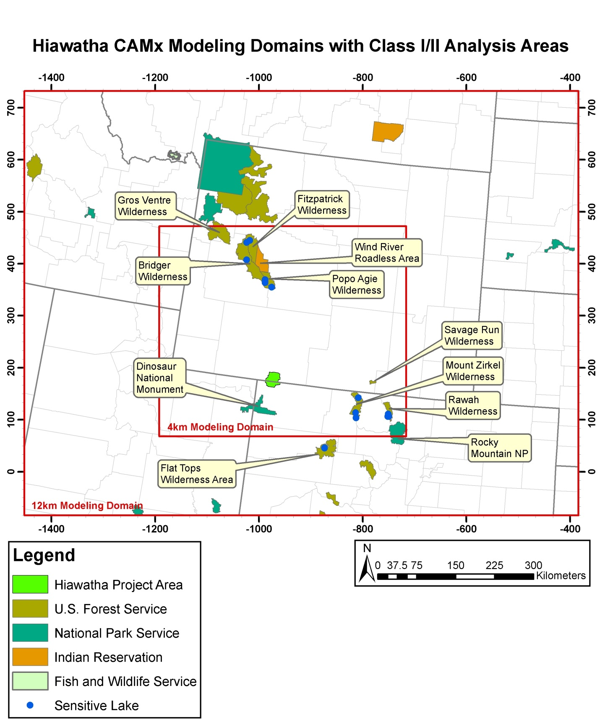
Figure 1. HREDP Project Area in bright green shading, and CAMx 12 and 4 km Modeling Domains in red. The PSD Class I and sensitive Class II areas included in the AQ/AQRV impact analysis are labeled.

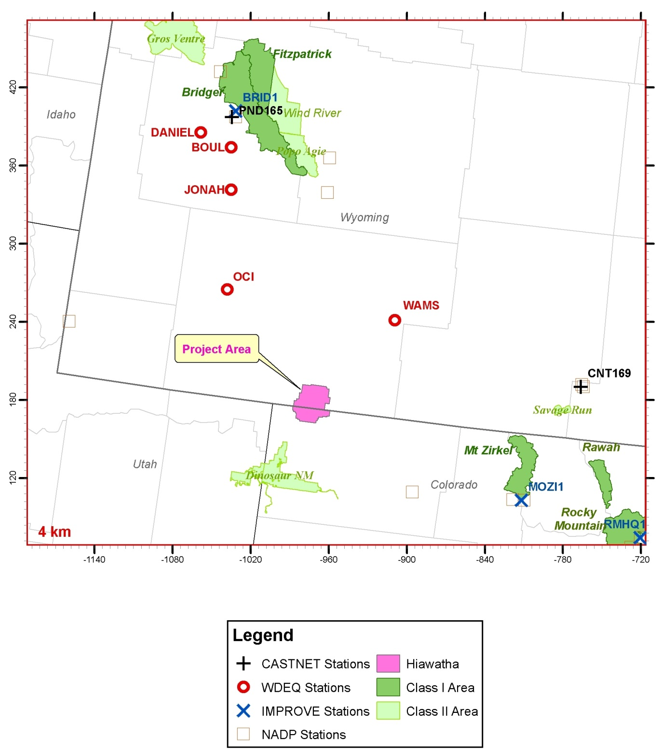
Figure 2. The HRDEP Project Area (pink) and 4 km CAMx modeling domain showing locations of ambient air monitoring sites from several monitoring networks and Class I and sensitive Class II areas.

Form 2. Proposed modeling specifications.
Emissions Modeling Platform
Parameter | Options | Example Entries
Modeling Periods | Base Case Emissions Year(s) | 2008
 | Future Emissions Year(s) | 2020
Source Information | Project Emissions | HREDP
 | US Emissions | EPA NEI08v2 and WestJumpAQMS
 | non-US Emissions | Canada, Mexico
 | Emissions Scenarios | 2008 Base Case  ~2020 Proposed Action, No Action Alternatives and other Alternatives
 | Emissions Scenarios (future case) | EPA NEI2007v5 2020 projections  HRDEP Project O&G Emissions  Other RFD O&G Emissions in Region
 | Spatial Surrogate Data | WestJumpAQMS Updates
 | Temporal Allocation Data | EPA NEI08v2
 | Chemical Speciation Data | EPA NEI08v2
Model Description | Name | SMOKE
 | Version | 3.0
Meteorological Modeling Platform
Parameter | Options | Example Entries
Model Description | Name | Not Applicable – using 2008 12/4 km WRF data in 3SDW from WestJumpAQMS
 | Version
 | Model Year(s)
Model Domain | Resolution
 | Horizontal Domain
 | Vertical Structure
Technical Features | Initial Conditions
 | Topographic Inputs
 | Vegetation Type and Land Use Inputs
 | Atmospheric Data Inputs
 | Time Integration
 | Diffusion Options
 | Boundary Conditions
 | Data Assimilation
 | Water Inputs
 | Physics Options
 | Grid Interaction
Photochemical Grid Modeling Platform
Parameter | Options | Example Entries
Model Description | Name | CAMx
 | Version | 6.10 (April 2014)
Model Period | Base Case Year(s) | 2008
 | Future Year(s) | ~2020
Model Domain | Resolution | 12/4 km
 | Horizontal Domain | 12 km: 89 x 68  4 km: 119 x 101
 | Vertical Structure | 25 Layers
Technical Features | Initial Conditions | CAMx 2008/2020 12 km 3-D output
 | Transport | PPM
 | Diffusion | Smagorinsky
 | Boundary Conditions | CAMx 2008/2020 12 km 3-D output
 | Gas-Phase Chemistry | CB6r2
 | Aerosol Chemistry | ISORROPIA
 | Aqueous-Phase Chemistry | RADM
 | Photolysis Rates | TUV
 | Deposition Schemes | Zhang
 | Grid Interaction | 12/4 km two-way interactive
 | Source Apportionment Configuration | OSAT and PSAT (except SOA)  - Natural Sources  - HREDP No Action/Proposed Action  - RFD Sources  - Everything Else

