AIR QUALITY OIL AND GAS MOU TECHNICAL TEAM
INTERMOUTAIN WEST DATA WAREHOUSE
DRAFT NEPA PROCESS OUTLINE
VERSION DATE: 08/29/2016

BACKGROUND

The National Environmental Policy Act (NEPA) requires federal agencies to conduct detailed air quality assessments for federal actions that may significantly affect the environment. These air quality assessments may be included in Environmental Assessments (EAs), Environmental Impact Statements (EISs) for planning level analyses (e.g., Resource Management Plans) and project level analyses, or leasing analyses for a variety of sources operating on Federal lands. Through the Memorandum of Understanding (MOU) among the U.S. Department of Agriculture, U.S. Department of the Interior, and the U.S. Environmental Protection Agency Regarding Air Quality Analyses and Mitigation for Federal Oil and Gas Decisions through NEPA signed in 2011 (hereafter referred to as “Air Quality MOU for Oil and Gas through NEPA”), the Department of Agriculture, the Department of Interior, and the Environmental Protection Agency have outlined a standard approach for conducting air quality analyses for oil and gas development on Federal lands. In general, NEPA air quality assessments evaluate the potential air quality and air quality related value (AQRV) impacts due to emissions from a proposed action and alternatives. The level of analysis required for a NEPA action depends on the type of development, location of development, and magnitude of emissions created from the development. Depending on these factors, the air quality assessments may include a qualitative analysis that describes the air quality issues or impacts using available monitoring data and studies conducted in other NEPA projects. The air quality assessments may also include a quantitative analysis that involves the use of air quality models to assess impacts to air quality and AQRVs.

A plume dispersion model (e.g., AERMOD) and a photochemical grid model (PGM) (e.g., CAMx and CMAQ) are typically used to quantitatively assess the air quality impacts associated with the development. These models require emissions and meteorological information to estimate the concentration and dispersion of pollutants that impact air quality. Considerable resources are needed to develop the model inputs and to conduct the air quality modeling analyses. As a result, multiple federal and state agencies in the intermountain west identified the need to more efficiently and expeditiously collect air quality data and conduct air quality modeling. To address this need, the agencies entered into an MOU in 2011 to initiate a pilot project (Three State Air Quality Study (3SAQS)) that would add ambient air quality monitoring stations and develop an air quality modeling platform to assess the air quality in the intermountain west. The 3SAQS developed a data warehouse that maintains the ambient monitoring data, emission inventories, meteorology, and air quality modeling inputs and outputs. After the 3SAQS culminated in 2014, the Cooperators of the study decided to continue the efforts for another three years and refer to the study as the Western-States Air Quality Study (WAQS).
PURPOSE

This document outlines the process for requesting and using data stored in the IWDW for future NEPA projects. This document has been reviewed and approved by the Signatories of the Air Quality MOU for Oil and Gas through NEPA and Cooperators of the Intermountain West Data Warehouse for Air Quality (IWDW-AQ).

REQUEST FOR DATA

Each new NEPA project will need a representative from a WAQS Cooperating Agency to sponsor the project, and complete a Data Request form and a sign a Data Use Agreement through the IWDW. The Data Request form and Data Use Agreement are provided on the IWDW. All components of the Date Request form will need to be completed for each NEPA project, unless the information requested in the Data Request form is pre-decisional or deliberative. Having a sponsor and completing a Data Request form assists the WAQS-IWDW in tracking the types and number of projects utilizing the WAQS products, prioritizing the release of the data, and notifying users when updates become available.

NOTE TO IWDW: We need the Data Request Form to be more specific about the Timeline information.

TYPES OF IWDW MODELING PLATFORM COMPONENTS FOR NEPA PROJECTS

The IWDW will only support CMAQ and CAMx photochemical grid models. Information needed for dispersion modeling (e.g., AERMOD and CALPUFF) should be available from state offices and FLMs. In particular, the IWDW will not provide tools or files specifically formatted for any dispersion models. If a NEPA project proposes to use the IWDW products as inputs for any dispersion models, it is up to the Lead Agency and affiliated contractors to develop or obtain the software tools for extracting and formatting the PGM data into model-ready files for the dispersion models.

IWDW MODELING PACKAGE DESCRIPTIONS FOR NEPA PROJECTS

- Initial and Boundary Conditions

The IWDW will maintain and provide initial/boundary conditions from the selected global model (e.g., MOZART, GEOS-Chem, AM3) for the PGM. These files will be included in the IWDW Modeling Package. Model evaluation tools will be available through the IWDW, allowing for selection and evaluation of specific sites and models.

- Emissions Inventories

The IWDW will maintain and provide model-ready U.S. and non-U.S. emission inventories, including area and point oil and gas emissions for current and future-year baseline scenarios. A user may need to modify these inventories to reflect a specific proposed project and possible alternatives.

- Meteorological Files

The IWDW will maintain model-ready meteorological input files (i.e., WRF files). These files will be included in the IWDW Modeling Package. Model evaluation tools will be available through the IWDW, allowing for selection and evaluation of specific meteorological performance metrics for specific sites.

- PGM Files

The IWDW will maintain the base case and future-year baseline PGM modeling scenarios. The IWDW will also maintain 3D outputs from the base case and future-year baseline scenarios to support the modeling approaches outlined below. The IWDW will not maintain 3D output files for the source apportionment cases. These files will be made available upon request. Model evaluation tools for the base case and future-year baseline scenarios will be available through the IWDW, allowing for selection and evaluation of specific sites and models.

- Documentation

The IWDW will maintain and provide MPE reports or summary reports discussing each model component (i.e., initial/boundary conditions, emissions, meteorology, and air quality model) and PGM model platform (i.e., CMAQ and CAMx model platform). The IWDW will also maintain and provide a Release Memorandum for each new platform that outlines the applications approved to utilize the IWDW model packages, the available packages, and any uncertainties or cautions regarding the PGM platform.

UTILIZATION OF IWDW MODELING PACKAGES FOR NEPA PROJECTS

The IWDW provides modeling products for a PGM base case, base case MPE, and future-year baseline scenario. These modeling products have been completed and approved by the WAQS. If resources allow, the WAQS intends to complete a base case, including a base case MPE, for the years associated with the National Emissions Inventory (NEI) distributed by the EPA. The NEI is released every three years (i.e., 2011, 2014, 2017, etc.). The WAQS may also complete a base case and base case MPE for non-NEI years, if resources are available. In any case, the most recent model platform approved by the WAQS will need to be used in each NEPA project. Any new NEPA project will not need to re-generate a base case and base case MPE if these procedures are followed by the Lead Agencies and affiliated contractors.

For each new NEPA project, the Lead Agency and affiliated contractors will need to download the executables/model versions and the future-year baseline scenario used in the selected WAQS model platform. The Collaborators have noticed significant differences in some of the model results when other versions of the executables or model versions are used for the air quality analysis. The NEPA project will need to repeat the future-year baseline simulation to demonstrate that the data transfer and modeling platform accurately reproduces the WAQS model results (performance guidelines are provided below). The WAQS recognizes that photochemical grid models will have differences in calculated concentrations when run on different computer systems. However, if significant differences are found (see criteria below), the NEPA Cooperating Agencies will work with the Lead Agency and affiliated contractors to identify the source of the differences. Each new NEPA project will also need to perform future-year baseline PGM simulations with the project emissions scenarios (additional details provided below). The results of these simulations will then be used to determine the impacts on air quality and AQRVs.

The WAQS realizes that the IWDW modeling platform includes a large 4-km model domain that encompasses several states in the intermountain west. In some cases, a NEPA project may prefer to reduce or “window down” the IWDW model domain to focus on the geographic area of their project and to potentially reduce the computational and data storage costs. The WAQS prefers that NEPA projects use the full model domains provided by the IWDW. The Collaborators of the WAQS have found that significant differences may occur in the model results when the model domain is reduced, particularly in the source apportionment results. If a NEPA project proposes to use a window-down approach, it is up to the Lead Agency and affiliated contractors to develop or obtain the software tools for extracting the boundary condition data from the larger 4-km domain, and demonstrate that the window-down approach will not significantly impact the model results. The demonstration or quality assurance checks are outlined below. Based on the experience of the WAQS Cooperators, the smaller model domain will also need to extend to a distance of 300 kilometers from the project area to ensure that transport and recirculation of the plume are included in the model domain. In addition, a sufficient number of monitor sites will need to be located within the smaller domain for the QA checks and the air quality assessment (i.e., calculating the Relative Response Factors). If this window-down approach is used in a NEPA project, the Lead Agency will need to provide the details of the approach in the modeling protocol and consult with the NEPA Cooperating Agencies for concurrence.

Two approaches for conducting PGM simulations using the products provided by the IWDW for NEPA projects are outlined below.

Approach 1: Future-Year Baseline and Project Modeling:

- Download the executables or model versions used for the WAQS model platform.
- Download the future-year baseline (e.g., 2018, 2020, etc.) PGM platform, meteorology, and emissions datasets from the IWDW. In this approach, the NEPA contractor does not need to download any of the base case modeling data sets.
- Perform the future-year baseline simulation to obtain PGM results for quality assurance (QA) checks. The QA checks will assist in determining whether different computer systems or utilizing a smaller domain (i.e., window-down approach) significantly impacts the model results, as compared to the WAQS future-year baseline results. In addition to demonstrating proper transfer of the modeling platform and verifying that model results are similar to the WAQS model platform, this simulation will provide the basis of comparison for the subsequent simulations to ensure that model-estimated differences are a result of changes in the model inputs, and not artifacts of the computer system or reducing the model domain. While other analyses could be helpful and may be provided as part of the QA checks, each NEPA project will need to compare their PGM results to the WAQS future-year baseline results for key species (including ozone, NO₂, CO, and PM_{2.5} species) and Air Quality Related Values (AQRVs) (including deposition and visibility) to verify that the results are similar. The comparisons will need to analyze the percentage difference and absolute difference using spatial figures and timeseries plots at selected monitor sites. Percentage differences can be large in grid cells, where the species concentration approaches zero. Therefore, the absolute differences will need to be evaluated in those cases. Figure 1 shows an example of a QA check comparing a model test case to the WAQS reference case. Typically, differences should be less than 0.1% or less than 0.1 ppb or 0.1 ug/m³ for key species and 0.001 kg/ha/yr for nitrogen and sulfur deposition and 0.1 dV for visibility AQRVs for most hours and grid cells. Although, larger differences found at limited numbers of grid cells and hours may be acceptable. When larger differences are observed, the model input data and model configuration will need to be evaluated to identify the cause of the differences (and corrected if necessary) and the results will need to be shared with the NEPA Cooperating Agencies to determine the acceptability. Results of QA checks will need to be summarized and shared with the Lead Agency and NEPA Cooperating Agencies for review and concurrence prior to conducting the air quality assessment.
- Develop project-specific emissions and add them to the future-year baseline emissions data.
- Perform future-year baseline PGM simulations with project emissions.
- The QA process and photochemical grid model results, and associated analyses will need to be disclosed in the Air Quality Technical Support Document.

Approach 2: Future-Year Baseline and Project Modeling with use of Relative Response Factors:

- Download the executables or model versions used for the WAQS model platform.
- Download base case model outputs and future-year baseline (e.g., 2018, 2020, etc.) PGM platform, meteorology and emissions datasets from the IWDW. In this approach, the NEPA contractor must download the base case modeling outputs for use in calculating ozone relative response factors (RRF).
- Steps 3-6 are the same as above.

It is possible that other approaches maybe acceptable. However, any deviations from the two approaches listed above and utilization of the IWDW datasets, or inability to adequately reproduce the WAQS future-year baseline model results may require additional model performance evaluations. The Lead Agency will need to discuss any deviations and performance issues with the NEPA Cooperating Agencies for concurrence at the earliest opportunity. The early discussion and coordination will avoid any delays, disparities, or problems in the future modeling efforts.

INFORMATION/DATA RETURNED TO AND MAINTAINED BY IWDW

After the Record of Decision (ROD), the items outlined below would need to be returned back to the IWDW. This information will inform future NEPA air quality assessments and will be used by the IWDW for tracking purposes.

- Revised project-level or alternative emissions inventories;
- Output files from the air quality model and results from the air quality analysis;
- Air Quality Technical Support Documents containing information about the NEPA project development, the model methodology, and predicted impacts on air quality and AQRVs; and
- Any follow-up modeling after the ROD that incorporates controls, Best Management Practices (BMPs), revisions, etc.

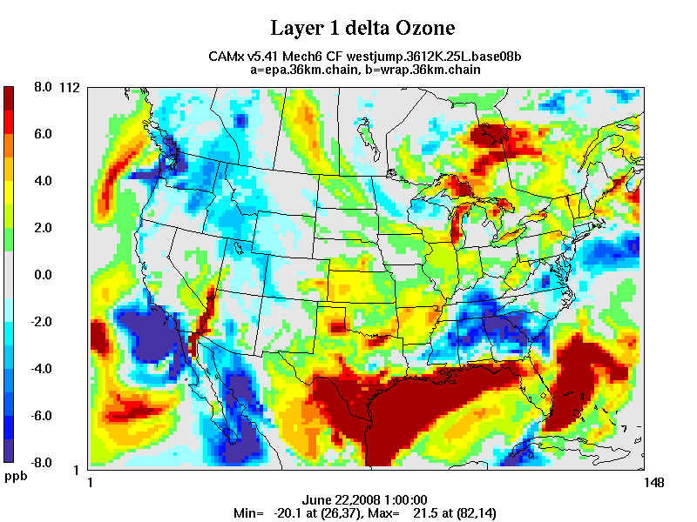
FIGURES

Figure 1. Example quality assurance check showing absolute difference in modeled O3 for a test case model simulation compared to the WAQS reference simulation. In this test case, large differences in ozone were observed which were attributed to incorrect initial conditions in the PGM test case.

http://www.epa.gov/sites/production/files/2014-08/documents/air-quality-analyses-mou-2011.pdf

